University Scholars Program 2023
The University Scholars Program introduces undergraduate students at the University of Florida to the exciting world of academic research. Students launch into a full research project under the guidance of a UF faculty member. Through this initiative, students develop an understanding of and an appreciation for the scholarly method. The University Scholars Program represents students from all disciplines. Scholars are selected by each college or unit partner though a competitive process to participate.

Table of Contents

AI Scholars………………………………………………………………………………………………………….………………………3
UF Online…………………………………………………………………………………………………………………………………38
UF Health Cancer Center…………………………………………………………………………………..………………………39
College of Agricultural and Life Sciences……………………………………………………………………………………51
College of the Arts…………………………………………………………………………………………………………………….77
College of Dentistry ………………………………………………………………………………………………………….………82
College of Design Construction and Planning ……………………………………………………………………………94
College of Education ………………………………………………………………………………………………………………101
Herbert Wertheim College of Engineering ………………………………………………………………………..……104
College of Health and Human Performance ……………………………………………………………………………153
College of Journalism and Communications ……………………………………………………………………………158
College of Liberal Arts and Sciences …………………………………………………………………………..……………161
College of Medicine ………………………………………………………………………………………………………………211
College of Nursing ……………………………………………………………………………………………………….…………244
College of Pharmacy ………………………………………………………………………………………………..……………245
College of Public Health and Health Professions ………………………………………………………………….…248
College of Veterinary Medicine …………………………………………………………………………………………..…254
George A. Smathers Library…………………………………………………………….………………………………………256
Digital Worlds Institute……………………………………………………………………………………………………….….257
Florida Museum of Natural History…………………………………………………………………………………………259

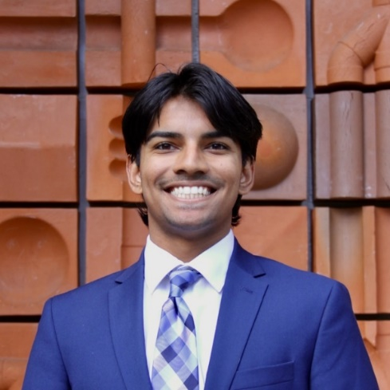
Name: Akshay Ashok
College: Herbert Wertheim College of Engineering
Major: Computer Science
Minor: Mathematics

Mentor: Dr. Ruogu Fang

Project Title: Diffusion Model Synthesis: Evaluating Older Aging vs. Parkinson’s Disease Specific Biomarkers in UK Biobank Fundus Imaging

Project Description: This project expands upon a previous study that explored prediction of Parkinson’s disease using deep learning on UK Biobank fundus images. In that project, researchers applied multiple deep learning and traditional machine learning models to a pruned dataset of fundus images, finding that deep learning models outperformed traditional ML models in predicting both prevalent and incident Parkinson’s in patients. In our project, we aim to validate this performance of deep learning models in predicting PD, by using a diffusion model to augment the dataset of fundus images for elderly patients (65-75) and patients with PD. By expanding the datasets for these two subsets, we will compare performance of deep learning models on (1) the original dataset, (2) on the dataset expanded solely with PD images, and (3) the dataset expanded solely with images from elderly patients. By comparing these three settings, we hope to find whether augmentation of the dataset allows deep learning models to use the correct biomarkers to predict Parkinson’s disease from fundus images.

Research Interests: AI, machine learning and applications in medicine, healthcare, and education.

Academic Awards: MCS AI Diversity Scholar, President's Honor Roll, Dean's List
Involvement: Indian Students Association, Freshman Leadership Experience, Dream Team Engineering
Hobbies and Other Interests: Traveling, working out, trying out new food/drink places in Gainesville, and generally trying out new things.

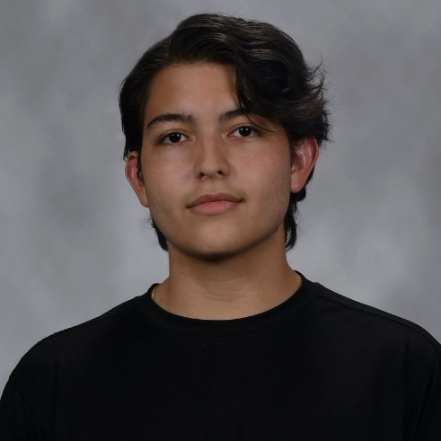
Name: Oscar Barrera
College: College of Liberal Arts and Sciences
Major: Physics & Astrophysics
Minor: N/A

Mentor: Dr. Peter Hirschfeld

Project Title: Graph Convolutional Neural Networks for Discovery of Novel Superconductors

Project Description: Material discovery has been greatly accelerated by machine learning methods ability to efficiently screen materials based on the prediction of relevant material properties. However, most models employed to screen materials across elemental space often have high data requirements and struggle to predict properties that are dependent on the periodicity of the material. This work seeks to accelerate the discovery of superconducting materials by applying transfer learning to the Crystal Graph Convolutional Neural Network1 (CGCNN), to directly predict TC, outperforming the current standard.

Research Interests: I am broadly interested in computational physics, quantum phenomena, astrophysics, and gravitational waves.

Academic Awards: Ronald E. McNair Scholar, UF AI Days Hackathon – First Place, AI Scholar, Christopher B. Schaffer Undergraduate Research Scholarship, University Scholars Program, Florida Academic Scholarship
Involvement: UF Liquid Propulsion Team
Volunteering: Military Heroes Campaign, Susan G Komen For The Cure
Hobbies and Other Interests: iOS App Development, Quantitative Trading, Guitarist & Singer

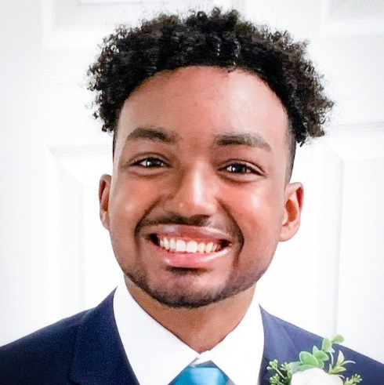
Name: Aidan Burrowes
College: Herbert Wertheim College of Engineering
Major: Computer Science
Minor: N/A

Mentor: Dr. Eleni Bozia

Project Title: Exploring Language Evolution and Bilingualism: A Syntactic Analysis of Linguistic Variation in Classical Languages Using Artificial Intelligence

Project Description: This project seeks to analyze the syntactic structure of Ancient Greek and Latin in literary writings and then train a machine learning model to gain insights into their linguistic variation to examine language evolution and the role of native and bilingual speakers.

Research Interests: Artificial Intelligence, Machine Learning, Natural Language Processing

Academic Awards: National Merit Scholar
Involvement: UF Association for Computing Machinery, UF Open-Source Club
Volunteering: HOPE Helps, Inc. and AdventHealth
Hobbies and Other Interests: Programming, Drawing, Soccer, Gaming

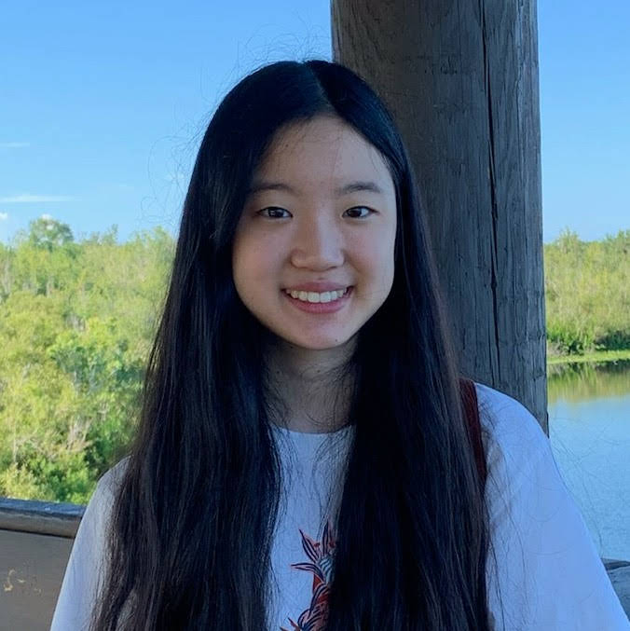
Name: Laura Chang
College: Herbert Wertheim College of Engineering
Major: Computer Science
Minor: Digital Arts and Sciences

Mentor: Dr. Prabhat Mishra

Project Title: Automated Data Augmentation for Deflating Data Bias

Project Description: Machine Learning (ML) has been widely adopted in many areas and data bias is a major concern in ML - certain elements of a dataset are more heavily weighted or represented than others. A biased dataset does not accurately represent a model’s use case, resulting in skewed outcomes, low accuracy levels, and analytical errors. In this project, we introduce an automated data augmentation framework using generative deep learning models to reduce data bias.

Research Interests: Machine Learning, Verifiable AI

Academic Awards: 2022 CISE Gartner Group Information Technology Scholarship, REU recipient
Hobbies and Other Interests: Piano, Pets

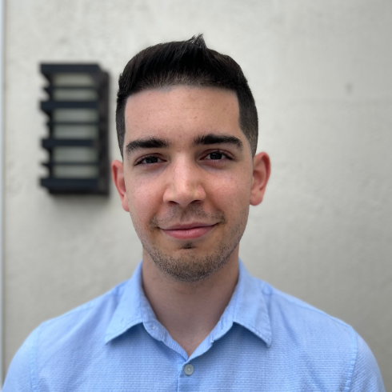
Name: Andy Chavez
College: College of Medicine
Major: Biochemistry and Mathematics
Minor: N/A

Mentor: Daniel Wesson

Project Title: Respiratory ML analysis for fear learning prediction and understanding striatal odor valence encoding

Project Description: The goal of this project is to compare and quantify the accuracy of different machine learning models in predicting freezing behavior (a measure of fear learning performance) using respiratory waveforms. This data will come from an existing GUI I previously developed for the Wesson lab and existing videos of previously recorded experimental trials. The models to be compared will be random forest, neural networks, and k-nearest neighbors to estimate the percent freezing behavior. Last, the components that most affected model accuracy will be used to learn about Striatal odor valence encoding mechanisms.

Research Interests: signal processing, use of AI in healthcare, education, applied math, synthetic biology.

Academic Awards: Dean’s list (2020-present)
Involvement: UF Chemistry Club
Volunteering: Haven Hospice (currently), Children Beyond our Borders (previously)
Hobbies and Other Interests: Hobbies: piano, music, soccer, cooking, math, programming. Interests: longevity, traveling and ecotourism, Cuban history, ethical technology, education, public health

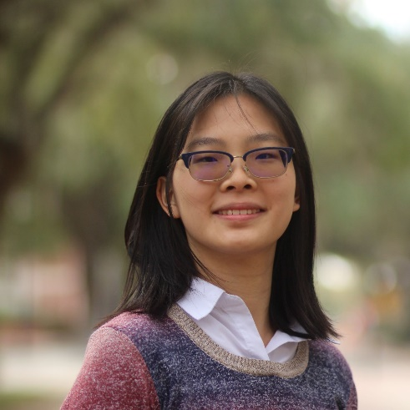
Name: Grace Cheng
College: Herbert Wertheim College of Engineering
Major: Biomedical Engineering
Minor: N/A

Mentor: Ruogu Fang

Project Title: Aging in Caenorhabditis Elegans

Project Description: This project aims to use a machine learning model to predict the age and lifespan of C. elegans worms from video footage. C. elegans worms are a useful model for human aging because they have similar physiological changes in their cellular systems at multiple levels compared to humans, paralleling lifespan stages. Through analysis of video footage, the model will aim to combine physiological features with movement patterns to predict stages of life, and prediction of death for C. elegans.

Research Interests: AI, medicine

Academic Awards: UF Honors Program, URSP
Involvement: Generational Relief in Prosthetics, CURBS, 3D Printing Club
Volunteering: Volunteering at Malcom-Randall VA hospital
Hobbies and Other Interests: Music, Dance, Art, Computers, CAD

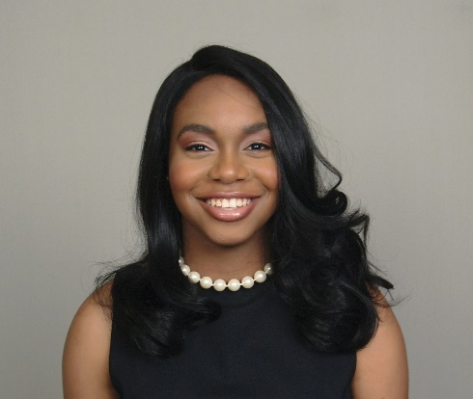
Name: Morgan Cobb
College: Herbert Wertheim College of Engineering
Major: Computer Engineering
Minor: N/A

Mentor: Jeremy Waisome

Project Title: Machine Learning with Fossil Teeth

Project Description: The aim of the project is to develop a machine learning model that can accurately identify fossil shark teeth. Currently, the project utilizes Google's Teachable Machine and Roboflow to train the models, with the input data coming from the myFOSSIL database. The project also involves providing teachers with guidance on how to implement these concepts in the classroom. However, we aim to expand the scope of the project by creating our own system to analyze a larger dataset, sourced from the archives of the museum. The images within this dataset are 2D and contain a range of background information, including color and text, which will require filtering. Our objective is to accurately sift through these backgrounds and develop a system that can do so consistently. Ultimately, we hope to showcase the potential of AI in other museums and inspire the use of this technology in other fossil collections beyond our own.

Research Interests: Artificial intelligence, Machine Learning, Engineering Education

Academic Awards: University Scholars Program Recipient 2023, Florida Bright Futures Academic Scholarship
Involvement: National Society of Black Engineers, Women in Computer Science and Engineering, Innogators
Hobbies and Other Interests: Reading, listening to music, exploring fashion, playing basketball,

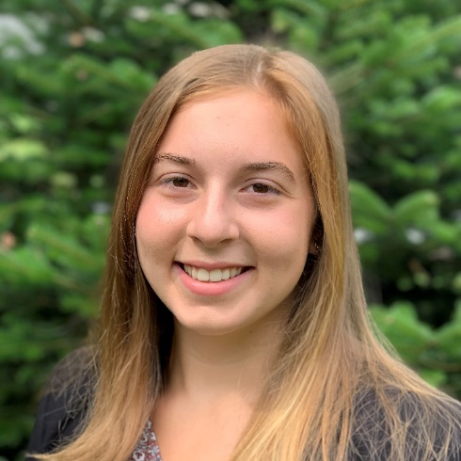
Name: Rachel Fenton
College: College of Liberal Arts and Sciences
Major: Data Science
Minor: Spanish

Mentor: Kiley Graim

Project Title: AI-Driven Modeling for a More Consistent and Ancestrally Inclusive Disease Signature

Project Description: Unbalanced ancestral representation within genomic data has contributed to a Eurocentric understanding of disease, subsequently increasing ancestral and socioeconomic patient health disparities. While many research studies seek to address these disparities by increasing genomic sequencing of diverse populations, these studies are expensive, time-consuming, and are so far unable to keep up with the increasing amounts of newly sequenced data from already well-represented ancestral populations. As a result, the field still lacks sufficient genomic data to accurately represent global ancestral diversity. I contribute to the development of an AI framework already in development by the Graim lab, PhyloFrame, which improves ancestral equity though joint modeling of ancestral population variation and disease signals from training data. It does this through the incorporation of population level variation from already existing, well-curated human population variant repositories such as the Genome Aggregation Database (gnomAD) and dbSNP. By building an AI model that incorporates ancestry-specific variants with variants associated with disease in training data, we can create disease signatures pertinent to all populations.

Research Interests: Genomics, Ancestry, Machine Learning

Involvement: Florida Club Swim Team
Hobbies and Other Interests: Running, Swimming, Gardening

Name: Harmony Gibaldi
College: College of Liberal Arts and Sciences
Major: Psychology & Women's Studies (Theories & Politics of Sexuality)
Minor: Sociology

Mentor: Dr. Xiaoya Zhang

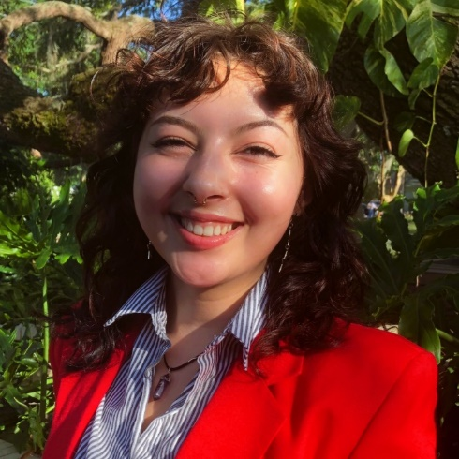
Project Title: Investigating Barriers to Undergraduate Students’ Mental Health Support Using AI Methods
Project Description: I will be using natural language processing (NLP) methods to investigate the unique barriers that undergraduate students at the University of Florida face while seeking out mental health support and resources. I am interested in investigating the nature of their support needs, the specific barriers present for marginalized identities, and the intersections involved in students' experiences. This study aspires to identify the factors contributing to UF students' expressions of mental health concerns and promote opportunities for implementing tangible interventions which may meet the needs of every student.

Research Interests: Barriers to mental health resources, LGBTQ+ psychology, LGBTQ+ women's sexuality, counseling psychology, social constructions of gender

Academic Awards: Florida Academic Scholar
Involvement: Psi Chi, Italian Student Association, OSTEM, PSU
Volunteering: Alachua County Crisis Center
Hobbies and Other Interests: Feminism and social justice, content creation, sex education, aspiring counseling psychologist, ADHD & autism in women, mental health crisis prevention, marginalized college students' mental health, trauma, mindfulness, humanistic psychology, natural lang

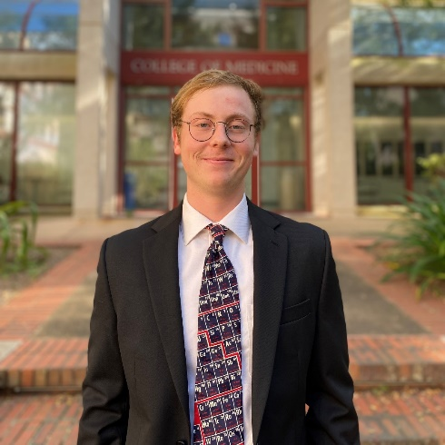
Name: Michael Guyot
College: College of Medicine
Major: Interdisciplinary Studies - Basic Biological and Medical Sciences
Minor: Spanish

Mentor: Brittany Bruggeman

Project Title: Using Artificial Intelligence algorithms for pancreatic cell detection and classification

Project Description: We are planing to train an Artificial Neural Network that can be added to a processing pipeline that can take a whole slide image, segment each cell, then correctly classify each cell.

Research Interests: Artificial Intelligence, Machine Learning, Image Analysis, Embryology

Academic Awards: President's Honor Roll
Volunteering: Crisis Text Line
Hobbies and Other Interests: Working out, walking by dog, local GNV coffee shops

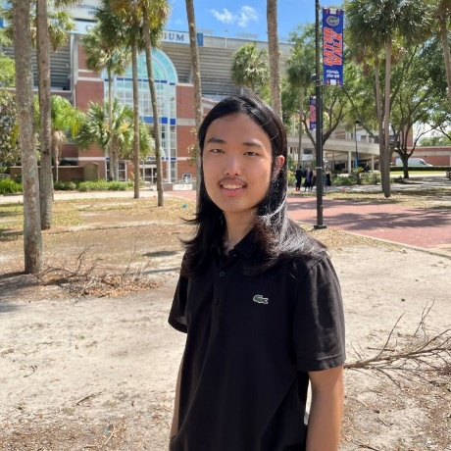
Name: Heon Heo
College: Florida Museum of Natural History
Major: Computer Science
Minor: N/A

Mentor: Nicolas Gauthier

Project Title: Predicting Potential Natural Vegetation Using Machine Learning

Project Description: Potential natural vegetation (PNV) represents a hypothetical state of vegetation that would be expected based solely on climate without being affected by human activity. PNV can be used to predict shifting forest distributions in response to climate change, acting as inputs to global climate models and baselines for biodiversity conservation efforts. Previously, PNV maps were created with poor-quality data and only represent specific time slices. These were predicted through expert opinion, empirical summaries, or simple regression models, which are often subjective and biased. The advancement of machine learning techniques enabled creating of a PNV prediction model that incorporates nonlinear interactions between climate variables driving plant growth (Levavasseur 2012). However, the former attempts to create a map are either only on a regional level or have less accuracy on a global scale. Recent studies have shown the potential for machine learning to address the issues (Hengl 2018), while these maps have been static assessments of a single time slice. I am planning to improve the PNV prediction model by making dynamic maps of PNV. In particular, the research would focus on making dynamic PNV models that change over time, improving the accuracy of the model to resemble the real-world climate and terrain, and finding proper validation metrics. Efforts on creating a dynamic PNV map would provide valuable insights into vegetation change caused by human influence and can be applied to other geospatial-oriented problems, such as global crop distributions.

Research Interests: Data Science, Machine Learning, Artificial Intelligence

Academic Awards: AI Scholar, Alumni Merit Scholarship, Dean's List
Involvement: Software Engineering Club, Open Source Club, Korean Student Association, GAITOR
Hobbies and Other Interests: Electronic Music Producing, Soccer

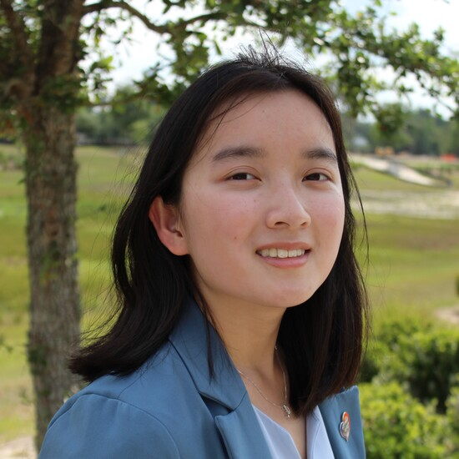
Name: Michele Himadi
College: College of Agricultural and Life Sciences
Major: Biology
Minor: Music Theory

Mentor: Dominick Lemas

Project Title: The impact of maternal obesity on pregnancy complications and maternal-infant outcomes

Project Description: The goal of my project is to investigate the association of obesity with common pregnancy complications as well as infant outcomes.

Research Interests: Emergency Medicine, Infant Outcomes

Academic Awards: Ernest F. Lamothe Agricultural Scholarship Recipient, Fairing Music Scholarship Recipient, CALS Dean's List
Involvement: American Medical Student Association, Pre-professional Student Organization, Society for Viral Studies, School of Music Ambassador
Volunteering: Alachua County Victim Services, Haven Hospice
Hobbies and Other Interests: Playing the piano, journaling, writing music, cycling

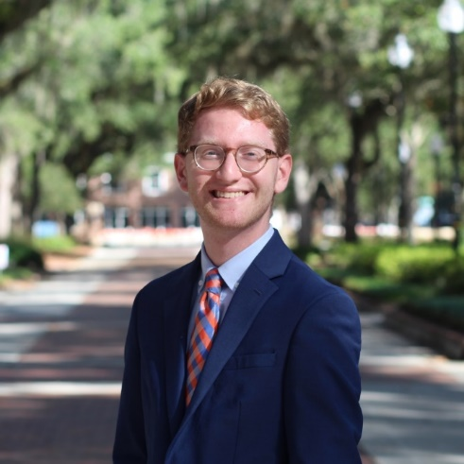
Name: Jonathan Kahn
College: College of Liberal Arts and Sciences
Major: Computer Science
Minor: N/A

Mentor: Kiley Graim

Project Title: ExoGAN

Project Description: Background and Significance: Designing patient-specific targeting peptides for use in drug delivery systems is an emergent strategy to maximize cancer therapeutic outcomes. While experimentally designing and validating these peptides is cost- prohibitive and carries significant systematic error, artificial intelligence (AI) can drastically reduce these barriers. However, developing effective AI methods for peptide design requires significant AI and domain expertise. Knowledge of which molecular features drive peptide-tissue interactions remains unclear, hindering AI peptide design. While several methods have attempted peptide design using AI, none can generate multi-tissue-specific targeting peptides. I propose to tackle this issue. ExoGAN, an AI approach that effectively generates MHC-I targeting peptides. ExoGAN currently lacks tissue-specificity, which I will address in this proposal by extending ExoGAN to a multi-targeting peptide design. My proposal dramatically expands the application of our existing generative AI model, ExoGAN. I will apply ExoGAN to several proteins and extend it to have tissue-specific binding affinity predictions. By doing this, I will enable the cost-effective development of precision drug delivery for patient- specific precision medicine. Additionally, by applying ExoGAN’s across tissues, I will be able to identify previously undetectable molecular patterns relevant to binding affinity, providing critical information to the field.

Research Interests: Bioinformatics, Machine Learning, Data Science

Involvement: CUR Ambassador, Phi Sigma Pi, UF ACM
Hobbies and Other Interests: Playing guitar, listening to music, photography and filmmaking

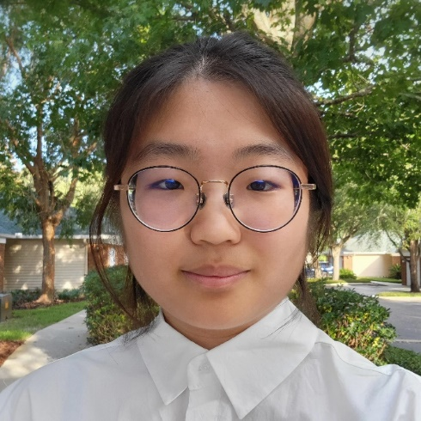
Name: Joanne Kim
College: College of Liberal Arts and Sciences
Major: Computer Science, Mathematics
Minor: N/A

Mentor: Jong Hyuk Kim

Project Title: AI-Implemented Early Detection of Cancer in Companion Dogs using Liquid Biopsy

Project Description: Diagnosis of cancer could leave a life-changing impact on a patient's life. Yet it is a time-consuming task since patients have to wait until a specialized doctor could review their case. In our research, we explore different methods of diagnosing cancer using machine learning to provide quick and reliable guidance for the future treatment of dog patients. Through blood samples of dogs, we obtain the next-generation RNA sequencing dataset to analyze the presence of tumor DNA. We are specifically interested in determining a potential biomarker regarding certain mutations that might suggest cancer cells. We are also interested in medical diagnosis through cytology images. With lymphosarcoma and reactive lymph node samples from dogs, we train the Convolutional Neural Network to increase the accuracy of diagnosis. We visualize the predictions via Grad-CAM and optimize the performances of each architecture, varying from ResNet to VGG models, through hyperparameter tuning. Our goal is to expand both classification and computer vision methods to more generalized cases of cancers to create machine learning models that can be easily used in cancer diagnosis.

Research Interests: Machine Learning, Artificial Intelligence, Computer Vision, Neural Network

Academic Awards: Dean’s List (21-23), UF Honors Program
Involvement: UF Korean Student Association, Women in Computer Science & Engineering (WiCSE)
Hobbies and Other Interests: Playing Video Games, Watching Mystery Shows, Cooking with Friends

Name: Nabil Koney-Laryea
College: Herbert Wertheim College of Engineering
Major: Computer Science
Minor: Engineering Innovation

Mentor: Daisy Wang

Project Title: AI Chatbot to Improve Patient Knowledge on Genetic Testing

Project Description: In my research, I plan to use medical domain language models in the implementation of an onboarding chatbot for genetic testing patients at UF Jacksonville. To accomplish this, I will first talk to the precision medicine team at UF Jacksonville to understand the functional requirements of the chatbot. I will then create a scalable system design that will enable the team to develop for testing as well as production. The design will be modular and allow for the testing of multiple language models to study their performance for our unique problem space. Following the initial design of the system I will implement a prototype of the chatbot for testing and potential clinical trials.

Research Interests: Natural Language Processing (NLP) for Question-Answering Tasks and Socio-Political Analysis, Computer Vision for Perception in Autonomous Robots, Internet of Things (IoT) for Smart Spaces

Academic Awards: Distributed Research Experiences for Undergraduates (DREU) Scholar
Involvement: National Society of Black Engineers (NSBE)
Hobbies and Other Interests: Rollerblading, Science Fiction, Foodie

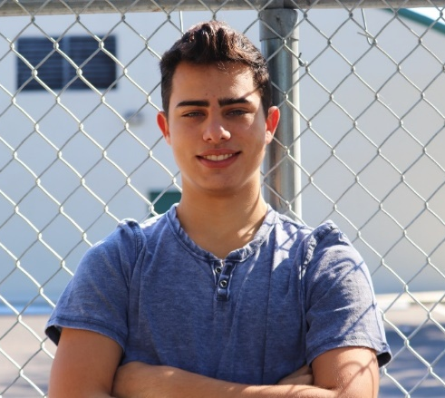
Name: William Kratochvil
College: College of Liberal Arts and Sciences
Major: Psychology
Minor: Innovation

Mentor: Won Lee

Project Title: Drone system for two-spotted spider mite detection and prevention using artificial intelligence.

Project Description: I plan on building the drone by 3D modeling the parts in Fusion 360 (like the rotors and body of the drone) and printing the pieces using the 3D printers in Dr. Lee’s lab. I will use the grant money to buy various components for the drone as well, such as the motors, camera, and a Raspberry Pi Model 4B. I want to explore different types of camera vision, whether it is possible to detect the spider mites using infrared vision or whether it is easier to detect them at night. I also want to explore various AI models, especially whether deep learning models are the most appropriate for this application. I plan on training my AI model with pictures from the field and exploring different transfer learning models. I hope to detect spider mites before they do too much damage to our precious crops and to provide an effective and cost efficient way in doing so. I would love to incorporate the data collected into a system or app, so farmers can utilize this data for increasing crop yield.

Research Interests: Neuroscience, 3D-Printing, 3D Design, Robotics, and AI in Strawberry Pest Detection/Prevention..

Academic Awards: Dean’s List (Summer 2021, Spring 2022, Summer 2022), Franklin Merit Scholarship Recipient (Fall 2020) Fernandez Family Foundation Scholarship Recipient (Fall 2020, Fall 2022)
Involvement: UF Chess Club, Gator Scuba Club, UF Marching Band, Innovation Fellows
Volunteering: Gator Scuba Club, Marching Band
Hobbies and Other Interests: Music, Scuba Diving, and Rapid Prototyping.

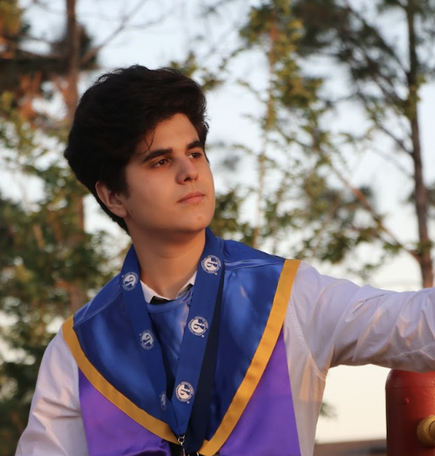
Name: Abraham Banos Lombardero
College: College of Liberal Arts and Sciences
Major: Computer Science
Minor: N/A

Mentor: Kristy Boyer

Project Title: Dialogue Act’s and Collaboration

Project Description: Investigating the Relationship between Dialogue Acts and Satisfaction among Middle School Computer Science Learners

Research Interests: Computer Science, Artificail Intelligence

Academic Awards: AI Scholar
Involvement: DevLUp, SHPE
Volunteering: N/A
Hobbies and Other Interests: Hiking, Biking, Soccer, Volleyball.
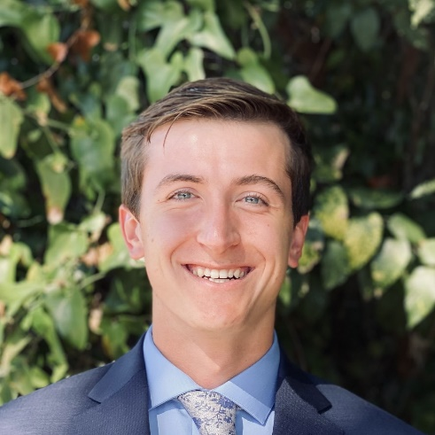
Name: Griffin Martin
College: Herbert Wertheim College of Engineering
Major: Mechanical Engineering
Minor: Computer Science

Mentor: Umesh Persad

Project Title: The Design of Below-Knee (Transtibial) Leg Prosthetics using Artificial Intelligence and Computational Design

Project Description: Much of the world is without access to lower-limb prosthetics to enable human mobility for patients with amputations, due to factors such as lack of availability, affordability, trained personnel, and data. This project seeks to solve this problem with Artificial Intelligence based prosthetic design software that can automate the design process of below-knee (transtibial) prosthetic legs.

Research Interests: Additive manufacturing, generative design

Involvement: Florida Club Rowing
Hobbies and Other Interests: Piano, backpacking, travel, cooking

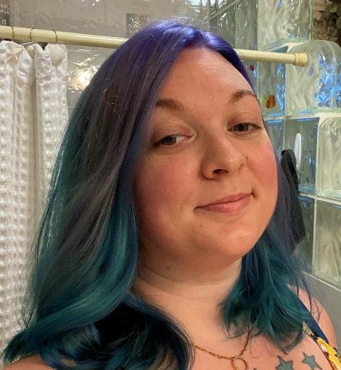
Name: Jennifer Maxwell
College: College of Liberal Arts and Sciences
Major: Geography
Minor: N/A

Mentor: Anwar Sounny-Slitine

Project Title: Shoreline Loss Progression in Rodanthe North Carolina

Project Description: An analysis of the loss of shoreline due to excessive erosion despite remediation efforts

Research Interests: Georeferencing, GIS, Land Change

Academic Awards: Dean's List, President's List and Honor Roll
Volunteering: Habitat for Humanity, Reciprocal Ministries
Hobbies and Other Interests: Photography, Painting, Gardening

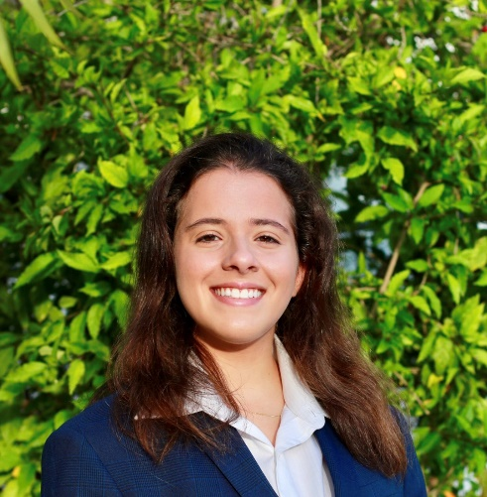
Name: Melody Morales Rojas
College: College of Dentistry
Major: Materials Science and Engineering
Minor: N/A

Mentor: Mateus Garcia Rocha

Project Title: Development of Artificial Neural Network to Predict the Degree of Conversion of Resin-Based Cements

Project Description: The aim of this study is to implement artificial neural networks (ANN) to investigate the relative importance of each one of the variables on the DC of resin-based cement and predict the DC based on the top radiant exposure.

Research Interests: Biomaterials, dentistry, fractography

Academic Awards: Deans list
Involvement: Society of Hispanic Professional Engineers, Delta Delta Sigma, Materials Advantage
Volunteering: SHPE Jr, SHPE Jr Jr, UF Shands
Hobbies and Other Interests: Dentistry, Mentoring, Weightlifting, Music, Reality TV

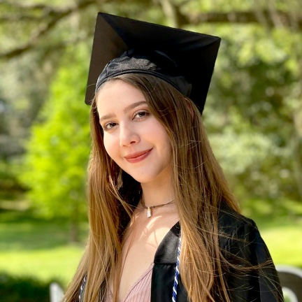
Name: Valentina Oropeza
College: College of Agricultural and Life Sciences
Major: Food and Resource Economics
Minor: N/A

Mentor: Won Suk Lee

Project Title: Efficient Farming with AI: The Economic Advantages of Strawberry Mite Detection

Project Description: Pest management relies on thorough pest scouting to prevent economic losses. It's critical for growers to take action to control pests as soon as their population surpasses the economic threshold to minimize any potential financial damages to the grower. Strawberry growers face the need to monitor pests in order to determine the best options for pest management to reduce yield damage. The traditional way of counting pests is by doing it manually which can be very time-consuming. By using artificial intelligence to count pests, growers can save time and improve counting consistency. In this research, we use a single-camera platform and a six- camera imaging system to take images of the strawberry leaf. We also use a deep learning model, YOLOv4, that is trained to detect existing pests on the strawberry leaf. This technology is trained to detect two-spotted spider mite (TSSM) motile, TSSM eggs, and predatory mites (Neoseiulus californicus and Phytoseiulus persimilis).

Research Interests: Strawberry mite detection

Academic Awards: College of Agricultural and Life Sciences Dean’s Honors List, College of Agricultural and Life Science Scholar, Food and Resource Economics Scholar, Santa Fe College Dean's Honors List, Phi Theta Kappa Society Member
Involvement: IDEA committee
Volunteering: Sonar Despierto, a non-profit organization whose purpose is to help young in need throughout Latin American countries.
Hobbies and Other Interests: Research, listening to music, spending time with my loved ones and horseback riding

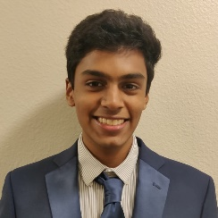
Name: Abhinav Penmetcha
College: College of Medicine
Major: Biology
Minor: Bioinformatics

Mentor: Jason Brunson

Project Title: Racial Ethnic Disparities in Post–Lung Transplant Outcomes

Project Description: Lung transplantation (LT) is a contemporary surgical procedure with major outcomes of short- and long-term survival post-transplant. Many variables can potentially influence these outcomes, one such variable of particular interest being race/ethnicity due to the systemic effects a patient’s racial-ethnic identity can have on their healthcare. While race/ethnicity has been studied in past literature, it is typically used as a covariate or studied as an individual variable. As race/ethnicity does not operate in a vacuum in the real world, I have worked with Dr. Brunson and Omolola Suleiman to undertake statistical analyses to model the relationships between race/ethnicity and a large set of covariates to determine their influences on lung transplant survival outcomes. To accomplish this, we undertook a literature review through which we identified prevalent covariates to be included in our preliminary analysis. After producing this large set of covariates, we developed a causal diagram that divided the covariates into subgroups interconnected by potential causal relationships. Through our statistical modeling, we are currently evaluating these relationships in the United Network of Organ Sharing’s lung transplant database to generate an overarching model that weighs the interaction effects within our set of covariates and with race/ethnicity to evaluate how they work together to influence survival outcomes post-transplant.

Research Interests: Clinical Outcomes, Statistical Modeling, Social Disparaties

Academic Awards: Dean's List
Involvement: UF Science Olympiad
Volunteering: Chemistry Club Outreach
Hobbies and Other Interests: Reading, Video Games

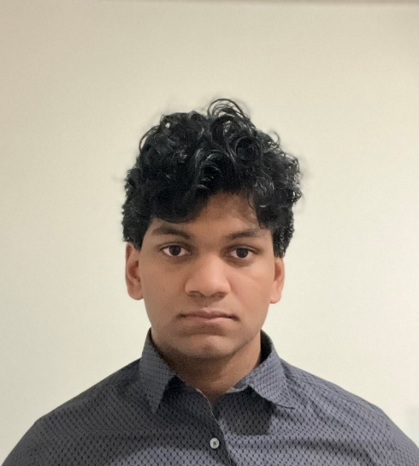
Name: Rohan Prasad
College: Herbert Wertheim College of Engineering
Major: Computer Science
Minor: Statistics

Mentor: Eleni Bozia

Project Title: Classifying Relationships of Subjects in Classical Texts

Project Description: Texts contain large amounts of data and information about the nature of interactions between two or more subjects that provide a view into both subjects and the author's perspective. Through the use of relation extraction, a natural language processing technique, these semantic relationships can be examined to provide these in-depth perspectives. Relation Extraction is a analytical procedure in natural language processing that utilizes labeled relation statements and input entities to classify and identify the relationships between two subjects, while considering the contextual information within the data. The research will examine the use of relation extraction on ancient Greek literary texts in order to analyze the relationships within the ancient world. Classical texts help explore more about ancient society and their relations towards others and prominent individuals. An analysis of these ancient texts helps show what society thought or prominent authors thought of different groups or individuals of the time.

Research Interests: Artificial Intelligence, Natural Language Processing

Academic Awards: Dean's List, 1st Place Google Cloud Special Challenge SwampHacks 2022
Hobbies and Other Interests: Horticulture, wood working, coding

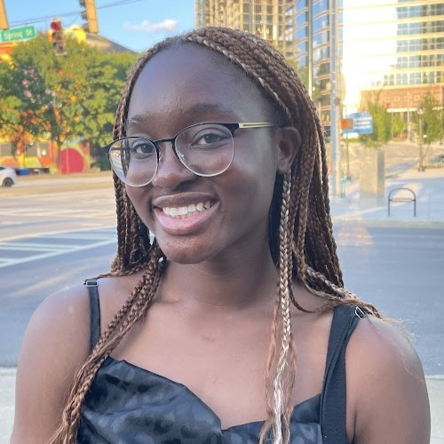
Name: Wilermine Previlon
College: College of Liberal Arts and Sciences
Major: Linguistics
Minor: Anthropology and Sociology of Social Justice and Policy

Mentor: Sarah Moeller

Project Title: Using Dependency Parsing to Disambiguate Features of African American English

Project Description: AI algorithms often fail to accurately analyze speech produced by marginalized groups such as African Americans who use African American English (AAE) (Blodgett and O’Connor 2017). This can result in biased language processing tools such as those used for identifying abusive language on social media (Davidson et al. 2019). To address this issue, we propose using dependency parsing to disambiguate key AAE features from Standard American English (SAE). Previous research has focused on using part of speech tagging to disambiguate the habitual be in AAE. Building off the work of Santiago (2022), this study proposes using dependency parsing to analyze more complex syntactic relationships and determine whether this methodology can also be applied to other AAE features. Santiago (2022) achieved a 65% disambiguation rate over 10 models but we believe that dependency parsing may yield even better results. The method used to disambiguate between AAE and SAE features can be used in larger AI models such as the one previously mentioned from Twitter. Once the algorithm identifies the language an utterance comes from it can then apply different algorithms that correlate to each language rather than using a general one that ignores the nuanced differences in the two. Overall, this research hopes to assist in the broader movement of creating Artificial Intelligent tools that are ethical, useful and unbiased.

Research Interests: Computational Linguistics, African American English

Academic Awards: Dean's List
Involvement: Undergraduate Linguistics Society
Hobbies and Other Interests: Performing with Genesis Dance Crew!

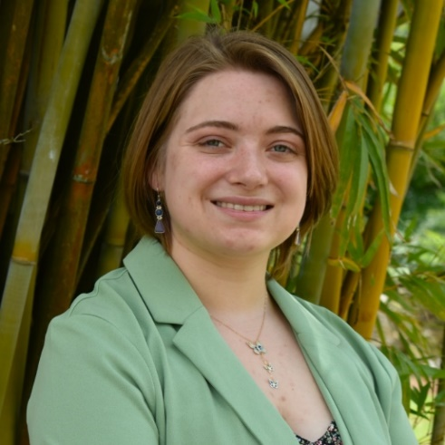
Name: Serena Price
College: College of Liberal Arts and Sciences
Major: Zoology
Minor: Anthropology

Mentor: Robert Guralnick

Project Title: Using AI image analysis to test camouflage as an evolutionary driver of voluntary color change in Anolis carolinensis

Project Description: The Green anole (Anolis carolinensis) is the only species of anole native to the United States, and it is one of many species of anole capable of voluntary color change. Multiple hypotheses exist to explain why color changes occur in this species, including social behavior, thermoregulation, and camouflage. The lack of consensus on the purpose of body color shifts in A. carolinensis provides an opportunity to investigate the adaptations of a native species that is on the rise as a model organism for morphological evolution. In this project, we plan to use a deep learning image-processing pipeline to extract body and background color data from iNaturalist images and assess the effects of substrate and ambient temperature on anole body color across space and time. AI image processing of iNaturalist data can provide us with spatially and temporally broad trait observations, presenting an opportunity to test multiple proposed hypotheses at once and help determine what is primarily driving the evolution of color change in Anolis carolinensis.

Research Interests: AI in Zoology, Herpetology, Evolution and Adaptation, Natural History Collections, Ecology

Academic Awards: Deans List Fall 2022
Involvement: Alpha Phi Omega, Tau Chapter
Volunteering: Florida Museum Herpetology Collection, APO,
Hobbies and Other Interests: Art, Cooking, Japanese Language and Literature, TRPG, Creative Writing, Video Games, Hiking

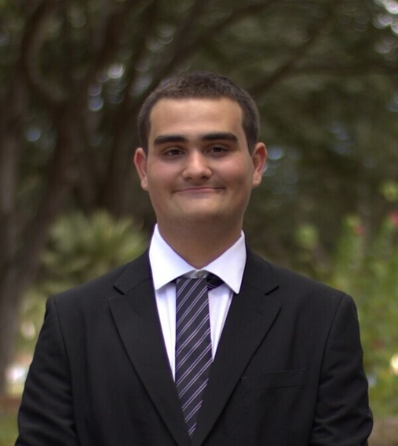
Name: Legasse Remon
College: Herbert Wertheim College of Engineering
Major: Computer Science
Minor: N/A

Mentor: Natalie Ebner, Ph.D.

Project Title: Modeling the Neurocognitive Mechanisms Underlying Fake News Detection using Artificial Intelligence

Project Description: Fabricated information mimicking news media, referred to as ‘fake news’, is an epidemic deception technique to manipulate public opinion. Older adults, and especially those with lower cognitive functioning, are particularly vulnerable to deception via fake news. Currently only technical solutions exist (e.g., fact checking), but fake news continues to break through, leaving human decision making as the last line of defense. The purpose of this project is to develop a neural network model to identify deceptive features in news headlines and cognitive characteristics in the decision maker toward enhancing fake news detection. Findings from this work have the potential to inform the design of new algorithms and inventions towards reducing fake news deception in aging.

Research Interests: Cybersecurity, Social Engineering, Usable Security,

Academic Awards: Dean's List (Fall 2022), Hispanic Scholarship Fund Scholar, Sunshine Opportunity Scholar, Florida Academic Scholar
Involvement: Society of Hispanic Professional Engineers, University of Florida Security Information Team
Volunteering: Elks National Foundation, Hispanic Scholarship Fund
Hobbies and Other Interests: Rhythmic Gaming, Hiking, Cooking,

Name: Robert Rice
College: College of Liberal Arts and Sciences
Major: Data Science and Mathematics
Minor: N/A

Mentor: Dr. Christopher Mccarty

Project Title: Exploring Jazz Music with AI: Uncovering the Melodic Properties of Jazz Improvisation

Project Description: Jazz music, characterized by its improvisational style and emotive expressiveness, serves as a unique canvas for examining the intricate balance between spontaneous creation and inherent musical structures. This research seeks to unpack the melodic nuances of jazz improvisation, utilizing a synthesis of Anthropological and AI methodologies. The primary goal is to elucidate the relationship between jazz musicians and the emergent patterns in their improvisations. By employing machine learning algorithms, we plan to dissect and categorize musical features from a dataset of jazz recordings. Additionally, by analyzing musicians' collaborations, we aspire to chart out a network showcasing the synergy between artists and the arising improvisational styles. This investigation aims to offer a richer understanding of jazz improvisation, marking a novel contribution to Ethnomusicology.

Research Interests: Social Network Analysis, Topological Data Analysis, Musicology

Academic Awards: Dean's List 2023 Spring, Dean's List 2023 Fall
Involvement: DSI, Balkan Student Association
Volunteering: Student-led Johannisheim Elderly Home Care, Freiburg im Breisgau, Germany
Hobbies and Other Interests: Music, Philosophy, Agriculture

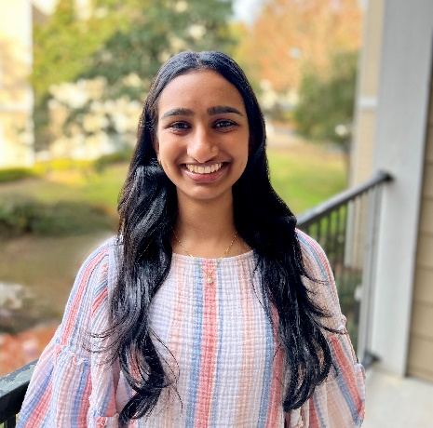
Name: Kirthana Sane
College: College of Liberal Arts and Sciences
Major: Health Science
Minor: Health Disparities

Mentor: Edith Kaan

Project Title: Can Some Types of Code-Switching Make You Better At Inhibition?

Project Description: Code-switching, the alternation between different languages within a single sentence or conversation is common amongst bilinguals. We aim to examine whether conflict resolution in a non-verbal task is affected by the type of code-switching. To test this, the experiment alternates pre-recorded code-switched and unilingual sentences with Flanker trials. Participants will be Spanish-English bilinguals in the US who learned Spanish from birth and English before the age of 12. Participants will listen to three blocks of language contexts: insertional and dense Spanish-English code-switching, or Spanish only. After each sentence type, participants perform Flanker trials (congruent [&gt;&gt;&gt;&gt;&gt;] or incongruent [&gt;&gt;&lt;&gt;&gt;]) to which they respond by pressing a button to indicate the direction of the middle arrow. We will collect reaction times and accuracy on the flanker responses, as well as ERP P3 and N2 components. Statistical analysis will be performed to compare the adaptation effect between the three language contexts. This study will help us determine whether varied bilingual speech involves various types of control processes, how these control processes transfer to domain general cognitive control, and how they adapt to different conflicting situations within the same individual.

Research Interests: Linguistics, Bilingualism, Cognitive Control

Academic Awards: UF AI Research Scholars Program
Volunteering: Baby Gator Volunteer, Wilmot Gardens Volunteer
Hobbies and Other Interests: cooking, trying new foods, spending time with friends and family, making spotify playlists

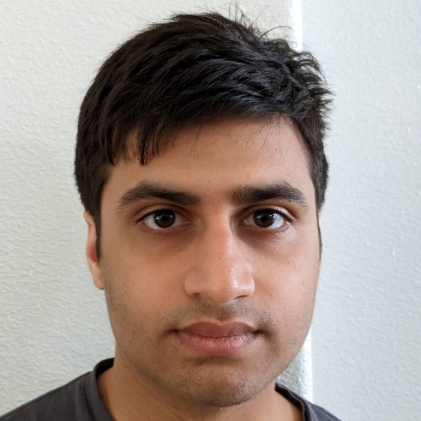
Name: Vedic Sharma
College: College of Liberal Arts and Sciences
Major: Computer Science
Minor: N/A

Mentor: Damon Lamb

Project Title: Using AI to Understand PTSD

Project Description: Using neural networks and visual analytics to gain understanding on the mechanisms and factors behind Post Traumatic Stress Disorder

Research Interests: Neurology, Psychiatry

Academic Awards: Dean's List
Involvement: IGEM
Volunteering: FIRST, St. Francis House
Hobbies and Other Interests: Chess

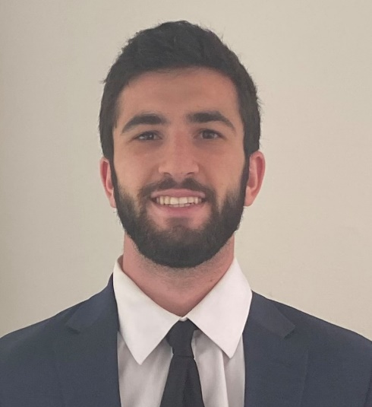
Name: Justin Strikowski
College: College of Liberal Arts and Sciences
Major: Computer Science
Minor: N/A (Artificial Intelligence Certificate)

Mentor: Mingjie Liu

Project Title: Cloud pipeline design for AI-enabled computational materials design

Project Description: My research project is to construct a database with an automated pipeline with computational data about carbon-based materials that will serve as the foundation for Artificial Intelligence guided carbon materials design for energy applications.

Research Interests: AI, Algorithms

Academic Awards: Dean's List Fall 2020, Spring 2021, Spring 2022 Fall 2022
Involvement: Gators Going Green, Green Greeks, Gator Growl, Zeta Beta Tau
Volunteering: Keep Alachua Country Beautiful, Repurpose Project, Dance Marathon, ZBTahiti
Hobbies and Other Interests: Sports, Reading, Coding, Magic, High Caliber Banter

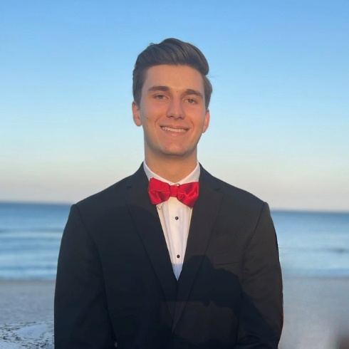
Name: Luke Sutor
College: Herbert Wertheim College of Engineering
Major: Computer Science
Minor: Statistics

Mentor: Amelia Winger-Bearskin

Project Title: Programmatic Pitch: Diffusion Models for Music Synthesis

Project Description: Exploring the use and viability of training large diffusion models for high fidelity LoFi-style music generation.

Research Interests: Machine Learning, Generative AI, Audio-Focused AI

Hobbies and Other Interests: Working out, playing guitar, and shooting hoops

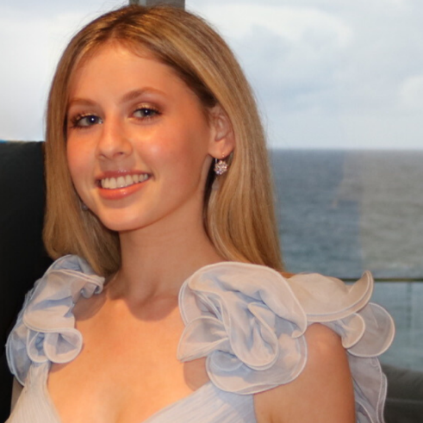
Name: Avery Teman
College: College of Liberal Arts and Sciences
Major: Economics
Minor: N/A

Mentor: Maximo Marin

Project Title: Leveraging Machine Learning to Aid in the Utilization of Diagnostic Testing in Thrombotic Thrombocytopenic Purpura

Project Description: Utilizing machine learning mechanisms to make the diagnostic testing for Thrombotic Thrombocytopenic Purpura more efficient with the goal of creating the lab of the future

Research Interests: Artificial intelligence to advance modern healthcare

Academic Awards: University of Florida Undergraduate Research Scholar, Study Abroad Honors Scholar, Dean's List
Involvement: Student Honors Organization, Luminaries, Alpha Kappa Psi, Alpha Chi Omega, Florida Women in Business, Entrepreneurship Collective
Volunteering: Performer - UF Beta Bring It On benefiting the Alzheimer's Association
Hobbies and Other Interests: Trying new restaurants, discovering the hidden gems around Gainesville, Entrepreneurship, and Medicine

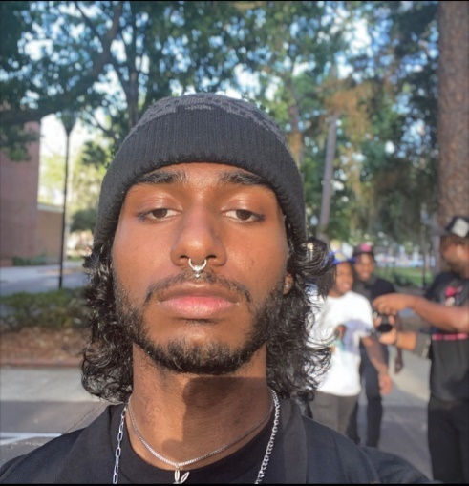
Name: Alaguvalliappan Thiagarajan
College: College of Liberal Arts and Sciences
Major: Mathematics and Data Science
Minor: N/A

Mentor: Christopher McCarty, Ph.D.

Project Title: CTSI and Rural Health Evaluation using Community Based Approaches

Project Description: The Clinical and Translational Science Institute (CTSI) has a vital mission of accelerating the translation of scientific discoveries into clinical practice for diagnosing, treating, and preventing diseases. However, the impact of the CTSI's efforts on the community needs to be evaluated to ensure meaningful outcomes. To achieve this, we aim to study the community, trace the impacts of translational research on the community, and facilitate collaboration between researchers and the community. We also aim to evaluate rural health in Florida by analyzing the accessibility of health services in the UF-FSU CTSI catchment area.

Research Interests: Data Analysis, Hazard Mitigation, Spatial Data, Machine Learning, Formal Logic, Algorithm Optimization
Academic Awards: Clarkson University-Best Undergraduate Oral Presentation in Data Analytics and Computational Modeling, Clarkson University-Best Undergraduate Poster Presentation in Civil and Environmental Engineering, SCUDEM-Outstanding Award, Florida Academic Scholars, University Scholars Program
Involvement University Mathematics Society (UMS), The GAITOR Club (UF's Machine Learning Club), Thrift Club
Hobbies and Other Interests: Thrifting, visiting small restaurants, going to the gym, and playing nintendo games

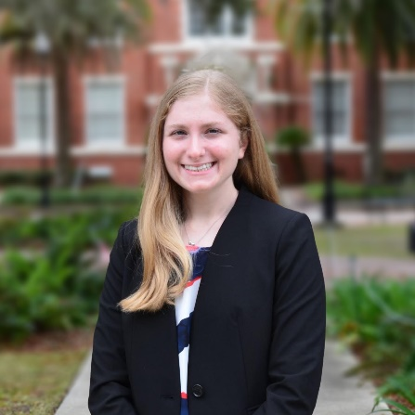
Name: Sophia Vellozzi
College: College of Liberal Arts and Sciences
Major: Computer Science
Minor: N/A

Mentor: Ratree Wayland

Project Title: Smart Electropalatography for Linguistic and Medical Applications: Computational Modeling of Speech Patterns

Project Description: This project stems from the NSF-funded project “Smart Electropalatography for Linguistic and Medical Applications” (https://selma.ece.ufl.edu/). It explores the idea of using speech as a non-invasive biomarker to recognize and compare changes in speech articulation patterns in people with and without neuromotor disorders. This involves developing a smart AI-powered mouth device known as SELMA to provide articulatory measurements for diagnosis, such as the pressure of the tongue and the duration of tongue and palate contact. Machine learning will be used to train models that can help capture and analyze the changes in speech in different atypical populations by predicting the degree of lenition, or the weakening of a consonant sound (e.g., slurring of speech). Using a deep learning, bi-directional recurrent neural network model known as Phonet, acoustic data and articulatory (electropalatography) data can be integrated into the model to study speech from Parkinson’s Disease (PD) patients, intoxicated speakers, and second-language speakers. These various extensions of the SELMA system provide numerous applications for not only linguistics, but also medical purposes. For instance, understanding tongue contacts during speech can also be used for monitoring other neurological disorders, such as ALS, traumatic brain injuries, and Down syndrome.

Research Interests: Computational linguistics, Natural language processing

Academic Awards: Gartner Group Information Technology Scholarship, Harvard WECode Distinguished Fellow Leadership Award, Grace Hopper 2022 Conference Grant, College of Liberal Arts & Sciences Dean's List
Involvement: Speech, Lexicon, & Modeling (SLaM) Lab, University Honors Program, University Research Scholars Program, Society of Women Engineers (SWE), Women in Computer Science & Engineering (WiCSE)
Hobbies and Other Interests: Working out, reading, yoga, tennis, cooking

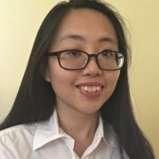
Name: Amy Wu
College: Herbert Wertheim College of Engineering
Major: Computer Science
Minor: Digital Arts and Sciences

Mentor: Jeremy A. Magruder Waisome

Project Title: Using Shark Teeth to Teach AI

Project Description: Easier accessibility and ability for remote access led computing to be used widespread in other non-computing fields. However, a lack of resources in non-STEM modelling encouraged more studies on introducing STEM concepts to students without prior computing experience. Therefore, researchers aim to develop a machine-learning model to identify fossil shark teeth for comprehension in computational modelling and beginning paleontology. Using Roboflow and Teachable Machine from Google to train models on shark teeth, the program will also use myFOSSIL as a database input within a middle school classroom. In class, middle school students will learn machine learning fundamentals through two-dimensional analysis of shark denticulation. With shark teeth images from the Florida Museum, researchers will filter through the varying background layer noises in order to analyze data accurately. Thus, we will create our own machine learning system from the training models that our participants will develop. For future works, we strive to encourage AI usage in other museums for other fossil collections. By collaborating with an interdisciplinary team across universities, we also seek to introduce AI concepts to non-STEM instructors as well as support AI learning in middle schools.

Research Interests: Artificial Intelligence, Human-Computing Interaction, Human-Robotic Interaction, Engineering Education

Academic Awards: Dr. Ralph Alexander Morgen StepUp Program Scholarship 2022, University Scholars Program (USP) 2022, Emerging Scholars Program (ESP) 2021, Benjamin A. Gilman Scholarship 2022, AI Scholars Program 2023, McNair Scholars Program 2023

Involvement: International Engineering Ambassadors (IEA)
Hobbies and Other Interests: Badminton, Creative Writing, Art, Reading, Traveling, Photography

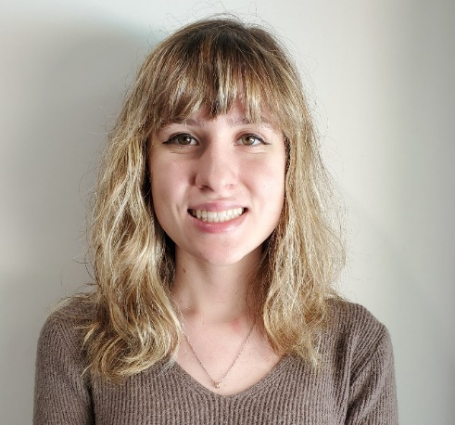
Name: Avril Rosano
College: College of Agricultural and Life Sciences
Major: Entomology
Minor: N/A

Mentor: Braham Dhillon

Project Title: Abiotic and biotic factors affecting disease development in Thielaviopsis – palm interaction
Project Description: The project will entail finding the pathogenicity of Thielaviopsis paradoxa through a detached leaf assay. This is done as infecting a whole palm takes a long time and disease symptoms on whole plants are similar to the symptoms on detached leaves. In order to find the pathogenicity, 9 different species of palm are tested (Solitaire (Ptychosperma elegans), Foxtail (Wodyetia bifurcate), Christmas Palm (Adonidia merrillii), Coconut (Cocos), Saw Palmetto (Serenoa repens), Queen Palm (Syagrus romanzoffiana), Areca Palm (Dypsis lutescens), Robellini (Phoenix roebelenii), and Coccothrinax (coccothrinax guantanamensis)) which are gathered from different parts of the UF Ft. Lauderdale Research & Ed Center campus. The leaves are cut and surface sterilized by treating them in 30% bleach for 1 minute, and 70% ethanol for 30 seconds before rinsing three times with autoclaved distilled water. Two small incisions are made per leaf and a plug of Thielaviopsis paradoxa will be placed on the incisions. They are then stored in a bin with damp paper towels and then placed in a dark room for two weeks. The leaflets are scanned and the measurements of the entire leaf and the lesion size are taken and then recorded on an excel sheet.

Research Interests: Plant pathology, Entomology

Hobbies and Other Interests: Painting, crocheting, pinning insects

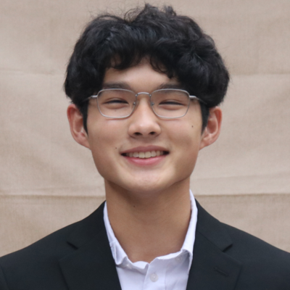
Name: Brian Blackwood
College: UF Health Cancer Center
Major: Biology
Minor: Asian Studies, Chemistry

Mentor: Daiqing Liao

Project Title: The epigenetic regulator DAXX in cancer biology.

Project Description: My project will examine the complex biological functions of Death Domain Associated Protein (DAXX) in its roles as both an oncogene and tumor suppressor. DAXX has elevated expression in diverse cancer types and exhibits oncogenic properties regulating transcription, apoptosis, immunity, and DNA repair. Given DAXX's promotion of oncogenesis, understanding of DAXX-regulated processes in oncogenesis may be informative towards developing cancer treatments. I plan to study the oncogenic and tumor suppression functions of DAXX by investigating DAXX intracellular localization in different biological contexts.

Research Interests: Epigenetics, Mechanisms of Oncogenesis, Cancer Biology

Academic Awards: Dean's List, Benacquisto Scholar
Involvement: Health Educated Asian Leaders, Society of Asian Scientists and Engineers, Liberty in North Korea
Volunteering: Arts in Medicine, Malcolm Randall VA Medical Center
Hobbies and Other Interests: Clarinet, Running, Chess, kDramas, Spending time with family and friends

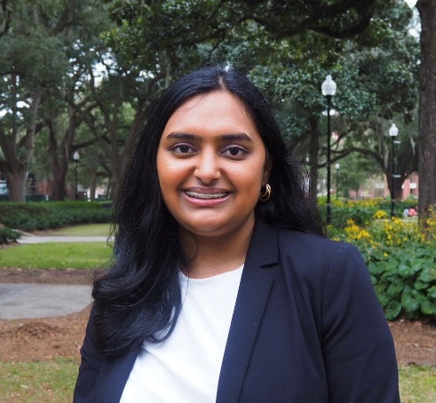
Name: Alisha Das
College: UF Health Cancer Center
Major: Biochemistry, Business
Minor:

Mentor: Dr. Naykky Singh Ospina

Project Title: The Impact COVID-19 has had on the treatment and survivability of cancer patients from low socioeconomic backgrounds

Project Description: The goal of this project is to better understand the impact COVID-19 has had on the health outcomes of individuals from underrepresented backgrounds. We can use the information obtained from this project to better dictate treatment plans of these individuals.

Research Interests: Health Disparities Research

Academic Awards: Dean's List (Spring 22, Fall 22)
Involvement: AMSA, WSA, Take Action Florida
Volunteering: UF HealthStreet Volunteer, Gator for Refugee Medical Relief Tutoring Volunteer, Shands Hospital Volunteer
Hobbies and Other Interests: Women's Rights Issues & Health policy advocacy

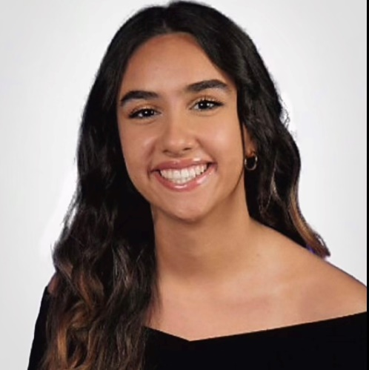
Name: Gissel Garcia
College: UF Health Cancer Center
Major: Preprofessional Biology
Minor: N/A

Mentor: Dr. Boone Prentice

Project Title: Imaging mass spectrometry methods and applications

Project Description: This research project aims to evaluate the role of bacterial metal uptake in wound healing. Examining how this process can be disrupted by the hyperglycemic state associated with uncontrolled diabetes.

Research Interests: Cancer Therapeutics and Host Response

Academic Awards: Dean's List, President's Honor Roll
Involvement: Leadership Team for the Machen Florida Opportunity Scholar's Mentorship Program
Volunteering: Lead Coordinator for the UF Health Mobile Outreach Clinic
Hobbies and Other Interests: Canoeing, Baking, and spending time with my family!

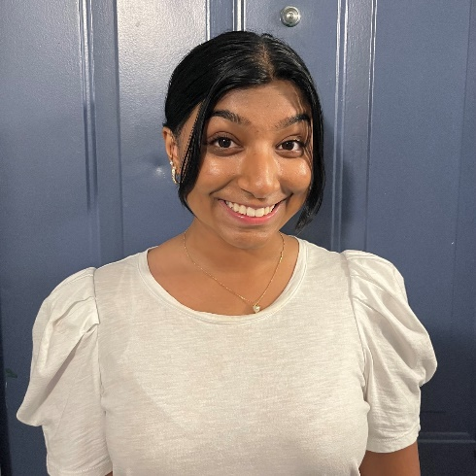
Name: Maheera Hossain
College: UF Health Cancer Center
Major: Health Sciences
Minor: Economics

Mentor: Yi Guo

Project Title:TBD

Project Description: TBD

Research Interests: Geo spatial biostatistics, cancer disparities

Involvement: UF Bangladeshi Students Association
Volunteering: Equal Access Clinic Network
Hobbies and Other Interests: Dancing

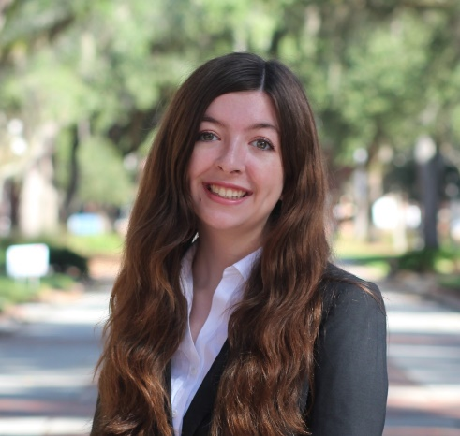
Name: Julia Jamieson
College: UF Health Cancer Center
Major: Biology
Minor: Biomolecular Engineering, Bioinformatics

Mentor: Coy Heldermon

Project Title: Effects of a Lipid Nanoparticle mRNA Vaccine on Mouse Soft Tissue Sarcoma

Project Description: This project assesses the application of a DOTAP lipid nanoparticle containing the total tumor RNA of soft tissue sarcoma generated in mice. The mRNA vaccine has been shown to inhibit soft tissue sarcoma growth in mouse models, and we aim to uncover the mechanism behind the vaccine and strategies to upregulate the inhibitory effects of the treatment.

Research Interests: Regenerative medicine, cancer therapeutics, microphysiological systems

Academic Awards: University Honors Program, College of Agricultural and Life Sciences Honors Program, Intersections Scholars Program, University Scholars Program
Involvement: Regenegators, Center for Undergraduate Research Board of Students, iGEM Competition Team
Hobbies and Other Interests: Baking, reading, and thrifting

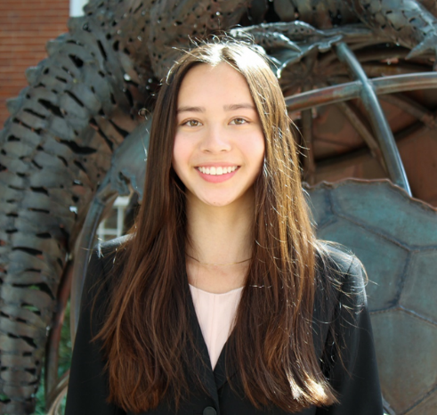
Name: Christina Klassen
College: UF Health Cancer Center
Major: International Studies
Minor: N/A

Mentor: Julie Bradley

Project Title: Breast Cosmesis after Radiotherapy: A Qualitative and Quantitative Analysis

Project Description: Background: The therapeutic ratio measures the balance between efficacy of treatments and their side effects. In treatment of women with breast cancer, while oncologic outcomes are the priority, quality of life including cosmesis and body image closely follow. Breast tissue and surrounding skin can be altered after breast cancer surgery and radiation. Following both breast conserving surgery and mastectomy with breast reconstruction, cosmetic changes can include asymmetry, retraction, fibrosis, volume loss, persistent edema, and/or permanent skin changes. Proton therapy is a type of radiation that can decrease exposure of the heart and lung in the treatment of breast cancer but may carry a higher risk of acute radiation dermatitis. The effect of radiation modality, specifically photon vs. proton, on breast cosmesis has yet to be reported. Hypothesis/ Objective: We hypothesize that women treated with either breast conserving surgery or mastectomy with reconstruction will have equivalent cosmetic outcomes between photon and proton radiotherapy as measured by (1) patient-reported outcome and (2) computer analysis of serial breast/chest wall photographs.

Research Interests: radiation oncology, radiotherapy, health disparities, oncology, proton therapy

Academic Awards: President's Honor Roll, Dean's List, UFHCC Poster Presenter, University Scholar's Program Travel Award

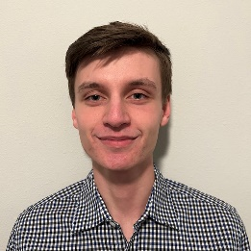
Name: Tyler Montgomery
College: UF Health Cancer Center
Major: Biology
Minor: N/A

Mentor: Weizhou Zhang

Project Title: Developing a Novel PROTAC-Based NR4A1 Degrader for Breast Cancer Therapy

Project Description: Proteolysis targeting chimera (PROTAC) molecules are a novel therapy that seeks to solve issues with current cancer therapies. PROTACs are bivalent small molecules which can degrade specific proteins via the ubiquitin-proteasome pathway. PROTACs all share a common design, with a protein of interest binding ligand on one end and an E3 ubiquitin ligase ligand on another; these domains are connected with a linker. PROTACs limit the accumulation of drug resistance because unlike other traditional inhibitors, they do not have to bind to the active site of the protein. Instead, they can be designed to bind to many different areas of the target and directly degrade proteins, making it harder for cancer cells to gain resistance by mutating to prevent binding. In collaboration with Dr. Guangrong Zheng’s chemical synthesis lab, our lab seeks to identify and develop PROTACs which can degrade the NR4A1 protein. This will be done in two phases. We first will utilize in vitro cancer cell models to screen NR4A1-PROTACs for efficacy in degrading NR4A1, evaluating them using western blot. After a promising candidate for degradation has been identified, we will move to in vivo mouse models to investigate the drug’s antitumor activity and impacts on both the host immune system and tumor microenvironment.

Research Interests: Cancer Immunotherapy, Intestinal Immunology/Inflammation

Academic Awards: Dean's List
Involvement: Tower Yearbook
Hobbies and Other Interests: Reading, Guitar, Singing

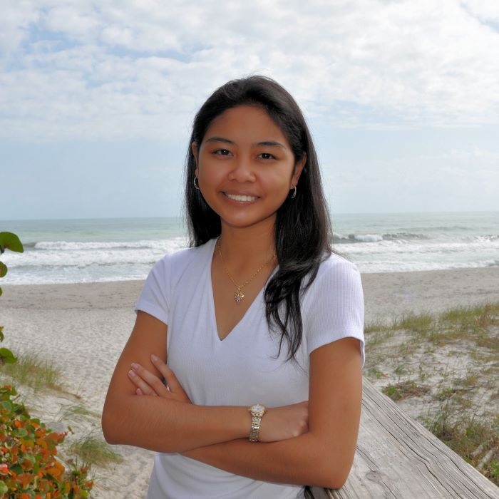
Name: Andrea Noy
College: UF Health Cancer Center
Major: Mechanical Engineering
Minor: N/A

Mentor: Dr. Xin Tang

Project Title: Stem-Like Cancer Cells’ Regulation of Tumorigenicity via Calcium Signaling

Project Description: We have previously found that inhibition of calcium signaling in calcium-spiking HCT-8 cells (which represent only 5-7% of the overall population) significantly suppresses in vivo tumor growth. These results suggest that the small subgroup of calcium-spiking HCT-8 cells are essential to tumor progression and may be fundamentally different from the major non-spiking cells, which are close to the properties of stem-like cancer cells. Hence, we will investigate the relationship between the calcium-spiking HCT-8 cells and stem-like cancer cells by harvesting the latter from a population of the former and examining their calcium dynamics.

Research Interests: Cancer Biomechanics, Mathematical Modeling

Academic Awards: President's Honor Roll (2020, 2021, 2022, 2023), National Merit Scholar
Involvement: Equal Access Clinic Network (EACN) Research, International Genetically Engineered Machine (iGEM), Tau Beta Pi
Volunteering: Organic Chemistry Teaching Assistant, Balance 180 Gymnastics, Norman Fixel Institute for Neurological Diseases
Hobbies and Other Interests: Reading, Spending Time with Family and Friends

Name: Hafsa Ouaakki
College: UF Health Cancer Center
Major: Biology
Minor: N/A

Mentor: Lei Zhou

Project Title: Deciphering roles of DAXX in cancer biology

Project Description: DAXX is a epigenetic regulator with a potential role in tumorigenesis, cancer progression and metastasis. The Liao laboratory has recently demonstrated that DAXX drives de novo lipogenesis and tumorigenesis in triple-negative breast cancer and other cancer types. The USP project will focus on understanding structure and function of DAXX and its role in cancer biology.

Research Interests: Mechanisms of Oncogenesis

Academic Awards: University Research Scholars Program
Involvement: Center for Undergraduate Research Board of Students
Volunteering: UF Health Shands Hospital
Hobbies and Other Interests: Reading, painting, running

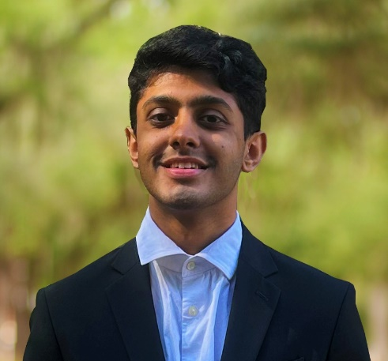
Name: Khushil Patel
College: UF Health Cancer Center
Major: Biology
Minor: N/A

Mentor: Zhe Ma

Project Title: Exploring the role of KSHV-encoded cGAS-STING inhibitors

Project Description: Kaposi’s sarcoma-associated herpesvirus (KSHV), is the etiological agent of several malignancies, including Kaposi sarcoma (KS), Multicentric Castleman's disease (MCD), and primary effusion lymphoma (PEL). Individuals with a weakened immune system, due to organ transplantation, advanced age, or HIV infection, have a higher risk of developing such KSHV-related cancers. Currently, there is still no KSHV-targeted treatment or prophylactic vaccines. KSHV sustains lifelong infections by taking advantage of a vast network of viral proteins that aid in the evasion of the host immune system. We have previously published that KSHV can be restricted by the innate immune response triggered by the cGMP-AMP synthase (cGAS) and stimulator of interferon-dependent genes (STING). However, in KSHV cancers, this pathway is largely dysregulated by inhibitors encoded by KSHV with undercharacterized mechanisms. This project aims to validate the previously identified potential inhibitors (KSHV ORF37, ORF48 and ORF55) of the cGAS-STING pathway, and evaluate how these inhibitors attenuate innate immunity to facilitate KSHV infection. My work will provide mechanistic insight into how a tumor virus manipulates host immunity to establish cancer.

Research Interests: Mechanisms of Oncogenesis

Academic Awards: Deans List ('21-'23)
Involvement: American Cancer Society on Campus President; CUR Ambassador; Community Health Service Corps Treasurer; AMSA member; Relay for Life Member, ISA member
Volunteering: HCA North Florida Game Cart Volunteer; HOSA Judge; Shands Volunteer (Dream Team)
Hobbies and Other Interests: Digital Art, Video Games, New Food

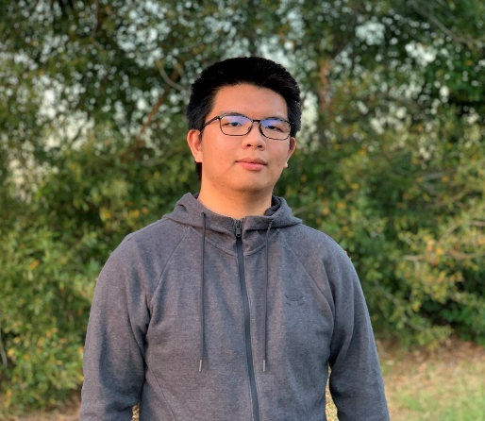
Name: Weihao Tang
College: UF Health Cancer Center
Major: Preprofessional biology
Minor: N/A

Mentor: Lei Zhou

Project Title: Genomic response in circulating macrophages in response to hyperplastic and neoplastic tumors in Drosophila

Project Description: The study was designed to monitor the genomic response in macrophages to tumors

Research Interests: Bioinformatics, cancer

Hobbies and Other Interests: Cooking

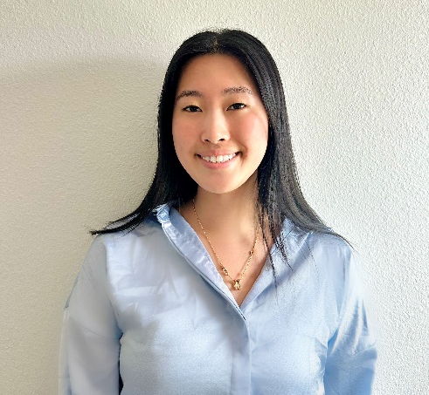
Name: Janie Zhang
College: UF Health Cancer Center
Major: Biology
Minor: N/A

Mentor: Jianping Huang

Project Title: SPDYE3, A Novel Cancer Testis (CT) Antigen for Glioma Immunotherapy

Project Description: Gliomas, in general, are heterogeneous and highly invasive, and complete neurosurgical resection is almost impossible. Consequently, most patients will eventually encounter disease progression. Even survivors are often left with severe and lifelong treatment-associated cognitive and motor deficits, which further entail enormous and unmeasurable economic costs for patients, their families, and society. Thus, developing more effective and less toxic tumor-specific therapies and improving clinical outcomes is essential for patients of all ages affected by malignant brain tumors. One attractive strategy is to develop tumor-specific targeted therapies, such as immunotherapy, which utilizes patients’ immune cells to attack tumors. However, few antigens/targets were discovered that share prognostic value and therapeutic utility. In search of such targets, a gene called SPDYE3 (Speedy/RINGO Cell Cycle Regulator Family Member E3, encoding an intracellular protein) was found to present interesting characteristics. Our preliminary result suggests that SPDYE3 is a cancer-testis (CT) antigen, with normal expression only restricted to male germ cells, but it is overexpressed by various malignancies, including gliomas. Our long-term goal is to translate the findings into the clinical application using SPDYE3 specific T cell receptor (TCR) modified T cells in patients with gliomas. If our hypothesis is substantiated, the results will promise to identify a novel therapeutic target for gliomas and other cancers.

Research Interests: Cancer Therapeutics and Host Response

Academic Awards: Dean's List
Involvement: Medigators Shadowing Program, Pre-Health Scholars Service Groups, Active Learning Program, International Scholars Program
Volunteering: Crisis Counselor

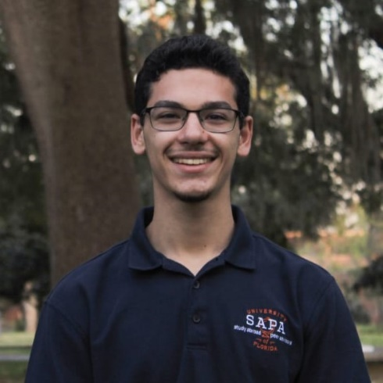
Name: Ryan Ames
College: College of Agricultural and Life Sciences
Major: Biological Engineering
Minor: N/A

Mentor: Dr. Razieh Farzad

Project Title: Shrimp structure and composition database preparation for alternative seafood production

Project Description: Current seafood production faces numerous issues: overfishing, marine habitat damage, and significant wastefulness. Cellular agriculture is a technology where agricultural products are cultured from cells in a bioreactor as opposed to harvested from livestock. Cellular agriculture has the potential to cause 92% less global warming, produce 93% less air pollution, use 95% less land, and require 78% less water than traditional agricultural practices. The research goal of this experiment is to investigate shrimp muscle’s morphology and physicochemical properties and to establish a database. This will provide a framework for future work in the field.

Research Interests: Sustainable food systems, waste management, and circular economy

Academic Awards: Kemerait Family Internationalization Fund Scholarship, University of Florida International Center Scholarship, University Scholars Program
Involvement: University of Florida Kickboxing Club, Study Abroad Peer Advisors, Society of Hispanic Professional Engineers
Volunteering: SHPE Jr. Mentorship
Hobbies and Other Interests: Training/fighting/teaching Muay Thai, learning Spanish, studying/discussing philosophy, training calisthenics, scuba diving

Name: Maeve Barger
College: College of Liberal Arts and Sciences
Major: French and Francophone Studies; Interdisciplinary Studies-Human and Organizational Development
Minor: International Development and Humanitarian Assistance; Business Adminstration

Mentor: Kimberly Wiley

Project Title: A Comparative Study on the Motivations of Child Advocacy in Child Welfare Organizations in France and the United States

Project Description: In France and the United States, the child welfare system is plagued with problems including lack of funding, instability, bureaucracy, lack of safe foster homes and adequate foster parents, and a shortage of child welfare workers (Baritello; National Technical Assistance and Evaluation Center for Systems of Care). By gaining a better understanding of the motivations behind why child welfare workers participate in child advocacy, strategies can be developed that appeal to their motivations. This could help organizations attract and retain high-quality employees who desire to improve the child welfare system and the care at-risk children receive (National Technical Assistance and Evaluation Center for Systems of Care). This research project will examine these issues in the form of a comparative case study between France and the U.S. to study the motivations behind participating in child advocacy across two cultures and countries. Through understanding the motivations that draw caring, passionate, and qualified individuals to the child welfare system that impacts a wide array of individuals in the U.S. and France, the quality of the systems can improve, allowing foster children to be more successful and better cared for in their lives.

Research Interests: Nonprofit Leadership, Social Entrepreneurship, French Language and Culture, Social Psychology

Academic Awards: University of Florida President's Award and Dean's List, Connor Scholarship, Beyond 120 Scholarship, University of Florida Honors Program
Involvement: Emerging Scholars Program, Pi Delta Phi (French Honors Society)
Volunteering: Westside Baptist Church
Hobbies and Other Interests: French, Traveling, Art, Running, Reading

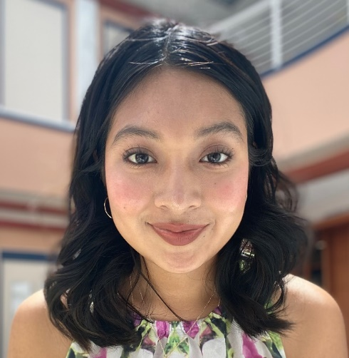
Name: Jessica Barrera-Solis
College: College of Liberal Arts and Sciences
Major: Biochemistry
Minor: N/A

Mentor: Taehoon Kim

Project Title: Agrobacterium-Mediated Rice Transformation to Characterize Protein-DNA Interactions Using Chromatin Immunoprecipitation

Project Description: Chromatic Immunoprecipitation(chIP) is fundamental molecular biology technique use to identify novel protein-DNA interactions. To perform a ChlP experiment, it is essential to generate a transformed plant expressing the gene of interest (GOI) as well as epitopes, which are antigenic peptides that bind to specific antibodies. Agrobacterium-mediated rice transformation is a widely used method for generating transformed rice plants with stable insertion of the cassette into rice genome. Therefore, we employed Agrobacterium-mediated rice transformation to produce transformed rice plants for our ChlP experiments.

Research Interests: Protein/chemical processes

Academic Awards: Machen Florida Opportunity Scholarship, Hispanic Scholarship Fund finalist, University Scholar Program
Involvement: Food and human Nutrition Club, Baking 4 wellness, SHPE
Volunteering: Wilmot Garden
Hobbies and Other Interests: Yoga, vegan baking, journaling

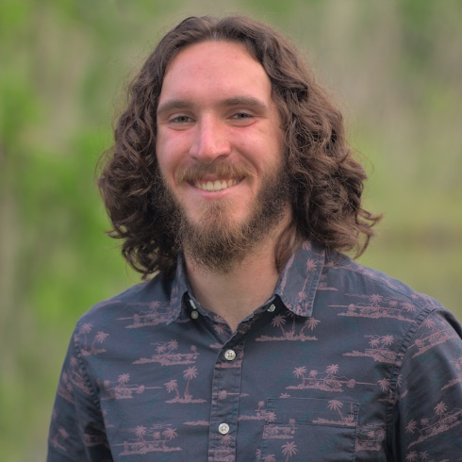
Name: Walker Bensch
College: College of Agricultural and Life Sciences
Major: Environmental Science
Minor: Entomology

Mentor: Rachel Mallinger

Project Title: Assessing the Impact of Land-use Change on the Wing Morphology of Southeastern Blueberry Bee (Habropoda laboriosa)

Project Description: Investigating the effect of urban and agricultural land use on the wing morphology of Habropoda laboriosa through geometric morphometric technique. Trends in wing shape and size may provide insights into the differing selective pressures of urban and agricultural landscapes on bee populations.

Research Interests: Conservation ecology of plant - pollinator communities

Academic Awards: Five times CALS Deans List Recipient, Three times Doris Lowe and Earl and Verna Lowe Scholarship Recipient, CALS Honors Program Member
Involvement: Environmental Science Alliance Member
Hobbies and Other Interests: Hiking, traveling, landscape and macro photography

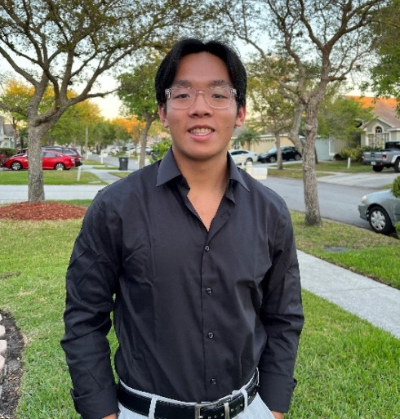
Name: Tyler Bui
College: College of Agricultural and Life Sciences
Major: Nutritional Sciences
Minor: Chemistry

Mentor: Dr. Zhiyong Cheng

Project Title: Studying adipose tissues to identify the molecular mechanism and develop mechanism-based therapeutics for metabolic disorders.

Project Description: Adipose tissue plays key roles in human health. In addition to storing excess energy as fat, adipose tissue has been shown to secret hormones (e.g., leptin and adiponectin) and regulate body temperature. However, the underlying mechanism remains incompletely understood. This research project will use cultured cells (e.g., 3T3L1 cells and C3H10 cells) to examine how nutrients (e.g., lipids and minerals) regulate the adipocyte development (i.e., cell growth and differentiation) and function (i.e., lipid accumulation and hormone synthesis). The methods include quantitative polymerase chain reaction (qPCR), Western blotting analysis, and oil red O staining. Understanding the molecular mechanism of adipose development may lead to the discovery of new target to promote adipose health and prevent adipose dysfunctions that precedes obesity and metabolic syndrome.

Research Interests: Mechanisms for nutrients, hormonal signaling, and metabolism, adipose tissues, metabolic health and diseases

Academic Awards: Principal Honor Academic Award, CALS Dean's List, SAT Scholarship, Presidential Award, Florida's Bright Futures Scholarship
Volunteering: Oldsmar Care
Hobbies and Other Interests: Competing in Marathons, running, weightlifting, triathlons, cooking, traveling

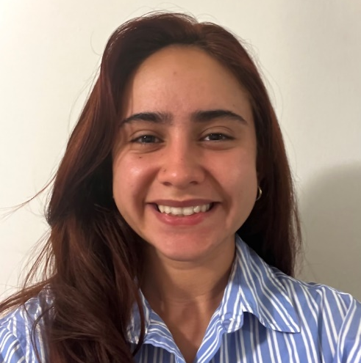
Name: Aneth Castaneda-Garcia
College: College of Agricultural and Life Sciences
Major: Plant Science
Minor: N/A

Mentor: Jeongim Kim

Project Title: The Role of Mediator Subunit 5 on Phenylpropanoid Production in Tomato

Project Description: The proposed project will elucidate the role of mediator subunit 5 (MED5) in tomatoes and provide theoretical knowledge to optimize an efficient strategy to improve tomatoes' nutritional and agricultural value. Though studies on MED5 have been done in Arabidopsis, studies have yet to be conducted to ascertain any roles of MED5 on phenylpropanoid production in tomatoes. Therefore, the proposed research project aims to determine the function of MED5 in tomatoes. The first objective of this project is to establish med5a/b1/b2 triple mutants. The second objective is to characterize med5 mutants in order to compare morphological phenotypes and metabolite production with wildtype plants.

Research Interests: Medicinal plants, plant genetics, and organic and sustainable crop production

Involvement: Gator Salsa Club and MFOS Scholars Program
Hobbies and Other Interests: Salsa dancing, cooking, gardening, and listening to music

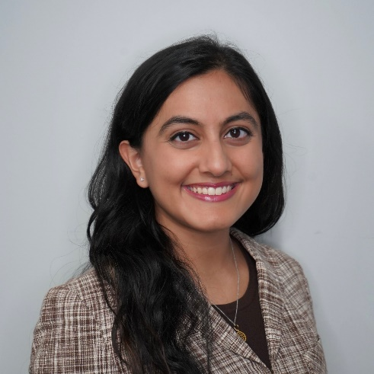
Name: Esha Chakraborti
College: College of Agricultural and Life Sciences
Major: Nutritional Sciences
Minor: AI in Public Health and Healthcare

Mentor: Dr. Melissa Vilaro

Project Title: Developing a Novel Communal Coping Cardiovascular Risk Reduction Intervention Supporting Dietary Adherence Among African American Cancer Survivors

Project Description: This is the pilot program of a larger NIH funded project to reduce disparities in health outcomes among African American cancer survivors. It aims to use family and other social support systems as a part of a behavioral intervention for patients with cardiovascular disease.

Research Interests: Nutrition, Behavioral Medicine, Health Disparities

Academic Awards: Phi Beta Kappa Honor Society; Dean’s List; National Merit Scholar
Involvement: Phi Delta Epsilon: Pre-Medical Fraternity; Vital Readings Book Club; Luminaries (UF Honors Program)
Volunteering: Equal Access Clinic Network; Peak Literacy: Reading Coach; UF Shands NICHE Volunteer Program; Texas Girls State: Staff Member
Hobbies and Other Interests: Cooking, Exercising, Arts and Crafts, Reading

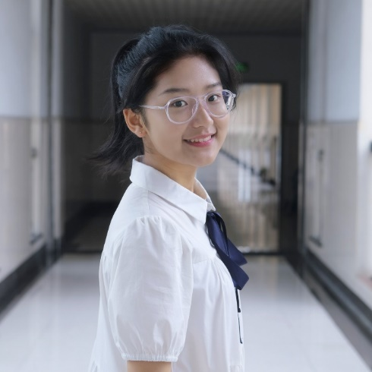
Name: Qiaowen Chen
College: College of Agricultural and Life Sciences
Major: Environmental Science (will change to Biology, Data Science)
Minor: N/A

Mentor: Dr. Tie Liu

Project Title: Cultivating Freshness: Exploring Factors that Affect the Shelf Life of Lettuce Cultivars

Project Description: The preservation of freshness and shelf life are critical components of successful lettuce cultivation. This ongoing study aims to examine the factors that impact the shelf life of different lettuce cultivars through a series of continuous experiments on their leaves. To achieve this goal, we are utilizing various methods, including imprinting, weight loss measurement, leaf morphology analysis, hyperspectrum imaging, and RNA extraction to comprehensively examine the cultivars. Our study seeks to potentially impact the wider agricultural industry. The development of more effective methods for lettuce cultivation and preservation could positively impact both the quality and quantity of lettuce production, not only in post-harvest field, but also in pre-harvest field. Further research will be necessary to fully understand the factors that influence the shelf life of lettuce and to optimize these methods. These efforts could ultimately lead to a more robust and reliable lettuce industry, benefitting both producers and consumers.

Research Interests: Post-harvest, Genetics, Machines Learning

Academic Awards: 22Fall CALS Dean's List
Involvement: UF Chinese Student Association
Volunteering: ENGAGE FLORIDA
Hobbies and Other Interests: Dancing, Singing, Traveling, Theatre, Movies

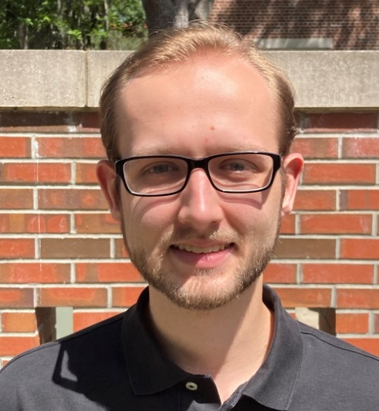
Name: Cade Cooper
College: College of Agricultural and Life Sciences
Major: Microbiology
Minor: Pathogenesis, Bioinformatics

Mentor: Kevin Folta

Project Title: Predicting Lettuce growth through analysis of seedling light response

Project Description: This project hypothesizes that exploitation of light signaling in lettuce seedlings can be used to improve varieties of lettuce and predict specific phenotypic developments.

Research Interests: Archaeal, Lettuce seedling light responses

Academic Awards: University Scholars Program
Involvement: UF Pre-vet Club
Hobbies and Other Interests: Fishing

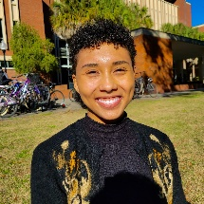
Name: Kayla Ehrlich
College: College of Agricultural and Life Sciences
Major: Environmental Science; Sustainability Studies
Minor: English

Mentor: Mark Clark

Project Title: Carbon Input/Output of Restored Oyster Reefs

Project Description: Oyster reefs have been ecological pillars of many estuaries across the globe as ecosystem engineers, benthic habitat providers for other marine species, and shoreline stabilizers through wave attenuation and vegetative support. Over the past 130 years, however, 85% of oyster reefs have been lost for various reasons. As a result, there are several ongoing initiatives across the state of Florida aimed at protecting and regenerating oyster reefs and the ecosystem services they provide. A potential service oyster reefs could provide is a form of carbon sequestration; however, the determination of the net carbon yield is difficult to determine as oysters do not have an analogous vegetative component and calcification of oyster shell releases CO2. This study would generate a net carbon emissions calculator for oyster reefs based on the following criteria: organic carbon content of the organic matter in buried sediments, organic carbon content and inorganic carbon content of the buried shell, a life cycle assessment of substrate material used, and the emissions from shipment of materials.

Research Interests: Wetlands, hydrology, plant science, microbiology, conservation ecology, savanna ecology, forest ecology

Academic Awards: Recipient of the William Bartram Undergrad Scholarship 2023, Recipient of the Black and Latinx Birders/Birders Fund scholarship 2022, Florida Georgia Louis Stokes Alliance For Minority Participation Scholar 2022
Involvement: PRISM Honors Magazine
Volunteering: Alachua Audubon Society, Sweetwater Wetlands Park, UF-IFAS Extension Cedar Key
Hobbies and Other Interests: Bird watching, hiking, thrifting, drawing, painting, writing, reading

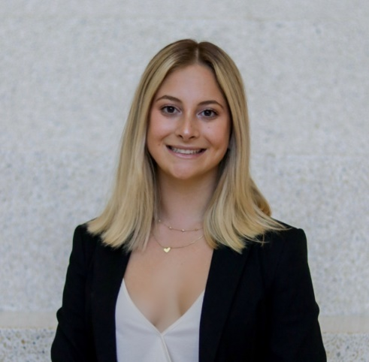
Name: Maya Fives
College: College of Agricultural and Life Sciences
Major: Environmental Science
Minor: Wildlife Ecology and Conservation; Leadership

Mentor: Dr. Matt Hallett

Project Title: A Study on Wildlife Temporal Behaviors During the Covid-19 Pandemic in Alachua County Wildlife Corridors

Project Description: The objective of this study is to determine the anthropogenic influence on wildlife temporal behaviors in Alachua County parks and preserves by comparing species-specific temporal behavior patterns during the parks’ closure amid the COVID-19 pandemic, directly after the parks’ reopening, and about one year after the reopening. Camera trap data will be collected and analyzed to determine significance.

Research Interests: Human-wildlife interactions

Academic Awards: Doris Lowe and Earl and Verna Lowe Scholarships
Involvement: Outdoor Area Conservation Committee, Green Greeks, Kappa Kappa Gamma, Alpha Zeta, UF Honors, CALS Honors, URSP, Lakes Vegetation and Landscaping Committee
Hobbies and Other Interests: Hiking, traveling, meeting other people, spending time with my loved ones, petting animals

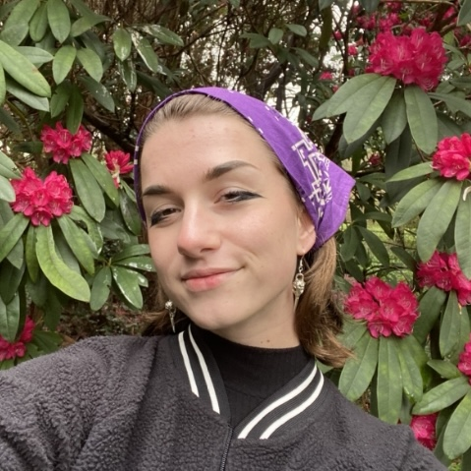
Name: Lauren Geiss
College: College of Agricultural and Life Sciences
Major: IS-EMANR & Natural Resource Conservation
Minor: Wildlife Ecology and Conservation

Mentor: Dr. Emma Matcham

Project Title: Soil Aggregate Stability and pH in Silage Corn and Peanut Production Systems

Project Description: Soil aggregate stability is an indicator of soil health as it relates to porosity, organic matter content, biological activity, and water holding capacity. pH in soils affects the availability of nutrients in the soil, which directly relates to crop health and production. Generally, greater pH indicates lower soil aggregate stability, which can affect the retention of water and nutrients during plant growth. However, this relationship is not well known in sandy soils such as those found in Florida. In this project, we aim to assess the relationship between soil aggregate stability and pH across silage corn and peanut fields being treated with fertilizer treatments of ammonium nitrate, gypsum, and lime. Our objectives are to (1) determine whether soil aggregate stability and pH are correlated in sandy soils, and (2) determine whether soil aggregate stability and pH will vary in relation to applications of different common agricultural inputs such as ammonium nitrate, gypsum, and lime.

Research Interests: Nutrient cycling, soil chemical & physical properties

Volunteering: City of Safety Harbor
Hobbies and Other Interests: Marching band, art, makeup

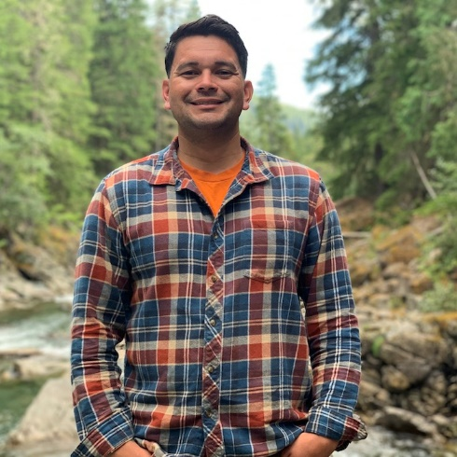
Name: Duane Hardy
College: College of Agricultural and Life Sciences
Major: Plant Science
Minor: N/A

Mentor: Masanori Fujimoto

Project Title: An analysis of microplastic abundance and distribution in agricultural soils

Project Description: The study's aim is to investigate the abundance and distribution of microplastics in agricultural soils of Alachua County, Florida. It is predicted that soil on farms with a history of plastic usage will contain microplastics, regardless of crop type or farming practice, and that farms with a longer history of plastic use will have a higher concentration of microplastics. The study will be approved by IRB prior to collecting survey about history of plastic use and collecting soil samples. Soil samples will be taken from local crop production farms, both organic and conventional, analyzed for microplastics, and the data collected will help evaluate the potential environmental effects of microplastics in the soil.

Research Interests: soil health and fertility. plant-microbe interactions. organic and sustainable crop production systems. microalgal biostimulants and biofertilizers in crop production. composting systems. soil-based carbon sequestration. ecosystem conservation. agroecosys

Academic Awards: CALS Dean's List for Fall 2022, Phelps Scholarship recipient Spring 2023, Edith Nourse Rogers STEM Scholarship recipient Spring 2023,
Hobbies and Other Interests: plant collector/enthusiast. container/indoor gardening. reading non-fiction books. hiking/camping. skateboarding and snowboarding.

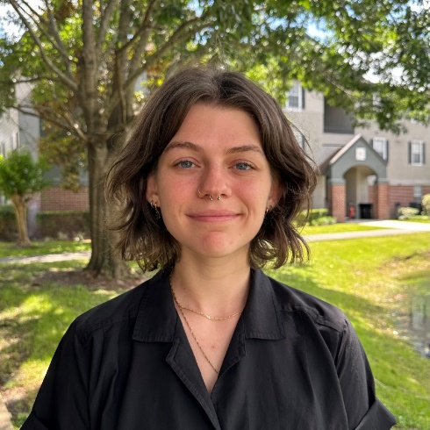
Name: Kylie Hollis
College: College of Agricultural and Life Sciences
Major: Environmental Science and Marine Sciences
Minor: N/A

Mentor: Anna Braswell

Project Title: The importance of shell quality and stability for restoration of a native ecosystem engineer - Eastern Oyster (Crassostrea virginica)

Project Description: I aim to understand the preferential settlement of larval eastern oysters in Florida's Big Bend to better oyster restoration efforts in the area. Oysters are sessile organisms, however, the larvae have some ability to choose where they settle based on several environmental preferences. While there is literature on other environmental cues for settlement, it is unclear to what extent shell quality and substrate stability play a role in choosing attachment sites. To address this gap in knowledge, I will compare settlement and growth of larval oysters on combinations of clean recycled shells, natural shells from the site, loose shells, and anchored shells. These findings will help determine which attributes to prioritize in restoration projects, ultimately helping the ecological and economic health of the Big Bend coastal communities.

Research Interests: Oyster restoration, marsh ecology, coastal ecology

Academic Awards: President's Honor Roll, CALS Dean's List
Involvement: Marine Biology Club
Hobbies and Other Interests: Hiking, live performances, reading, music

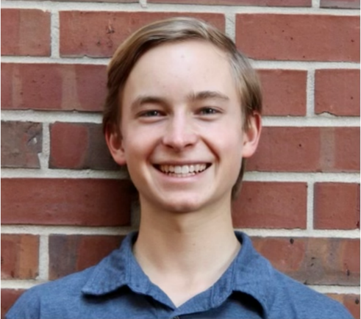
Name: Ethan Lantzy
College: College of Agricultural and Life Sciences
Major: Biological Engineering (Land and Water Resources Specialization)
Minor: N/A

Mentor: Eban Bean

Project Title: Identifying Effects of Time and Storage Conditions on the Spectrophotometric Analysis of Tannic Acid to Improve Low-Cost Water Quality Analysis with GatorSpec

Project Description: It is vital to have an accurate measure of a water sample’s chemical composition for legal, research, and agricultural purposes. However, chemical composition analysis is expensive and time-consuming with current methods. Spectroscopic techniques hold promise as a low-cost and accurate method of water quality analysis, especially when coupled with machine learning. The Urban Water Resources Engineering lab in UF’s Agricultural and Biological Engineering Department has developed a low-cost UV-Vis spectrophotometer (GatorSpec) that measures electromagnetic radiation in the UV and visible light range. However, there is a knowledge gap for the relationship between absorbance spectra and sample preparation, storage, and time before sampling. This project seeks to characterize interferences and potential sources of error within GatorSpec’s detection of chemical parameters and concentrations, as well as better understand artificial sample preparation and storage. This will be achieved through studying the spectrophotometric analysis of tannic acid compounds using GatorSpec.

Research Interests: Water resources conservation, nutrient management, sustainable materials, food waste, and more!

Academic Awards: Dean's List
Involvement: Honors Program, University Research Scholars Program, Florida Running Club
Volunteering: UF Native Plant Nursery, Wilmot Botanical Gardens, and CROS Ministries
Hobbies and Other Interests: Running, reading, cooking, and hiking

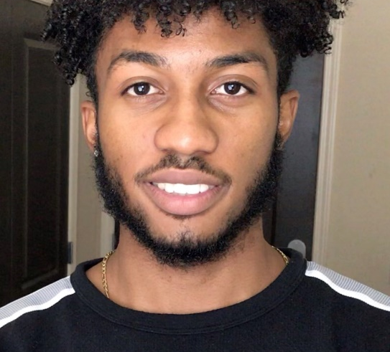
Name: Thelwell Lloyd
College: College of Agricultural and Life Sciences
Major: Food and Resource Economics: Marketing and Management

Minor: Agricultural Law

Mentor: Derek Farnsworth

Project Title: Tea (Camellia) a potential market substitute for citrus in Central Florida economy

Project Description: Florida crop growers are running out of market share due to a decline in citrus. In 2020- 21, the citrus industry supported 32,500 full-time and part-time jobs in Florida. It contributed an estimated value-added of $2.8 billion to the gross state product. The industry contributed at total estimated $151 million in local and state taxes. Total state and local tax contributions of the industry were an estimated $151 million. Production as low as 20 million boxes of oranges, a grim contrast compared to production in 2020-21 topping 58 million boxes, and a grimmer contrast compared to the 1990s and early 2000s topping at 200 million boxes. With Florida’s citrus industry being a pillar of the economy and a significant source of jobs and tax revenues, the continued decline could mean a state-wide recession. Recent research suggests that tea can be grown in Florida soil with equitable yield by acre and value from slightly higher profit margins. If tea proves to be equitable, Florida growers could adopt tea as an alternative or supplement to the citrus industry. Raising the question if there is a market for tea grown in Florida. If so, what are the characteristics of this market? A comprehensive preponderance analysis into the market for tea grown in Florida is required for a market analysis and the potential substitution/supplementation for Florida’s citrus industry.

Research Interests: Citrus, Management and Marketing

Volunteering: Student Government, Entrepreneurship club, United Way District 23, Marion County Senior Services
Hobbies and Other Interests: Fishing, Golf, Games, Exercising, Swimming, Travelling, Playing music, Public Speaking

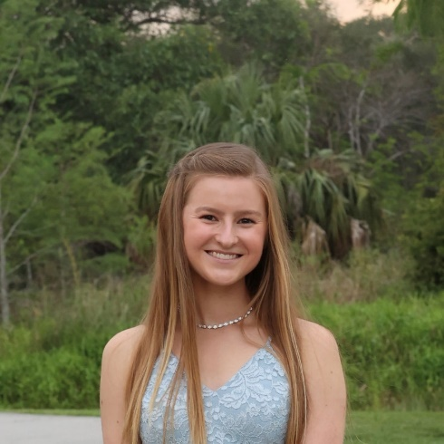
Name: Amber Lopez
College: College of Agricultural and Life Sciences
Major: Soil, Water, and Ecosystem Sciences
Minor: N/A

Mentor: Dr. Jonathan Judy

Project Title: Microplastic Occurrence Drinking Water Treatment Residuals

Project Description: Ubiquitous in nature, microplastics have been discovered on all continents and in all oceans throughout the world. However, limited information exists regarding the presence of microplastics in drinking water treatment residuals. Our research will focus on the quantification and identification of microplastics in residuals to determine if land-application is a suitable method of disposal.

Research Interests: Coastal biogeochemistry; Water sustainability and availability; Marine biology

Academic Awards: Frederick B. Smith Scholarship; Doris Lowe and Earl and Verna Lowe Scholarship; Dean's List
Involvement: Fellowship of Christian Athletes; Intramural Flag Football
Volunteering: Girl's Place (Volleyball Coach, Referee)
Hobbies and Other Interests: Exploring local trails with my dog; playing sports with friends; traveling to new places and trying new things; going to sporting events; working out and running

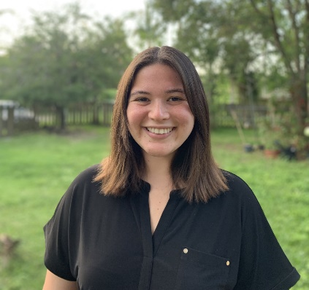
Name: Marina Marquis
College: College of Agricultural and Life Sciences
Major: Wildlife Ecology and Conservation
Minor: Spanish

Mentor: Brett R Scheffers

Project Title: Water loss and its relationship with traits, phylogeny, and decision making in Madagascar frogs

Project Description: The proposed study thus aims to investigate (1) the effects of traits and phylogeny (evolutionary relationships) on water loss in several species of frogs present in Madagascar, and (2) the consequences of water loss on the decision making and performance of Madagascan frogs. We expect that certain traits such as body size will predict the rate of water loss in Madagascar frog species and that rate of water loss is phylogenetically linked (i.e., closely related species will share similar hydration). We also hypothesize that water loss will impact their decision-making and performance, which has downstream consequences on their ability to survive and adapt under environmental change. Approximately 60 Madagascan frogs were put through two experiments: a vertical movement experiment and the horizontal movement experiment, both of which tested a frog's ability to find water resources. Specifically, the horizontal movement experiment provides frogs with a simple choice and tests whether frogs can choose the correct path towards water when dehydrated. The vertical movement experiment expands this question to include their ability to climb and find water resources. This experiment expands the horizontal movement experiment to include niche partitioning. Gaining an understanding of the phylogenetic relationships between water source seeking behaviors and frog species/species traits as well as the consequences of dehydration on decision making in frogs may have important implications for how frogs will respond to changing temperatures, rainfall patterns, and habitats in Madagascar.

Research Interests: I am interested in tropical ecology, conservation ecology, and wildlife behavior.

Hobbies and Other Interests: I enjoy hiking and wildlife watching. I am also very interested in intraspecific cooperative behaviors.

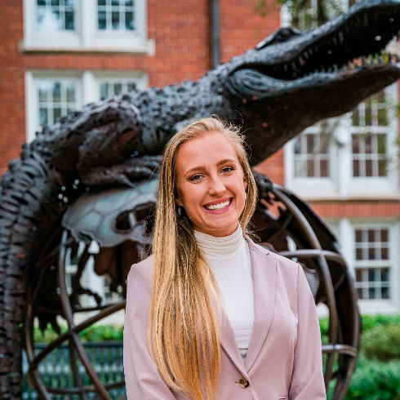
Name: Ashley Mae Peters
College: Herbert Wertheim College of Engineering
Major: Agricultural and Biological Engineering
Minor: N/A

Mentor: Dr. Ana Martin-Ryals

Project Title: AD Effluent Derived from Lettuce Waste as a Supplemental Fertilizer for CEA Systems

Project Description: The goal of this project is to investigate the potential for recycling lettuce waste as biologically derived nutrient and energy source for controlled environment agriculture (CEA) systems through anaerobic digestion (AD). The study will explore the effect of supplementing commercial fertilizer with nitrified anaerobic digestion effluent (ADE) on lettuce yield and quality in hydroponic and greenhouse CEA systems.

Research Interests: Controlled Environment Agriculture Systems Design, Agriculture, Horticulture and Engineering

Involvement: Girls Who Code
Volunteering: Strong Roots Movement and Read Lead Achieve
Hobbies and Other Interests: Gardening, cooking, nature walks and fitness

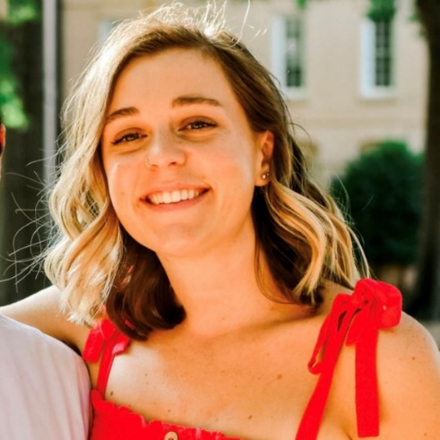
Name: Claire Pierce
College: College of Agricultural and Life Sciences
Major: Plant Science
Minor: n/a

Mentor: Dr. Kimberly Moore

Project Title: Combating the Negative Effects of Salt Water Intrusion on Native Plants in South Florida

Project Description: Water is a vital resource to the green industry with water conservation as a top priority. Demand for fresh water is increasing all over the world. Another issue in Florida is saltwater intrusion into wells. Depending on your location in the state and the quality of the well water, growers could experience an EC of 2 dS/m (200 ppm Na) up to an EC of 4 dS/m (400 ppm Na). With salt avoidance, as salts accumulate there is increased selectivity for K, resulting in transport of K inward and Na outward. However, in plants with a low salt tolerance, excess Na interferes with K absorption and could lead to K deficiency. Knowing that K contributes to osmoregulation, we question if the addition of K to the growing substrate would improve plant growth when watered with salt water. If the addition of K to the substrate improves plant growth of low salt tolerant plants when watered with water that is high in Na, this would improve grower’s results. Our objective is to test if the addition of K at varying rates to the substrate along with a controlled-release fertilizer improves plant growth when watered with water high in salts (Na) (salt water). The benefit is that regardless of the salt tolerance of the plant and the source of the water, the addition of K to the substrate would allow growers to use that water more effectively.

Research Interests: Salt water intrusion on native plants

Volunteering: Volunteer work at the FLREC in the Environmental Horticulture lab
Hobbies and Other Interests: In my free time I enjoy reading, going to the beach, skating, and going to yoga.

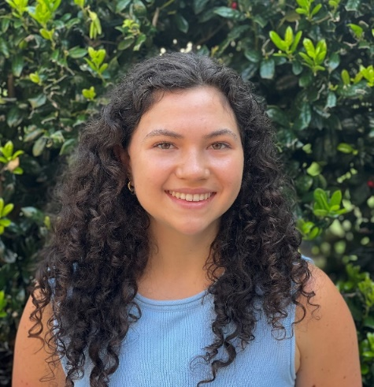
Name: Julia Quinones
College: College of Agricultural and Life Sciences
Major: Nutritional Sciences
Minor: Bioinformatics

Mentor: Dr. Diana Taft

Project Title: Analyzing Antimicrobial Resistance Genes in Chronic Kidney Disease Progression

Project Description: My project aims to determine if there is an association between uremic toxin levels and carriage of antimicrobial resistance genes in the gut for individuals with chronic kidney disease. Chronic kidney disease (CKD) results in uremic toxin buildup within the body. This buildup likely leads to suboptimal white blood cell functioning which increases risk of infection in CKD patients. With more infections, CKD patients tend to be given more antibiotics and to be in the hospital more where they are at increased risk of acquiring nosocomial drug-resistant bacteria. As a result, CKD patients experience more antimicrobial resistant infections and colonization than the general population. In humans, the gut is where the microorganisms with AMR are primarily found. For this project, I will develop statistical models describing the relationship between abundance of antimicrobial resistance (AMR) genes and levels of uremic toxins and describing the relationship between diversity of AMR genes and levels of uremic toxins from sampled individuals. I expect that higher levels of uremic toxins will correlate with greater AMR gene abundance and greater AMR diversity.

Research Interests: Chronic disease, antimicrobial resistance, human gut microbiome

Academic Awards: Dean’s List, President’s Honor Roll, Mayo Clinic Summer Undergraduate Research Fellowship 2023
Involvement: Gator Scuba Club, Theta Alpha Christian Sorority
Volunteering: Streetlight at UF Health, Fun & Fit Wellness Center at UF Health, Aces in Motion
Hobbies and Other Interests: Church involvement, scuba diving, running, volleyball, and trying new outdoor recreational activities

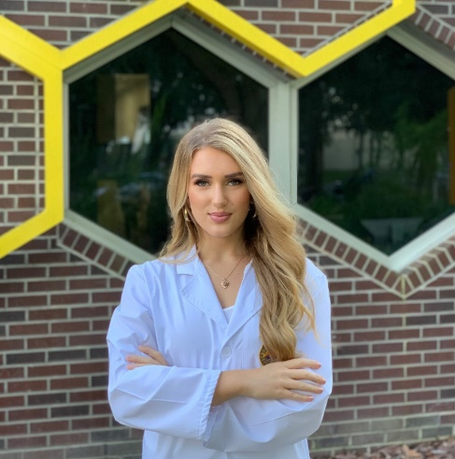
Name: Lauren Roberts
College: College of Agricultural and Life Sciences
Major: Entomology and Nematology
Minor: N/A

Mentor: Dr. Cameron Jack

Project Title: Evaluating the Effect of Oxalic Acid Vaporization on Honey Bee (Apis mellifera) Drone Reproductive Health

Project Description: The purpose of this study is to evaluate the effect of oxalic acid, a widely used organic miticide, on drone reproductive health when applied via vaporization during the late larval stage. Every year in the Bee Informed Partnership national survey, U.S. beekeepers identify queen failure as a top three colony stressor. Although often overlooked, drone health directly impacts queen productivity and longevity. To date, there have not been any studies on the effects of oxalic acid vaporization on drone larvae. This study will be useful for beekeepers, particularly queen breeders, who are interested in producing high-quality drones.

Research Interests: Honey bee reproductive health, genetics, queen breeding, and toxicology

Academic Awards: UF Presidential Scholarship, National FFA Organization Star in Agriscience
Involvement: UF Bug Club
Volunteering: UF Honey Bee Extension and Research Laboratory
Hobbies and Other Interests: On the weekends you can find me working my own honey bee colonies. I enjoy producing honey and educating the public through my business called "The Pink Hives" that promotes women in beekeeping.

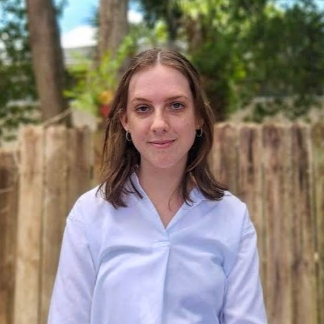
Name: Alexandra Scott
College: College of Agricultural and Life Sciences
Major: Natural Resource Conservation
Minor: Wildlife Ecology and Conservation

Mentor: Andrew Carlson

Project Title: Using temperature modeling to predict the invasion potential of two nonnative cichlids in Florida rivers

Project Description: The aim of this project is to understand the effect of climate change on two ecologically, recreationally important nonnative fish in Florida, contributing to a larger project in the Florida Cooperative Fish and Wildlife Research Unit. Understanding how habitat changes could affect populations of Mayan Cichlids (Mayaheros urophthalmus) and Oscars (Astronotus ocellatus) can inform management practices and highlight areas of importance. This method of modeling has not been used in Florida before, so its novelty may provide insights for future conservation strategies.

Research Interests: fisheries, aquatic ecology, conservation biology/ecology, human dimensions,

Academic Awards: Dean's List, Doris Lowe and Earl and Verna Lowe Scholarship
Involvement: GREBE, Society of Photography for Wildlife Conservation, Alpha Zeta
Volunteering: The Florida Aquarium, Florida Museum of Natural History, Save McCarty Woods
Hobbies and Other Interests: anything on the water (boating, fishing, tubing, etc.), gardening, playing with my pet cat, traveling

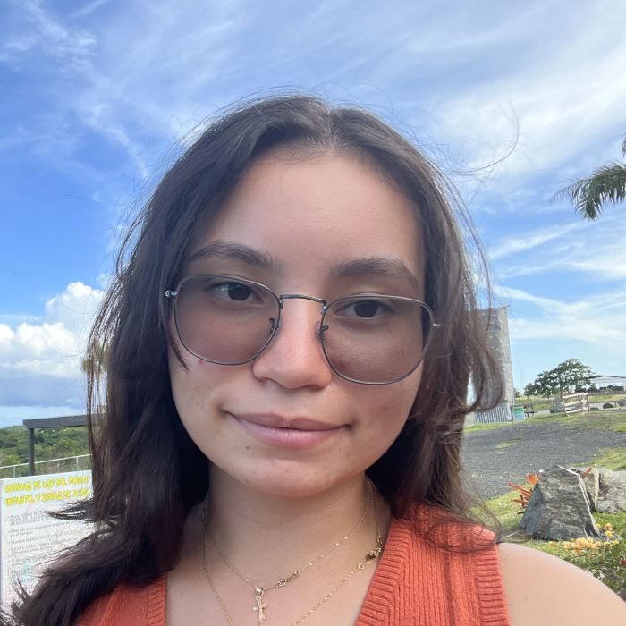
Name: Deyaneira Tirado
College: College of Agricultural and Life Sciences
Major: Microbiology and Cell Science
Minor: Pathogenesis

Mentor: Dr. Mariola Ferraro

Project Title: Synthetic Cannabinoids as Host-Targeting Approach to Reduce Inflammation and Clear Intracellular Infection

Project Description: The objective is using cannabinoids as a potential host-directed therapy for clearing Salmonella infection by treating macrophages with synthetic or natural cannabinoids to activate CB2 receptors which lead to signaling cascades that modulate cellular function. Our goal is to determine whether cannabinoids alleviate the symptoms of salmonella infection and could potentially be used as a host-targeted therapy for bacterial infections.

Research Interests: Microbiology, Pathogens, Cannabis Therapy

Volunteering: HCA North Florida Hospital (Volunteer),
Hobbies and Other Interests: Reading, Learning new languages

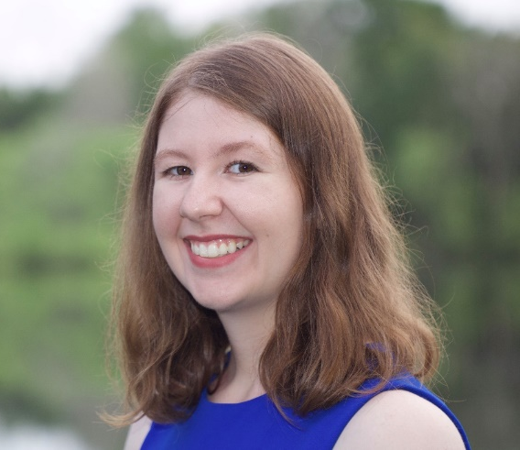
Name: Abigail Willer
College: College of Agricultural and Life Sciences
Major: Wildlife Ecology and Conservation
Minor: Fisheries and Aquatic Sciences

Mentor: Christina Romagosa

Project Title: Diet analysis of non-native Cuban knight anoles (Anolis equestris) across thermal regions in Florida

Project Description: Cuban knight anoles (Anolis equestris) were first introduced to South Florida in the 1950s, though little is known about their impact on the ecosystem. These diurnal, arboreal lizards are found as far South as the Florida Keys, and as far North as Volusia County. In Florida, the non-native anoles have been observed preying upon small vertebrates such as nesting birds, making them a potential threat to Florida fauna. I aim to analyze differences in the diet of 90 Cuban knight anoles across three thermal gradients in south and central Florida to assess risk in different ecosystems. The lizards will be necropsied to collect gastrointestinal contents and body condition data. Diet contents will be washed, sorted, and identified morphologically to the lowest possible taxonomic level. Preliminary results show the consumption of various insects, fruits, and small lizards in Key Largo.

Research Interests: Invasion ecology, herpetology, freshwater fisheries, arachnology,

Academic Awards: Florida Wildlife Federation scholarship, Arthur K. Woodman scholarship
Involvement: The Wildlife Society
Volunteering: National Wild Turkey Federation
Hobbies and Other Interests: Equestrian sports, fossil hunting, wildlife photography.

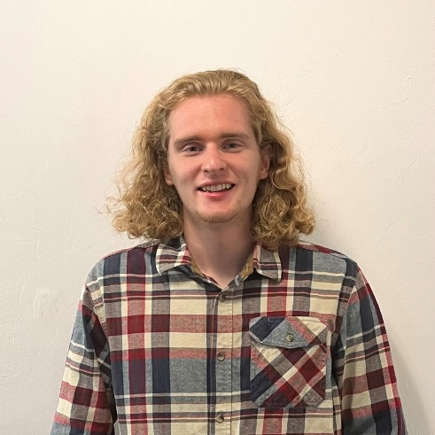
Name: John Williams
College: College of Agricultural and Life Sciences
Major: Entomology
Minor: N/A

Mentor: Andrea Lucky

Project Title: Taxonomic Revision of the Nylanderia austroccidua (Hymenoptera: Formicidae) Species Complex

Project Description: The ant genus Nylanderia (Emery) includes 125 described species and likely hundreds more undescribed. Classifying taxa within this genus has been difficult since delimiting characters for species are subtle, leading to distantly related genera looking very similar. The goal of this project is to revise the taxonomy of the Nylanderia austroccidua (Trager) species complex to help understand the biodiversity of this genus and be better prepared against invasive species. Nylanderia austroccidua is a single species that has a large geographic range, from Texas to Panama, and has a varied morphology as well; a vast native range and morphology likely means there is undiscovered species. In total, I anticipate 3-5 new species, I will image and collect qualitative and quantitative data from x specimens using 24 standardized measurements. The morphological and geographic data will be used to delimit new species and their boundaries of their native range, and a dichotomous key will be made.

Research Interests: ant taxonomy, evolution and medical entomology

Academic Awards: Williams Scholarship
Hobbies and Other Interests: Hiking and insect collecting and curation

Name: Serene Cheon
College: College of the Arts
Major: Digital Arts and Sciences
Minor: Computer Science

Mentor: Dr. Hyo Kang

Project Title: Crime VR Simulation

Project Description: The project aims to build a VR simulation of crime scenes in a collaboration with law enforcement agencies and criminologists. I will focus on creating a user-friendly interface for the VR simulation program.

Research Interests: User Experience Design

Academic Awards: Dean's List, President's Honor Roll
Hobbies and Other Interests: Baking

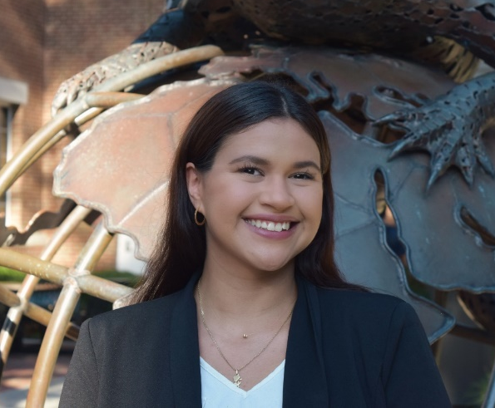
Name: Chrislian Daza
College: College of the Arts
Major: Digital Arts and Sciences
Minor: N/A

Mentor: Hyo Kang

Project Title: The impact of visual complexity in UI design on attention allocation in students with ADHD.

Project Description: This research paper focuses on investigating the impact of visual complexity in user interface (UI) design on attention allocation in individuals with Attention Deficit Hyperactivity Disorder (ADHD). The study aims to identify specific visual design elements that might have an impact on attention allocation and explore strategies to design user interfaces that could increase productivity and provide a better user experience for individuals with ADHD. The research will involve developing interactive prototypes of websites and apps and recruiting current students with ADHD from the University of Florida. The study will use tools like visual tracking, surveys, interviews, and evaluations to collect quantitative and qualitative data. The findings of the study will have significant implications in improving the design of digital products for individuals with ADHD.

Research Interests: Inclusivity, Design, User Experience, User Interface, Product Design

Academic Awards: Dean's List Fall 2023, University Scholars Program 2023
Involvement: Gator User Design
Hobbies and Other Interests: Design, art, technology

Name: Mariana García
College: College of the Arts
Major: Art History
Minor: Classical Studies

Mentor: Melissa Hyde, Ph.D.

Project Title: Gender and the Body Politic: An Exploration of Visual Representations of the Female Form through Allegory in Revolutionary France

Project Description: This project aims to investigate the impact of gender norms on imagery of the female form during the French Revolution, with a focus on the allegorical representations of women as symbols of the Republic's values. I aim to determine if the proliferation of such images and the exclusion of women from the public sphere ultimately reinforced traditional gender roles and privileged male citizenship. My research will analyze how the female form was used to represent abstract concepts such as Liberty, Equality, and Fraternity, and how this contributed to the construction of a gendered national identity. I will examine the impact of assigned gender roles in revolutionary imagery by exploring a range of primary sources, including paintings and prints as well as contemporary texts and documents. Finally, I seek to contribute to a wider discussion about the role of women’s bodies in shaping visual culture and the ways in which this impacts our broader cultural understanding.

Research Interests: Impact of gender norms on visual arts, representation of the female nude, depictions of women in Baroque & Neoclassical art.

Academic Awards: Valencia College President's List, Deiss Memorial Scholarship, Langadas Endowment for Classical Studies
Involvement: Student Ambassador for the School of Art + Art History
Hobbies and Other Interests: I have a deep appreciation for music, fashion, and the arts, which I enjoy cultivating through my interest in playing the piano, thrift shopping, and attending concerts and museums when I travel

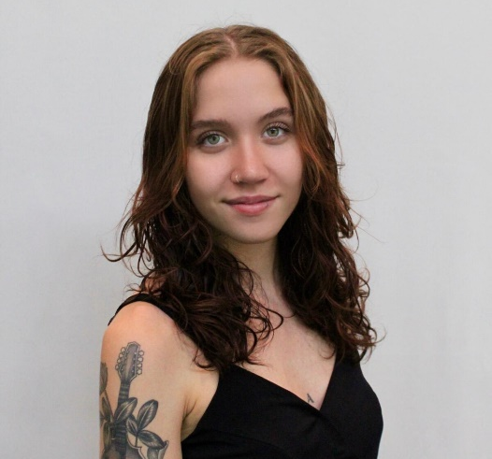
Name: Cec Wood-Barron
College: College of the Arts
Major: Dance and English
Minor: N/A

Mentor: Xan Burley

Project Title: The Body and The Archive

Project Description: My project explores the relationship between tangible archival work (in this case, poetry) and the creation of repertoire. Each piece will inspire another form of creation/iteration, finding a connection of interdisciplinary art.

Research Interests: Poetry and Choreography

Involvement: Student Senate
Volunteering: How Bazar events
Hobbies and Other Interests: Writing, dancing, fashion

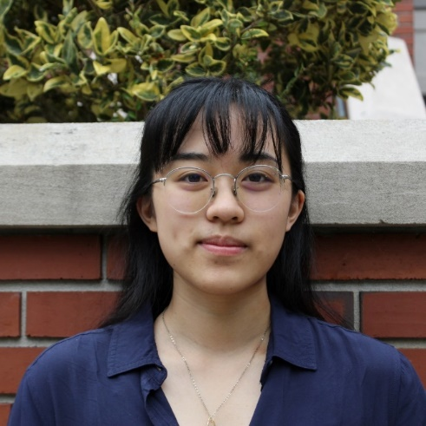
Name: Ashley Wu
College: College of the Arts
Major: Music in Combination with an Outside Field; Behavioral and Cognitive Neuroscience
Minor: Statistics

Mentor: Dr. Laura Dallman

Project Title: Emotional Impacts of Violations of Musical Expectation

Project Description: A natural consequence of listening to music is the development of musical expectations: rhythmic, harmonic, structural, etc. anticipations of what the listener predicts will occur in a piece. There is a substantial number of studies in psychology and neuroscience that examine the establishment of musical expectations, demonstrating that violations of musical expectations have physiological and emotional effects on the listener. Thus, violations of musical expectations could be implemented in musical compositions for different forms—such as video games, virtual mental health platforms, and therapy services—to produce a specific emotional effect in the listener. The difficulty in implementation lies in the complex and highly individualized experiences that each listener has when listening to music. This research aims to begin defining different types of violations of musical expectations and explore their emotional effects through a survey format. This format of research will expand upon existing quantitative data with qualitative data that explores emotional effects of music as described by the listener. The goal of this research project is to inform future compositions and use of music in different mediums to build more emotionally affective experiences for listeners.

Research Interests: Music and emotion, applications of musical expectations

Academic Awards: Edith P. Pitts Memorial Scholarship, George W. Tedder Jr. and Susan Heald Tedder Scholarship Fund, Sung Scholarship
Involvement: UF School of Music Ambassador
Hobbies and Other Interests: Baking, vinyls, listening to music

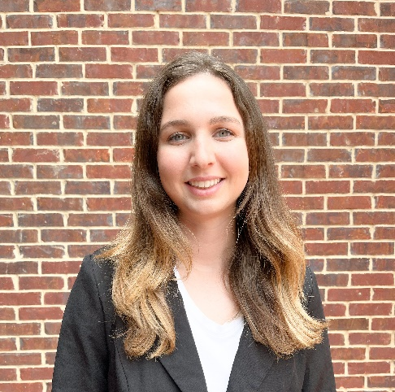
Name: Grace Adams
College: College of Dentistry
Major: Microbiology and Cell Science
Minor:

Mentor: Bruna Garcia

Project Title: Association of CBP+ Streptococcus mutans with root caries in older adults

Project Description: The oral health of older adults in the U.S. has been a growing concern due to the prevalence of oral-related conditions that have accompanied an increase in life expectancy. Dental roots are rich in collagen and, when exposed, are a favorable colonization site for CBP+ S. mutans which may lead to increased caries risk. Our hypothesis is that individuals who are colonized with CBP+ S. mutans, and are also experiencing gingival recession, have a higher risk of developing root caries than individuals who are infected with CBP- S. mutans in their oral microbiome. The goal of this research is to identify the presence the CBP genes cnm and cbm in S. mutans clinical isolates from older adults with (RC) or without (H) root caries. From each patient group (H and RC), we already obtained S. mutans-like isolates from saliva (S), plaque from a sound enamel surface (SE), and healthy root plaque (HRP) site. For the RC group, we also obtained S. mutans-like isolates from carious root plaque (CRP). The findings of this study will allow us to determine if there is an association between the development of root caries and the presence of CBP+ S. mutans in the oral microbiome of older adults. The outcome will add to the current knowledge that we have on root caries and provide support for more preventive measures and assessments for the condition in the future.

Research Interests: Oral biology and Microorganisms

Involvement: Sigma Kappa Sorority
Volunteering: Walk to End Alzheimer's, Keep Alachua County Beautiful
Hobbies and Other Interests: Running, Hiking, Baking

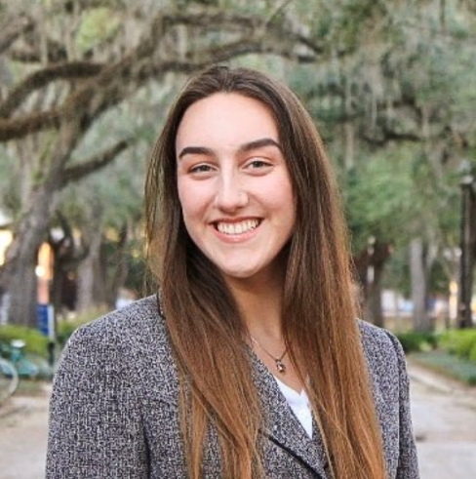
Name: Melissa Charret-McGuinness
College: College of Public Health and Health Professions
Major: Health Science
Minor: N/A

Mentor: Dr. Mateus Rocha

Project Title: Two-Body Wear Resistance of Universal and Bulk Fill Composites -- A Pilot Study

Project Description: This study assesses the strength and wear resistance of various dental composites against an antagonist on the occlusal surface of the sample. The present study subjected four dental composites to a two-body wear test using a chewing simulator machine.

Research Interests: Dentistry

Academic Awards: Dean's List
Involvement: Pre-Dental Society, CHAARG, Delta Delta Sigma
Volunteering: Habitat for Humanity
Hobbies and Other Interests: Volleyball and Kickboxing

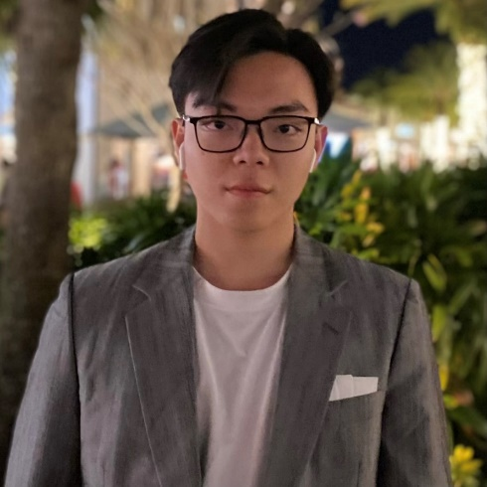
Name: Anh Hao Dang
College: Herbert Wertheim College of Engineering
Major: Chemical Engineering
Minor:

Mentor: Jia Chang

Project Title: Reposition of FDA-approved antidepressant, 2-PCPA, to treat periodontitis

Project Description: Trans-2-Phenylcyclopropylamin, or 2-PCPA, is a monoamine oxidase inhibitor approved as an antidepressant for decades. Recently it has been repositioned to treat leukemia as an epigenetic inhibitor targeting Lysine-Specific Histone Demethylase 1A (LSD1). Our previous research proved that 2-PCPA is a bone growth inducer. It prevents inflammatory bone loss induced by cytokine (TNF-α) and cigarette smoking extract in osteoblast cell cultures in vitro and mouse calvaria organ cultures ex vivo. We also found that systemic administration of 2-PCPA improves periodontal jawbone quality in mice.

Research Interests: Dentistry

Academic Awards: Silver Award in Physics StemCo Competitions, Bronze Award in Biology StemCo Competitions, and Bronze Award in Chemistry StemCo Competitions
Involvement: Member in Vietnamese Student Organization, Member with Distinction in Pre-Dental Society and Delegate in Pre-ASDA
Volunteering: Sugar and KIDs Vietnam (both are in Vietnam)
Hobbies and Other Interests: Piano, cooking, chemistry, lego and dentistry

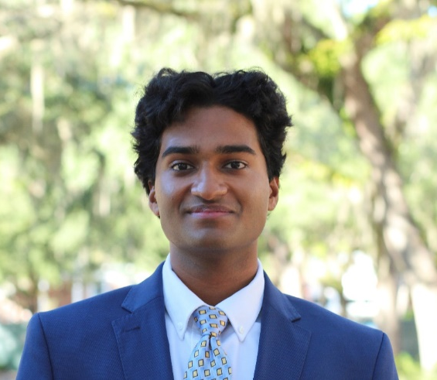
Name: Tushar Desaraju
College: College of Dentistry
Major: Nutritional Sciences
Minor: Health Disparities in Society

Mentor: Kesavalu Lakshmyya

Project Title: Examining alveolar bone resorption after polymicrobial periodontal infection in TLR2-/-gene KO mice”.

Project Description: To determine the extent of alveolar bone resorption to multiple oral bacterial infections including S. gordonii, F. nucleatum, P. gingivalis, T. denticola, and T. forsythia during ecological timely polybacterial periodontal infection in TLR2-/- mice. Pattern recognition receptors (PRRs) such as Toll-like receptors (TLRs1–9) are highly developed potent microbe-associated molecular pattern (MAMP) recognition receptors. These receptors initiate innate immune responses to periodontopathic bacteria in gingivitis and periodontitis.

Research Interests: Polymicrobial periodontal infections, alveolar bone resorption, gingivitis, and periodontitis

Academic Awards: University Scholars Program
Involvement: Center for Undergraduate Research Board of Students (CURBS), Delta Delta Sigma: Pre-Dental Honor Society, Gator Udaya, Indian Students Association
Volunteering: Dental assisting for the Mobile Dental Clinic Bus, Florida Dental Association (Mission of Mercy)
Hobbies and Other Interests: Competitive Dance Team, Basketball, Dentistry, Eating different types of Cheesecake

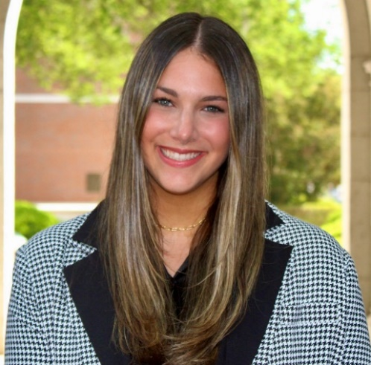
Name: Lauren Epstein
College: College of Dentistry
Major: Nutritional Sciences
Minor: Health Disparities

Mentor: Dayane Oliveira

Project Title: Curing efficiency of light-cured resin cements through lithium disilicate ceramics with different translucencies and thicknesses

Project Description: Light-cured materials revolutionized Dentistry as they allowed to control the setting of the materials in a timely manner simply upon light exposure. The use of light-cured materials in Dentistry was possible with the arising of photoinitiators in the composition of dental materials. Although blue light has been widely used to cure dental restorative materials for over 50 years, the US Food and Drug Administration considers these devices to be Class II medical devices. The reason is because it poses risks to patients as there is the potential for adverse effects owing to the potential direct effects of this specific short wavelength. On the other hand, long wavelengths, such as red light, are known to have opposite effects. Although the blue-light hazards in Dentistry are well known, there are no alternatives to this problem because of the lack of photoinitiators that absorbs longer wavelengths. The purpose of this study is to evaluate and compare the cure efficiency while using blue- and red- light to polymerize dental resin cements through different simulated ceramic restorations. The potential cure efficiency of the different wavelengths through the different simulated ceramic restorations will be evaluated using Fourier-transformed infrared spectroscopy to calculate the degree of conversion of the resin cemented placed underneath it.

Research Interests: Dental Biomaterials

Academic Awards: Emerging Scholars Program, University Research Scholars Program, Dean's List
Involvement: Alpha Omicron Pi, Delta Delta Sigma Pre-Dental Honors Society
Volunteering: Shands Hospital Child Life Volunteer, A Soccer Life Foundation External Director of Affairs, Dental Assistant at Gainesville Community Ministry
Hobbies and Other Interests: I love to play and watch soccer, bake, cook, go to Orangetheory, and travel to new places!
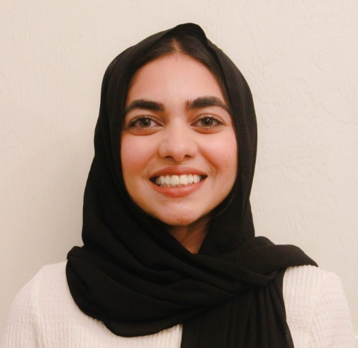
Name: Rida Imran
College: College of Dentistry
Major: Nutritional Sciences
Minor: Disabilities in Society

Mentor: Dr Seunghee Cha

Project Title:The impact of PNPase on monocyte activation in childhood Sjögren’s Disease

Project Description: This project is to identify the roles of self-dsRNA, particularly mitochondrial dsRNA (mtdsRNA), in augmenting type I IFN secretion via the activation of intracellular dsRNA sensor, PKR, as a consequence of altered PNPase and SUV3 expression in cSjD monocytes.

Research Interests: DNA, RNA, proteins

Academic Awards: Machen Florida Opportunity Scholar
Involvement: Islam on Campus, UF Pre-Dental Society, Pakistani Student's Association, Bangladeshi Student's Association, DMDMP UF,
Volunteering: Project Downtown Gainesville
Hobbies and Other Interests: I enjoy spending quality time with my friends and family. I also enjoy activities that allow me to be creative such as doing makeup, henna, and painting. I am also active by playing a variety of sports such as basketball, volleyball, and weightlifting.

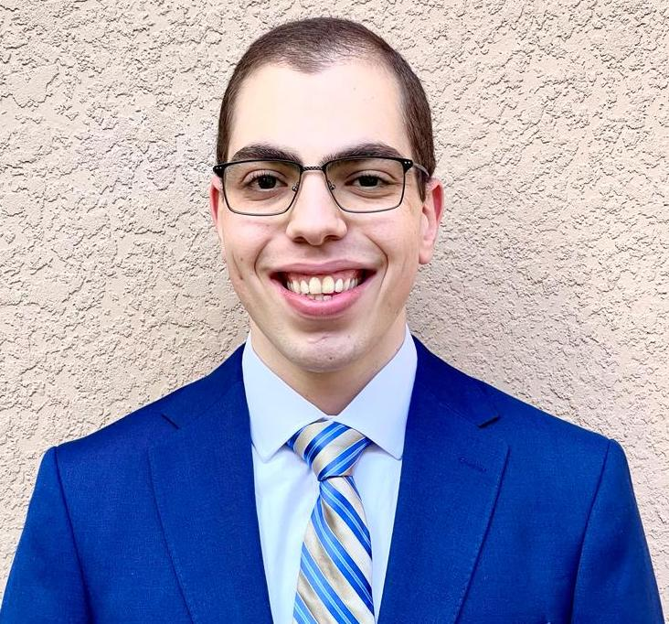
Name: Emile R. Karam
College: College of Dentistry
Major: Biology
Minor: Health Disparities in Society, Economics

Mentor: Frank C. Gibson III, Ph.D.

Project Title: Defining the contribution of Porphyromonas gingivalis outer membrane vesicles to the delivery of sphingolipids to the host.

Project Description: Periodontal disease (PD) is a bacteria-induced complex chronic inflammatory disease of the oral cavity that destroys the soft and hard tissue supporting the teeth. Porphyromonas gingivalis is a Gram-negative, anaerobic bacterium that resides in the subgingival biofilm of humans and is closely associated with PD. P. gingivalis is known to be a prodigious producer of nanoscale structures called outer membrane vesicles (OMVs); yet what OMVs do in the context of PD is essentially unknown. The main goal of this research project is to determine if OMV biogenesis by P. gingivalis controls sphingolipid transfer to the host. To test our hypothesis, we will use molecular techniques to generate P. gingivalis galE mutants in the wild type P. gingivalis strain W83 and its isogenic sphingolipid deficient mutant ΔSPT. If the project is successful, we will develop a firm understanding of how P. gingivalis delivers its sphingolipids to the host and would be a significant advance to our current understanding of how P. gingivalis interacts with the host in the context of periodontal health and disease.

Research Interests: Host-Pathogen Interaction, Inflammation

Academic Awards: Florida Academic Scholarship, Machen Florida Opportunity Scholarship, College of Liberal Arts and Sciences Dean's List, University Scholars Program
Involvement: Arab Student Association, First Generation Leadership Program, Student Honor Code Administration, Office for Accessibility and Gender Equity, Medi-Gators Virtual Shadowing Program
Volunteering: Malcom Randall VA Medical Center, Bruce W. Carter VA Medical Center, Alachua Habitat For Humanity
Hobbies and Other Interests: Walking, biking, painting, construction work

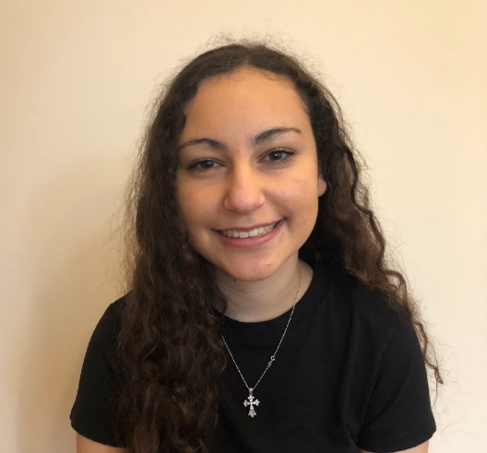
Name: Gabrielle Makar
College: College of Dentistry
Major: Nurtitional Sciences
Minor: N/A

Mentor: Mateus Rocha

Project Title: Wear Resistance of a New Bulk Fill Composite

Project Description: The aim of the project is to assess the effectiveness of a new bulk-fill composite by Bisco. The trials incorporate a cycling to stimulate decades of wear on fillings. This involves a chewing simulator with alternating cool and warm water and a measured number of a cycles of contact between an antagonist and the sample. The wear of the samples of varying cycles is then analyzed and calculated using an intraoral scanner.

Research Interests: wear resistance on bulk and universal composites; responses to opioids and NSIADs post dental surgical procedures

Academic Awards: Dean's List ('21-'23); B.S. DMD Entering Class of '24; Biomaterials Research Program '22-present
Involvement: Orthodox Christian Campus Ministries (OCCM)
Volunteering: OCCM Service Coordinator '22-'23
Hobbies and Other Interests: I love to read and spend time with my friends trying new things that are happening around Gainesville.

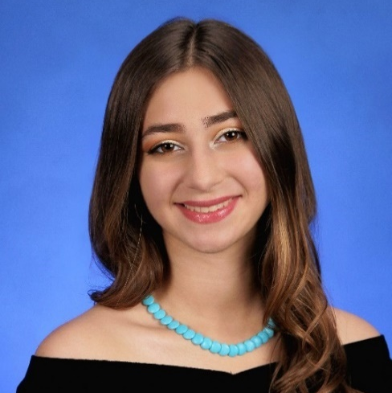
Name: Alexandra Martinez
College: College of Dentistry
Major: Biology (Concentration in Biotechnology)
Minor: N/A

Mentor: Yenisel Cruz-Almeida, M.S.P.H., Ph.D.

Project Title: Investigating the Influence of Highly Inflammatory Simple Carbohydrates on Chronic Pain in Individuals with Knee Osteoarthritis

Project Description: Based on the noted deleterious interactions that excess simple carbohydrate consumption have with the immune system, we hypothesize that excess refined carbohydrates in the diet may result in exacerbated pain and inflammation and neuronal damage (centrally and peripherally). (R.R. Ji, 2014 Nat. Rev. Drug Discov). Therefore, the proposed research question will determine the association between simple carbohydrate consumption and self-reported pain severity and disability levels in individuals with knee osteoarthritis. We will use biomarkers such as blood glucose levels and pro-inflammatory immune system cytokines and chemokines to measure to quantify inflammation. Together, the proposed study will provide new insights into the nutritive factors that may modulate the variability in pain outcomes in older adults with chronic musculoskeletal pain. It will also lay the groundwork necessary to expand research into dietary interventions for in the clinical setting for persons with chronic pain.

Research Interests: Pain and Nutrition

Involvement: Delta Delta Sigma, MFOS Scholar, Cuban American Student Association
Volunteering: H.E.A.T (Health Education and Training Center of Gainesville)
Hobbies and Other Interests: Fitness, Dentistry, Music (Jazz, Oldies, EDM), Healthy Eating/Cooking, Sustainability, Nature.

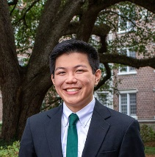
Name: Danniel Pham
College: College of Dentistry
Major: Microbiology and Cell Science
Minor: Pathogenesis

Mentor: Lin Zeng

Project Title: Genetic Characterization of a single nucleotide polymorphism in the manL subunit of Streptococcus sanguinis glucose-PTS permease, examining fitness and competitiveness against major caries pathogens.

Project Description: The oral cavity hosts an extensive range of microorganisms, a diverse population with possibly 700 species of bacteria, whose growth are fueled by the modern carbohydrate-rich human diet. The oral cavity undergoes a variety of conditions, including varying carbohydrate concentrations, aerobic availability, and saliva production. Under suitable conditions, bacteria can secrete acids as a byproduct of various metabolic pathways. Prolonged exposure to acidic environments increases the likelihood of dental erosion or enamel demineralization/decalcification, leading to the formation of dental caries. Streptococcus sanguinis is a known health-associated commensal bacterium due to its ability to secrete hydrogen peroxide, which inhibits primary etiological caries agents such as Streptococcus mutans. This project will attempt to test the hypothesis, through site-directed mutagenesis, that the glucose-PTS modulates bacterial fitness and microbial ecology in the oral environment and that the mutations in this system can contribute to greater oral health overall. This project could contribute additional information about the glucose-PTS in S. sanguinis, specifically how it affects gene transcription and fitness. These results can be translated into developing new caries risk assessment and prevention strategies.

Research Interests: Bacterial Genetics, Bacterial Physiology, Biofilm, Dental Caries, Microbiology, Oral Biology, and Streptococcus sanguinis

Academic Awards: Florida Academic Scholars Award
Involvement: Pre-Dental ASDA
Volunteering: Florida Dental Association and Health First
Hobbies and Other Interests: 3D Modeling & Printing, Hiking, Music Composition, Rafting, Reading, Tennis, and Watercolor painting
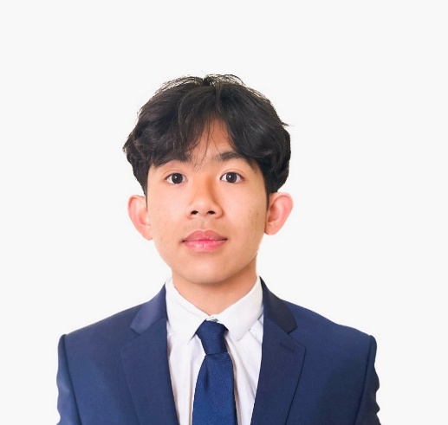
Name: Edison Tran
College: College of Dentistry
Major: Health Science
Minor: N/A

Mentor: Dr. Jorge Frias-Lopez

Project Title: Characterization of PGN_1547 in Porphyromonas gingivalis Adhesion

Project Description: Porphyromonas gingivalis is a key pathogen of periodontitis, a polymicrobial disease characterized by a chronic inflammation that destroys the tissues supporting the teeth. Thus, understanding the virulence potential of P. gingivalis is essential to maintaining a healthy oral microbiome. Part of our results shows that compared to the wild type, a mutant with a deletion of the Cas3 gene, an essential nuclease part of the class 1 type I CRISPR-Cas system, increased the virulence of P. gingivalis ATCC 33277 and controls the expression of PGN_1547, a hypothetical protein with adhesine domain characteristics. PGN_1547 belongs to a superfamily of adhesins which are important virulence factors in Gram-negative pathogens. This proposal aims to determine if PGN_1547 acts as an adhesine to assess its role in the pathogenesis of P. gingivalis.

Research Interests: Periodontitis, Biofilm Formation, and Metatranscriptomics

Academic Awards: UF College of Public Health and Health Professions Dean's List and Florida Bright Futures Scholar
Involvement: UF Pre-Dental Society
Volunteering: UF Habitat for Humanity and UF D.M.D. Student Clinic
Hobbies and Other Interests: Cooking new recipes, going to the gym, and playing golf

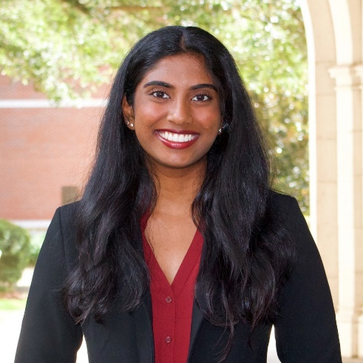
Name: Ashitha Yada
College: College of Dentistry
Major: Nutritional Sciences
Minor: Disabilities in Society

Mentor: Lakshmyya Kesavalu

Project Title:Intravascular dissemination of periodontal bacteria after polymicrobial infection in TLR2-/- mice.

Project Description: To determine intravascular dissemination of multiple oral bacteria including S. gordonii, F. nucleatum, P. gingivalis, T. denticola, T. forsythia during time-sequential polymicrobial infection in TLR2-/- mice.

Research Interests: Periodontal pathogens invasion, proliferation, and dissemination to systemic tissues/cells.

Involvement: UF Footprints Buddy and Support Program, Delta Delta Sigma: Pre-dental honor society, Equal Access Clinic Network Research, and Indian Students Association
Volunteering: UF Footprints Buddy and Support Program: volunteering on the pediatric Immunocompromised inpatient and Infusion outpatient clinics at the UF Health Shands Children's Hospital.
Hobbies and Other Interests: dancing, traveling, and trying new foods

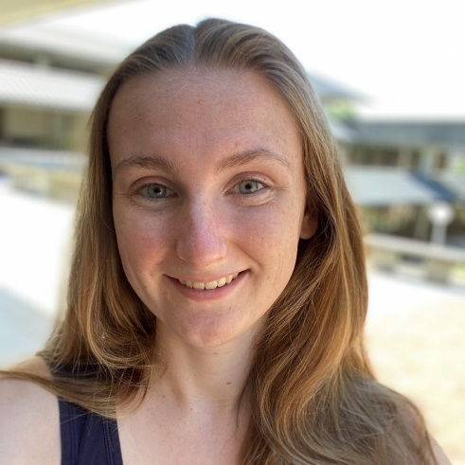
Name: Erin Beck
College: College of Design, Construction, and Planning
Major: Architecture
Minor: N/A

Mentor: Charlie Hailey

Project Title: Architecture for Advancing the Life of a Maintenance Worker

Project Description: I will conduct an architectural study on the break rooms, storage, utility, and circulation spaces used every day by janitors and custodians at the University of Florida. By interviewing janitors and custodians about the design of their workspaces, I seek to identify potential ways these spaces can be re-designed for a better quality of experience while occupying them. Additionally, I will tour the janitorial and custodial spaces in three UF buildings: the University Auditorium, the Student Health Care Center, and the Architecture Building. I will then propose new guidelines to the architecture community on how to design more enjoyable and accessible spaces for janitors and custodians, utilizing the three UF buildings as precedents for constructing my suggestions.

Research Interests: Historic Preservation, Sustainable Design Solutions, PreColumbian Earth Architecture

Involvement: American Institute of Architecture Students, Receptionist with University of Florida Performing Arts
Hobbies and Other Interests: Exploring historic architecture sites, reading, writing, biking

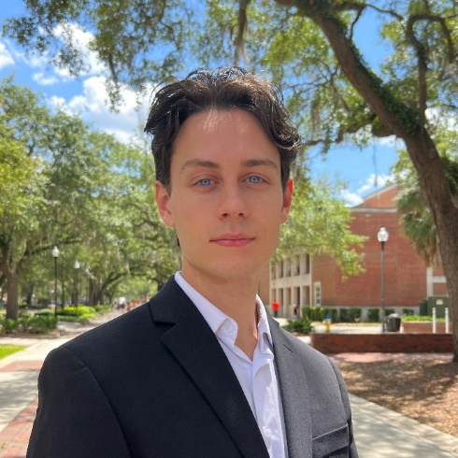
Name: Jackson Budd
College: College of Design, Construction, and Planning
Major: Architecture
Minor: Classical Antiquity

Mentor: Peter Sprowls

Project Title: Lowering Building Emission Through the Use of Traditional Florida Architecture

Project Description: This research investigates the carbon footprint of contemporary student housing popping up all over Gainesville. These student apartments are primarily concerned about maximizing the capacity of residents while often over relying on air conditioning to cool the building. This dependency on central cooling and heating increases the carbon footprint of the structure indefinitely as it will forever rely on energy for the occupants to remain comfortable. With the ongoing climate crisis this solution no longer is justifiable and more architects should take initiative to create energy forward buildings. This proposal aims to look at the current energy requirements of contemporary student apartments, redesign the apartments with traditional Florida architectural characteristics and compare the data of energy consumption between the two models. The goal of which is to prove that the solution to the climate crisis within architecture is a careful consideration of site and context, rather than a general universal fix.

Research Interests: Sustainable Building Techniques

Academic Awards: All American Student Athlete 2021-2022, Deans List 2021, 2022
Involvement: UF D3 Club Ice Hockey and UF Formula One
Hobbies and Other Interests: Recently I ran the 2022 Berlin Marathon and have always been a distance runner, as well as play hockey in the D3 Ice Hockey team and was assistant captain for the 21'-22' season.

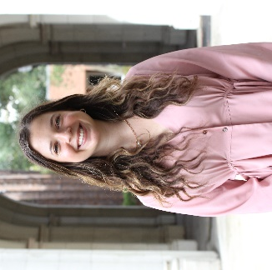
Name: Olivia Cederquist
College: College of Design, Construction, and Planning
Major: Interior Design
Minor: N/A

Mentor: Shabboo Valipoor

Project Title: Home Modifications for Aging in Place: Practical Solutions by Community-Living Older Adults.

Project Description: The “graying of America” is a term coined to describe the increased number of older adults in the United States. However, this population trend is not exclusive to the United States. The World Health Organization states that every country is experiencing the growth of older adults. As the global population ages, the desire for older adults to stay in their homes for as long as possible increases. Aging in place has several advantages such as lower care costs and lower progression of memory loss. Research shows that home modifications, which are adaptations to the home environment, facilitate the ability of individuals to age in place. This research aims to develop a data collection platform prototype for collecting home modification data from older community dwellers. Identifying the wide range of solutions used by older adults based on different abilities and disabilities, resources, and everyday experiences will facilitate informed decision-making in designing and examining future modifications. These may include available solutions on the market or those devised by community dwellers to increase their own comfort. This study is expected to enhance our understanding of not only practical home modification solutions but also the problems faced by older adults who are aging in place and facing a wide range of challenges due to their physical and functional limitations.

Research Interests: Aging-in-place interior design solutions. The intergenerational age gap.

Academic Awards: Citizenship Award- Department of Interior Design. Outstanding Peer Leader Award Fall 2022- Center for New Student, Parent & Family Engagement, First Year Florida.
Involvement: President of Gator Interior Design. Interior Design Representative for DCP Ambassadors. Peer Leader for First Year Florida. Member of Greek Life.
Volunteering: Rebuilding Together. Habitat for Humanity. The JED Foundation.
Hobbies and Other Interests: Scuba-diving, swimming, traveling.

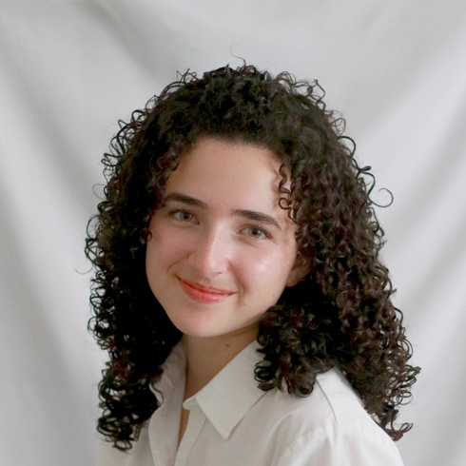
Name: Emily Garnica
College: College of Design, Construction, and Planning
Major: Architecture
Minor: Religion

Mentor: Sarah Gamble

Project Title: House Relocation in Relation to Future Sea Level Rise in Florida

Project Description: My research will focus on house relocation and its use in Florida’s coastal communities in response to rising sea levels. House relocation is a specialized practice of physically moving house structures within a property or to a new property. For example, moving houses horizontally and/or vertically in response to flooding, the expansion of transportation infrastructure, and/or future redevelopment. Documented in recent research by Prof. Gamble focused on Texas communities, house relocation presents environmental, economic, and preservation benefits, and has potential for expanded use in Florida in response to the climate crisis.

Research Interests: Sea-Level Rise, Urban Planning, House Relocation, Religious Architecture, Gender and Architecture

Involvement: Architrave
Hobbies and Other Interests: Crochet, sewing, rock climbing, running, listening to music, hiking

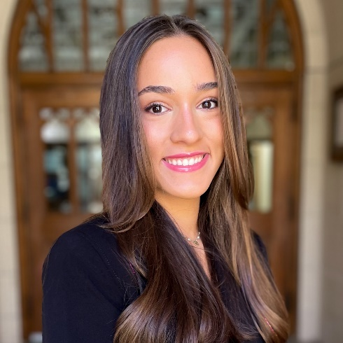
Name: Hannah Gutierrez
College: College of Design, Construction, and Planning
Major: Architecture
Minor:

Mentor: Vandana Baweja

Project Title: The Emergence of Climate Justice and Implementation in Architecture Schools

Project Description: This research will explore how movements in climate justice emerged considering the intersections of climate justice with other justice movements like civil rights, and social justice. Research will also cover the integration and influence of climate justice on architecture schools curriculum.

Research Interests: Climate Justice, Environmental impacts on the built environment

Involvement: Extreme Dance Company, Be The Match
Volunteering: Be The Match, Project Makeover, Grace Marketplace
Hobbies and Other Interests: Half Marathon Training, Art, Dance, Traveling

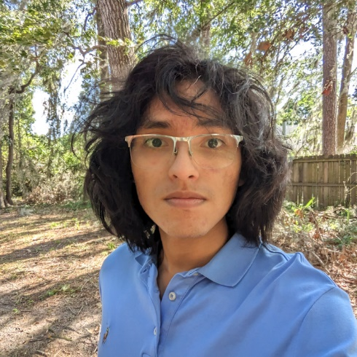
Name: Gabriel Matos
College: College of Design, Construction, and Planning
Major: Sustainability and the Built Environment
Minor: N/A

Mentor: Dr. Azza Kamal

Project Title: Design Recommendations for Passive House Certification in Gainesville’s Historic Districts

Project Description: As the effects of climate change and global warming exacerbate the intensity and magnitude of climate disasters, the state of Florida must quickly adapt to an increasingly hostile environment by creating a more resilient and sustainable built environment. Structures, including historic ones, must also adapt to the changing necessities. Consequently, this research will study the relationship between Florida’s climate and the built environment to determine issues and solutions to the problem of sustainability and resiliency in Gainesville’s historic homes to produce specific design recommendations for achieving passive house certification.

Research Interests: Sustainability, vernacular architecture, art nouveau

Involvement: Architrave, Green Building Club
Hobbies and Other Interests: Photography, reading, drawing, watching movies

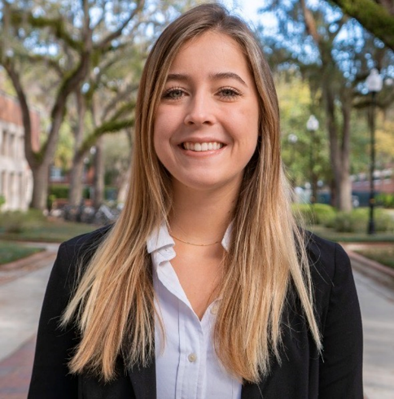
Name: Abigail Toenjes
College: College of Design, Construction, and Planning
Major: Architecture
Minor: Sustainability and the Built Environment

Mentor: Dr. John Maze

Project Title: Design and disease: Evidence-based design and implementation

Project Description: An exploration into the different strategies used to promote human health in cities and spaces and changes made throughout history following epidemics.

Research Interests: Sustainable design

Involvement: Project Makeover
Hobbies and Other Interests: Reading and going to the beach

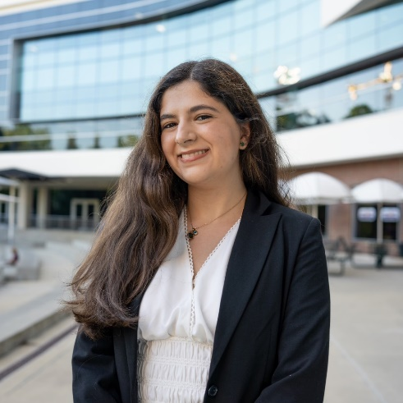
Name: Dahlia Fabregat
College: College of Education
Major: Education Sciences and Spanish
Minor: N/A

Mentor: Erica McCray

Project Title: Unveiling the Cultural Capital of Latinx ESOL Paraprofessionals in US Secondary Schools

Project Description: This project will evaluate the experiences of Latinx ESOL paraprofessionals with the intentions of understanding their involvement and the cultural capitals they reveal when working with Latinx EL students.

Research Interests: Experiences of culturally diverse teachers and students in the K-12 educational system.

Academic Awards: Ronald E. McNair Scholar,
Involvement: Hispanic Student Association, Kappa Delta Pi Honor Society
Volunteering: ADELANTE
Hobbies and Other Interests: Knitting, embroidery, cooking, listening to music

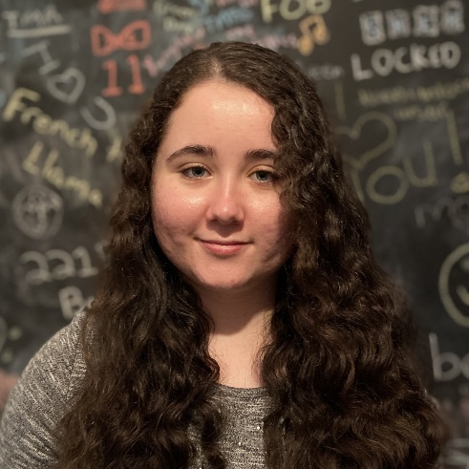
Name: Alyssa Holmquist
College: College of Liberal Arts and Sciences
Major: Chemistry and Psychology
Minor: Music History and Art History

Mentor: Dr. Joni Splett

Project Title:TBD

Project Description: Examining the effects of the "Parental Rights in Education Act" on Florida high school students' feelings of safety and belonging in school and their perceptions of changes in attitudes toward LGBTQ+ issues among students, educators and lawmakers

Research Interests: School Psychology

Academic Awards: Dean's List
Involvement: Gator MIC
Volunteering: Head Start

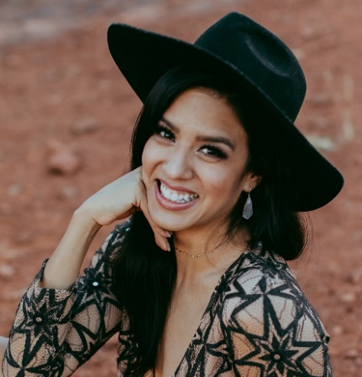
Name: Paola J. Sullivan
College: College of Agricultural and Life Sciences
Major: Family, Youth, and Community Sciences
Minor: Communications

Mentor: Anna Puig

Project Title:The Efficacy of a Sensory Development Intervention on Children’s Spirituality, Happiness, and Psychological Well-Being: A Pilot Study

Project Description: The proposed work has the following objectives: 1. Deepen children's spiritual awareness through a sensory development children’s book which is part of an enriched educational program; 2. Identify, describe, and analyze the attitudes and practices of children’s spirituality; and 3. Ensure that all participants receive the sensory development children’s book so that they may continue to develop their sensory awareness, spirituality, happiness, and overall psychological well-being. The research questions are: 1. Does a spiritual intervention tool such as a sensory development children’s book help increase students’ spirituality, happiness, and/or overall psychological well-being? And 2. What is the relationship between children’s spirituality, happiness, and psychological well-being? To answer these questions, the research is a quasi-experimental design study wherein the sample will be composed of children in 3rd, 4th, and/or 5th grade levels in an elementary school in Gainesville, Florida. Participants will be randomly assigned to treatment and control groups. Participants in the treatment group will receive an intervention consisting of a guided activity in an outdoor setting. Potential treatment effects will be assessed through a pretest (i.e., in-person questionnaires) administered immediately before the intervention, and a posttest to be completed immediately after the intervention.

Research Interests: Spirituality, Children, Education, Psychological Well-Being, Positive Psychology

Academic Awards: Dean's List 2020, 2021, 2022; Academic Team Scholar of the Year 2021
Involvement: Tau Sigma Honor Society, First Generation Organization
Volunteering: Gainesville Thrives, Sun Market, First There Foundation

Name: Nikolai Abraimov
College: Herbert Wertheim College of Engineering
Major: Mechanical Engineering
Minor: N/A

Mentor: Matthew Traum

Project Title: Benchtop Tensile Tester for Student Use

Project Description: This project is aimed at designing and manufacturing a portable tensile tester that would benefit students in settings outside of brick and mortar and with limited funds. The need for such was demonstrated during the situation of COVID, where it was not plausible to run hands-on demonstrations, and in classes as Mechanics of Materials Lab, where it was difficult to provide lab availability to all students. Currently, the project is emerging from the preliminary design and manufacturing stage, with the upcoming work being in troubleshooting and programming.

Research Interests: Fluid Simulation, Design and Manufacturing

Academic Awards: Dean's List Fall 2022
Involvement: SWAMP Launch, ASME SDC
Volunteering: Honors Review Volunteering (UF)
Hobbies and Other Interests: Woodworking, Hiking, Biking, Programming

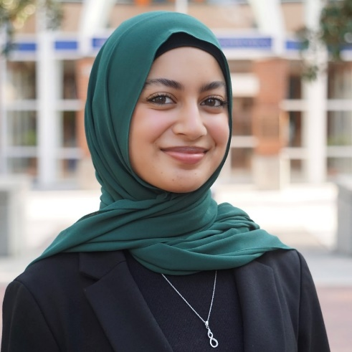
Name: Sofia Ahmed
College: Herbert Wertheim College of Engineering
Major: Aerospace Engineering
Minor: Women's Studies

Mentor: Matthew J. Traum

Project Title: Revealing the Bulk Mechanical Property Threshold for Thin Metallic Samples to Support a Desktop-Scale Stress-Strain Apparatus

Project Description: Availability of inexpensive, accessible, and turnkey lab equipment for students’ engineering educational use has received growing attention. In order to develop a bench-top tensile tester, the thickness of samples that can be tested on it must be identified. This project aims to reveal the threshold thinness of common engineering metals at which bulk properties emerge. This thinness value can then be used to produce accurate stress-strain curves on a smaller tensile testing machine for educational use.

Research Interests: Experimental Mechanics, Aerospace Structures, Space Systems

Academic Awards: UF Honors Program, UF URSP
Involvement: Treasurer of Swamp Launch Rocket Team, Adab Chair of Islam on Campus
Volunteering: Project Downtown Gainesville
Hobbies and Other Interests: Reading, pursuing my certification in Quran Recitation, exploring coffee shops, and making candles

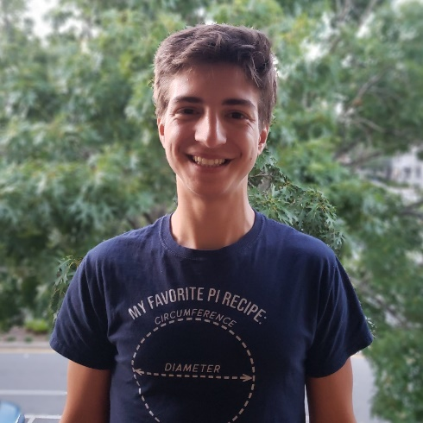
Name: Jorge Alberto
College: Herbert Wertheim College of Engineering
Major: Electrical Engineering
Minor: Computer Science

Mentor: Erin Patrick

Project Title: Rapid Predictor Model

Project Description: This research project evaluates non-conventional stimulation programs used in deep brain stimulation applications. The work will entail running Python scripts that model the activation of nerve fibers near DBS electrodes and subsequent data analysis for different stimulation scenarios. The work will incorporate machine learning strategies as necessary.

Research Interests: Neural Interfaces & Machine Learning

Academic Awards: University Research Scholar's Program, UF Honor's Program, Dean's List
Volunteering: Calculus 1 Learning Assistant
Hobbies and Other Interests: Long Distance Running, Basketball, Soccer, Football, & Website Creation

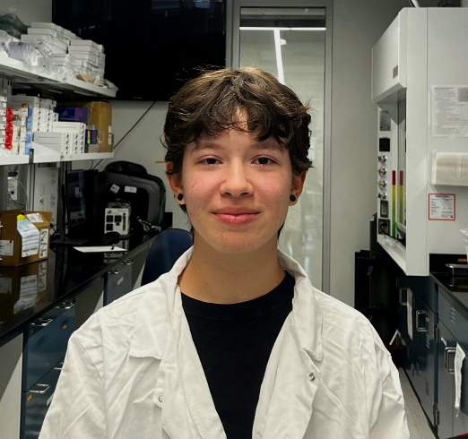
Name: Hannah Bagnis
College: Herbert Wertheim College of Engineering
Major: Chemical Engineering
Minor: Biomolecular Engineering

Mentor: Whitney Stoppel

Project Title: Dynamics of chemical and physical crosslinking of methacrylated silk fibroin hydrogels for application in 3D printing

Project Description: Leveraging photocrosslinking properties to enable favorable viscoelastic mechanical properties

Research Interests: Nanoparticles/Hydrogels

Academic Awards: Summer 2023 NIH Diversity Research Scholar, AP Scholar with Distinction
Involvement: AIChE, SWE
Hobbies and Other Interests: Sand Sculpting

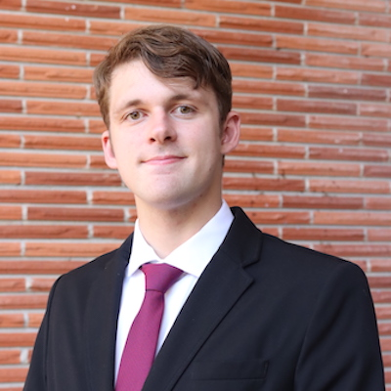
Name: Hunter Black
College: Herbert Wertheim College of Engineering
Major: Chemical Engineering
Minor: N/A

Mentor: Ranga Narayanan

Project Title: Faraday Instability at Interfaces

Project Description: For this project, I am creating a voltage drop over a oil/water interface that creates a faraday instability between the fluids. The voltage drop is created by forcing an oscillatory waveform at the bottom of the plate and grounding the top of the plate. The waves that are formed at the water/oil interface are bessel functions and the onset of the instability can be measured to determine physical properties of the fluid.

Research Interests: I am very interested in fluid instabilities and the properties that you are able to determine from them.

Hobbies and Other Interests: Fishing, scuba diving, going to the gym

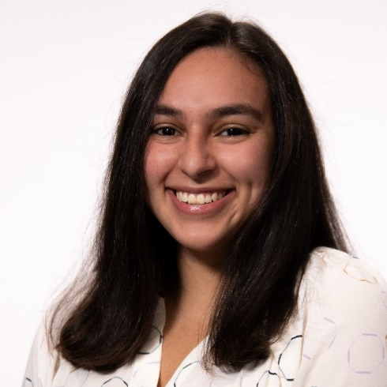
Name: Andrea Camacho-Betancourt
College: Herbert Wertheim College of Engineering
Major: Industrial and Systems Engineering
Minor: N/A

Mentor: Dr. Katie Basinger-Ellis

Project Title: Continuous Improvement of CNC Manufacturing Lab Course

Project Description: Engineering internships and jobs require one to be comfortable with experiential learning. Students are challenged with combining the knowledge and theory learned in the classroom with the practical applications needed in a work environment. My research project constitutes helping with the creation and continual update of a new computer numerical control (CNC) manufacturing course taught primarily through experiential learning. The research focuses on identifying the ideal extent of experiential learning needed to challenge students while still enabling growth of knowledge.

Research Interests: Experiential Learning, Manufacturing Engineering

Academic Awards: Carlos & Olga del Sol Supply Chain/Manufacturing Scholarship, Kemerait Family Internationalization Fund Scholarship, University Scholars Program, V. Mohan Undergraduate Scholarship
Involvement: Alpha Pi Mu, Center of Undergraduate Research Ambassadors, Industrial and Systems Engineering Ambassadors
Hobbies and Other Interests: Playing board games, watching movies, hiking, spending time with friends

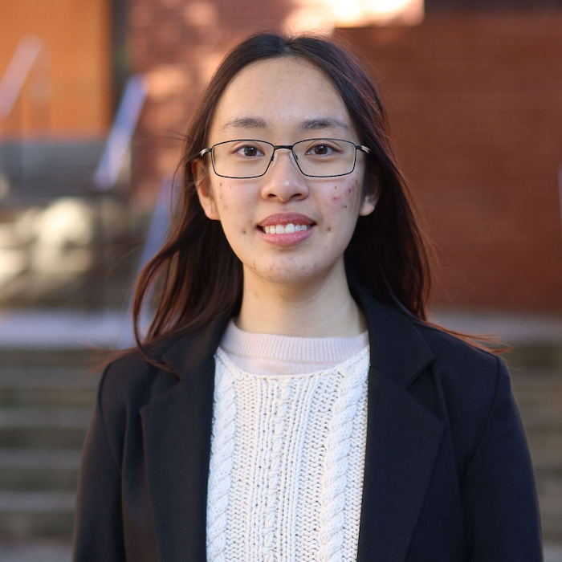
Name: Lydia Chung
College: Herbert Wertheim College of Engineering
Major: Computer Engineering
Minor: Statistics

Mentor: Prabhat Mishra

Project Title: Compositional Security Verification of Trusted Execution Environments

Project Description: Trusted Execution Environment (TEE) relies on isolation properties in hardware architecture to ensure that client code and data in applications, containers or virtual machines can neither be deciphered (confidentiality) or modified (integrity) by untrusted parts of the system software stack such as a hypervisor provided by the cloud vendor. There are many commercial TEE solutions including ARM TrustZone/Realms, AMD Secure Encrypted Virtualization (SEV), Intel Software Guard Extensions (SGX) / Trust Domain Extensions (TDX), IBM-Z Secure Execution, etc. One of the foundational components of security in a TEE is platform attestation via hardware-root-of-trust that ensures secure storage and operations on encryption keys and related secrets. Another important component is the hardware architecture combined with trusted computing base (TCB) part of the software stack such as firmware which guarantees the security properties for the rest of the software stack. Due to the presence of design implementation bugs as well as hardware supply chain related vulnerabilities, it is crucial to verify hardware-specific security properties.

Research Interests: Cybersecurity, trusted execution environments

Involvement: Society of Women Engineers, Society of Asian Scientists and Engineers
Hobbies and Other Interests: Video games, visiting restaurants, building model tanks

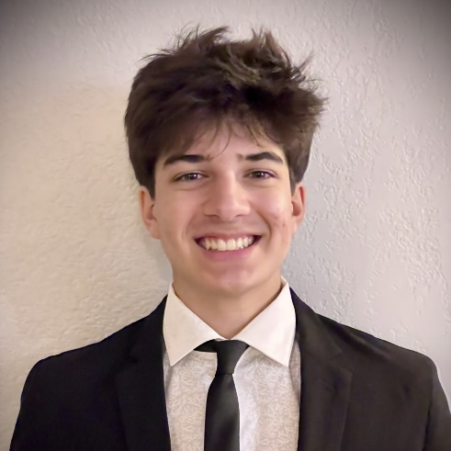
Name: John Dodd
College: Herbert Wertheim College of Engineering
Major: Industrial and System Engineering
Minor: N/A

Mentor: Dr. Wayne Giang

Project Title: Inclusive Design of Automated Vehicles for Individuals with Mild Cognitive Impairments

Project Description: Vehicles with automated driving capabilities offer a new world of independence and freedom to individuals with mild cognitive impairments. However, modern automated vehicles can be difficult for individuals with MCI to use due to the complexity of the systems. In this project, we we strive to design and evaluate a more inclusive automated vehicle to support those with MCI.

Research Interests: Ergonomics, Human Factors

Involvement: Human Factors Ergonomics Society; Society of Hispanic Professional Engineers
Volunteering: NicAid
Hobbies and Other Interests: Guitar, Piano, Pottery, Movies, Surfing, Working Out

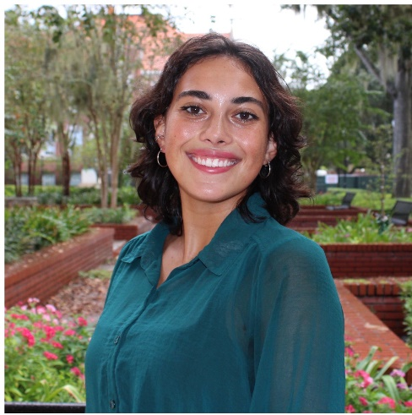
Name: Eliana Duarte
College: Herbert Wertheim College of Engineering
Major: Civil Engineering
Minor: Urban & Regional Planning

Mentor: Xiang 'Jacob' Yan

Project Title:Leveraging mobility data analytics to inform mobility hub development in Florida

Project Description: The project goal is to develop a methodology for site-selection of mobility hubs. This begins with synthesizing the existing literature regarding mobility hubs, examining user preferences regarding mobility hub location, and using a combination of these factors along with various datasets to create an analytical tool that can facilitate the development of mobility hubs.

Research Interests: Transportation planning, public transit, new mobility, travel behavior

Academic Awards: Dean's List, McNair Scholar
Involvement: Theta Tau, Engineers without Borders, International Engineering Ambassadors
Hobbies and Other Interests: Snowboarding, traveling, yoga, scuba diving

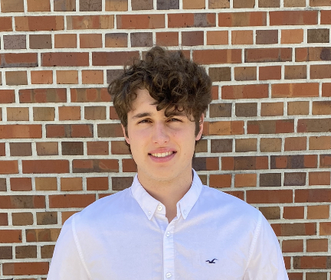
Name: Artem Egorov
College: Herbert Wertheim College of Engineering
Major: Civil Engineering
Minor: N/A

Mentor: Dr. Kyle Riding

Project Title: Concrete Materials for 3D-printing

Project Description: We will work on materials, aggregates, and admixtures for 3D-printed concrete.

Research Interests: Concrete, 3D-printed concrete, Structural Topology Optimization

Involvement: Steel Bridge, American Society of Civil Engineers Student Chapter, Russian Culture Club
Hobbies and Other Interests: Tennis, skiing, lifting, guitar, Star Wars, concrete, structural, geotechnical, and coastal engineering

Name: Cade Ferguson
College:
Major:

Minor: N/A

Mentor: Jing Pan

Project Title: TBD

Project Description:TBD

Research Interests:

Academic Awards:
Involvement:
Volunteering:
Hobbies and Other Interests:

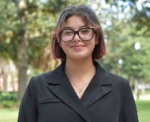
Name: Camil Coss Flores
College: Herbert Wertheim College of Engineering
Major: Biosystems Engineering
Minor: French and Francophone Studies

Mentor: Bin Gao

Project Title: Environmental Applications of Organic Waste Hydrochar

Project Description: Food waste is a major problem in the United States, with one third of all food produced annually going to waste, resulting in a $240 billion loss (American Journal of Agricultural Economics, 2020). However, we are not only wasting food but also the resources used in its production, transportation, and packaging. Furthermore, organic waste that ends up in landfills decomposes and releases harmful greenhouse gasses, exacerbating the problem of climate change. Given that the food system is responsible for one quarter of greenhouse gas emissions, it is critical to find ways to reduce food waste and its impact on the environment. This research project aims to repurpose food waste; reduce atmospheric carbon by using organic waste as feedstock for hydrochar; and target nitrogen and phosphorus contaminants. By exploring hydrochar as a water treatment agent, the problems of eutrophication and soil degradation will be addressed. Additionally, this project will identify the most cost-effective and energy-efficient method for hydrochar/biochar production. Overall, this project has the potential to mitigate the negative impact of food waste on the environment and contribute to sustainable waste management practices.

Research Interests: Sustainability, Ocean Farming, Natural Climate Solutions, Cradle-to-Grave Analysis, Agrivoltaics, and Land & Water Conservation

Academic Awards: 3rd Place in X-treme Engineering Design Challenge (2022) & Emerging Scholar (2023)
Involvement: Society of Hispanic Professional Engineers, SWE, UF ASABE, and UF Kickboxing Club
Volunteering: Seminole Trails Elementary School
Hobbies and Other Interests: I love reading, traveling, learning new things, being in nature, crafting, diving, and roller skating.
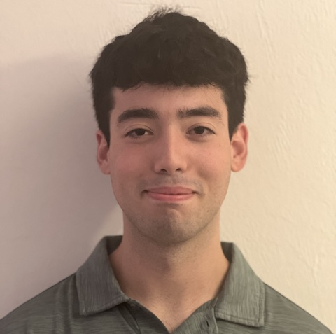
Name: Lazaro Fuentes Alfonso
College: Herbert Wertheim College of Engineering
Major: Nuclear Engineering
Minor: Physics

Mentor: Wesley Bolch

Project Title: Blood dosimetry modeling for adult female breast radiotherapy

Project Description: This project involves creating vasculature through the use of modeling software within the breast of an adult female reference computational phantom. Once complete, this model can be used to determine radiation dosage to circulating lymphocytes in photon and proton radiotherapy.

Research Interests: Medical Physics

Involvement: Society of Health and Medical Physics
Hobbies and Other Interests: Drumming and gardening

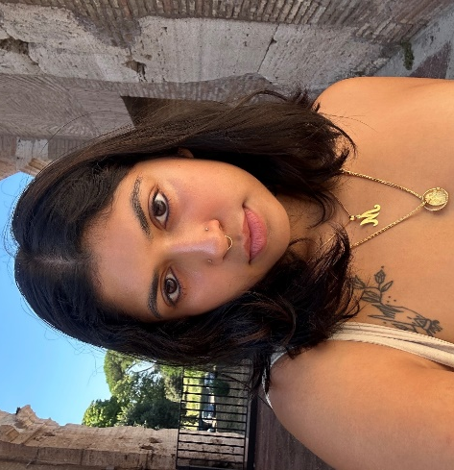
Name: Mily Gandhi
College: Herbert Wertheim College of Engineering
Major: Biological Engineering

Mentor: Melanie Correll

Project Title: 360˚ automated multispectral/LiDAR imaging system for building plant disease diagnosis models in controlled environment agriculture

Project Description: The proposed research will have one objective—to design, build, and test the multispectral/LiDAR imaging system

Research Interests: Plants, space, engineering, controlled environment agriculture, lettuce, plant stress/disease diagnosis, multispectral imaging, LiDAR

Hobbies and Other Interests: Gardening, cooking, hiking

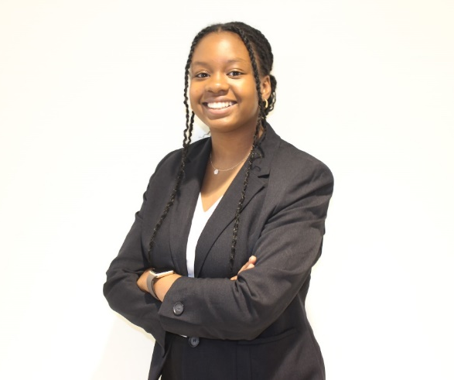
Name: Ann-Kareen Gedeus
College: College of Liberal Arts and Sciences
Major: Computer Science
Minor: N/A

Mentor: Kyla McMullen

Project Title: An Augmented Reality Corsi Block-Tapping Test Framework

Project Description: Common tasks such as getting a cup from the cupboard, driving to work, or clicking icons on a computer screen, make use of the human capacity to store and recall location information. More critical tasks, such as remembering the location of anatomical structures during a surgical operation or a fire escape during a fire make use of the same ability. The part of human memory that allows us to remember where things are in our environment is commonly referred to as spatial memory. The importance of spatial memory to human action and interactions makes it an area of interest in various research fields, including psychology, medicine, and human-computer interaction. One of the most used tests for measuring spatial memory is the Corsi Block-Tapping Test (CBT). While physical CBTs have been used extensively to study human spatial memory in the physical world, few CBTs have been created to examine spatial memory in virtual worlds such as those created with virtual and augmented reality headsets. The design of a digital CBT for virtual environments could lead to a better understanding of spatial memory in such environments. It could also allow for the design of intuitive user interfaces as well as a deeper understanding of human spatial memory.

Research Interests: AR/VR, Mixed Reality, Social and Ethical Computing

Academic Awards: Dean's List
Involvement: National Society of Black Engineers (NSBE)
Hobbies and Other Interests: Cooking, Reading, and Crocheting

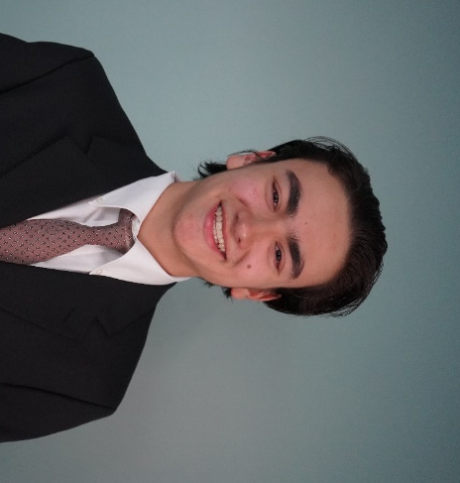
Name: John Glass
College: Herbert Wertheim College of Engineering
Major: Computer Science
Minor: Electrical Engineering

Mentor: Kyla McMullen

Project Title: Spatial Audio Localization GUI

Project Description: Graphical User Interface that utilizes and displays location data from a Raspberry PI that gathers information from nearby sensors developed in Python.

Research Interests: Machine Learning, Spatial Audio Localization

Involvement: University of Florida Association for Computing Machinery, Society of Software Developers, University of Florida Programming Team
Volunteering: N/A
Hobbies and Other Interests: Game Development, Golf, Exercise, Gaming

Name: Riley Hackworth
College:
Major:

Minor: N/A

Mentor: Lawrence Ukeiley

Project Title: TBD

Project Description:TBD

Research Interests:

Academic Awards:
Involvement:
Volunteering:
Hobbies and Other Interests:

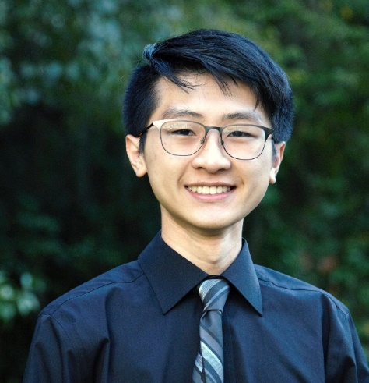
Name: Jarvis He
College: Herbert Wertheim College of Engineering
Major: Mechanical and Aerospace Engineering
Minor: N/A

Mentor: Sean Niemi

Project Title: Device for Extreme-environment Continuous Directed Evolution Research (DECODER)

Project Description: One of the factors that limit space exploration currently is the conservation of mass. That is, the spacecraft system is limited to the supplies that are brought on board during initial loading. However, upon consumption of these supplies, astronauts on board will generate organic waste, which will become useless without a mechanism to recycle such waste. Thus, we are interested in evolving microorganisms such that organic waste can be converted back into useful materials, allowing for biomanufacturing in space. Sending microorganisms to space to perform research and data collection is often cost prohibitive, so a terrestrial analog to space environmental conditions is required. This project aims to develop a bioreactor which can serve as a ground-based microgravity simulation platform capable of continuous directed evolution. By applying selective pressures with the aforementioned device on Earth, we can develop microbes capable of surviving the harsh environment of space.

Research Interests: Space Synthetic Biology, Simulation of Space Environments Using Terrestrial Analogs

Academic Awards: University Research Scholar, HWCOE Dean's List, Florida Academic Scholar, Mary and Bob Sierra Scholarship Recipient, WREC Scholarship Recipient
Involvement: Florida Rocket Lab
Hobbies and Other Interests: Running, Plane Spotting, Cars, Photography, 3D printing

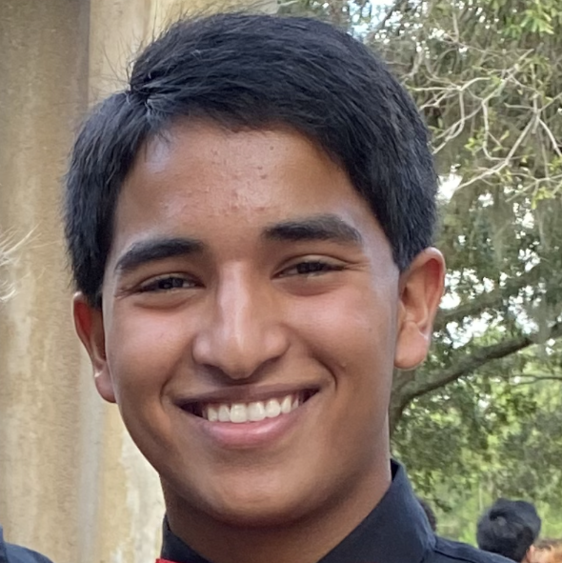
Name: Varun Hoskote
College: Herbert Wertheim College of Engineering
Major: Biomedical Engineering
Minor: N/A

Mentor: Z. Hugh Fan

Project Title: Low Cost and Rapid Diagnostics

Project Description: The goal of my research is to develop point-of-care pathogen detection devices that are low-cost and hand-held. I will be exploring the use of surface treatment and Laminated paper-based analytical devices for pathogen detection.

Research Interests: Microfluidics, Medical Diagnostics

Academic Awards: University Scholars Program 2023, UF Herbert Wertheim College of Engineering Dean's List
Involvement: GRiP
Hobbies and Other Interests: Tennis, Pickleball

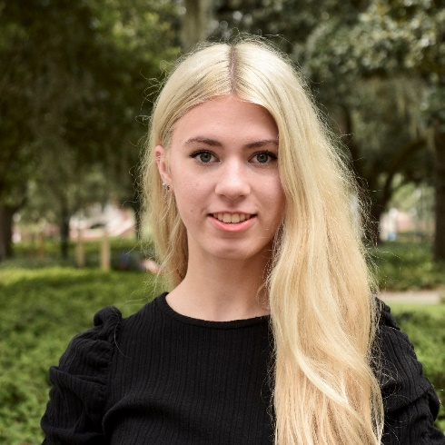
Name: Jillian Jacek
College: Herbert Wertheim College of Engineering
Major: BME
Minor: N/A

Mentor: Blanka Sharma

Project Title: Osteoarthritis

Project Description: Evaluating the chondroprotective effects of manganese dioxide nanoparticles by quantifying histological changes and completing biochemistry assays.

Research Interests: Osteoarthritis

Academic Awards: Honors student, Advanced Platform Technology Scholar, Fernandez Scholar
Involvement: BMES, GRiP, POLSA
Volunteering: UF Health, Meals on Wheels, Clearwater Marine Aquarium
Hobbies and Other Interests: Weightlifting, photography, hiking

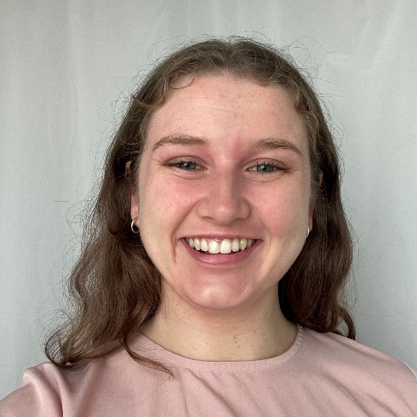
Name: Sarah Langham
College: Herbert Wertheim College of Engineering
Major: Material Science and Engineering
Minor: N/A

Mentor: Angelika Neitzel

Project Title: Synthesis of well-defined polyelectrolytes via ROMP and ADMET polymerization

Project Description: Analysis of ADMET and ROMP polymer synthesis techniques for specific polyelectrolytes

Research Interests: Polymer, Polymer Synthesis

Involvement: Material Advantage
Hobbies and Other Interests: Crossword and puzzles

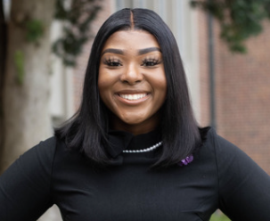
Name: Teley Laporte
College: Herbert Wertheim College of Engineering
Major: Electrical Engineering
Minor: Sales Engineering

Mentor: Janise McNair

Project Title: The Evolution of 5G and Introduction of 6G

Project Description: My project will discuss the issues of 5G in IoT, what 6G is and the opportunities its technologies could present in IoT networks.

Research Interests: IoT, Wireless Networks

Involvement: National Society of Black Engineers, Delta Sigma Theta Sorority, Inc.
Hobbies and Other Interests: Working out, content creating, cosmetology

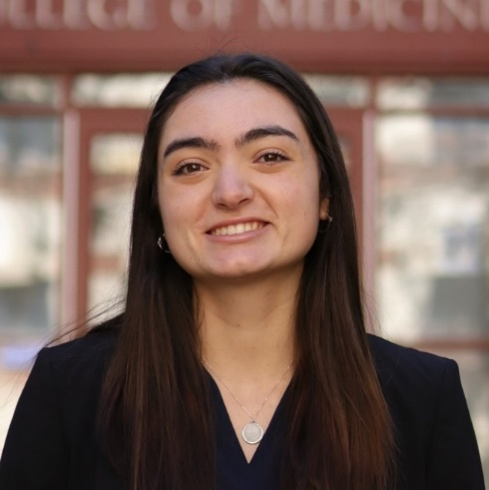
Name: Karina LaRubbio
College: Herbert Wertheim College of Engineering
Major: Computer Science
Minor: French

Mentor: Eakta Jain

Project Title: Understanding personal space in virtual reality to mitigate emerging modes of harassment

Project Description: Understanding personal space in virtual reality to mitigate emerging modes of harassment Harassment in virtual spaces, especially physical harassment, is a growing problem. The current solution is for virtual reality platforms to create bubbles, that is, regions around the user’s avatar that cannot be entered by another avatar. The problem with the current state of the art in bubble design is that it provides the user with a binary choice. When activated, the bubble encloses the user completely and complicates interactions such as passing objects or performing social gestures such as a high five. When safety of personal space is not balanced with utility, the personal space bubble becomes a gilded cage. In this paper, we raise the possibility of alternate designs for personal space bubbles. We have examined these designs for how they balance safety with collaborative task performance. Future explorations will analyze user preferences for adapting the boundaries around their personal space, including boundary shape and behavior.

Research Interests: Human-Computer Interaction, Virtual Reality

Academic Awards: CISE Cottmeyer Family Scholarship (2023), Dean's List (2020-23), Elks Most Valuable Scholar Semifinalist (2020)
Involvement: Dream Team Engineering, University Research Scholars Program, Study Abroad Peer Advisors
Hobbies and Other Interests: Live music, yoga, coffee

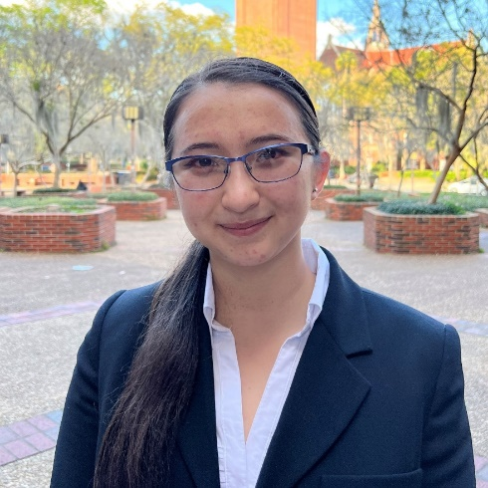
Name: Adriana LaVopa
College: Herbert Wertheim College of Engineering
Major: Materials Science and Engineering
Minor: Linghuistics

Mentor: Yeongseon Jang

Project Title: Engineering Sensory Globular Protein Vesicles

Project Description: Vesicles are enclosed compartments composed of a membrane of self-assembled amphiphilic molecules, and their properties present a promising avenue in creating artificial cells. A fundamental property of cells is the ability to sense and react to changing environmental conditions; protein vesicles offer a way to imbue artificial cells with sensing capabilities. This project seeks to expand the limits of protein vesicle engineering and explore this promising avenue of smart biomaterials.

Research Interests: biomaterials, synthetic cell research, recombinant proteins research

Academic Awards: Deutscher Akademischer Austauschdienst Scholarship, National Merit Scholarship
Involvement: Society of Women Engineers, Society of Asian Scientists and Engineers, STEAM Team, University Research Scholars Program, Material Advantage, oSTEM, Chemistry Club
Volunteering: Forming our Identities through Networking and Development (FiND)
Hobbies and Other Interests: Competitive rock climbing, reading epic fantasy, drawing, playing Hollow Knight

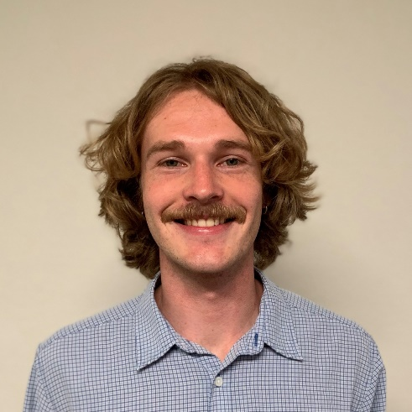
Name: Leighton Levering
College: College of Agricultural and Life Sciences
Major: Marine Sciences
Minor: N/A

Mentor: Andrew Altieri

Project Title: Developing methods to assess corals resilience to ocean deoxygenation

Project Description: Ocean deoxygenation is a poorly understood but growing threat to coral reefs worldwide. I will examine multiple stress responses in corals to determine how their onset is related to duration of exposure and whether they are reliable indicators of time until death.

Research Interests: Coral Reef Ecology and Conservation

Involvement: Marine Biology Club, Gator Scuba Club
Hobbies and Other Interests: Scuba Diving, Soccer

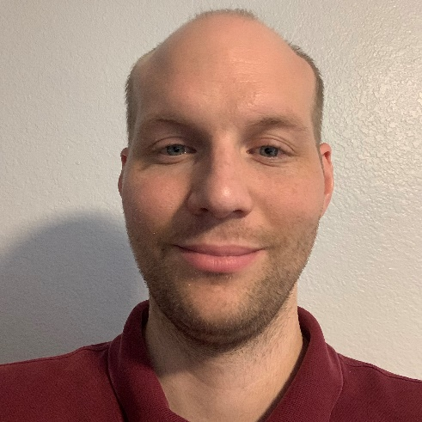
Name: Wesley Madyda
College: Herbert Wertheim College of Engineering
Major: Materials Science and Engineering
Minor: N/A

Mentor: Angelika Neitzel

Project Title: Synthesis of Well-defined Polystyrenes via Controlled Radical Polymerization

Project Description: We'll be using Reversible Addition-Fragmentation chain-Transfer polymerization (RAFT) to produce bulk batches of low dispersity polystyrene. After we replace the trithiocarbonate end-groups, it will be passed on to another group for further processing.

Research Interests: Polymer Synthesis and Characterization

Volunteering: Planned Parenthood
Hobbies and Other Interests: Reading, shooting
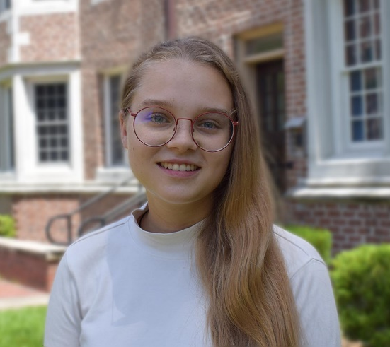
Name: Viktoria Marcus
College: Herbert Wertheim College of Engineering
Major: Industrial and Systems Engineering
Minor: Mathematics

Mentor: Sanaz Motamedi

Project Title: Pedestrians and Fully Automated Vehicles: Technology Acceptance and Design of External Communication Interface

Project Description: The goal of this project is to understand the factors most important to pedestrians when deciding to cross in front of a Fully Automated Vehicle (FAV). The project will conduct a lab activity with students enrolled in a Human Factors and Ergonomics Design class to design external human-machine interfaces (eHMIs) that will facilitate communication between pedestrians and FAVs. It will also conduct a survey with those same students to determine which factors are important to pedestrians' intention to cross in front of an FAV.

Research Interests: Human Computer Interaction, Human Robot Interaction, Outer Space

Academic Awards: Dean's List, USP Scholar 2022
Involvement: Student Animal Alliance, Space Systems Design Club
Hobbies and Other Interests: Photography, Learning, Reading

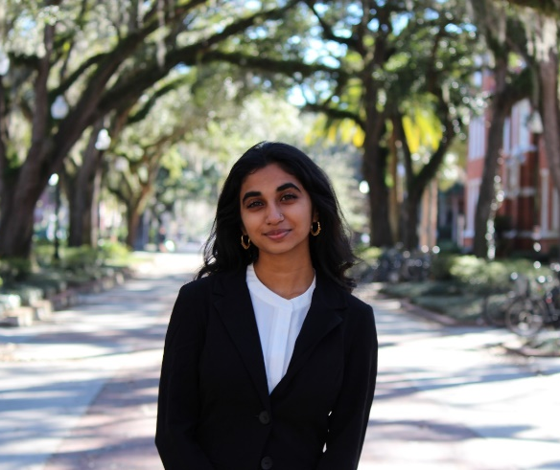
Name: Nikita Narasimhan
College: Herbert Wertheim College of Engineering
Major: Chemical Engineering
Minor: N/A

Mentor: Peng Jiang

Project Title: Development of Novel Chromogenic Sensors Enabled by Smart Shape Memory Polymers

Project Description: We will develop novel chromogenic sensors for detecting a large variety of chemical in solid, liquid, and gas phases using smart shape memory polymers. A scalable bottom-up nanomanufacturing technology will be utilized in fabricating 3D highly ordered macroporous photonic crystal sensors.

Research Interests: Clean Energy, Sustainable Materials

Involvement: FLEG, Unlitter
Hobbies and Other Interests: Hiking, hammocking, travel, and reading

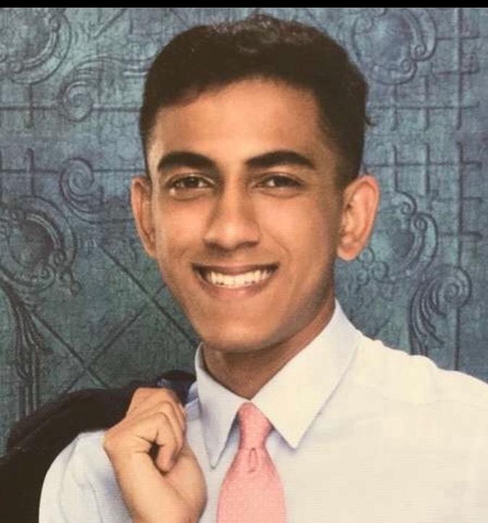
Name: Imran Nasrullah
College: Herbert Wertheim College of Engineering
Major: Computer Engineering
Minor: Physics

Mentor: Dr. Shreya Saxena

Project Title: Using Neural Networks/Deep Learning to predict Pain Ratings given EMG Data

Project Description: We hypothesize that EMG data carries underlying data-driven information concerning pain-status of nearby peripheral pain receptors that neural networks/deep learning can exploit to make predictions concerning ICU pain-ratings in a consistent, predictable fashion

Research Interests: Neural engineering, Quantum drug discovery and design, cancer epigenetics research

Academic Awards: 4 time HWCOE Dean's List Recipient, Mayo Clinic SURF 2022
Involvement: UF Engineering without Borders, Undergraduate Scholar's Program, Islam on Campus
Volunteering: Muslim American Social Services
Hobbies and Other Interests: Basketball, programming, bouldering

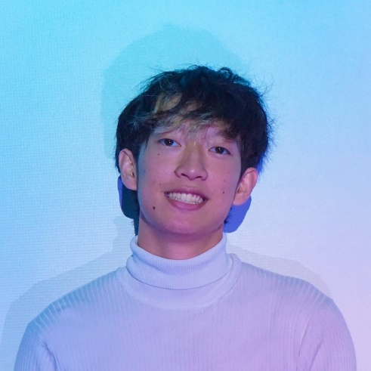
Name: Tri Nguyen
College: Herbert Wertheim College of Engineering
Major: Civil Engineering
Minor: Computer Science & Electrical Engineering

Mentor: Eric Du

Project Title: Deep Learning for Automated Hazardous Environment Capture and Understanding

Project Description: This study involves solving research questions and developing software to simulate hazardous environments - integrated with computer science and civil engineering concepts - in order to better understand expected and unexpected situations in real space and improve methods of first responder rescue. Environments will be immersed through virtual and augmented reality technology with information enhanced using machine learning and artificial intelligence.

Research Interests: Mixed Reality, ML/AI, IoT

Involvement: Surge Interest Group, Chinese American Student Association
Volunteering: Dream Team Engineering
Hobbies and Other Interests: JiaTing Lion & Dragon Dance, Carillon

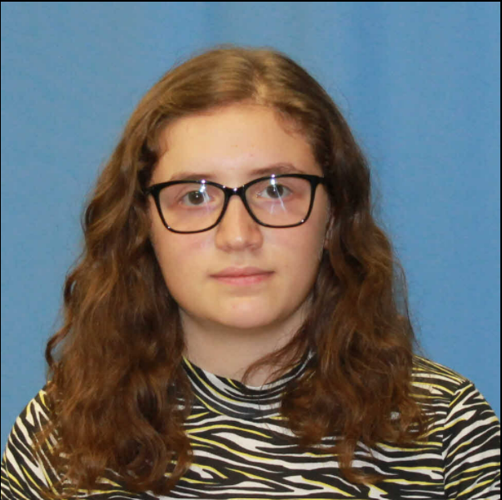
Name: Elsa Osmani
College: Herbert Wertheim College of Engineering
Major: Computer Engineering
Minor: Physics

Mentor: Janise McNair

Project Title: Distributed Space Networks

Project Description: Space is the new frontier for data collection, processing and dissemination. In this project, researchers will study how to deliver data from a heterogeneous set of nodes (space craft, space station, satellites, etc.) to the appropriate destination with the requested bandwidth and quality of service. This project also allows the student to do multi-disciplinary research with astronomers, remote sensing engineers, aerospace engineers and physicists.

Research Interests: I am interested in understanding how data is collected and processed in space through space crafts, satellites, space station, etc.

Involvement: Association of Computer Engineers, UF Astro Club, Tau Sigma National Honor Society
Volunteering: N/A
Hobbies and Other Interests: Origami, crafts and tinkering, karate and aikido, foreign languages, baking.

Name: Chaitra Peddireddy
College: Herbert Wertheim College of Engineering
Major: Computer Science
Minor: Geography

Mentor: Dr. Lisa Anthony

Project Title: ENKIx: Enabling Knowledgeable Task Guidance In the extremes

Project Description: The Perceptually-enabled Task Guidance (PTG) program aims to develop artificial intelligence (AI) technologies to help users perform complex physical tasks while making them more versatile by expanding their skillset and more proficient by reducing their errors. PTG seeks to develop methods, techniques, and technology for artificially intelligent assistants that provide just-in-time visual and audio feedback to help with task execution. The goal is to provide users of PTG assistants with wearable sensors (head-mounted cameras and microphones) that allow the assistant to see what they see and hear and what they hear, and augmented reality (AR) headsets that allow assistants to provide feedback through speech and aligned graphics. The target assistants will learn about tasks relevant to the user by ingesting knowledge from checklists, illustrated manuals, training videos, and other sources of information. They will then combine this task knowledge with a perceptual model of the environment to support mixed-initiative and task-focused user dialogs. The dialogs will assist a user in completing a task, identifying and correcting an error during a task, and instructing them through a new task, taking into consideration the user’s level of expertise.

Research Interests: AI Ethics & Governance, Fine-Tuning Techniques for LLMs, Human-Centered AI

Academic Awards: National Space Grant Recipient (2022, 2023)
Involvement: Women in Computer Science & Engineering (WiCSE)

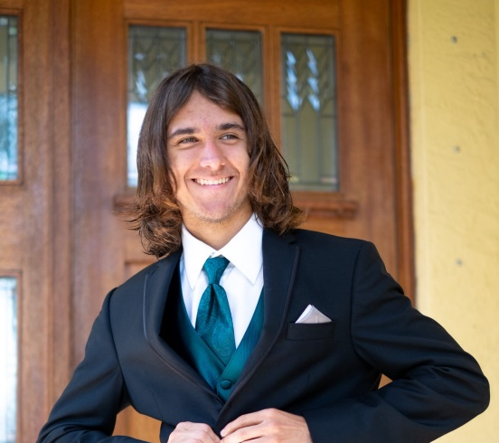
Name: Lucas Pereira
College: College of Liberal Arts and Sciences
Major: Computer Science
Minor: Botany

Mentor: Kiley Graim

Project Title: Understanding the Genomic Landscape of Sepsis and the Impacts of Global Ancestry on Sepsis Outcomes

Project Description: The project involves creating a pipeline that can determine global ancestry in sepsis patients in order to create ancestry-aware models when analyzing sepsis patient data.

Research Interests: Computational biology, Population genomics

Academic Awards: Broad Summer Research Program participant (incoming), University Scholars Program
Hobbies and Other Interests: Playing and writing music, botany, art

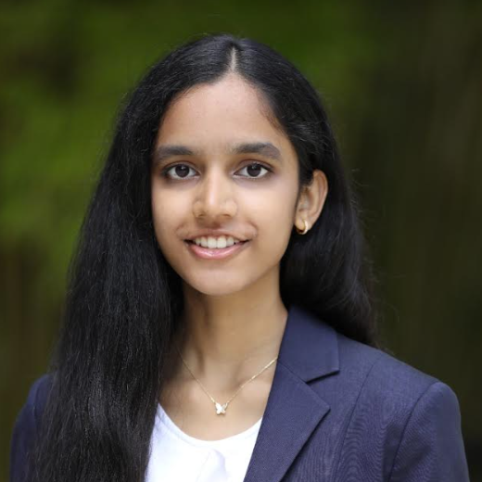
Name: Tejaswi Polimetla
College: College of Liberal Arts and Sciences
Major: Economics, Geography
Minor: N/A

Mentor: Xiang Yan

Project Title: Promoting Equitable AI in Transportation

Project Description: Identify applications for artificial intelligence (AI) in transportation systems and assess potential sources of bias that could lead to inequitable outcomes. Examine transportation professionals' perceptions towards AI adoption, and evaluate methods to improve this transition.

Research Interests: Spatial patterns and trends, artificial intelligence, ethics, human-computer interaction

Academic Awards: National Merit Scholar, President's Honor Roll
Involvement: GatorTech, The GAITOR Club, Theatre Strike Force, Business Ethics Case Team, Business Ethics Ambassadors, University Honors Program, International Scholars Program
Volunteering: The Portrait Project
Hobbies and Other Interests: Arts, crafts, and cooking

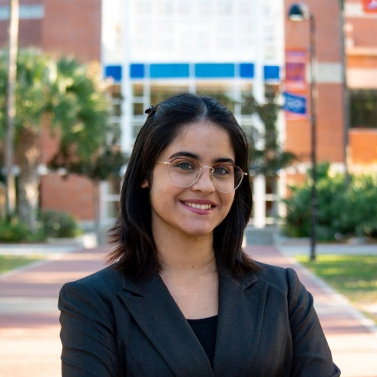
Name: Marian Pulgar
College: Herbert Wertheim College of Engineering
Major: Chemical Engineering
Minor: Biomolecular Engineering

Mentor: Dr. Carl Denard

Project Title: Discovery of Nanobody Modulators for Protease Activity Utilizing High-Throughput Activity Screening

Project Description: Aiding in the development of HARP, a High-Throughput Activity Screen for Reprogramming Proteases, to map enzyme distal regulation and discover ligand properties for the stabilization of substrate conformations.

Research Interests: Protein Therapeutics, Antibody Discovery, Genome Editing

Academic Awards: Florida Academic Scholars Award
Involvement: Society of Hispanic Professional Engineers, American Institute of Chemical Engineering UF Chapter
Volunteering: N/A
Hobbies and Other Interests: Crochet, Reading, Music, Painting

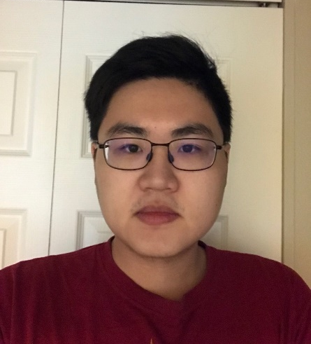
Name: Andrew Qiu
College: Herbert Wertheim College of Engineering
Major: Electrical Engineering
Minor: Mathematics

Mentor: Ant Ural

Project Title: Measurement of Nanodevices

Project Description: Set-up and perform electrical measurements on nanodevices

Research Interests: Devices

Hobbies and Other Interests: Cryptography

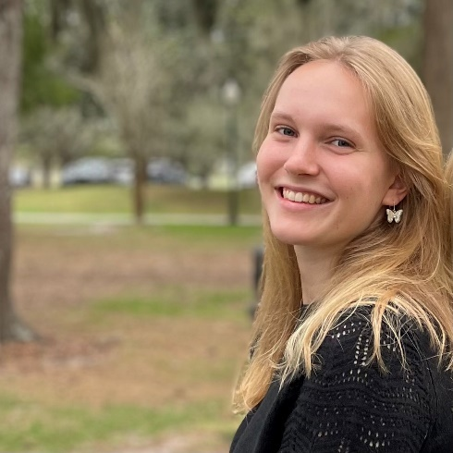
Name: Adelyn Richgels
College: Herbert Wertheim College of Engineering
Major: Chemical Engineering and English
Minor: Education

Mentor: Whitney Stoppel

Project Title: Optimizing Solubility of Plodia Interpunctella Silk Fibroin Towards Biomedical Applications

Project Description: Silk, a complex biopolymer made primarily from fibroins and sericins, has been used to create various materials in the biomedical field that provide robust mechanical properties, with biocompatibility and biodegradability. Currently, this field is dominated by the unilateral study of the species Bombyx mori (BM), chosen due to its prominence in the textile industry. Despite the range of functions that BM silk has been used for, including films, sponges, hydrogels, and microparticles, researchers are still limited in its applications for a variety of reasons, including a lack of control over silk production. Since silk proteins can vary greatly amongst silk producing organisms, studying alternative sources of silk fibroin (SF) proteins can expand these applications. Contrary to BM silk, which must be imported in, PI silk can be grown and harvested in a lab environment. Research will begin by examining the structure and protein composition of the PI silk fibers, using various stains and microscopes to look at the way proteins form and shape in PI silk, and how they compare to BM Finally, after we have developed a set protocol for the solubilization of PI silk fibers that results in a stable, concentrated solution, we will begin to work on the creation of biomaterials for this solution. This includes making and testing them for compatibility with intended application, overall effectiveness, and how they compare to similar biomaterials from BM silk fibers.

Research Interests: New applications of natural resources; understanding the world around us

Academic Awards: National Merit Scholar, Benacquisto Scholarship
Involvement Society of Women Engineers, MentorGNV, AIChE, ESA, FOSTER
Volunteering: Elementary school tutoring; Bookshare proofreading
Hobbies and Other Interests: Reading, running, basketball

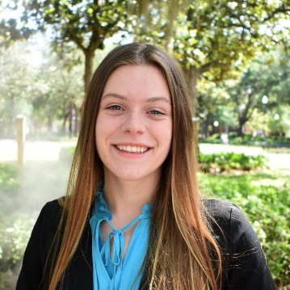
Name: Abilene Roberts
College: Herbert Wertheim College of Engineering
Major: Biomedical Engineering
Minor: Pathogenesis, Spanish

Mentor: Edward Phelps

Project Title: ECM-Functionalized Microporous-Annealed PEG Particles as a Platform to Study Cell Migration in Type 1 Diabetes

Project Description: Type 1 diabetes is an autoimmune disease characterized by an attack on the insulin-secreting pancreatic islets. Islet transplantation is a promising treatment for Type 1 Diabetes, with impressive improvements in metabolic control. However, few islet transplant patients maintain long-lasting insulin independence due to the loss of islets from inflammatory responses. Islet viability can be improved with the use of a delivery vehicle that promotes survival and immunoprotection. Hydrogels are long chains of polymers crosslinked together to form a network that can be used as a tissue scaffold for isolated pancreatic islets. However, synthetic hydrogels such as Polyethylene Glycol (PEG) have a nanoscale crosslinking network that forces cells to enzymatically degrade the crosslinks, inhibiting movement, and lack a natural extracellular matrix (ECM) which relays signals for cell behavior. This project explores crosslinking spheroid microgels together to form microporous-annealed PEG particles, a scaffold with inherent pores over a micron in diameter, and functionalizing them with ECM to form ECM-MAP-PEG. Studies will include optimization of hydrogel packing, cytocompatibility studies, tuning of ECM-proteins, and rapid cell migration of immune cells within the ECM-MAP-PEG scaffold.

Research Interests: Biomaterials, pathology and disease physiology, immunoengineering, tissue engineering, stem cells

Academic Awards: Dean’s List Fall 2021, President’s Honor Roll Spring, Fall 2022
Involvement: Biomedical Engineering Society, International Scholars Program, University Honors Program, Research Excellence Program for Undergraduates
Hobbies and Other Interests: Spanish, traveling, swimming, and drawing

Name: Salminen Spencer
College: Herbert Wertheim College of Engineering
Major: Nuclear Engineering
Minor: N/A

Mentor: Bolch Wesley

Project Title: Development of a Microscale Histology-Based Mesh Model of the Spleen

Project Description: We will be making a series of polygon- mesh models of various tissues of interest for the avoidance of organ toxicity in the application of alpha-particle emitters for radiopharmaceutical cancer therapy. I will assist in the imaging of serial histology sections within the UF Histology Library managed by Dr. Aris. Following digital imaging, the work will entail the segmentation of those images and the construction of mesh-based 3D tissue models as needed for radiation transport simualtion of alpha particle emitted from a therapy radiopharmaceutical.

Research Interests: Nuclear related

Involvement: American Nuclear Society
Volunteering: Sarasota Memorial Hospital
Hobbies and Other Interests: Video Games, Biking

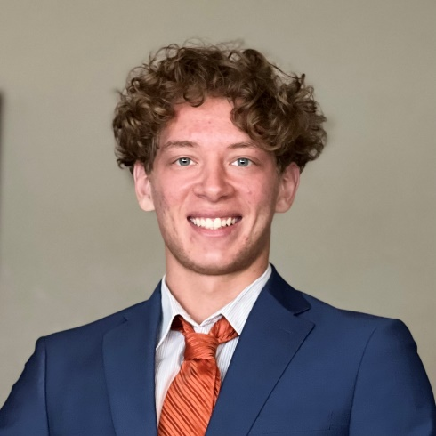
Name: Adam Sardouk
College: Herbert Wertheim College of Engineering
Major: Aerospace Engineering
Minor: Electrical Engineering

Mentor: Christopher Petersen

Project Title: Utilizing electron motion to induce angular momentum on a spacecraft

Project Description: Accelerating an electron (or many) around a ring of metal should (in theory) cause the ring of metal to spin (*very* slowly) in the other direction provided nothing is stopping it from doing so.

Research Interests: Spacecraft dynamics, electric space vehicle propulsion, design of chemical rocket propulsion systems

Academic Awards: Dean's List, (Elligible for) Magna Cum Laude
Involvement: Florida Engineering Society, Swamp Launch Rocket Team, UF Rock Climbing Club
Volunteering: Florida Engineering Society
Hobbies and Other Interests: Rock Climbing, Volleyball, Soccer

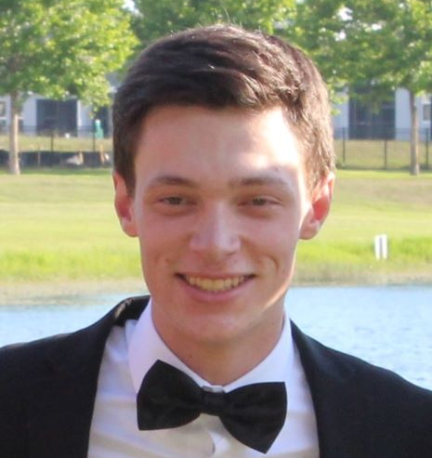
Name: Ethan Slaton
College: Herbert Wertheim College of Engineering
Major: Chemical Engineering
Minor: Biomolecular Engineering

Mentor: Carl Denard

Project Title: igh-throughput discovery, engineering, and characterization of protease modulators

Project Description: Developing a platform in order to isolate protease and kinase inhibitory antibodies that could be used as efficient drugs to treat autoimmune and infectious diseases.

Research Interests: Synthetic Biology

Academic Awards: BMS Scholars Program, Fernandez Family Scholars Program
Involvement: Chemical Engineering Peer Advisors
Hobbies and Other Interests: Watching Sports

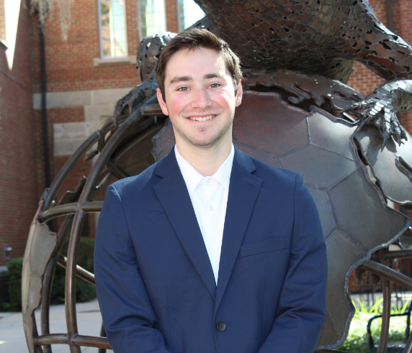
Name: Dylan Smurlick
College: Herbert Wertheim College of Engineering
Major: Biomedical Engineering
Minor: N/A

Mentor: Edward Phelps

Project Title: Engineered exosome therapy for type 1 diabetes autoimmunity

Project Description: Use ImageJ software to analyze confocal microscope images and quantify fluorescent signals. Routinely manage and passage cell cultures. Perform exosome isolations from cell cultures, characterize exosomes, and perform cell culture experiments with exosomes.

Research Interests: Drug delivery, immunology, cell signaling, tissue engineering, biomechanics

Academic Awards: Bright Futures Florida Academic Scholar, Minto Scholarship Program Scholar, Medi-Gators Virtual Shadowing Program Certificate
Involvement: UF Chemistry Outreach, GRiP, UF Hillel, UF Chabad
Volunteering: Dance Marathon
Hobbies and Other Interests: Running, Biking, Kayaking, Rock Climbing, Basketball

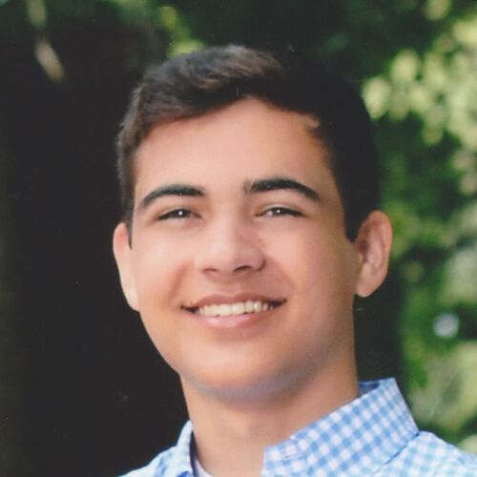
Name: Carson Sobolewski
College: Herbert Wertheim College of Engineering
Major: Computer Engineering
Minor:

Mentor: Domenic Forte

Project Title: Automated Pipeline for PCB Reverse Engineering Using X-ray Tomography

Project Description: With the consistent development of technology over the past years, many organizations and companies establish their operations around technological components that quickly become outdated. Once these devices become legacy, it is hard for the organizations to continue to use and work with the older hardware. Sometimes they need additional functionality and are unable to upgrade to newer hardware. Through reverse engineering, it is possible to analyze the board and use the data to recreate the original design files for modification. This research project focuses on the creation of an automated pipeline for design file creation using data obtained from x-ray tomography.

Research Interests: Computer Vision, Machine Learning, Hardware Security

Academic Awards: University Scholars Program, Wentworth Honors Scholarship, Helen E. Khouri Memorial Scholarship, Benacquisto Scholarship, National Merit Scholar, Dean's List
Involvement: IEEE, Club Swimming, Catholic Gators
Hobbies and Other Interests:

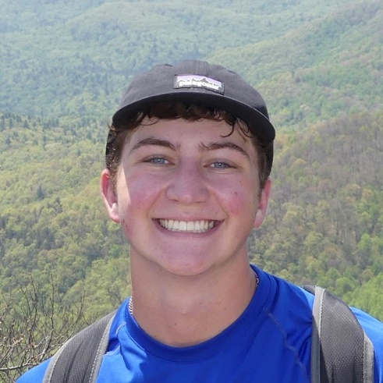
Name: Andrew Steiner
College: Herbert Wertheim College of Engineering
Major: Materials Science & Engineering
Minor: N/A

Mentor: Megan Butala

Project Title: Optimizing the Product Phase of R-Nb2O5 For Use in Batteries

Project Description: R-Nb2O5 is a proven substitute for cobalt oxides cathodes used in lithium-ion batteries. Currently we are testing to maximize the capacity of R-Nb2O5 batteries by synthesizing and assembling under different parameters within the constraints of the synthesis procedure.

Research Interests: Renewable Energy Technology, Photovoltaics, Thermoelectrics, Sustainable Batteries

Academic Awards: Dean's List (2021-Present)
Involvement: Florida Engineering Society, Kappa Phi Epsilon, Outdoor Active Recreation
Volunteering: Service Director and Fellowship Group Leader (Kappa Phi Epsilon)
Hobbies and Other Interests: Hiking, Backpacking, Exploring, Guitar, Jazz, Bluegrass, Philosophy, Coffee Shops, 19th Century Literature, Basketball, Running, Lifting, NBA, NFL

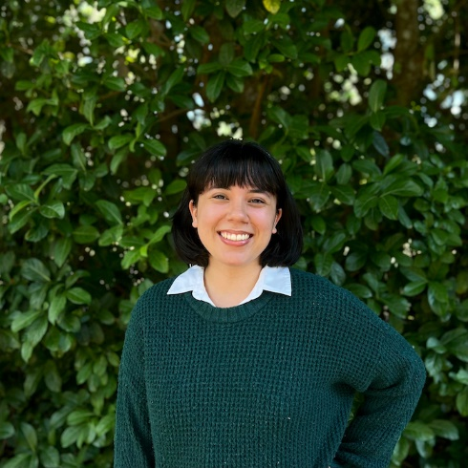
Name: Nicole Strecker
College: College of Liberal Arts and Sciences
Major: Physics, Mathematics
Minor: Chemistry

Mentor: Dr. Wesley Bolch

Project Title: A Computational Dosimetry Model of the Laboratory Rat for Preclinical Radiopharmaceutical Therapy

Project Description: Develop a two-region skeletal model on rat whole-body phantom (ROBY) and use PHITS to run radiation transport simulations for this model. The goal is to integrate this data into MIRDcalc, which is a nuclear medicine software that is being developed with Memorial Sloan-Kettering Cancer Center.

Research Interests: dosimetry, immunotherapy, radiopharmaceutical therapy with alpha-particle emitters, using density functional theory to study zeolites for nuclear waste management

Academic Awards: AAPM DREAM 2023 Fellowship, University Scholars Program
Involvement: Society of Physics Students, Tau Sigma National Honor Society, Thai-Lao Student Association
Hobbies and Other Interests: cooking and trying different cuisines, gardening, playing clarinet, reading, spending time with my cats, swimming, going to the beach, exploring the outdoors

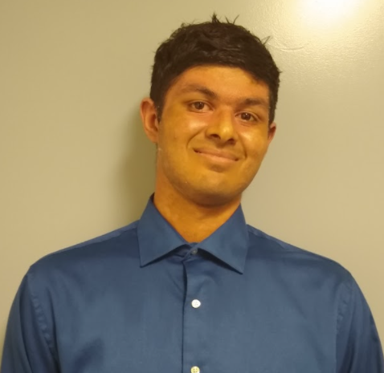
Name: Joshua Thomas
College: Herbert Wertheim College of Engineering
Major: Computer Science
Minor: Innovation Minor and Digital Arts and Science Minor

Mentor: Eric Schwartz

Project Title: Computer Vision and Human-Computer Interaction in Autonomous Robots

Project Description: My proposed research is to understand computer vision and human-computer interaction in autonomous robots and how these can be applied to allow robots to operate and function more like human beings. I plan utilize two autonomous robots for this project. Those robots are SubjuGator, an autonomous underwater vehicle, and NaviGator, an autonomous boat.

Research Interests: Artificial Intelligence, Robotics, Generative AI, IOT technology, Human-Computer Interaction, and Virtual Reality

Academic Awards: Emerging Scholar 2022, UF Summer 2022 Catalyst Showcase Power of Design Award, University Scholar 2022-2023, Fernandez Family Scholar 2022-2023, UF Innovation Fellows 2022-2023, UFIC Summer 2023 Engineering Scholarship
Involvement: UF Indian Student Association, UF Innovation Fellows, UF Machine Intelligence Lab, GatorVR, UF GAITOR Club, UF Open Source Club, UF Society of PC Building, UF Association of Computer Machinery, UF WiCSE, UF CyberSecurity Club
Volunteering: UF Indian Student Association
Hobbies and Other Interests: Basketball, Sports in general, Weightlifting, Traveling, Technology, Product Design, Robotics and AI, VR and Gaming

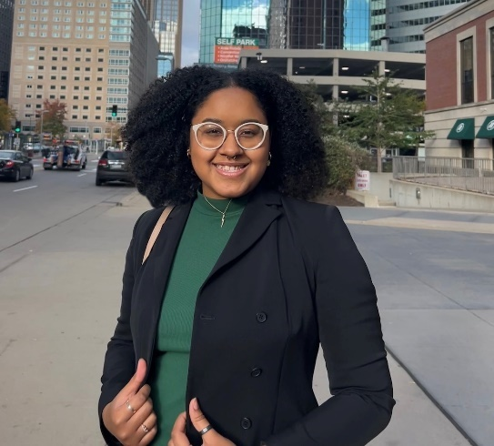
Name: Talianna Ulloa
College: Herbert Wertheim College of Engineering
Major: Electrical Engineering
Minor: N/A

Mentor: Dr. Megan Butala

Project Title: TBD

Project Description: TBD

Research Interests: Materials, Lithium-ion batteries

Involvement: National Society of Black Engineers
Hobbies and Other Interests: Music, thrifting

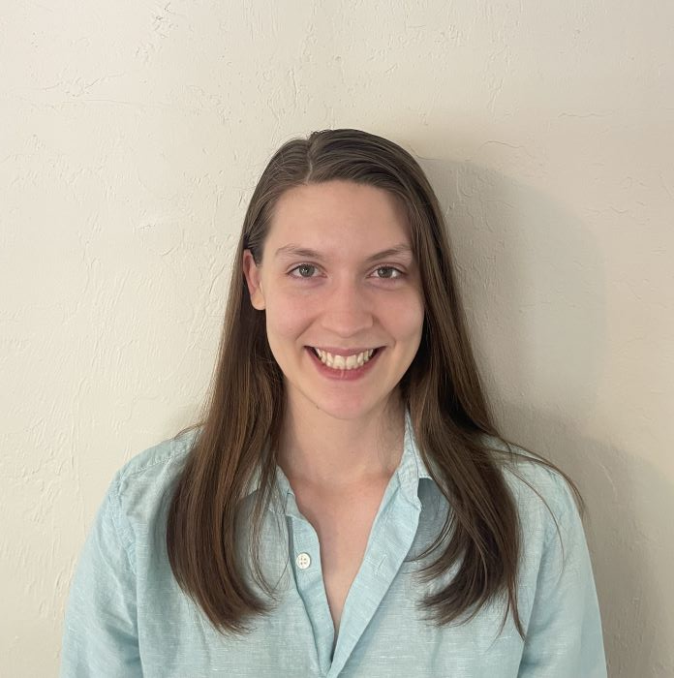
Name: Madysen Wiley
College: Herbert Wertheim College of Engineering
Major: Mechanical Engineering
Minor: Engineering Innovation

Mentor: Youping Chen

Project Title: Stress localization associated with defects and interfaces in materials

Project Description: The project aims to use computer simulations to investigate the nature of stress localization in the materials or structures, and to develop a mechanistic and qualitative understanding of effect of defects and interfaces on stress and materials failure.

Research Interests: Computer simulation and analysis of advanced structures

Volunteering: In the past I have volunteered at a church helping less fortunate kids. I also volunteered in managing/assistant coaching the high school boys volleyball team.
Hobbies and Other Interests: Hobbies: reading and puzzles; Interests: organization and efficiency

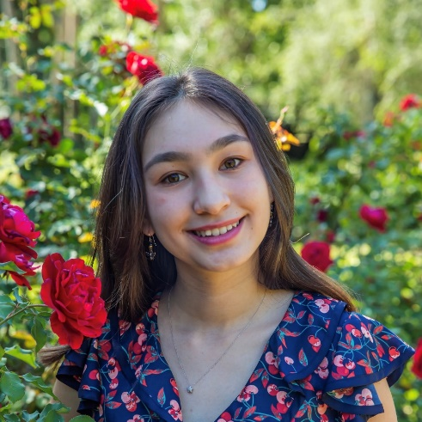
Name: Izabela Zmirska
College: Herbert Wertheim College of Engineering
Major: Biomedical engineering
Minor:

Mentor: Christine Schmidt

Project Title: 3D Printed Tissue Culture to Study Spinal Cord Injury In Vitro

Project Description: The annual incidence of spinal cord injury (SCI) in the United States is approximately 54 cases per million, or approximately 17,000 new cases per year. Individuals suffering from SCI often suffer debilitating and life-altering effects, which can be temporarily alleviated through analgesics or physical therapy. However, there is no permanent cure for spinal cord regeneration. To better understand the cellular effects of spinal cord injury, more accurate spinal cord test beds must be developed to accurately mimic extracellular matrix (ECM) patterns. Our testbeds consist of hyaluronic acid (HA) ECM that is 3D printed into polyethylene glycol (PEG) based microgel (μGel), which provides structural support for the print. This fabrication method allows for the spatial deposition of various ECM components.

Research Interests: Tissue engineering, biomaterials

Academic Awards: John V. Lombardi Scholar, University Research Scholar
Involvement: Dream Team Engineering, Engineers Without Borders, iGEM
Hobbies and Other Interests: Hiking, fossil hunting, running

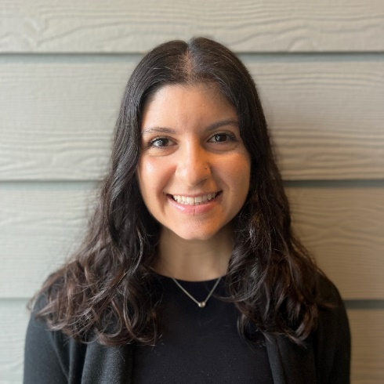
Name: Callie Alexiadis
College: College of Health and Human Performance
Major: Applied Physiology and Kinesiology
Minor: Health Promotions

Mentor: Dr. Stephen Coombes

Project Title: Effects of chronic pain and aging on working memory and brain activation

Project Description: Working memory (WM) refers to the ability to store and manipulate information over a short period of time. An increase in age leads to performance deficits in tasks that require WM (Gajewski et al., 2018; Hou et al., 2018; Lubitz et al., 2017; Rhodes & Katz, 2017). Studies utilizing the n-back task, a test used to assess WM, have found age-related differences in brain activation between young and old adults. Specifically, older adults show less activation in brain regions which involve WM, such as the prefrontal cortex, and over activation in unrelated areas, such as the parietal cortex, when compared to young adults. (Gajewski et al., 2018; Hou et al., 2018; Suzuki et al., 2018; Vaque-Alcazar et al., 2020; Yaple et al., 2019). Additionally, performance accuracy and reaction times on n-back tasks are negatively affected by pain conditions in young adults (Attridge et al., 2015). However, much of the WM literature focuses on either aging or experimentally induced pain, with limited evidence on the impact of chronic pain on WM in older adults. I will address this limitation in my research by testing the hypothesis that chronic pain in older adults will negatively affect n-back performance and present with changed activation in brain areas within and beyond established WM networks.

Research Interests: Functional and structural changes in the brain associated with aging and chronic pain

Academic Awards: Florida Academic Scholars Award, UF Honors College, USP Scholarship 2023
Involvement: College of Health and Human Performance Student Ambassador
Volunteering: Undergraduate Teaching Assistant for Anatomy
Hobbies and Other Interests: CrossFit, Weightlifting

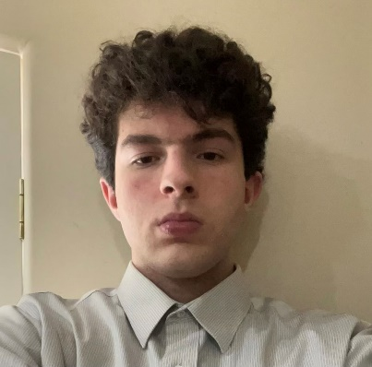
Name: Tarek Alsaghir
College: College of Liberal Arts and Sciences
Major: Microbiology and Cell Science
Minor: Arabic Language and Literature

Mentor: Elisabeth Barton

Project Title: Contribution of Fibro-Adipogenic Progenitors to Spinal Muscular Atrophy Pathology

Project Description: Spinal muscular atrophy (SMA) is the leading cause of heritable infant mortality and affects between 1:6,000 to 1:10,000 newborns. SMA is a neurodegenerative disease caused by loss-of-function mutations in the survival motor neuron 1 (SMN1) gene, which is critical for developing motor neurons. Loss of SMN1 will cause the progressive loss of the motor neurons and disrupts communication between the central nervous system and the muscles, which can lead to severe atrophy. A devastating attribute of muscular weakness in SMA is the massive intramuscular adipocyte infiltration and fibrosis which replace contractile proteins and impede muscle regeneration. Fibro-Adipogenic Progenitors (FAPs) are mesenchymal stem cells located between myofibers essential for sufficient muscle regeneration and homeostasis, but FAPs are also the primary progenitor cells that cause intramuscular adipocyte infiltration in pathological conditions. The behavior of FAPs in SMA has yet to be studied. Thus, the goal of my project is to examine FAP properties in muscles from SMA mice. Given that FAPs are largely unexplored and have not been investigated in SMA, studying their behavior will contribute to a deeper understanding of the pathology of intramuscular adipocyte infiltration and fibrosis in spinal muscular atrophy, and may lead to new avenues for therapies to improve muscle function.

Research Interests: Neuromuscular diseases and muscle pathology

Academic Awards: University Scholars Program 2023, Presidents List
Involvement: UF Honors
Volunteering: FIT for All, Gators for Refugee Medical Relief
Hobbies and Other Interests: Fishing, basketball

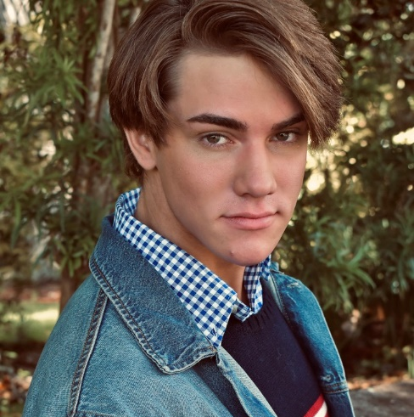
Name: Eric Kunz
College: College of Health and Human Performance
Major: Applied Physiology and Kinesiology
Minor: N/A

Mentor: Terence Ryan

Project Title: Impact of exercise preconditioning on skeletal muscle myopathy in a mouse model of access-related hand dysfunction

Project Description: This project aims to test the hypothesis that a two-week acute exercise intervention (wheel running), applied to mice with chronic kidney disease prior to AVF creation, will promote significant improvements in limb function and health after AVF creation.

Research Interests: The role of mitochondria in various pathologies, particularly chronic kidney disease, peripheral artery disease, and amyotrophic lateral sclerosis.

Academic Awards: Florida Academic Scholars Award
Involvement: MEDLIFE and Gator Emergency Medical Response Unit
Volunteering: Free Grocery Store
Hobbies and Other Interests: Running, Coffee, and Traveling

Name: Sara Tahir
College:
Major:

Minor: N/A

Mentor: Michael Reid

Project Title: TBD

Project Description:TBD

Research Interests:

Academic Awards:
Involvement:
Volunteering:
Hobbies and Other Interests:

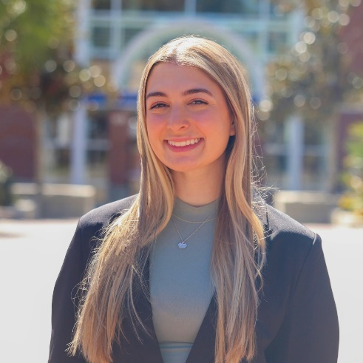
Name: Romina Torchia
College: College of Health and Human Performance
Major: Applied Physiology and Kinesiology

Mentor: Chris Hass

Project Title: Somatosensory Function and Obstacle Crossing in Older Adults

Project Description: Assess the association between mechanical somatosensory function and obstacle crossing performance in older adults

Research Interests: Applied Neuromechanics

Involvement: Pre-Professional Service Organization
Hobbies and Other Interests: I enjoy working out and going to the beach

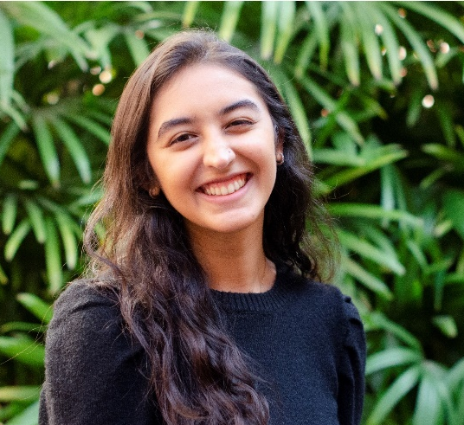
Name: Marium Abdulhussein
College: College of Journalism and Communications
Major: Public Relations, Statistics
Minor: N/A

Mentor: Marcia DiStaso

Project Title: Analyzing the use of statistics by communications professionals

Project Description: This project aims to analyze the utilization of statistics by communications professionals along key demographics including title and generation to observe the impact data has on the industry.

Research Interests: Communications

Academic Awards: Bright Futures Academic Scholar, Dean's list recipient
Involvement: Asian Public Relations Student Association, Sparks Magazine
Hobbies and Other Interests: Reading, traveling and exploring different food spots in Gainesville

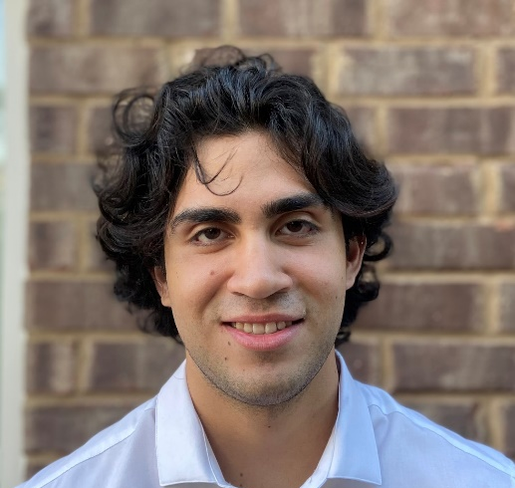
Name: Miguel Celi
College: College of Journalism and Communications
Major: Advertising
Minor: N/A

Mentor: Benjamin Johnson

Project Title: New Media Meditation for Athletes

Project Description: My proposed research will examine the value of mediation apps for student-athletes, especially with regard to their flow states, mental well-being, and performance on the field.

Research Interests: Athletic Performance

Involvement: UF Pre-Law Phi Alpha Delta
Hobbies and Other Interests: Weightlifting

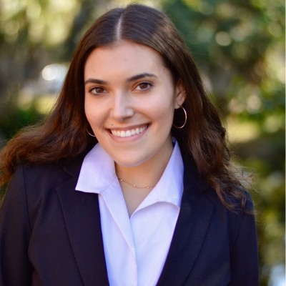
Name: Ilyssa Mann
College: College of Journalism and Communications
Major: Public relations and political science
Minor: Innovation Academy

Mentor: Myiah Hutchens

Project Title: Strategic Communication in Creating a Sense of Place

Project Description: I will research people's sense of place in Gainesville, and the concept of third places in relation to the gentrification of the city.

Research Interests: Communication, cultural communication.

Academic Awards: Catalyst Judges Award: Innovation Academy
Involvement: UF SAPA, Rowdy Magazine
Volunteering: Florida Forward
Hobbies and Other Interests: Painting and baking

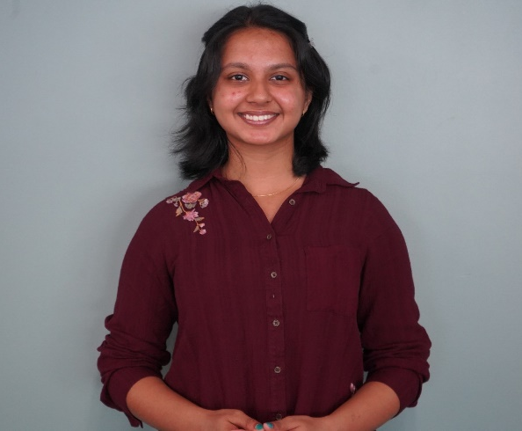
Name: Sadia Barua
College: College of Liberal Arts and Sciences
Major: Anthropology and Psychology
Minor: Statistics

Mentor: Erin Westgate

Project Title: Can self-compassion be the antidote to negative feelings of social comparison?

Project Description: In recent years, Psychologists have been using self-compassion interventions to alleviate symptoms of low self-esteem, eating disorders, substance abuse, and general well-being. Research supports the efficacy of many of these interventions. Existing research found people who are more self-compassionate experience less negative effects of social comparison. However, these studies are correlational, and do not provide evidence for a causal link between self-compassion interventions and alleviation of negative comparison outcomes.This study aims to test the efficacy of self-compassion interventions on the negative affect and self-evaluations resulting from social comparison.

Research Interests: Acculturation, perfectionism, mindfulness, impulsiveness, personality disorders, cultural psychology

Academic Awards: Phi Beta Kappa
Involvement: AWARE Ambassador
Volunteering

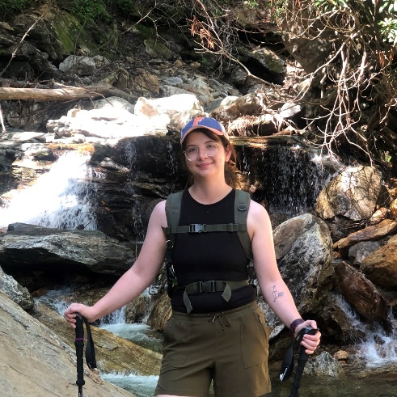
Name: Christina Bennett
College: College of Liberal Arts and Sciences
Major: Geology
Minor:

Mentor: Ellen Martin

Project Title: Effect of radiogenic isotope composition of bedload on chemical weathering trends in Western Greenland

Project Description: Sampling and analysis of glacial waters and sediments in order to see the effects of bedload source on weathering trends

Research Interests: Radiogenic Isotpes, Chemical Weathering in Glacial Landscapes

Academic Awards: Dean's List
Involvement: GeoClub (President)
Hobbies and Other Interests: Hiking, Paddleboarding, Camping

Name: Caeli Benyacko
College: College of Liberal Arts and Sciences
Major: Physics with emphasis in nanoscience and Astronomy
Minor: Electrical Engineering and Materials Engineering

Mentor: Mark Meisel

Project Title:Characterization of the Magnetic Properties of Pyrogel

Project Description: During the construction of a high-temperature furnace designed to process materials while applying a magnetic field of up to 9 Tesla [1], referred to as the BxT Facility at UF, Pyrogel® XTE and Pyrogel® 2250 were identified for potential use due to their thermal-insulating properties. The manufacturing specifications for Pyrogel® XTE [2] report the presence of iron oxide, whereas an unknown primary opacifier is in Pyrogel® 2250 [3]. Due to the absence of any magnetic properties being reported in the literature, experiments were designed to characterize the magnetic fingerprints of these materials to allow a more informed decision about their potential use in the BxT Facility. [1] “A Simultaneous High Temperature and High Magnetic Field Furnace for Advanced Materials Synthesis and Processing”, S. Flynn, M.E Bates, J.C Lee, M.R Tonks, M.S Kesler, M.V Manuel, V.M Miller, M.W Meisel, J.J Hamlin, Bull. Am. Phys. Soc. MAR22 (2022) K31.09, https://meetings.aps.org/Meeting/MAR22/Session/K31.9 [2] Pyrogel® XTE: https://www.aerogel.com/product/pyrogel-xte/ - overview [3] Pyrogel®2250: http://www.aspenindo.com/download/Pyrogel_2250_DS.pdf

Research Interests: Low temperature condensed matter physics and quantum devices

Involvement: Society of Physics Students
Hobbies and Other Interests: Physics

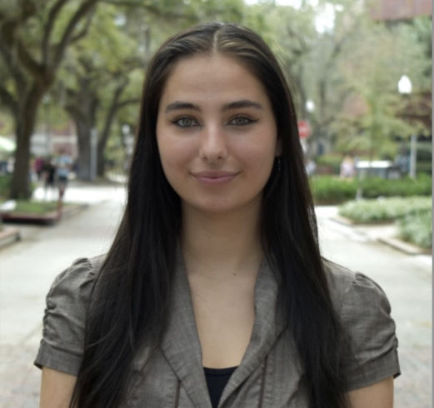
Name: Rachel Brown
College: College of Liberal Arts and Sciences
Major: Psychology
Minor: N/A

Mentor: Erin Westgate

Project Title: Art and the "Good Life"

Project Description: The project seeks to further investigate the differentiation between the three elements of the "good life": happiness, meaning, and psychological richness. I aim to view the effects of artistic expression and perspective on psychological richness. Participants will be asked to reflect on their life to date (past) or the next 20 years of their life (future), with a random condition of participants drawing their life narrative or writing out their life narrative in words. After subsequently reporting how happy, meaningful, and psychologically rich their lives are, they will be asked to report the extent to which their lives have involved a change in perspective. The study will provide preliminary evidence on whether artistic expression contributes to the psychologically rich life and whether changes in perspective elicited by artistic medium have causal effects on well being.

Research Interests: Personality, intergroup relationships, implicit biases, curiosity

Involvement: Psi Chi Honors Society
Hobbies and Other Interests: Photography, music, hiking, ultimate frisbee

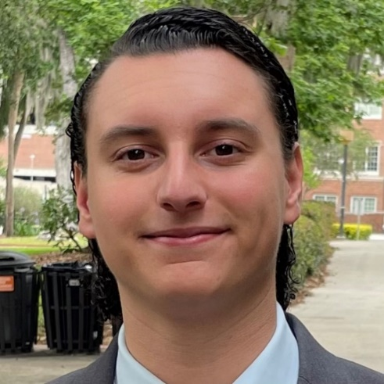
Name: Nelson Canales
College: College of Liberal Arts and Sciences
Major: History and Political Science
Minor: Economics

Mentor: Dr. Florin Curta

Project Title: Pope Innocent III, the German Lands, and the Iberian Peninsula

Project Description: My research will look at the papacy of perhaps the most politically prolific and influential pope of the medieval Church—Pope Innocent III—and analyze his interactions with the German Empire and the kingdoms in the Iberian Peninsula from 1198-1216 through a comparative lens. My research will focus on the pope’s justifications and methods in dealing with different Christian kingdoms. The fundamental question to answer is whether Innocent III was aware of differences between those kingdoms—including their political circumstances—and whether that awareness was modified in time throughout his term. Besides papal interactions with kingdoms involved in battle against Muslim forces either in the Iberian Peninsula (Castile, Aragón) or in Outremer (German crusaders), my study will bring to the fore Pope Innocent III’s attitude towards heresy in those kingdoms of medieval Europe. I expect to demonstrate that while aware of different political and temporal concerns, Innocent III’s attitude remained remarkably consistent in terms of his justifications for intervening in the temporal affairs in both areas.

Research Interests: The Catholic Church, Medieval Period, Early Modern Period, Irish History

Academic Awards: President's (Fall '20) and Dean's List (Spring '21-Spring '23) Recipient, Florida Bright Futures Academic Scholarship
Involvement: Pre-Legal Honor Society, PLHS Mock Trial
Volunteering: Bread of the Mighty Food Bank
Hobbies and Other Interests: Soccer, National Parks, Roadtrips

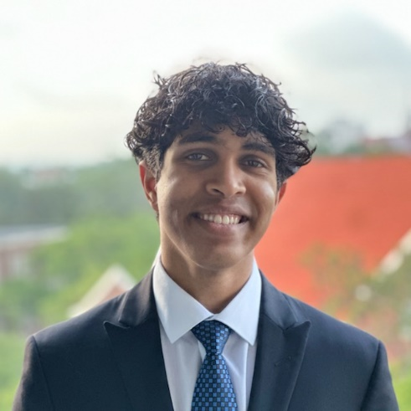
Name: Jay Chavakula
College: College of Liberal Arts and Sciences
Major: Microbiology and Cell Science
Minor: Philosophy

Mentor: Molly Gardner

Project Title: Strengthening Patient Privacy: The Ethics of Information Disclosure in Electronic Health Records

Project Description: I am conducting research on the ethics of privacy in healthcare by reviewing arguments for the claim that patients face impediments regarding implicit or explicit bias. Based on these arguments and accounts, an original argument will be developed for the protection of patient privacy with consideration to the methods in which electronic health records are stored and accessed. Objections will be considered and responses will be given.

Research Interests: Medical Ethics, Privacy, and Confidentiality

Academic Awards: Dean's List
Involvement: Gator Emergency Medical Response Unit, Squash
Volunteering: Levy County Department of Public Safety
Hobbies and Other Interests: Tennis, Pickleball, Reading

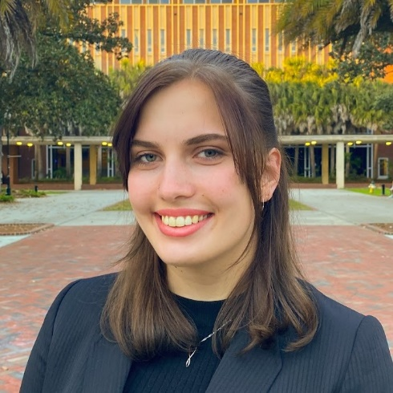
Name: Sophie Clark
College: College of Liberal Arts and Sciences
Major: Astrophysics, Physics
Minor: N/A

Mentor: Elizabeth Lada

Project Title:Investigating the Effects of Environment on the Properties & Evolution of Young Star Clusters: A Characterization of NGC1977

Project Description: Stars form from the collapse of cold, dense molecular clouds in space, and groups of stars that form from the same molecular cloud are called star clusters. My research focuses on star clusters in the Orion molecular cloud complex, which is a large group of molecular clouds relatively close to us with ongoing star formation. NGC 1977 is a region of the cloud complex that has recently become of greater interest because it is one of the weakest far-ultraviolet (FUV) environments possessing circumstellar disks currently known. For this project I aim to use multiwavelength data from Spitzer, 2MASS, and Gaia to learn more about the properties of the cluster’s stars and their disks, and how the influence of its irradiated environment alters the cluster characteristics in comparison with other clusters of similar age and total mass in different environments. My investigation of NGC1977 will extend the diversity of cluster environments that have been studied, and will advance our understanding of how a cluster’s environment affects its stars’ properties, evolution, and circumstellar disks.

Research Interests: Embedded clusters, circumstellar disks, observational astronomy, time-domain astronomy, accretion processes

Academic Awards: Phi Beta Kappa, President's Honor Roll, 2023 Caltech SURF Award
Involvement: University Research Scholars Program Student Advisory Board, Astronomy & Astrophysics Society
Hobbies and Other Interests: Bicycling, hiking, playing video games, knitting, and cross-stitching

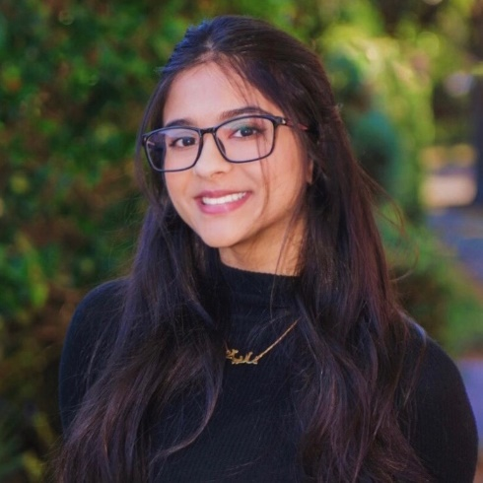
Name: Mariyah Dhanani
College: College of Liberal Arts and Sciences
Major: Behavioral and Cognitive Neuroscience
Minor: Chemistry

Mentor: Dr. Kate Ratliff

Project Title: Do healthcare professionals accept that they might harbor implicit racial biases?

Project Description: Racial minorities experience higher rates of mortality and illness in the United States when compared to white individuals. Black women experience maternal mortality rates three times higher than white women. During the COVID-19 pandemic, black individuals experienced higher rates of hospitalization and death when compared to white individuals. While there may be several factors that contribute to these disparities within the field of medicine, one reason may be attributed to the implicit biases that healthcare professionals harbor against racial minorities. Provider bias was stated as a reason for racial health disparities, but not much research has been done that looks at how receptive healthcare professionals are at accepting or remedying their own implicit biases. The purpose of this study is to determine whether healthcare professionals accept that implicit racial biases impact their practices. In order to test the implicit– or subconscious– racial biases of healthcare professionals, an Implicit Association Test (IAT) will be administered. By determining both the self-reported and implicit biases of healthcare professionals, we can evaluate the extent to which healthcare professionals accept that racial biases may impact their scope of practice. In doing so, the field of medicine can gain knowledge about the awareness of implicit biases in medical practice and implement interventions that actively fight against racial disparities overall.

Research Interests: Implicit bias, social ontology, comparative psychology, and public health

Academic Awards: University Scholars Program, Emerging Scholars Program, Community Service Award, Florida Academic Scholars Program, National Merit Commended Scholar
Involvement: Center for Undergraduate Research Board of Students and Floridance
Volunteering: Footprints Buddy & Support Program and Down to Dance
Hobbies and Other Interests: Dance, sudoku, and jigsaw puzzles

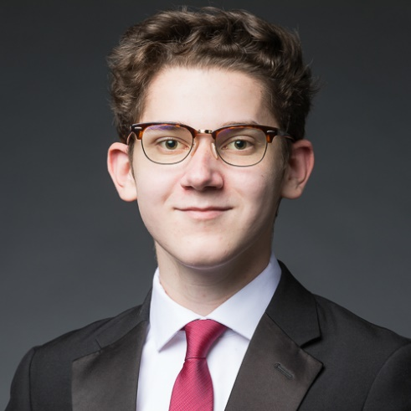
Name: Jordan Dickens
College: College of Liberal Arts and Sciences
Major: History & Political Science
Minor: Russian & East-Central European Studies

Mentor: Dr. Steven Noll

Project Title: The History and Legacy of the Johns Committee at the University of Florida

Project Description: In 1956, the Florida State Legislature established the Johns Committee as a means of rooting out activity deemed “subversive” in the state. Initially targeting groups like the NAACP, the Committee eventually set its sights on state universities, where it sought to subjugate LGBTQ+ faculty and students. The purpose of this study is to examine how the Committee collaborated with organizations like the University of Florida Police Department to target individuals, often interrogating them about their activities in the basement of university buildings. Additionally, it seeks to compare the Johns Committee to wider historical events in the United States, including McCarthyism and the Lavender Scare of the 20th century. Centering the narratives of victims, this study intends to draw connections with wider discussions of political repression and academic freedom that persist in the modern day.

Research Interests: History of the Cold War, History of Civil Rights and State Repression

Academic Awards: Phi Beta Kappa, Phi Kappa Phi, President's & Dean's List, Reubin Askew Scholar, Foreign Language & Area Studies Grant Recipient
Involvement: First Year Florida, UF Mock Trial Team
Hobbies and Other Interests: Reading, Writing, & Watching Movies

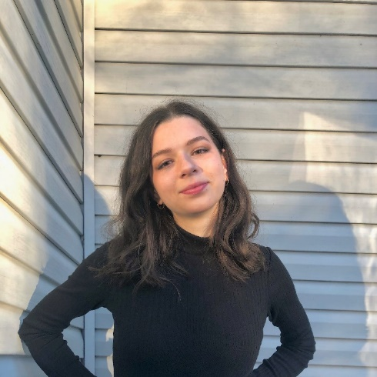
Name: Adriana Fortier
College: College of Liberal Arts and Sciences
Major: Anthropology
Minor: Family, Youth, and Community Sciences & Education Studies

Mentor: Adrienne Strong

Project Title: The Impacts of Power and Identity in Patient-Healthcare Provider Relationships

Project Description: Millions of people in the United States seek biomedical care each year and, in doing so, enter a complex relationship with their healthcare providers. Power is a feature of all relationships, and current literature describes the relationships between patients and healthcare providers as far from equal. How patients and healthcare providers perceive their power factors into the care that is given and received. Power, in this case, is defined as culturally and symbolically created and anchored by cultural, social, and symbolic capital within the fields in which they are produced. The aim of this research project is to closely examine the power dynamics in current clinical settings, and how they may impact the quality of care that patients receive using the framework of both critical medical anthropology and intersectionality. The data collected as part of this research project will offer healthcare providers insight into their patients’ perceptions of power, how it affects their health, and how to better construct a more collaborative environment for a more positive experience.

Research Interests: Health equity, rural health, reproductive health,

Academic Awards: Dean's List 2021, 2022; President's Honor Roll 2021
Involvement: Undergraduate Florida Anthropology Student Association, Emic Magazine
Volunteering: Florida Museum of Natural History
Hobbies and Other Interests: Florida Fencing

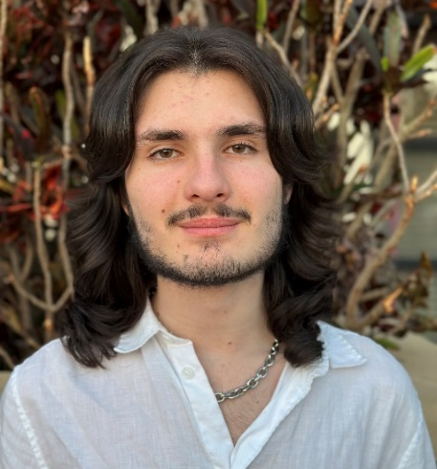
Name: Allan Frasheri
College: College of Liberal Arts and Sciences
Major: Philosophy and Economics
Minor: French

Mentor: Jonathan Rick

Project Title: Evaluating Kantian and Humean Forms of Constructivism In Terms of Our Moral Intuitions on the Contingency of Normative Reasons

Project Description: Metaethics is a sub-discipline in philosophy concerned with the nature of morality, including ethical statements, moral judgements, and normativity. Metaethical theories attempt to provide a cohesive picture of the relationship between ethical statements, facts about the world, our moral judgements and our actions. These theories provide different answers to some of the most important questions in moral philosophy: the origins of morality, whether morality is objective, how we know the difference between right and wrong, and how we understand ourselves as moral agents. The purpose of my study is to evaluate two relatively new and impactful metaethical theories, Kantian Constructivism and Humean Constructivism, by how well they align with our intuitions on the objectivity of morality and the universal moral duty of agents. The conclusions of this study will contribute to the larger debate between Realism and Anti-Realism within Metaethics and help further our understanding of the nature of morality.

Research Interests: Metaethics, Social and Political Philosophy, Political Economy, Comparative Economics

Academic Awards: Dean's List Fall 2021-2023, UF Honors, Phi Beta Kappa
Involvement: UF Young Democratic Socialists of America
Hobbies and Other Interests: Organizing/activism, reading, baking, and hiking

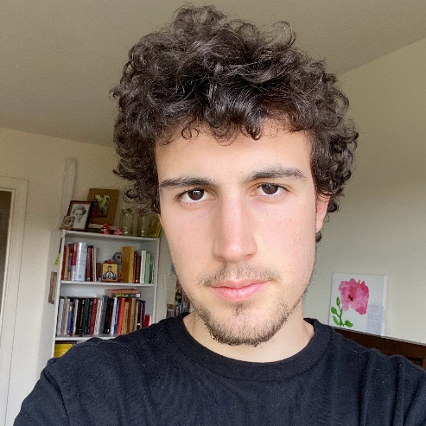
Name: Sebastian Gillespie
College: College of Liberal Arts and Sciences
Major: Philosophy
Minor:

Mentor: Rodrigo Borges

Project Title: On the Nature of Justification

Project Description: Justification and its relationship to truth has been debated by philosophers at least since Plato’s Theaetetus. The central inquiry concerns how our beliefs are justified in accurately describing the actual world. Yet, though this justification is the backbone of epistemology and the scientific method, the contemporary discourse is in a deadlock between several contradictory theories of justification; these include coherentism, foundationalism, and others (Huemer & Audi, 2008, pg. 369). Despite the historical eminence of such a question, little detailed work has been done to trace its philosophical, historical, or linguistic progression throughout the history of philosophy. This gulf has obscured the significance of this progression for current discourse, leading contemporary authors to neglect important insights found in pivotal historical texts. For instance, neglect of Hegel’s conception of truth as justification in a social and semantic context has led to the (in)famous Gettier problem, which fails to understand truth in this context. Ignorance of this context by popular ‘coherentists’ such as Keith Lehrer has led to such deadlocks found today. This project therefore seeks to fill this gap from several perspectives using integrated philosophical, historical, and linguistic methods explored by major philosophers such as Hume, Kant, Hegel, Frege, and Sellars.

Research Interests: Epistemology

Academic Awards: The Michopoulos Scholarship - Awarded by UF Classics department as a diligent student of Greek studies.
Involvement: Geist, President and Founder (2023 - Present) President and Founder of Undergraduate club dedicated to intersection of Philosophy, Neuroscience, Physics, and other fields Lead and oversee General Body Meetings, officer meetings, topic selection, concept c
Volunteering: Bay Chapel Food Pantry
Hobbies and Other Interests: Christianity, Philosophy, Art, Sports, etc.

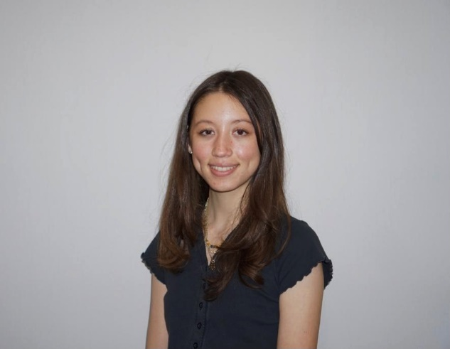
Name: Zoe Golomb
College: College of Liberal Arts and Sciences
Major: History and International Studies
Minor: European Union Studies

Mentor: Sheryl Kroen

Project Title: Liberty, Equality, Motherhood: An Examination of Gender, Republicanism, and Politics in Vichy France

Project Description: This project examines the extent to which the Vichy government fostered an unprecedented degree of conservatism and repression in French society during the Second World War. Drawing upon periodicals, women’s and feminist magazines, newspapers, and other publications popularly circulated in France during the Vichy years, this project will examine how language and rhetoric surrounding women and their role in society changed during the Vichy regime while also considering the extent to which these measures predated the Vichy regime. A thorough study of these sources is integral to understanding the gradual shifts in views, policies, and rhetoric surrounding gender roles and relations and roots of conservative movements predating Vichy.

Research Interests: Postwar Europe and European Democracy

Academic Awards: Phi Beta Kappa
Involvement: European Union Club; PRISM Student Magazine
Volunteering: Samuel Proctor Oral History Program
Hobbies and Other Interests: Reading, baking, dancing, and spending time with family

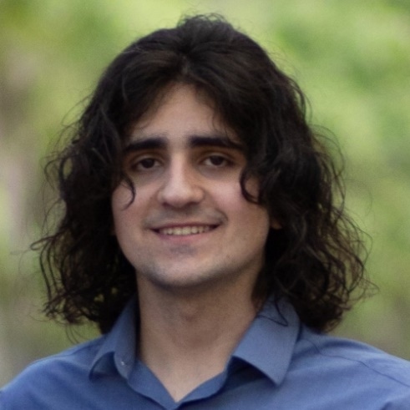
Name: Adrian Gonzalez Socorro
College: Herbert Wertheim College of Engineering
Major: Materials Science and Engineering
Minor: N/A

Mentor: Dr. Liu Mingjie

Project Title: Transition Metal Atom Clusters on Graphyne-n for CO2RR

Project Description: Single atom catalysts where the isolated metal is embedded in carbon materials have emerged as a promising class of catalysts due to their low-cost, tunable activity and selectivity towards CO2 reduction reactions. The interaction between the metal and the carbon lattice determines the reactivity of the catalysts. In recent decades, intensive research efforts have been made in understanding and designing SACs in graphene-based materials both from experiments and computations. Graphyne is a graphene derivative in which the benzene rings are connected with linear acetylene chains of varying lengths. This makes graphyne have both sp and sp2 hybridizations. Moreover, it has recently prompted intense research into designing single metal catalysts with graphyne substrate due to the variation of carbon hybridization and conjugation of π-bonds, facilitating the transfer of charge and stabilization of a metal atom center. Recent literature also demonstrates that metal clusters can offer better catalytic activity than a SAC due to increased capacity for CO2 adsorption. In spite of that, the systematic and comprehensive understanding on the metal anchored in graphyne is still lacking due to the diverse graphyne lattice as well as the variety of metals. Therefore, my research project will focus on using computational models based on density functional theory simulations and combining them with data-driven models to understand the single metal and metal clusters hybridized in graphyne for CO2 reduction reactions.

Research Interests: Carbon Materials for Sustainability Applications, Machine Learning Assisted Material Discovery, Energy Materials, Structure-property Relationship

Academic Awards: Dean's List
Hobbies and Other Interests: Cooking, Horror Films, Music

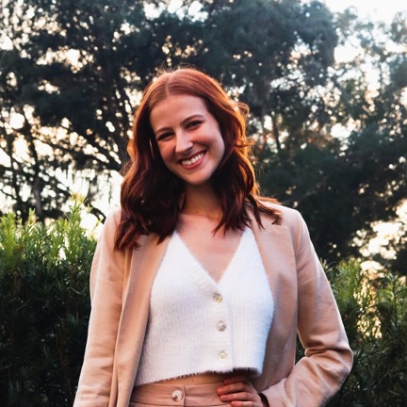
Name: Merrill Garlington
College: College of Liberal Arts and Sciences
Major: Psychology; Behavioral and Cognitive Neuroscience
Minor: Health Disparities in Society, Women's Studies

Mentor: Steven Weisberg

Project Title: Structural Neural Correlates of Spatial Navigation Behavior Across the Lifespan: A Hippocampal Subfield Analysis

Project Description: A review of a larger, ongoing project at UF that will look specifically at MRI strucutral data and navigational strategies

Research Interests: Dementia, Developmental Disorders

Involvement: Kappa Delta, Best Buddies, One Love
Volunteering: Girls Inc
Hobbies and Other Interests: Playing guitar/piano, painting, and hanging out with friends

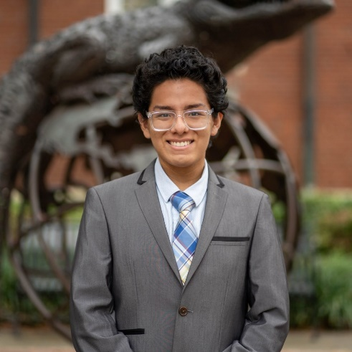
Name: Patrick Grey
College: College of Liberal Arts and Sciences
Major: History and Spanish
Minor: Latin American Studies

Mentor: Paul Ortiz, Ph.D.

Project Title: "Free Florida Oral History Project"

Project Description: This project will investigate how the massacres of the past continue to affect communities in the 21st century. Additionally, the project also seeks to find how the descendants of communities in Florida that experienced lynchings liberated themselves from the pain of the past.

Research Interests: African Diaspora Studies; Atlantic History; Southern History; Oral History; Linguistics.

Academic Awards: Beinecke Scholar, BIG 10 Summer Research Grant Recipient (University of Maryland), Princeton University Prospective Ph.D. (P3) Scholar, Daniel J. Koleos Scholarship Recipient, University Scholar, Hispanic Scholarship Fund Award Recipient, Ford “Salute to
Involvement: Dance Marathon
Volunteering: Keep Alachua County Beautiful
Hobbies and Other Interests: Traveling, reading, going to the beach, and traveling again.

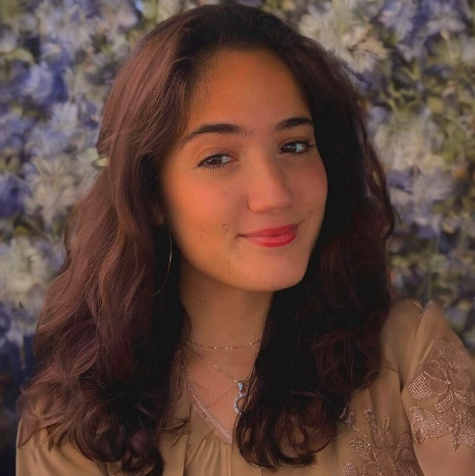
Name: Fatima Gutierrez
College: College of Liberal Arts and Sciences
Major: Psychology; International Studies with a Specialization in Latin American and Caribbean Studies
Minor: Portuguese; Anthropology

Mentor: Peter Collings

Project Title: Representing Culture and Researcher Responsibility: The Yanomami Case

Project Description: The Amazon is a politically, economically, and environmentally charged place, and the native populations tend to be most vulnerable to these pressures. This proposal seeks to examine the roles and responsibilities that anthropologists have toward the people they work with through one specific group, the Yanomami. The Yanomami are a group of Indigenous tribes found in Venezuela and Brazil that have been the object of several anthropological expeditions. From the 1960s to the early 2000s, attitudes regarding the Yanomami have continuously shifted, each time influencing how they are portrayed. These competing images and representation for the Yanomami people may have contributed to loss of land and human rights, and violence against them for over 30 years. Accordingly, the main goal of this research is to determine if there is a correlation between the anthropological research conducted on the Yanomami and the political regulations set in place regarding their human rights and lands. By discovering connections between anthropological studies, political reform, and the effects on the Yanomami people, one can understand the weight of cultural anthropological research and how it can entirely alter the trajectory of civilizations. In addition, politics that are heavily influenced by the fieldwork can also benefit from viewing multiple perspectives regarding the amazon’s people and should remain conscious of human rights.

Research Interests: History of mankind and how it has manifested in various cultures and places, linguistics, behavior, and psychology.

Academic Awards: Recipient of the 2022 Foreign Language and Area Studies Fellowship,
Involvement: Hispanic Student Association
Hobbies and Other Interests: My hobbies include dancing and painting. I enjoy dancing various Latin dances such as salsa and bachata. I enjoy painting with acrylic paint and water colors.

Name: Morgan Himes
College: College of Liberal Arts and Sciences
Major: Physics, Astrophysics, and Mathematics
Minor:

Mentor: Adam Ginsburg

Project Title: ALMA-IMF SPICY

Project Description: The goal of this research project is to measure the YSO (young stellar object) population of the young cluster sample from the ALMA-IMF (Atacama Large Millimeter/submillimeter Array - Initial Mass Function) large program. From this data, we aim to measure the individual properties of YSOs to infer the ages of the star clusters. Some of the properties we measure are stellar temperature, stellar luminosity, stellar radius, line of sight masses, disk masses, and sphere masses.

Research Interests: Astrophysics

Academic Awards: Benacquisto Scholarship, University Research Scholars Program, UF Honors, Phi Beta Kappa
Involvement: Society of Physics Students, Astronomy and Astrophysics Society, Gender Equity Student Advisory Board
Volunteering: UF Science Olympiad, Cox Science Center and Aquarium
Hobbies and Other Interests: Going to rock concerts, drawing, sculpting

Name: Rhett Hoke
College: College of Liberal Arts and Sciences
Major: Physics
Minor: N/A

Mentor: Amlan Biswas

Project Title: Implementing Capacitance-Based Angle Measurement Techniques to Investigate Anisotropic Magnetoresistance

Project Description: I will construct a device that can measure the angle that our sample is rotated that does not use a technique that relies on the magnetic field applied to our sample.

Research Interests: Optimizing lab efficiency and data analysis with code and newer techniques.

Involvement: Society for Physics Students
Hobbies and Other Interests: Reading/Coding/Gaming

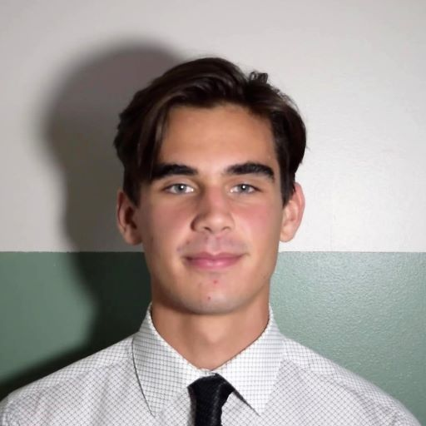
Name: Brandon Isenman
College: College of Liberal Arts and Sciences
Major: Economics
Minor: Mathematics, Philosophy

Mentor: Renata Serra

Project Title: Does Climate Change Affect Youth Aspirations, Perceptions of Their Own Future, or Evaluation of Their Prospects?

Project Description: Determining if and how the perceptions of individuals in the African Sahel change with respect to time and also to the frequency of climate related shocks.

Research Interests: Developmental Economics, Political Economy, Economic Philosophy

Involvement: Young Democratic Socialists of America (YDSA)
Volunteering: Samuel Proctor Oral History Program
Hobbies and Other Interests: Coffee and Espresso, Rock Climbing, Existential Philosophy

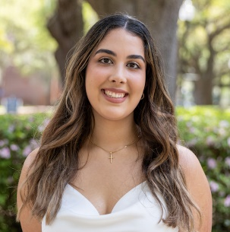
Name: Jahiris Jauregui
College: College of Liberal Arts and Sciences
Major: Psychology
Minor: English & Chemistry

Mentor: Erin Westgate, PhD

Project Title: Reducing Implicit Gender Bias in Student Evaluations of University Professors

Project Description: With the passing of HB 233, colloquially known as the “Stop W.O.K.E. Act”, University of Florida faculty face risk of being penalized for being seen as promoting political indoctrination. Biased ratings can affect the integrity of an assessment; this phenomenon is seen in all professional environments, beyond academia, where women are compared to men. This study will provide additional relevant data facilitating in reforming the widespread issue of gender bias in student faculty evaluations through evidence-based interventions. By eliminating as many confounding variables as possible, the results of the study will be more strongly associated with gender than other variables such as lecture content, course scheduling, or presentation of educational resources. As such, the implications of this research can inspire future studies to broaden the scope and pool of participants to promote the likelihood of generalizing findings to other professional environments.

Research Interests: Implicit bias, Intersectionality, Gender, Race, Human Sexuality, Social Behavior.

Academic Awards: Hispanic Scholarship Fund Scholar, College of Liberal Arts and Sciences Deans List (Fall 2022 and Spring 2021), Florida Bright Futures Academic Scholarship, 2023 University Scholar
Involvement: Alpha Phi Omega - Tau Chapter, University of Florida American Student Dental Association, Pre-Dental Society
Volunteering: Florida Baptist Mobile Dental Unit

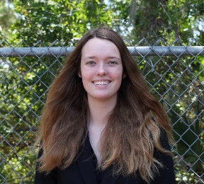
Name: Faith Kern
College: College of Liberal Arts and Sciences
Major: Chemistry
Minor: Spanish, Communications

Mentor: Ronald Castellano

Project Title: Hydrogen Bonded, Pi-Conjugated Molecules for Organic Solar Cell Applications

Project Description: Organic photovoltaics (OPVs) are becoming a notable and cost-effective source of electricity due to their potential improvements to environmental sustainability as well as electrical power. Currently, the bulk heterojunction (BHJ) model is widely used and features active layers formed by blending donor and acceptor organic materials during processing. The morphology of the active layer depends on the interactions between materials but its consequences on efficiency are hard to predict and control. Well-designed molecular structure can help derive ideal structure-property relationships and control morphology in the active layer. Hydrogen bonding organizes the active layer of the solar cell and helps with self-assembly, further helping the hierarchical structure of the active layer. Thus, this research aims to improve upon this molecular design by developing a new donor-acceptor molecule with a centralized PH containing building block, which will afford an easier synthesis as well as improve pi-pi interactions between target molecules, named QPH. Characterizing QPH with proton and carbon NMR and IR spectra confirms its structure and optimal geometry. TQPH is characterized by its hydrogen bonding capabilities and extended pi-conjugation network in comparison to QPH’s smaller pi-conjugation network. The synthesis and testing of TQPH will help to determine if the extended pi-conjugation network makes a more efficient molecule for organic solar cells.

Research Interests: Organic Chemistry

Academic Awards: URSP Scholarship Award
Involvement: URSP Advisory Board, Greenhouse Church

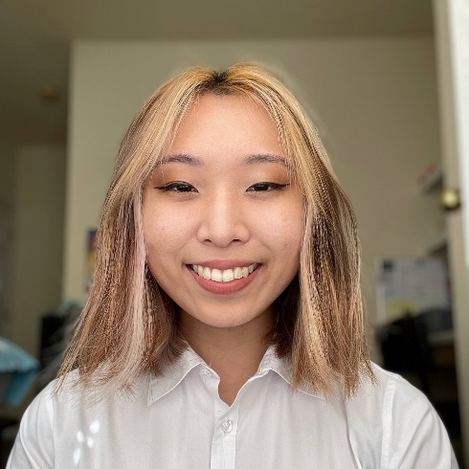
Name: Emily Kim
College: College of Liberal Arts and Sciences
Major: Microbiology
Minor: Spanish, Computer Science

Mentor: Dr. W. Brad Barbazuk

Project Title: Exploring the fern life cycle: gene expression patterns between gametophytes and sporophytes and sex determination in ferns

Project Description: The purpose of this project is to explore differential gene expression and alternative splicing events between the fern gametophyte and sporophytes stages, as well as expression patterns between male and female gametophytes. Additionally, we will place these findings in a broader macroevolutionary framework, allowing us to better understand the evolution of the alternation of generations as well as sex determination.

Research Interests: Transcriptomics, alternative splicing, gene expression

Academic Awards: Winona Jordan Undergraduate Scholarship, Undergraduate Research Assistantship Program, National Merit Scholar, Elks Scholar
Involvement: Korean Undergraduate Student Association, SwampHacks, Forming our Identities through Networking and Development
Hobbies and Other Interests: Dancing, playing the piano, drawing, playing volleyball

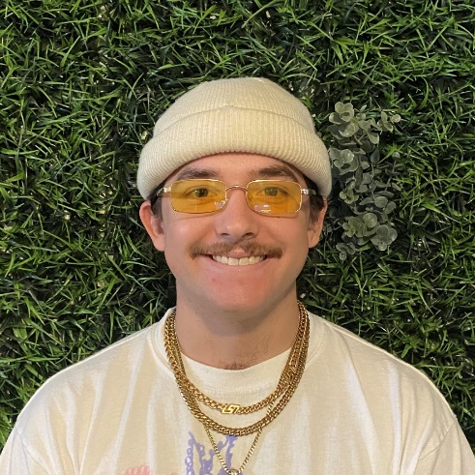
Name: Luke Kline
College: College of Liberal Arts and Sciences
Major: Sociology
Minor: N/A

Mentor: Dr. Mary Watt

Project Title: Dante Alighieri's Divine Comedy as a Journey into the Collective Unconscious: An Exploration of Jungian Archetypes

Project Description: The aim of this research is to explicate the relationships between Carl Jung's archetypes and Dante Alighieri's Divine Comedy. This will be done by analyzing the trajectories and directionalities Dante employs through the use of language and imagery and how they correlate to his use of light and dark to take him from the conscious realm into one that is unconscious. Moreover, the literary traditions used by Dante will be synthesized with Jung's archetypes to explain how Dante has not only highlighted Jung's ideas, but also intuited them. Both the literal and allegorical levels of the Divine Comedy will be used to understand how language and imagery inform the relationship between the conscious and unconscious realms discussed by Dr. Jung.

Research Interests: Sociology of Media & Culture, Jungian Psychology & Archetypes, Abnormal Psychology, Dante Alighieri's Divine Comedy, Comparative Literature

Academic Awards: Dean's List
Hobbies and Other Interests: Running, Weightlifting, Traveling, Skydiving, and

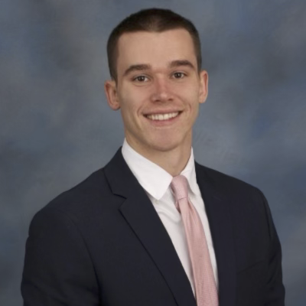
Name: Caleb Koresh
College: College of Liberal Arts and Sciences
Major: Data Science
Minor: Computer Science

Mentor: Emma MacKie

Project Title: Examining the Relationship Between Topographic Roughness and the Temperate Layer

Project Description: I will be examining the relationship between topographic roughness and the temperate layer found at the base of ice sheets. This will allow for a greater understanding of continental ice-sheet movement and provide critical model parameters that can reduce uncertainty in sea-level change.

Research Interests: Reinforcement Learning, Quantifying Topographic Roughness

Involvement: Data Science & Informatics
Hobbies and Other Interests: Running, Game Development, Reading, Scuba

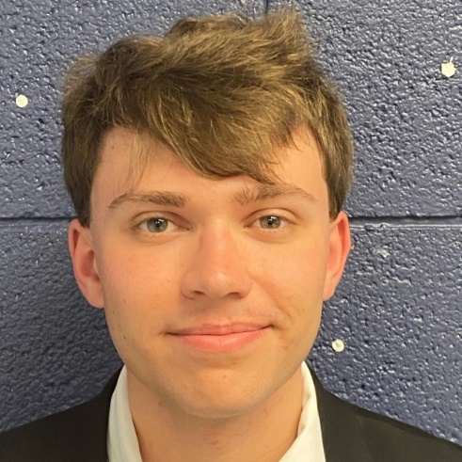
Name: Benjamin Liberles
College: College of Liberal Arts and Sciences
Major: Physics and Astrophysics
Minor: Mathematics

Mentor: Jason Dittmann

Project Title: A Statistical Interpretation of the Size Distribution of Single and Multi-Planetary Systems

Project Description: One way to statistically study the planet population is to look at the number of planets in a planetary system - the so-called “Kepler dichotomy.” Single planetary systems have one planet orbiting its host star, while multi-planetary systems have multiple planets orbiting around a host star. Multi-transiting planet systems typically contain multiple planets in stable orbits with semi-major axis lengths of less than one AU, in a dynamically packed arrangement where any additional body would be unstable. This project investigates Kepler planetary systems (consisting of both single and compact multiples systems) to statistically investigate the distribution of planetary sizes in these two subsamples using radius as a proxy for planetary mass. Here we propose to investigate whether the (more metal rich) host stars for single planet systems produce statistically more massive (and larger) planets than the compact multiple systems.

Research Interests: Exoplanet Populations, Rocky Planets, Orbital Dynamics

Involvement: Society of Physics Students, Astronomy and Astrophysical Society
Hobbies and Other Interests: Running, Hiking, Baking, Sports

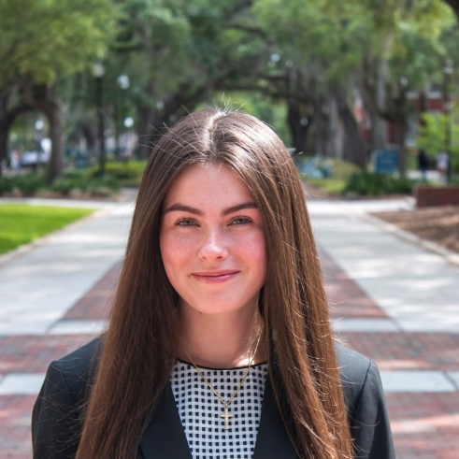
Name: Martha Lockman
College: College of Liberal Arts and Sciences
Major: History and English
Minor:

Mentor: Dr. Seth Bernstein, PhD

Project Title: Soviet Women’s Changing Contributions to the Economy in Perestroika

Project Description: The Soviet Union necessitated that women work in factories and contribute most of their time to their professional lives. This life was difficult as women still had their time-consuming roles at home. In 1985, Soviet leader Mikhail Sergeyevich Gorbachev instituted a new policy called Perestroika that called for a partial marketization of the Soviet planned economy. I will investigate how the role of women transformed during the era of reform when the Soviet Union modified their social structure to be more of a market society.

Research Interests: Economic and intellectual history

Academic Awards: Dean’s List, University Scholar, Bright Futures Academic Scholar
Involvement: History Honors Program, Sigma Tau Delta, Special Olympics, Phi Alpha Theta, Public Leadership Society, Phi Alpha Delta, Pre-Legal Honor Society, UF Habitat For Humanity Chapter, Gators Vote Cabinet, A Reason To Give
Volunteering: UF and Alachua County Habitat for Humanity, Special Olympics Tennis, Gainesville Giving Garden
Hobbies and Other Interests: Sudoku, Cycling, Tennis

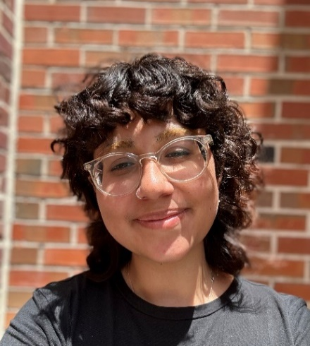
Name: Lauren Manso
College: College of Liberal Arts and Sciences
Major: Sociology, History, Women's Studies
Minor: N/A

Mentor: Dr. Sandy Chang

Project Title: The Turkish Body Politic and Its Body Politics: Historicizing Feminized Labor and Its Liminality in Modern, Neoliberal Türkiye

Project Description: My intention is to trace the history of prostitution and other forms of feminized labor in the Republic of Türkiye since its establishment under Mustafa Kemal Atatürk in 1923. I will argue that neoliberal regimes tend to vilify non-normative bodies, which are relegated to liminal spaces and are heavily surveilled if not overtly sanctioned–examining Türkiye as exemplary of this. I will discuss how feminized labor practices, including affective and intimate labor (such as prostitution), are considered illegitimate by neoliberal, traditionalist conceptions of productivity–hinging on scholarship pertaining to their prevalence in modern Turkish history. I will synthesize sociological theory and established studies to examine the carceral conflation of queerness with prostitution, codified in both secular and religious law; discussion of Orientalism, Islam’s influence, and Foucauldian theory will also be necessary in examining the way in which this paradigm necessitates the rendering of non-normative–queer, feminized, and sex working–bodies as disposable or illegitimate by the state. Divulging the thematic understandings of intimate and affective labor in modern Türkiye, I will claim that the feminine production of capital is relegated to private (mahrem) or sanctioned spaces in accordance with traditionalist, neoliberal/conservative regimes.

Research Interests: Queer Theory, History of Sex Work/Prostitution in the Middle East, Gender Studies, Sexual Politics, Cultural History/Sociology, Women’s History

Academic Awards: Dean's List, Florida Bright Futures Scholarship
Involvement: Samuel Proctor Oral History Program (Florida Queer History Project)
Volunteering: Samuel Proctor Oral History Program
Hobbies and Other Interests: Reading, writing, crocheting, knitting, cooking, shopping, and baking

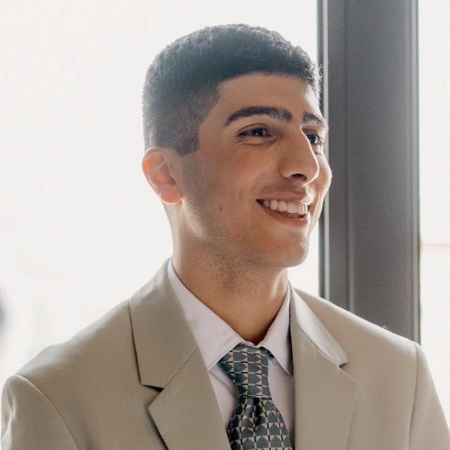
Name: Edgar Martirosyan
College: College of Liberal Arts and Sciences
Major: English & Education Sciences
Minor: N/A

Mentor: Eric Kligerman

Project Title:Kafka and Learning: Deterritorialized Identity in Educational Spaces

Project Description: The process of learning and intellectual growth as related to the deterritorialized notion of categorical, static identity takes various metaphoric forms and appears in many works of Franz Kafka in examples of a man from the country abandoning home for the acquisition of the Law, an ape learning to speak, or a land surveyor by the name of K. trying to reach The Castle. In my research project, I wish to investigate the insights that the epistemological thought of Kafka may bring into the study of education, organized learning and pedagogy while dismantling what we recognize as “identity” within educational spaces.

Research Interests: literature, learning and development in school and community

Academic Awards: United World Scholar
Hobbies and Other Interests: Literature, Learning and Development in School and Community Settings

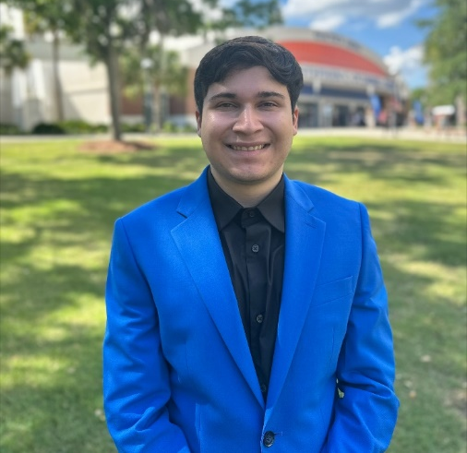
Name: Rodrigo Mello Medina
College: College of Liberal Arts and Sciences
Major: Linguistics
Minor: Anthropology, Urban and Regional Planning

Mentor: Dr. Edith Kaan

Project Title: Spanish-English Codeswitching and Its Effect on Cognitive Control

Project Description: Codeswitching is the practice of using more than one language at once in a sentence or conversation (e.g., "Spanglish"). While in most cases, people process only one language at a time, bilinguals may switch between and process multiple languages at a time in an almost seamless manner. Recent research suggests that in switching languages, bilinguals activate cognitive processes that inhibit automatic processing and guide working memory. The objective of the study is to investigate this uniquely multilingual phenomenon and see if the results of codeswitching may affect nonverbal processes which require correction and activation of cognitive control processes.

Research Interests: Psycholinguistics, multilingualism

Academic Awards: Dean's List
Involvement: Korean Language Table, Undergraduate Linguistics Society
Hobbies and Other Interests: Piano, language learning, playing video games

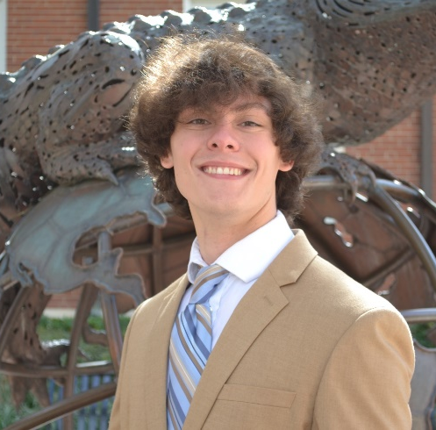
Name: Simon Mesen
College: College of Liberal Arts and Sciences
Major: Economics
Minor: Mathematics

Mentor: Dr. Michelle Phillips

Project Title: An Analysis of the Effect of University Ranking and County Employment Rate on State Per-Capita GDP

Project Description: This paper will examine how university ranking and employment rate affects GDP per-capita for the state in which a county containing a university is located. The data will be examined using OLS, looking at the relationship between the dependent variable and multiple independent variables. When a university in America experiences a change in tanking, its representative county and state could experience a change in GDP per-capita.

Research Interests: Macroeconomics, Public Policy, Econometrics & Quantitative Methods

Academic Awards: Dean's List (Fall '20 & '21)
Involvement: Alpha Kappa Psi - Alpha Phi Chapter
Volunteering: N/A

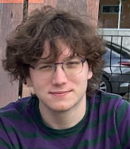
Name: Marcus Mynatt
College: College of Liberal Arts and Sciences
Major: Physics, Astrophysics BS
Minor: Mathematics

Mentor: Chunjing Jia

Project Title: Machine Learning Hamiltonian Prediction in 2D Skyrmion Lattices

Project Description: We seek to study the phenomenon of magnetic skyrmions and their topological effects through the lens of machine learning simulation, by utilizing atomic spin dynamics simulation software to model Hamiltonians to train a learning algorithm upon, to eventually generate new configurations.

Research Interests: Atomic Spin Dynamics

Academic Awards: Garrett Endowment
Involvement: UF Fencing
Hobbies and Other Interests: Biking, hiking, fencing and listening to music

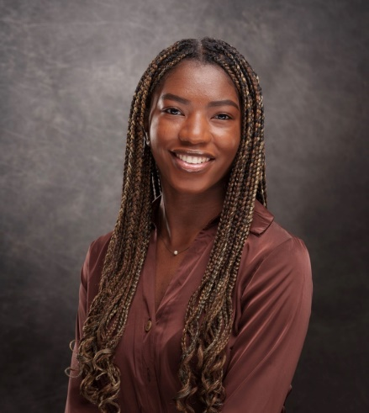
Name: Jasmyne Nelson
College: College of Liberal Arts and Sciences
Major: Psychology and Criminology
Minor: Sociology of Social Justice and Policy

Mentor: Abigail Fagan

Project Title: Disproportionate Minority Contact (DMC) in Alachua County

Project Description: Minority youth’s contact with the juvenile justice system is a significant social problem in the United States. From arrests to dispositions, there is a disparity between youth of color and White youth at every stage of the juvenile justice system. This project aims to better understand DMC in the local context of Alachua County. This project will examine DMC through the use of focus groups to answer questions such as: what are the causes of DMC, What are its impacts on communities and/or individuals? And how may individuals viewpoints about DMC be similar or different? The objective of this project is to not only contribute to DMC literature, but have practical applications in informing future DMC initiatives and practices in Alachua County.

Research Interests: Disproportionate Minority Contact; Incarceration; Crime Prevention

Academic Awards: McNair Scholars Program; 3x CLAS Dean’s List
Involvement: Psychology Club; Honors Luminaries
Volunteering: Florida Alternative Breaks
Hobbies and Other Interests: Reading!

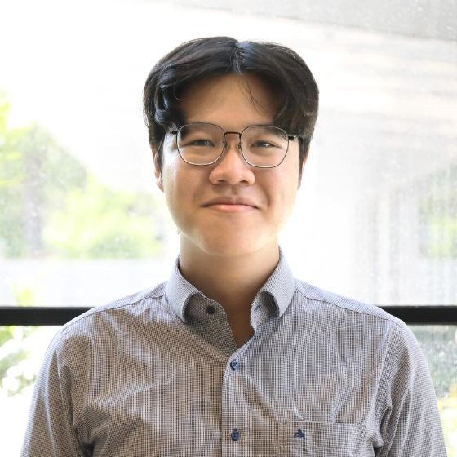
Name: Phuoc Nguyen-Cuu
College: College of Liberal Arts and Sciences
Major: Economics B.A., Mathematics B.S., Statistics B.S.

Mentor: Ignacia Mercadal

Project Title: Import Competition’s Effect on Productivity Growth

Project Description: This research examines how increased competition from imports resulting from the Comprehensive and Progressive Trans-Pacific Partnership (CPTPP) impacts domestic competition, productivity growth, and R&D spending in member countries. By utilizing a Difference-in-Difference approach, the study investigates the relationship between increased imports and Total Factor Productivity (TFP) growth and R&D expenditures. The research aims to contribute insights into the effects of imports on growth dynamics in developing nations and to extend the ongoing debate surrounding trade liberalization's implications for middle-income economies, providing a basis for future growth models.

Research Interests: Industrial Organization, Development, Economic Growth

Academic Awards: Davis Scholar, Civic Scholar, University Scholar, Honors '25

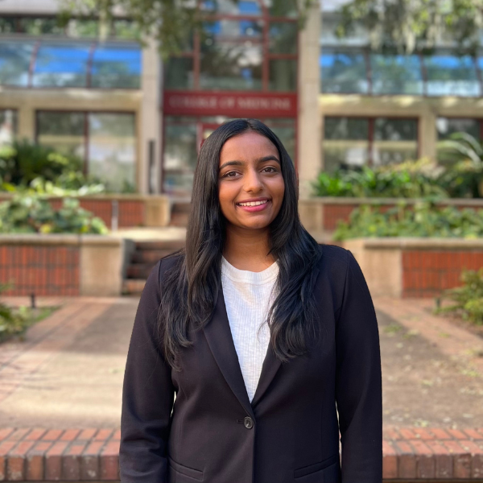
Name: Rishika Podarala
College: College of Liberal Arts and Sciences
Major: Microbiology and Cell Sciences
Minor: Health Disparities in Society

Mentor: Keith Choe

Project Title: Battle of the sexes: identifying genetic mechanisms of sexual dimorphism in stress resistance

Project Description: My aims are to test a broader array of environmental stressors and to identify genetic mechanisms using C. elegans as a model organism to better understand the affects of sexual dimorphism.

Research Interests: Microbiology, Genetics, Physiology, Health Disparities and Health Promotion

Academic Awards: 1ST Place in Biomedical Laboratory Sciences and Public Service Announcement competitive events
Involvement: HOSA - Future Health Professionals, Indian Student Organization
Volunteering: Hearts for the Homeless, Down to Dance
Hobbies and Other Interests: Indian Classical Dance, Swimming, Baking, Traveling

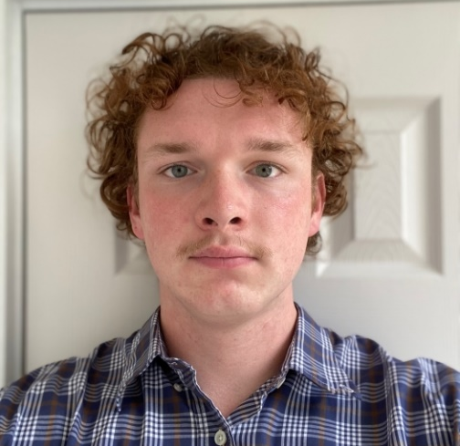
Name: Zachary Potter-Zimmerman
College: College of Liberal Arts and Sciences
Major: History
Minor: Anthropology

Mentor: Florin Curta

Project Title: Retracing Their Steps: Piety and Pilgrimage by Women in 15th Century Lübeck

Project Description: My project will attempt to illumine the lives of the women of the medieval commercial hub Lübeck, a city that once enjoyed the helm of the Hanseatic League. This group has not been studied in much depth in the historiography of the Hanseatic League. My project will explore the patronage of the Lübeck merchant class on the city's ecclesiastical institutions, particularly the actions of merchant wives concerned for their families’ salvation. It will examine how these expressions of piety constituted themselves through pilgrimage to holy sites in Rome and Jerusalem. Finally, it will investigate how this devotion created a sense of political and social awareness among merchant-class women that established their role in civic life and conflict management.

Research Interests: The Medieval & Early Modern Periods, Religious & Social History, Northern & Central Europe
Involvement: Phi Alpha Theta, Reitz Union/Newell Hall Student Council
Volunteering:
Hobbies and Other Interests: History, Theology, Medieval Studies

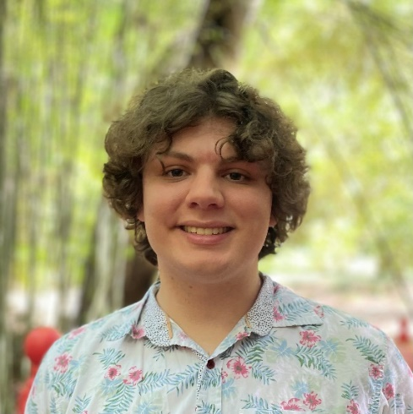
Name: Kurt Ramsey
College: College of Liberal Arts and Sciences
Major: Philosophy, Classics
Minor: Linguistics

Mentor: John Biro

Project Title: Kant and Leibniz

Project Description: Kant’s view of Leibniz’s philosophy in the Critique of Pure Reason can be summarized as having “allowed sensibility no peculiar mode of intuition to itself,” thereby reducing sensibility to confusion and giving the understanding access to the thing-in-itself. Yet, in On a Discovery, Kant seems to attribute to Leibniz “an obscure awareness” of the distinctness and harmony of sensibility and understanding through Leibniz’s doctrine of pre-established harmony. Thus, there seems to be an inconsistency within Kant’s views on Leibniz: one belief holds that sensibility is a mere confusion of the understanding, providing no new material itself. Yet, another holds that pre-established harmony somehow recognizes the distinctness of the two faculties as well as their harmony. This research project will seek to understand how these seemingly inconsistent beliefs can be resolved if they can. This project will be conducted by first investigating in parallel Kant’s reasons for holding each belief. Investigating the first belief entails understanding why Kant might think that Leibniz provides no intuition for sensibility. Investigating the other belief requires understanding Kant’s harmony between understanding and sensibility, Leibniz’s pre-established harmony between mind and body, and how these might be reconciled. Once each belief has been investigated on its own, we will then investigate how both beliefs may be reconciled and whether or not such a reconciliation would be faithful to either philosopher’s ideas.

Research Interests: History of Philosophy

Involvement: Undergraduate Philosophy Society
Hobbies and Other Interests: Playing and listening to music, learning history, and visiting nature parks

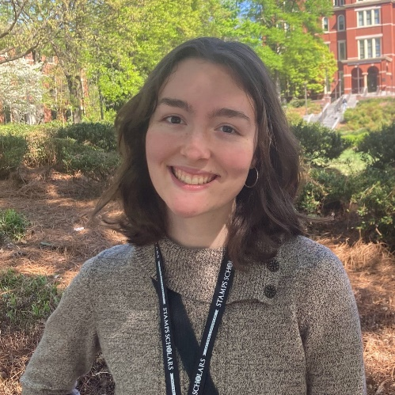
Name: Kate Rush
College: College of Liberal Arts and Sciences
Major: Physics; Philosophy
Minor:

Mentor: Rodrigo Borges

Project Title: The Computer Analogy Within Modern Philosophy of Mind

Project Description: Modern philosophy of mind has stagnated. Once a rich and multifaceted subject intertwined with metaphysics and epistemology, this field is now treated as isolated, increasingly neurocentric, and largely ahistorical. In the face of these challenges, there exist two promising avenues for revitalizing contemporary philosophy of mind. The first is to reevaluate the efficacy and scope of its conceptual tools, particularly the analogy of the modern computer for human cognition. The second avenue is to examine the intellectual tradition which is the foundation of today’s philosophy of mind discourse. Thus, the aim of this research is to utilize insights from both the rich philosophical tradition and modern science to assess the strengths, weaknesses, and proper scope of the brain-computer analogy, pushing the field forward through the limitation and historicization of this central analogy.

Research Interests: German Idealism, Christianity, Comparative Religion, Philosophy of Science

Academic Awards: Stamps Scholarship
Involvement: GEIST
Hobbies and Other Interests: metabolizing tomes, writing (frenetic and otherwise), ambling about, prayer

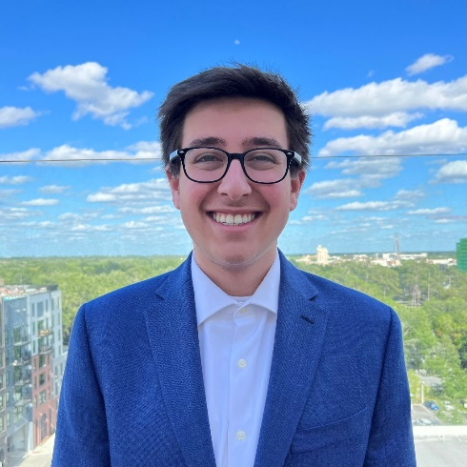
Name: Sonny Russano
College: College of Liberal Arts and Sciences
Major: History, Emphasis in Legal History
Minor:

Mentor: Dr. Seth Bernstein

Project Title: American Origins of the Nuremberg Trials

Project Description: My project will tell the story of the foundations for the IMT from the perspective of the United States government and the various institutions within it that took primary roles in the development of the American idea of international justice from 1928 to 1945.

Research Interests: International Law, Constitutional Law, US Foreign Policy

Academic Awards: Phi Beta Kappa
Involvement: Campus Votes Project
Volunteering: Florida High School Model United Nations
Hobbies and Other Interests: Reading, going to the beach, cooking, spending time with my dog

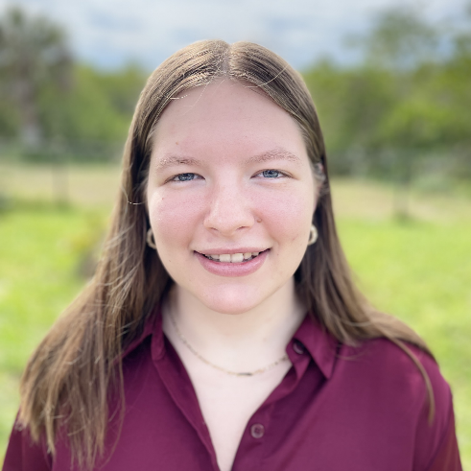
Name: Kailey Schaible
College: College of Liberal Arts and Sciences
Major: Microbiology and Cell Science
Minor: N/A

Mentor: Kim Valenta

Project Title: The Impact of Free-roaming Dogs on Native Fossa Populations in Andasibe-Mantadia

Project Description: The Andasibe-Mantadia region of Madagascar is home to large populations of free-roaming domestic dogs who are expected to disrupt native ecosystems. The goal of this project is to determine how these dog populations affect the spatial behavior of Madagascar's largest endemic carnivore, the fossa. After individually assessing and categorizing camera trap captures, a co-occupancy model of dogs and fossa will be created using multispecies occupancy models to estimate interspecies occurrence probabilities in each study area.

Research Interests: Anthropology, astrobiology, plant pathology

Academic Awards: USP Scholar, Dean's List
Involvement: Bioethics Society
Volunteering: US Oncology
Hobbies and Other Interests: Tennis, reading, baking

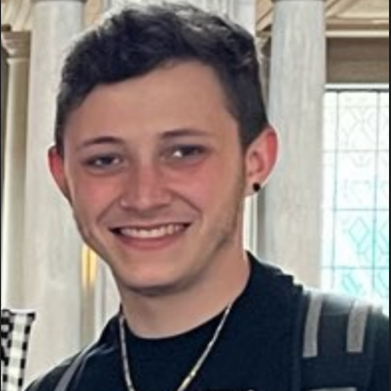
Name: Meir Schochet
College: College of Liberal Arts and Sciences
Major: Astrophysics
Minor: Philosophy

Mentor: Jamie Tayar

Project Title: Searching for stellar interactions: Identifying unusual stellar remnants and potential progenitors

Project Description: There are many types of objects in space that are extremely dense and massive and are yet small and difficult to see. We call these things compact objects, and they have been researched by others in the field for decades now. When we observe these objects displayed as a distribution of masses however, the objects don't occupy a continual distribution of masses. Instead, there is a gap in our plots between around two (around our most massive neutron stars) to five solar masses (around our least massive black holes), where nearly no objects reside. Utilizing the Sloan Digital Sky Survey Milky Way Mapper spectroscopic survey, we will measure the different properties of potential mass gap objects and binary star systems that may hold a mass gap object within, in the hopes of further understanding the true nature of these objects in our universe.

Research Interests: Compact objects, massive star evolution, binary star system evolution

Academic Awards: Discovery Fellowship in Special Collections (Spring 2022)
Involvement: UF Jewish Voice for Peace, UF Young Democratic Socialists of America, UF Pride Student Union, Sigma Alpha Mu Fraternity
Volunteering: Keep Alachua County Beautiful
Hobbies and Other Interests: anime/manga, soccer, hockey, PCs and PC games, music festivals

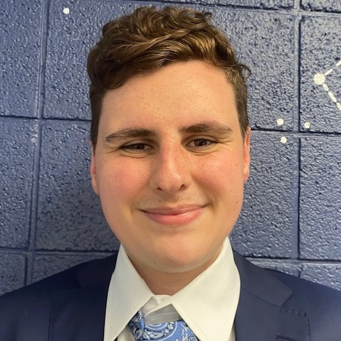
Name: Ben Sherwin
College: College of Liberal Arts and Sciences
Major: Mathematics, Physics, Astrophysics
Minor: Theatre

Mentor: Zachary Slepian

Project Title: Searching for Parity Violation Using Topological Data Analysis

Project Description: In this project, I will be building on previous work by the Slepian group which computed thousands of coefficients needed to describe the 4-Point Correlation Function (4PCF), which is the lowest-order statistic sensitive to parity breaking [2,3]. Fundamentally, the 4PCF describes the number of tetrahedra formed by quadruplets of galaxies in 3D within a sky survey. Each galaxy defines one vertex of the tetrahedron. These coefficients have been computed from the roughly 1M galaxies in the BOSS survey using a GPU-based algorithm on HiPerGator 3.0. However, the 4PCF is high-dimensional: there are on the order of 10,000 different coefficients that capture all relevant information. To find a parity-violation detection in the coefficients, we combine them weighted by the inverse covariance, which measures how independent each measured coefficient is from the others. Unfortunately, the covariance matrix is then enormous: 10,000 by 10,000. This is problematic because the covariance is estimated from mock catalogues but we need about five mocks per coefficient. Hence, this leads to a need for about 50,000 mocks which are unfeasible to compute. An AI-based compression scheme is needed that captures the impact of parity-violating in the 4PCF yet reduces the dimensionality significantly. Therefore, I will collaborate with Prof. Zachary Slepian and math professor Hubert Wagner to use Topological Data Analysis (TDA) to identify the key “invariants” in the space of 4PCF coefficients. TDA can also be used as a machine learning technique and can help to isolate and remove systematic errors that may be present in the data. The ultimate goal of this project is to reduce each parity-breaking inflation model’s signature in the 4PCF down to unique values of just a few topological invariants and understand why these invariants persist.

Research Interests: Cosmology, Computational Physics

Academic Awards: Presidential Platinum Scholarship, University Scholars Program
Involvement: Society of Physics Students
Hobbies and Other Interests: Theatre

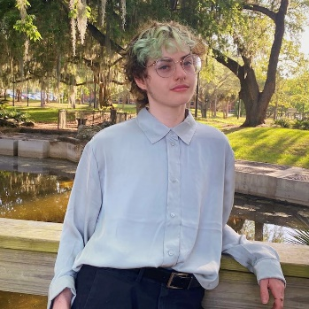
Name: Sacha Sides
College: College of Liberal Arts and Sciences
Major: Anthropology
Minor: Zoology and Theatre Production (Costume Track)

Mentor: Valerie DeLeon

Project Title: Hypsodont Incisors and Facial Growth in the Aye-Aye

Project Description: Daubentonia madagascariensis, colloquially known as the Aye-Aye, harbors an expansive range of adaptations which distinguish it from the rest of the Madagascan Lemur superfamily. When foraging, Daubentonia use their unique 3rd digit to rapidly tap on trees and “percussive hunt”, or echolocate grub from within hollow insect tunnels in the wood. Their ever-growing, rodent-like hypsodont incisors allow the aye-aye to gnaw holes in bark, enabling easy to access to prey. This cranial feature formerly motivated taxonomists to separate the aye-aye from other primates, but it has since been identified as a unique–and adaptive–trait across known primate evolutionary history. In my project, I am utilizing 3DSlicer, an open-access 3Dvisualization software, to reconstruct the skulls of adult and juvenile Daubentonia. I am using a combination of microCT to visualize bone and diceCT for visualizing soft tissues to analyze the aye-aye’s cranial morphology. Expanding upon the existing research will elucidate a more comprehensive understanding of primate evolutionary history. This will enable anthropologists from all disciplines to effectively explore the importance of different biological and social mechanisms, and how they might have influenced human evolution through today.

Research Interests: Evolutionary anthropology, functional and comparative morphology, ontogeny, biomechanics

Academic Awards: Dean's List (2022-Present), American Association for Anatomy 2023 Undergraduate Poster Presentation Award Finalist, AAA 2023 Undergraduate Travel Award
Involvement: Emic Magazine, uFASA
Hobbies and Other Interests: Storycrafting and world-building, creative writing, digital art, gothic literature, crafting, musical theatre, and my cat Artemis

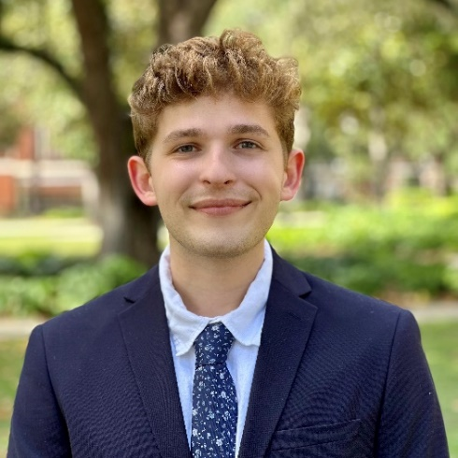
Name: Tyler Thompson
College: College of Liberal Arts and Sciences
Major: BS Psychology, BS Biology
Minor: N/A

Mentor: Lori Knackstedt

Project Title: Applying behavioral economic approaches to investigate Oxytocin-sucrose motivational interactions in a rat model.

Project Description: Opioid use disorder is at epidemic levels in the United States. The National Institute of Drug Abuse reports in 2020 that 68,630 out of 91,799 lethal overdoses were primarily attributable to opioids. Oxytocin, a neuropeptide and endogenous modulator of reward, demonstrates promise as an emerging treatment for substance use disorders. One pre-clinical alcoholism study found that pre-session, intraperitoneal-injections of oxytocin reduced oral alcohol intake of male Sprague-Dawley rats. Subsequently, our lab has investigated oxytocin’s potential treatment effects and found that chronic oxytocin treatment decreases demand for oxycodone using a rodent model of intravenous self-administration (IVSA). Economic demand for oxycodone can be quantified using animal models of operant drug administration. We found that 1mg/kg oxytocin enhances demand elasticity to self-administer oxycodone (i.e., reduce seeking). Because oxytocin is known to modulate food-rewards through regulating mesolimbic, reward-associated circuits, in this project we plan to use the same operant self-administration model to test oxytocin’s effect on demand for sucrose pellets. By evaluating the interaction between oxytocin and sucrose pellet seeking, we can characterize the relative specificity of oxytocin’s effects for opioids versus natural rewards. We hypothesize that oxytocin+sucrose rats will demonstrate an increased elasticity of demand for sucrose pellets (i.e., reduced seeking) compared to saline+sucrose rats (controls).

Research Interests: Drug discovery, chemical biology, and neurophysiology

Academic Awards: Dean's List: Fall 2020, Spring 2021
Involvement: UF Neuroscience Club, UF Queer Cultivation Program, UF Pride Student Union
Hobbies and Other Interests: Yoga, walking outdoors, cycling, and listening to podcasts

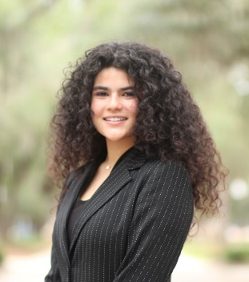
Name: Brianey Torres
College: College of Liberal Arts and Sciences
Major: International Studies
Minor: N/A

Mentor: Christopher Smith

Project Title: Between Waifu and Besto Friendo: Parasocial Relationships and Cowboy Bebop, Attack on Titan, and Death Note Fans

Project Description: The eruption of Anime has captivated western pop culture animation fans. Its increased popularity gives fans a space to have passionate relationships with the medium. Recently, these relationships have reached their sociological extreme in the form of parasocial relationships and interactions. The term parasocial interactions, originally coined by sociologists Donald Horton and R. Richard Wohl, describes one-sided relationships that give a sense of platonic or romantic friendship without having to maintain the responsibility of an actual one. Eastern and western audiences have comparatively different parasocial relationships with anime, primarily in the intensity of relationship types. This research intends to analyze the relationships of the fanbases surrounding anime and what factors contribute to creating them, specifically: how character design could induce or enforce those relationships. The focus of this paper is to bridge the research gap between the concept of parasocial relationships and the uncanny valley. Animators, across genres, seem to overcompensate for character features in their quest to differentiate characters’ and avoid the Uncanny Valley, leading to the over-sexualization of characters and unrealistic body proportions The term Uncanny Valley–originally coined by Roboticist Masahiro Mori–describes how as a robot’s appearance becomes more human-like, one’s affinity toward the robot is decreased. The goal of this research is to explain the growing prevalence and acceptance of parasocial relationships. As immersive technology continues to advance, these relationships could be further consummated, altering human interactions and society at large.

Research Interests: Japanese Media/Pop Cultures
Involvement: Florida Cicerones, CURBS
Volunteering: Turlington Language Studio
Hobbies and Other Interests: Crochet/Cooking

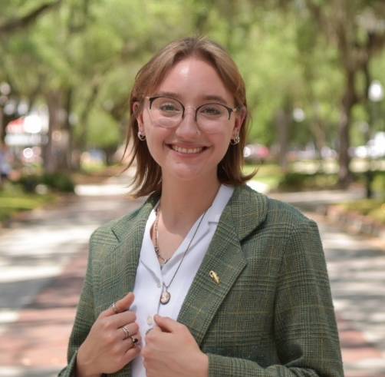
Name: Lauryn Tyler
College: College of the Arts
Major: Art and Anthropology
Minor: N/A

Mentor: Marit Østebø

Project Title: Aesthetic Microtrends on Social Media

Project Description: In this research project I will examine aesthetic microtrends on social media to gain information about how they are tied to identity, who participates in them, and what they are made up of. Aesthetic microtrends as a whole can be described as performative identity niches in which visual cues are associated with one’s personal online identity. Key motifs go beyond simply what you’re wearing– many incorporate wholesale lifestyle choices like the music you listen to, your favorite movies, your coffee order, etc. I will explore how identity becomes intertwined with online and offline performance.

Research Interests: Digital anthropology, the anthropology of social media, visual anthropology

Involvement: Rowdy Magazine, Fluidity Fashion, FLC council member 2021-2022
Hobbies and Other Interests: Hiking with friends, exploring new places, and going to local concerts

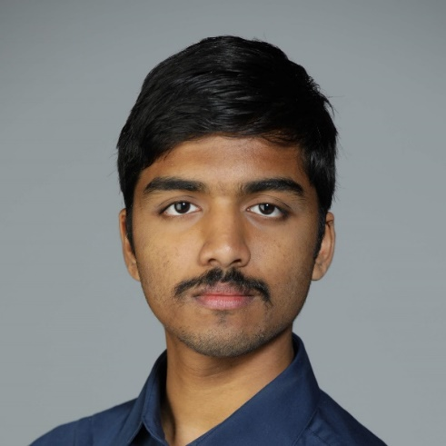
Name: Sreeram Vasudevan
College: College of Liberal Arts and Sciences
Major: Physics, Math
Minor: Computer Science

Mentor: Neil Sullivan

Project Title: Further Optimizing Tunnel Diode Measurements and the Detection of the Magneto-electric Effect

Project Description: Tunnel diodes can used to detect small changes in the magnetic susceptibility of quantum magnets. These changes can be associated with phase transitions or with spin cross-over effects due to applied fields or strains. A prime example of current interest is the detection of electric field induced magneto-electric responses. Such responses could provide new lower power means of manipulating quantum spins used as qubits. Because the tunnel diodes depend on quantum tunneling, they can be used at cryogenic temperatures, thereby improving the signal to noise ratio by several orders of magnitude. The current-voltage characteristics of these diodes have a negative resistance region, and this feature is used to create a very stable radio frequency oscillator, the frequency of which is a function of the magnetic susceptibility of a sample contained inside the inductance of the oscillator. The limit of the resolution of a tunnel diode oscillator depends on the stability with respect to small changes (noise) in the operating point (position on IV characteristics) used. This dependence is not well understood, and the goal of this research project is to explore the frequency stability of a tunnel diode operating at liquid helium or liquid nitrogen temperatures as a function of voltage bias. The diode and its bias circuitry will be maintained in cryogenic bath at fixed temperature and the fluctuations in the frequency monitored with a frequency counter.

Research Interests: Condensed Matter, Quantum Computing

Involvement: Society of Physics Students
Hobbies and Other Interests: Anime, Gaming

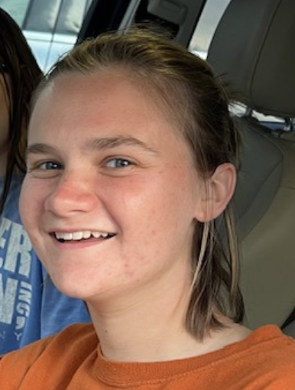
Name: Victoria Williamson
College: College of Liberal Arts and Sciences
Major: Astrophysics
Minor: Math

Mentor: Zachary Slepian

Project Title: Understanding Turbulence in the Interstellar Medium with the 4PCF

Project Description: The Interstellar Medium (ISM) is the gas and dust between stars, composed primarily of low-density regions as well as sparse star-forming molecular clouds. The ISM is the birthplace of stars, and the gas within it is governed by turbulence and magnetic fields. SARABANDE is a python code for measuring the 3-and 4-Point Correlation Functions on 2D and 3D gridded data using Fast Fourier Transforms. Its ability to take in gridded data sets allows it to easily run on many magnetohydrodynamic simulations of the ISM, enabling us to explore varying parameters such as B-field and turbulence in the simulations. The aim of this project is to expand our understanding of turbulence in the ISM through the 4PCF (3PCF and 4PCF) by using SARABANDE. By applying the code on 2D and 3D gridded data of the ISM we intend to sharpen our understanding of the physical processes that control the medium and conduct the first 4PCF study of the ISM to better understand how turbulence and magnetic fields impact star formation.

Research Interests: Cosmology, the interstellar medium, high-mass star formation, black holes

Academic Awards: University Research Scholars Program
Involvement: Astronomy & Astrophysics Society, Outdoor Adventure Recreation, Horticulture Science Club
Volunteering: Alachua County Public Schools
Hobbies and Other Interests: Painting, hiking, gardening, soccer, yoga

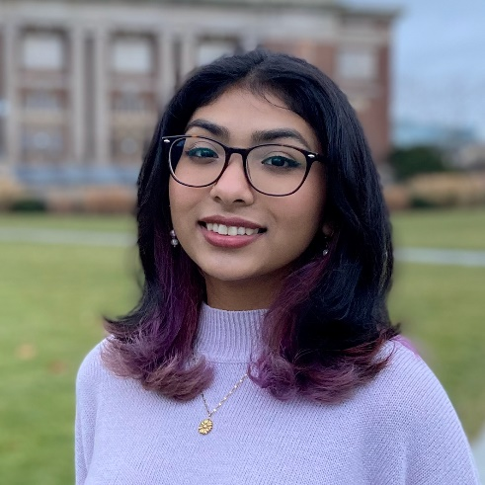
Name: Sabrina Yeahia
College: College of Liberal Arts and Sciences
Major: Anthropology
Minor: Classics

Mentor: Gabriel Prieto

Project Title: Viru Ceramics: Exploring ceramic vessel wares from domestic and burial contexts with consideration of morphology and decoration from the Huanchaco Maritime Community, North Coast of Peru

Project Description: I will be studying the morphological and decorative differences between Viru ceramics found in burial and domestic contexts. I would work to determine classify these differences for easier identification in the field. I will also explore the social and cultural significance of the distinctions between style and context when unearthing these vessels.

Research Interests: Anthropology and Archeology

Involvement: uFASA
Hobbies and Other Interests: Cooking, baking, painting, photography

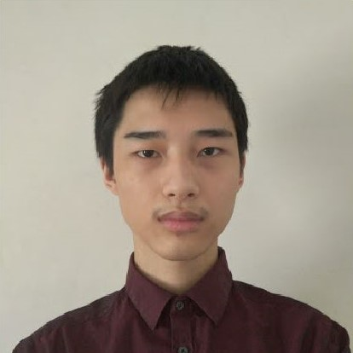
Name: Bill Zhao
College: College of Liberal Arts and Sciences
Major: Chemistry
Minor: N/A

Mentor: Wei Wei

Project Title: Mo Single-Atoms Supported by g-C3N4 for Electrocatalytic Nitrogen Reduction

Project Description: Nitrogen gas reduction into ammonia is an important reaction used in the production of fertilizer. This project seeks to construct a molybdenum single atom catalyst stabilized by the nitrogen atoms on graphitic carbon nitride, and have its nitrogen reduction catalytic properties assessed.

Research Interests: Catalysis, Synthesis

Academic Awards: National Merit Finalst. Dean's List Fall 2021 - Fall 2022.
Involvement: UF Chemistry Club, UF Quizbowl.
Hobbies and Other Interests: Basketball, Chess

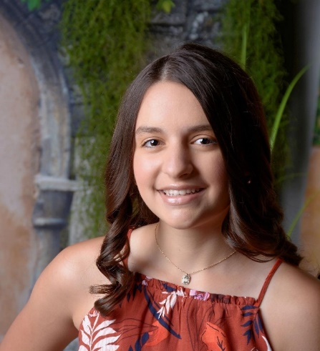
Name: Katerina Anamisis
College: College of Liberal Arts and Sciences
Major: Biochemistry
Minor: N/A

Mentor: Dr. Piyush Jain

Project Title: CRISPR-mediated genome editing tool development for targeting and addressing USH2A mutation for patients with Usher syndrome Type

Project Description: Usher syndrome is a rare genetic disease that affects both hearing and vision. Out of three distinct types of Usher syndrome, type II is the most common. Type II is caused by mutations of the USH2A gene. This triggers progressive deterioration of photoreceptor function, commencing with the more susceptible rod cells. This subtype of Usher syndrome includes moderate to severe sensorineural hearing loss from birth and progressive loss of vision, prompting retinitis pigmentosa (RP). Despite the varying severity of hearing loss, people with this condition can benefit from hearing aids and cochlear implants. As such, more attention is focused on developing treatments for the RP component of Usher syndrome. The objective of my project is to develop a CRISPR-based gene editing technology directed towards addressing Usher syndrome type II. I will design and test various engineered CRISPR/Cas-based prime editing systems for correcting USH2A gene mutations to treat Usher Syndrome in vitro and then in vivo. My overall goal is to apply a CRISPR-mediated prime editor tool to correct USH2A gene mutations that can be used in clinical trials.

Research Interests: Developing CRISPR-based genome editing tools for rare diseases and CRISPR-Cas systems for diagnostic purposes, Usher syndrome, signal transduction pathways, gene expression.
Academic Awards: College of Medicine University Scholar Award (Title: Sex Differences in Mitochondrial Function in Mouse Inner Ears, $1,750); Dean’s Medal for Excellence in Liberal Arts and Sciences
Involvement: Orthodox Christian Fellowship, Gator Diplomats
Volunteering: Afieroma Greek Dance Troupe, Lake Como School Tutoring PrograHobbies and Other Interests: Greek folk dancing, Greek language, American Sign Language, traveling, cooking, running, medical coursework (have completed: Introduction to Breast Cancer, Vital Signs: What the Body is Telling Us, Introduction to Hearing Loss, Introduction to the Biology

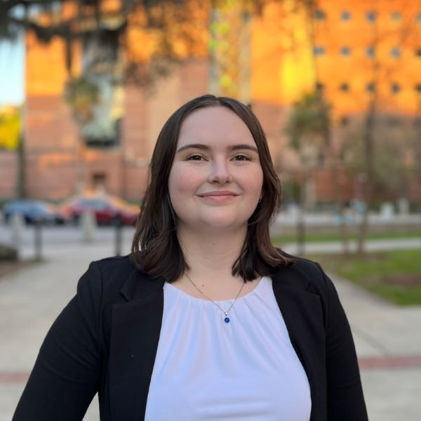
Name: Natalie Barber
College: College of Medicine
Major: Psychology (Behavioral and Cognitive Neuroscience) and Biology (pre-professional)
Minor: Health Disparities in Society

Mentor: Barry Setlow, PhD

Project Title: Chronic Effects of THC and CBD on Hippocampal Function in Aging

Project Description: This study will investigate the effect of chronic THC (with and without CBD) consumption on hippocampal function in male and female young adult and aged rat models.

Research Interests: Cognition, addiction, and aging

Academic Awards: Raytheon National Merit Award
Involvement: Out in STEM, Equal Access Clinic Network
Volunteering: Equal Access Clinic Network

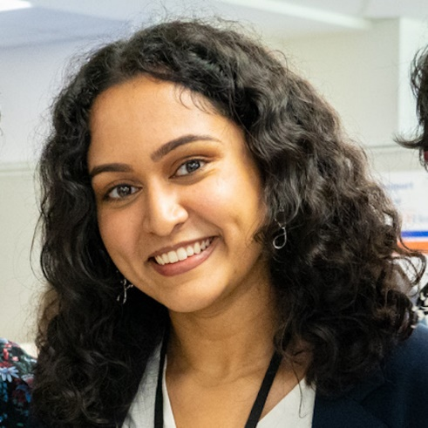
Name: Mauli Bhogade
College: College of Medicine
Major: Biochemistry and Molecular Biology
Minor: Biomolecular Engineering

Mentor: Habibeh Khoshbouei

Project Title: Role of T-Cells in Parkinson's Pathology Progression

Project Description: The objective of this project is to evaluate the role of gut immune system in the generation of a-syn reactive T-cells in a gut-first model of Parkinson’s disease (PD). PD is characterized by loss of dopamine neurons in substantia nigra and accumulation of Lewy bodies (composed of a-syn protein aggregates), which also appear in the enteric nervous system. It is hypothesized that PD begins in the gut and spreads to the brain, but the factors are not well understood. The immune system may play a role - a-syn reactive T-cells have been found in the blood of PD patients, raising the question of where these disease-associated T-cells originate. When macrophages in the gut phagocytose a-syn they present specific antigens via major histocompatibility complexes (MHC) to T cells. These T cells then differentiate and play an important role in immunity against pathogenic agents. To measure the phenotype and reactivity of T-cells in the gut and in circulation, we will be utilizing a flow cytometry and MHC tetramer assay. To study the dynamics within the brain we will examine the brain parenchyma and the brain borders, including the meninges using the Kaede mouse line.

Research Interests: Translational Medicine, Immunology, Neuroscience

Academic Awards: Dean's List, University Scholar's Program 2022
Involvement: Equal Access Clinic Network, Florida Club Swim and Dive
Volunteering: Equal Access Clinic Network, Gators for Refugee Medical Relief
Hobbies and Other Interests: Swimming, Running, Music, Cooking

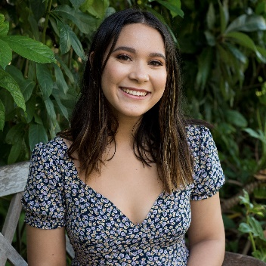
Name: Kayla Booth
College: College of Liberal Arts and Sciences
Major: Anthropology
Minor: Health disparities

Mentor: Martin Cohn

Project Title: Development of Sex Differences in the Mouse Bladder

Project Description: Men and women are known to differ in their susceptibility and responses to many diseases. For example, bladder cancer is much more common in men, but women are approximately 35 times more likely to be affected by urinary tract infection (UTI). Although fewer men contract UTIs, they have much worse clinical outcomes than women. In both of these diseases, the basis of the sex difference is not well understood. The Cohn Lab investigates the mechanisms responsible for the sexual differentiation of genitourinary organs, especially external genitalia, and found that there are sex differences between male and female genitalia at the single-cell level. I will test the hypothesis that prenatal exposure to vinclozolin disrupts the sexual differentiation of the bladder in the mouse model. I will examine this by treating pregnant mice with vinclozolin during the critical development period when the lower urinary track is known to respond to androgen signaling, and then I will examine effects on the histological structure, gene expression, and cell type identities in male and female bladders collected from vinclozolin-treated and control mice. This research has multiple applications for basic science and human health, including understanding sexual differentiation of an organ not previously known to be sexually dimorphic, whether early exposure to EDCs affects normal bladder development, and susceptibility to disease.

Research Interests: Sexual dimorphisms, developmental biology, epigenetics

Academic Awards: University Research Scholars Program, UF Honors Program
Involvement: UF Pre-Physician Assistant Association, Book Explorers, Medigators
Volunteering: UF Pre-Physician Assistant Association
Hobbies and Other Interests: Reading, playing piano and flute, traveling

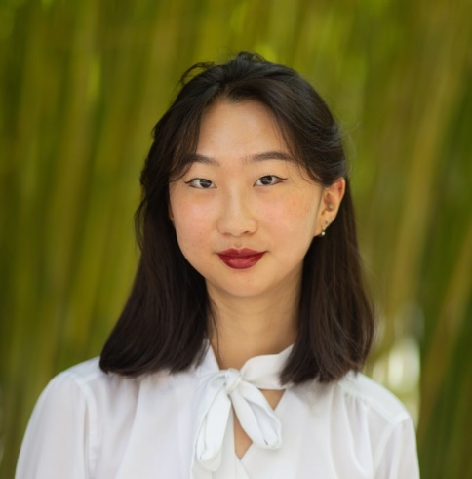
Name: Lily Cao
College: College of Medicine
Major: Mathematics
Minor: N/A

Mentor: Barry Setlow

Project Title: Contributions of the Ventral Hippocampus to Risky Decision Making

Project Description: The ventral hippocampus has been linked to approach-avoidance conflict, but it is unclear how the ventral hippocampus is involved in risky decision making, which involves probabilistic negative outcomes. In order to understand the contributions of the ventral hippocampus to risky decision making, rats were trained in operant chambers on the “risky decision-making task” (RDT). In the RDT, rats made a choice between two levers: one that delivered a small, “safe” food reward and the other that delivered a large, “risky” food reward that was accompanied by varying probabilities of mild footshock. Optogenetic inhibition was conducted during discrete phases of the task in separate sessions. Depending on rats’ choice on each trial, three outcomes were possible: delivery of the small, safe reward; delivery of the large reward without footshock (large, unpunished reward); and delivery of the large reward with footshock (large, punished reward). Inhibition of the ventral hippocampus during receipt of the large, punished reward led to a reduction in choices of the large, risky reward. These results indicate that ventral hippocampus is involved in encoding information about the magnitude or frequency of punishment relative to the large reward. More broadly, these results provide evidence for a causal role of temporally-discrete ventral hippocampus activity in cost-benefit decision making.

Research Interests: Decision making, social behavior, learning and memory

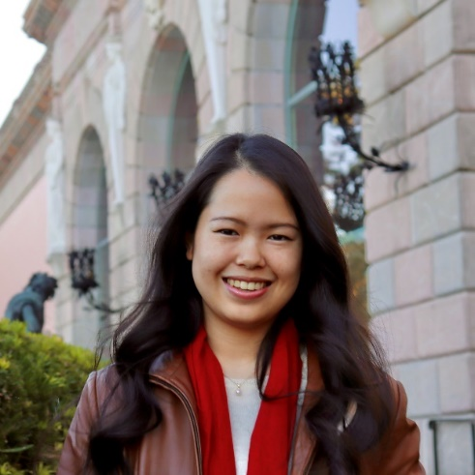
Name: Rosenna Chan
College: College of Medicine
Major: Microbiology and Cell Science
Minor: N/A

Mentor: Dr. Zhe Ma

Project Title: Characterizing the Effect of KSHV miRNAs on the cGAS-STING Innate Immunity Pathway

Project Description: Kaposi’s - Sarcoma Associated Herpes Virus (KSHV) is the etiologic agent of several malignancies including Kaposi’s Sarcoma (KS), Primary Effusion Lymphoma (PEL), and Multicentric Castleman Disease (MCD). KSHV establishes lifelong infection by encoding genes that manipulate the host immune system. It was identified that KSHV is able to evade host innate immunity by suppressing the cGAS-STING pathway. Viral proteins were determined to be one of the agents responsible for this response. However, the KSHV genome also encodes viral miRNAs that have been shown to inhibit the expression of cellular proteins and the exact functions of these miRNAs remain yet to be characterized. Presently, we are working on analyzing the effect miRNAs have on STING expression across various cell lines. This project aims to enhance our understanding on how KSHV uses viral miRNAs to evade host immune responses, especially within the cGAS-STING pathway. Results from these experiments can be later applied to explore potential therapeutic targets for treating the various malignancies associated with KSHV.

Research Interests: Molecular Biology, Virology, Cancer Therpeutics

Academic Awards: University Honors Program, University Scholars Program
Involvement: Equal Access Clinic Network, Chinese American Student Association (CASA), MFOS Peer Mentor
Volunteering: EACN, Shands Volunteering, Gainesville Giving Garden, Habitat for Humanity
Hobbies and Other Interests: 3D origami, outdoor recreation, cooking, baking

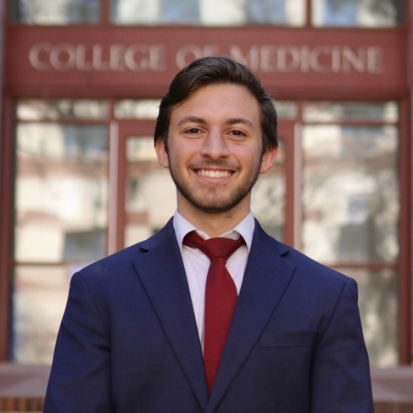
Name: Jared Coleman
College: College of Medicine
Major: Biomedical Engineering
Minor: Chemistry and Entrepreneurship

Mentor: Clive Wasserfall, Ph.D.

Project Title: Optimization of an antibody panel for high-parameter fluorescence imaging of pancreas and immune tissues in the study of type 1 diabetes

Project Description: Recent evidence suggests type 1 diabetes (T1D) pathogenesis involves a combination of immune, islet, and acinar pancreas defects. As a result, there exists a need to understand each of these facets together throughout T1D progression, linking islet and acinar cell function with precise cellular composition of the insulitis lesion. Using ultra-high content imaging to provide profiling of immune and pancreas phenotypes, this research project seeks to discover if intrinsic β-cell stress triggers innate inflammation; this inflammation would result in immune trafficking and localized islet and acinar pathology and culminate in immune-mediated destruction of β-cells. The imaging will assess in situ expression of 70 immune and pancreas cell markers, encompassing vascular and lymphatic annotation indicative of inflammation, extravasation/trafficking, or immune cell presence in those with well-characterized insulitis. A comparison will then be made between non-inflamed and inflamed islets to determine correlation of insulitis with islet and acinar cell phenotypes.

Research Interests: Type I diabetes, immunohistochemistry, fluorescence imaging, autoimmune disorders

Academic Awards: University Research Scholars Program, Jorge Mas Canosa Freedom Foundation Scholarship
Involvement: Dream Team Engineering, Biomedical Engineering Society, Hispanic Student Association, Sigma Phi Epsilon
Volunteering: Member Leadership Program Servant Leadership director
Hobbies and Other Interests: Working out, traveling, community service, cooking

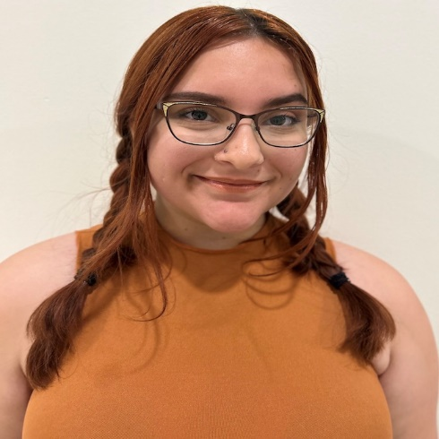
Name: Anamaria Cotelo
College: College of Medicine
Major: Psychology on the BCN track
Minor: Computer Science

Mentor: Dan Wesson

Project Title: Organization of Midbrain Dopaminergic Input to the Tubular Striatum

Project Description: The focus of this project is to map the innervation of ventral tegmental area (VTA) dopaminergic neurons into regions of the ventral striatum (VS). The VS plays a critical role in motivated behavior, and having a better idea of how dopamine innervates this area allows future research to better target specific areas for the manipulation of dopamine. This work will also go on to support future work in our lab.

Research Interests: Reward and Motivated Behavior

Academic Awards: Best Undergraduate Poster Presentation at the UF CARE Symposium
Hobbies and Other Interests: I play guitar, piano, and sing.

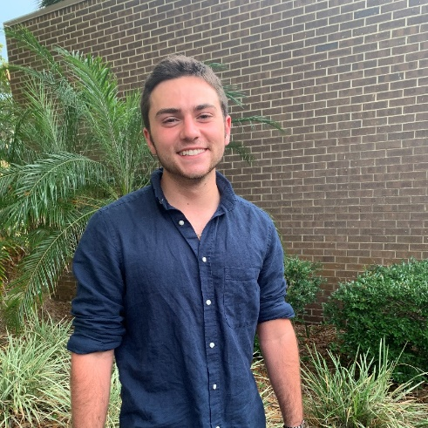
Name: Lewis DeCicco
College: College of Medicine
Major: Microbiology
Minor: Pathogenesis

Mentor: Dominick Lemas

Project Title: The Impact of the Human Milk Metabolome on Maternal-Infant Health Outcomes

Project Description: There is limited information on how maternal obesity impacts the composition of the human milk metabolome and ultimately influences infant health outcomes. The goal of this proposal is to investigate the impact of maternal obesity on the human milk metabolome and infant outcomes. Breastmilk collected from mothers in the BEACH study will be identified and analyzed. Mass spectrometry, protein assays, and chromatography are techniques that will be utilized to determine the levels of specific metabolites in the mother. This process will be repeated for milk samples collected at 2 weeks, 2 months, and 12 months postpartum. The results of this study will provide new insights on the human milk metabolome and how maternal obesity can influence infant health and growth through the process of breastfeeding.

Research Interests: Virology, molecular biology, and metabolomics

Involvement: Florida Cicerones, Alpha Epsilon Delta, and President of Hearts for the Homeless
Volunteering: GRACE Marketplace, St. Francis House, Bread of The Mighty Food Bank, and HarborChase Senior Living Community
Hobbies and Other Interests: Yoga, playing the piano, gardening, and traveling

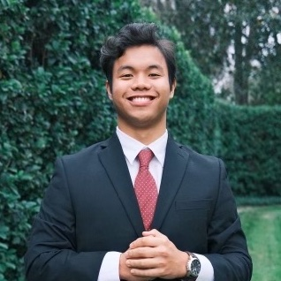
Name: Glen Dizon
College: College of Medicine
Major: Business Administration
Minor: Chemistry

Mentor: Khoshbouei

Project Title: Understanding the Relationship Between T cell and B cell subsets' expression of DAT/TH in PD Patients

Project Description: Parkinson’s Disease (PD) is characterized by loss of dopamine neurons, decreased dopamine transporter (DAT), and tyrosine hydroxylase (TH) expression in the central nervous system (CNS). Recent studies suggest a relationship between peripheral immunity and degeneration of brain dopamine neurons, but the underlying mechanism remains elusive. Previous USP fellow from our lab, Stephen Franks, investigated the connection between loss of dopamine neurons in PD patients and animal models of PD. His data suggest that loss of CNS dopamine leads to dysregulation of dopamine transporter (DAT) and tyrosine hydroxylase (TH) in peripheral monocytes of PD patients and PD mice. These data represent a potential blood-based biomarker for PD. Additional data from our lab revealed an immunosuppressive role for DAT on peripheral immune cells suggesting increased monocytic suppressive cells could be a response to the reported inflammation in PD patients. Additional in vivo and ex-vivo studies from our lab shown that genetic deletion of DAT increases inflammatory responses in DAT KO mice, therefore, our data is consistent with the interpretation that increased DAT expressing peripheral immune cells is a compensatory response to inflammation in PD. The overarching goal of my USP project is to continue these studies testing the hypothesis that both innate and adaptive immunity are changed in PD.

Research Interests: Innate and Adaptive Immunity changes in PD Patients

Involvement: Gator Innovators
Volunteering: Community Hospice & Palliative Care
Hobbies and Other Interests: Golfing and Playing the violin

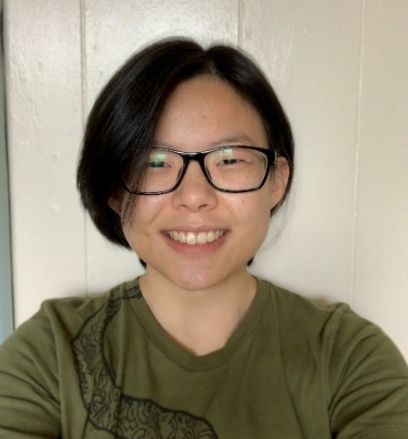
Name: Jessi Effinger-Morris
College: College of Medicine
Major: Biology
Minor: N/A

Mentor: Mingyi Xie

Project Title: The role of snaR-A non-coding RNA in cellular processes

Project Description: A large portion of RNAs that exist in cells are non-coding RNAs. These RNAs do not code for a protein but have important roles in gene regulation and are often implicated in cancer. The snaR family of non-coding RNAs are highly structured with conserved sequences1,2. snaR-A is the most abundant of this family and has been shown to interact with the RNA-binding protein NF90. NF90 is a protein that has been implicated in various cellular processes including RNA metabolism. snaR-A is upregulated in several tissues and immortalized cell lines, indicating a possible role in cell proliferation and cancer cells. The function of snaR-A is ambiguous, as well as the biological function of its interaction with NF90. It has been shown to associate with ribosomes but the function this plays in the cell is unknown. We will study the function of snaR?A in the cell by generating tetracycline conditional knockdowns of the snaR-A transcript, targeting the promoter and body of snaR-A using a dCas9 lentivirus system. This knockdown will be conducted in immortalized cell lines 293T, MCF7, and U87mg due to their high expression of snaR-A. We will observe the phenotypic effects of this knockdown in the cells to identify the role snaR-A may play in cellular processes and possibly cancer. This project seeks to identify the role of snaR-A interactions in cells and provide a better understanding of the pathological mechanisms.

Research Interests: Cancer, developmental biology, rna

Academic Awards: ESP 2021-2022
Volunteering: Astra

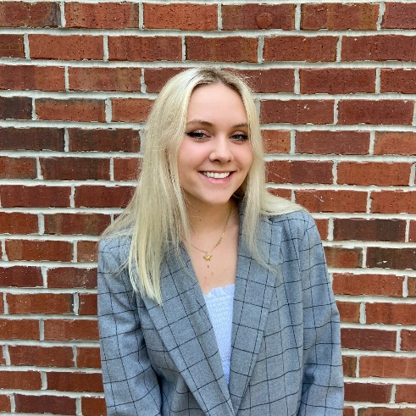
Name: Ivy Fitzsimons
College: College of Liberal Arts and Sciences
Major: Psychology
Minor: Disability in Society

Mentor: Sara Jo Nixon

Project Title: Examining the relationship between naturalistic hallucinogen drug usage and alcohol consumption in individuals seeking treatment

Project Description: In this project, I plan to investigate whether individuals seeking treatment who report both alcohol use disorder (AUD) and regular use of hallucinogens drink less than their non-hallucinogen using counterparts. While hallucinogens have begun to develop clinical significance, their nonclinical interaction with AUD has yet to be thoroughly examined.

Research Interests: Neuroscience and Cognition, Substance Use, Attachment Theory

Academic Awards: University of Florida's Dean's List
Involvement: Swamp Records, New Age Radio Club
Hobbies and Other Interests: Yoga, Writing, Tennis, Traveling, Live Music

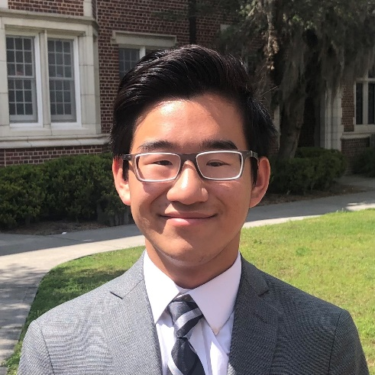
Name: Jonathan French
College: College of Medicine
Major: Biomedical Engineering
Minor: N/A

Mentor: Walter O'Dell

Project Title: Metastatic Tumor Early Detection

Project Description: In 2020, an estimated 18 million people were diagnosed with cancer; of those, an estimated 9.89 million died of the disease. Approximately 90% of those deaths are attributed to metastatic cancer, where parts of the cancer tumor break off of the original tumor and travel to different parts of the body. Also, cancer mortality drastically increases the longer treatment is delayed. Despite this, roughly half of all lung cancers are detected when they’re at the most advanced stage. These data suggest the significance of early detection and prevalence of metastatic cancer. My research project aims to improve early metastatic cancer detection via three aims: computer-aided detection (Aim 1), expansion and updates to the datasets used for validation and testing (Aim 2), and usage of whole-body MRI scans (Aim 3). Most current databases assume a spherical, constant-density nodule, despite the fact that tumors grow in many shapes and densities. The expanded database will house more than just the “ideal” tumor, but those with deformities, varying densities, irregular shapes, etc to better represent realistic tumor growth in humans. Aim 3 hopes to improve patient outcomes by evaluating the current whole-body MRI protocols for those at an increased risk of metastatic cancer. The benefits of successful early detection have already been discussed, and this aim directly addresses the goal of early detection.

Research Interests: Oncology and

Academic Awards: Florida Academic Scholars, Deans' List (every semester)
Involvement: Biomedical Engineering Society,
Hobbies and Other Interests: piano, swimming, walking

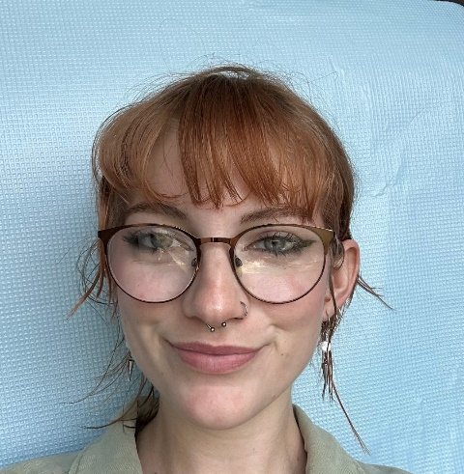
Name: Madison Halcomb
College: College of Medicine
Major: Psychology- BCN
Minor: Health Disparities in Society

Mentor: Barry Setlow

Project Title: Neurobiological effects of polysubstance use on cocaine use and relapse

Project Description: The goal of my proposed project is to use a rat model to determine how comorbid cannabis use affects the neurobiology underlying cocaine use and relapse, so as to better understand how the co-use of these drugs may produce different neuroadaptations than cocaine alone.

Research Interests: Drug addiction and relapse behaviors

Academic Awards: National Merit Scholar
Involvement: Footprints, Neuroscience club, Psychology club
Volunteering: Alachua County Crisis Center
Hobbies and Other Interests: painting, scenic walks, thrifting, and collecting vinyls

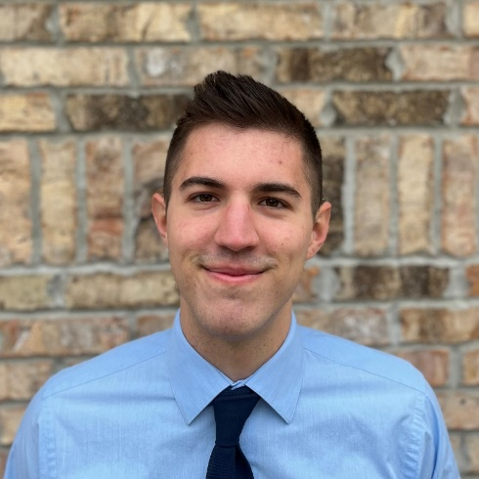
Name: Hunter Hutchinson
College: College of Liberal Arts and Sciences
Major: Biochemistry
Minor: N/A

Mentor: W. Clay Smith

Project Title: Molecular evolution of an arrestin1 therapeutic to treat retinal degeneration

Project Description: Genetic dysfunctions of the retina are a category of orphan diseases which affect over 150,000 Americans. Regulating the metabolism of retinal photoreceptors is a possible method for treatment of retinal degeneration without targeting the specific underlying defect. Photoreceptors have one of the highest energy demands of any cell in the body and fulfill this demand primarily through aerobic glycolysis. In photoreceptors, enolase1 has been shown to complex with arrestin1, a phototransduction enzyme which inhibits the activity of enolase1 by up to 25 percent. As part of the University Scholars Program, I will test the hypothesis that a modified mouse arrestin1 variant gene delivered via Adeno Associated Virus (AAV) will demonstrate increased efficacy at raising the glycolytic potential in mouse photoreceptors and will thus be more effective at slowing retinal degeneration in a mouse model of inherited retinal disease.

Research Interests: Genetics, Ophthalmology, Artificial Intelligence

Academic Awards: CLAS Dean's List
Volunteering: Organic Chemistry Teaching Assistant, UF Health Shands
Hobbies and Other Interests: Reading, Guitar, Weightlifting, Rock Climbing

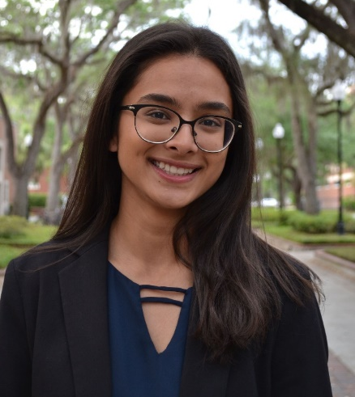
Name: Neha Iyer
College: College of Medicine
Major: Microbiology
Minor: Nutrition

Mentor: Stephanie Karst

Project Title: The role of the GPBAR1 (TGR5) receptor in bile acid-mediated antiviral response against MNV

Project Description: Norovirus is an enteric virus that is transmitted by the fecal-oral route and is responsible for approximately 20% of gastroenteritis in the world. From a global perspective, there is an estimated 685 million annual norovirus cases, 200 million of which occur in children and 200,000 to pediatric deaths. Gut microbiota are comprised of trillions of bacteria that have many effects on the mammalian host. Previous studies demonstrated that depletion of microbiota by administering oral antibiotics prior to murine norovirus infection results in higher viral titers in the proximal small intestine compared to titers in control mice, indicating that gut microbiota playa protective role during MNV infection. However, it’s unknown what role gut microbiota have on MNV disease since adult mice do not develop symptoms in response to MNV infection. Based on our earlier studies in adult mice, we hypothesize that a specific class of microbiota-derived metabolites are responsible for this protective effect. Specifically, we predict that microbiota-derived bile acids bind their cognate receptor called TGR5 and activate an antiviral immune response. Overall, intestinal microbiota and TGR5 activation both protect from severe MNV diarrhea, so we hypothesize that microbiota-derived bile acids bind TGR5 and induce an antiviral IFN response which suppresses MNV infection and disease.

Research Interests: Virology and Molecular Genetics

Academic Awards: UF CLAS Dean's list, USP 2023,Bright Futures Recipient
Involvement: American Physician-Scientist Association, Equal Access Clinic
Volunteering: Tallahassee Memorial Hospital, Tallahassee Womens Clinic, Gainseville Comprehensive Retina Consultants
Hobbies and Other Interests: Dance, trying new foods, travel

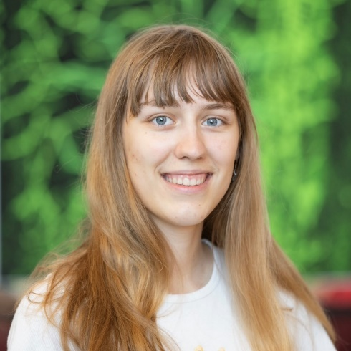
Name: Victoria Karaluz
College: College of Medicine
Major: Microbiology and Cell Science
Minor: N/A

Mentor: Dr. Megan Stanifer

Project Title: Investigating the Effect of Oxygen Level on Intestinal Stem Cell Differentiation

Project Description: My project will be studying stem cell differential within the intestinal system. The intestines are made up of villi, which are protrusions into the gut. The villi tip and invaginations experience an oxygen gradient, with the tips hypoxia in the villi and normoxia in the crypts. The intestinal systems lives in a delicate balance of coexisting with the many beneficial bacteria in our gut while remaining vigilant against potentially harmful ones. One way it is able to balance this is possibly by creating different microenvironment based on oxygen level. It has also been found that stem cells primarily reside in the normoxia crypts. This project will further investigation what role oxygen level has in determining the differentiation of these stem cells and how this may relate to immune response. Various techniques, such as fluorescent in situ hybridization, and models, including organoids and mice, will be used to understand this process.

Research Interests: Gut microbiome, cancer biology and immunotherapy, immune system

Academic Awards: National Merit Scholar; NSHSS Research and Academic Paper Scholarship
Involvement: URSP; Women's Ultimate Frisbee Club; Trip Leader in Training with UF CORE
Volunteering: St. Francis Pet Care; Delray Medical Center
Hobbies and Other Interests: I love playing Ultimate Frisbee! I also love anything in the outdoors - hiking, camping, canoeing. I love to read and do picnics.

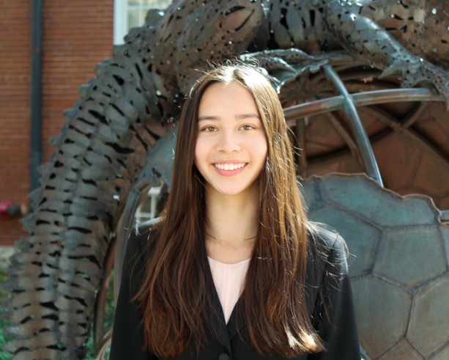
Name: Christina Klassen
College: College of Liberal Arts and Sciences
Major: International Studies
Minor: N/A

Mentor: Julie Bradley

Project Title: Breast Cosmesis after Radiotherapy: A Qualitative and Quantitative Analysis

Project Description: The therapeutic ratio measures the balance between efficacy of treatments and their side effects. In treatment of women with breast cancer, while oncologic outcomes are the priority, quality of life including cosmesis and body image closely follow. Breast tissue and surrounding skin can be altered after breast cancer surgery and radiation. Following both breast conserving surgery and mastectomy with breast reconstruction, cosmetic changes can include asymmetry, retraction, fibrosis, volume loss, persistent edema, and/or permanent skin changes. Proton therapy is a type of radiation that can decrease exposure of the heart and lung in the treatment of breast cancer but may carry a higher risk of acute radiation dermatitis. The effect of radiation modality, specifically photon vs. proton, on breast cosmesis has yet to be reported. We hypothesize that women treated with either breast conserving surgery or mastectomy with reconstruction will have equivalent cosmetic outcomes between photon and proton radiotherapy as measured by (1) patient-reported outcome and (2) computer analysis of serial breast/chest wall photographs. The results from the PRO and the symmetry photographic analysis will be evaluated based on type of radiation treatment (photons vs protons) as well as patient factors including race, age, and co-morbidities that can increase the risk of radiation toxicity including diabetes, smoking status, obesity, and low vitamin D level.

Research Interests: radiation oncology, radiotherapy, health disparities, oncology, proton therapy
Academic Awards: President's Honor Roll, Dean's List, UFHCC Poster Presenter, University Scholar's Program Travel Award
Involvement: UF MEDLIFE, University of Florida Club Swim Team, Vietnamese Student Organization, UF HEAL
Volunteering: UF MEDLIFE, Global Children's Initiative
Hobbies and Other Interests: Traveling, reading, learning new languages, surfing

Name: Joanne Koshy
College:
Major:

Minor: N/A

Mentor: Habibeh Khoshbouei

Project Title: TBD

Project Description:TBD

Research Interests:

Academic Awards:
Involvement:
Volunteering:
Hobbies and Other Interests:

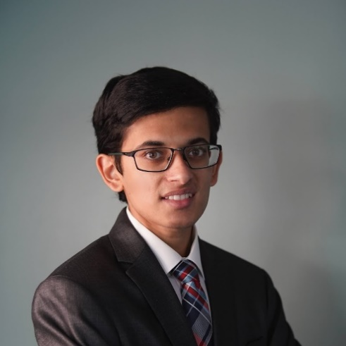
Name: Achyudhan Kutuva
College: College of Medicine
Major: Microbiology and Cell Sciences, Data Science
Minor: N/A

Mentor: Dr. Henrique de Assis Lopes Ribeiro

Project Title: A Boolean Network Model of Gene Regulation in Airway Epithelial Cells in SARS-Coronavirus Treatment

Project Description: SARS-CoV-2 is a viral respiratory illness that causes COVID-19, which was first detected in December 2019. Based on the public health crisis involving this disease and with current knowledge of the various biological mechanisms that COVID-19 employs, an integrative Boolean network model will be developed. This model will discretely represent actions that take place continuously in the human body, specifically focusing on viral effects on pneumocytes. By incorporating elements of various cellular processes, including the AKT-mTOR pathway, the ACE 2-Angiotensin pathway, and other pathways involved in cellular apoptosis and necroptosis, we hope to develop a robust model to document how biological mechanisms interact upon infection with COVID-19, which we hope will guide the development of novel therapeutics. Many of these mechanisms also overlap with responses to other major viruses and diseases, providing motivation to generalize this model while maintaining relative simplicity and high accuracy upon external validation with gene expression time-series data. We would also like to employ novel approaches, such as a genetic algorithm and a neural network, to iteratively improve node connections and regulatory functions based on time-series gene expression data. By developing these model variants, we wish to explore the space of potential networks that can be formed to ascertain how deterministic these networks exist in the real world.

Research Interests: Computational Biology, Systems Biology, Oncology, Artificial Intelligence

Academic Awards: AI Diversity Fellow, CLAS Dean's List, University Research Scholars Program, National Merit Scholar
Involvement: UF Science Olympiad, Data Science and Informatics Student Organization, Scrabble Society

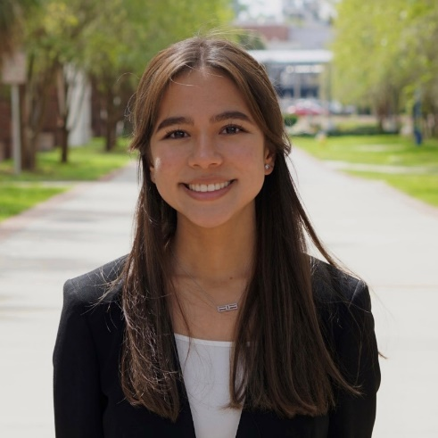
Name: Isabella Mark
College: College of Medicine
Major: Behavioral and Cognitive Neurosciene
Minor: Chemistry

Mentor: Barry Setlow

Project Title: Effects of Acute Cannabis on Age-Related Cognitive Decline

Project Description: The demographics of cannabis consumers has shifted such that older adults now represent one of the most rapidly growing groups of cannabis consumers. With this, it is imperative to understand how age influences the health of chronic cannabis consumers. Age of introduction has been reported to influence the severity of cannabis use effects on cognitive development in both animal and human studies; however, cannabis has also been suggested to positively influence cognition among older adults. Cannabis has been viewed as a potential therapy for Alzheimer’s disease associated cognitive decline, as it can reduce inflammation and Alzheimer’s pathology in cell culture and improve memory function in transgenic mouse models. Currently, the contributions of CBD to potential cognitive benefits of THC have been unexplored. The goal of my project is to determine whether and how CBD modulates the effects of THC on cognitive performance in aged rats.

Research Interests: Neurodegenerative Diseases and Dermatologic Conditions

Involvement: uAMWA
Volunteering: PACE Center for Girls
Hobbies and Other Interests: Badminton and photography

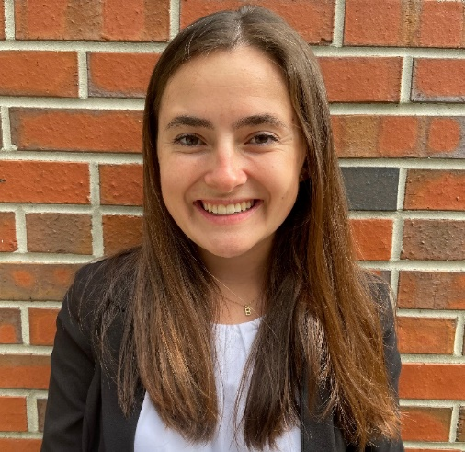
Name: Bailey McCracken
College: College of Liberal Arts and Sciences
Major: Biology
Minor: N/A

Mentor: Dr. Barry Setlow

Project Title: Effect of Oral Chronic Cannabinoids on Tau Pathology in Mice

Project Description: Older adults are among the fastest growing population of cannabis users in the United States. Along with this increase, there is also growth in the number of older adults suffering from Alzheimer’s disease (AD) and cognitive decline. Cannabinoids have been proposed as a possible therapy for AD by stimulating the endogenous cannabinoid system, which can lead to inhibition of hyperphosphorylation of tau protein and reduction in pro-inflammatory cytokine release through decrease microglial activity. Preclinical studies assessing the effects of cannabinoids have been conducted in models of amyloidosis, however, very few studies have examined the effect that cannabinoids can have on tauopathy, which is a critical component of AD pathogenesis. Additionally, these studies have largely used routes of administration (ex. intraperitoneal injections) that do not mimic common human consumption methods. Given the limitations in previous studies, the goal of this experiment is to determine the effects of chronic oral THC and CBD administration on tau pathology and associated markers in a tau overexpression mouse model of tauopathy, as well as the duration of the effects at different points post-cannabinoid exposure.

Research Interests: Age Related Neurodegeneration and Cannabis

Academic Awards: N/A
Involvement: Gator Students for Haven Hospice, Alpha Epsilon Delta
Volunteering: Haven Hospice

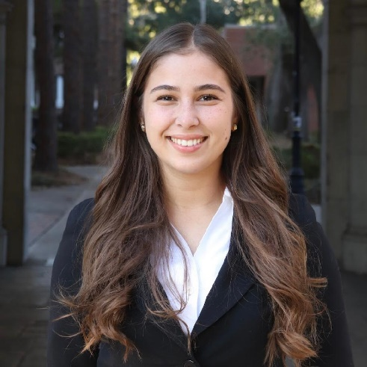
Name: Bryanna Mirabal
College: College of Medicine
Major: Applied Physiology and Kinesiology
Minor: N/A

Mentor: Dominick Lemas

Project Title: The Impact of Obesity on Maternal Physical Activity and Health Outcomes

Project Description: Using data from the Breastfeeding and Early Child Health study, directed by Dr. Dominick J. Lemas, maternal BMI and physical activity questionnaires will be used to evaluate a correlation between maternal and infant obesity.

Research Interests: Preventative Care

Involvement: Alpha Epsilon Delta
Volunteering: Days for Girls, North Florida Regional Medical Center, Climb for Cancer, Florida Diabetes Camp
Hobbies and Other Interests: On my free time, I enjoy playing soccer; going to the gym; cooking, baking, and singing. However, sharing these hobbies with family and friends is priceless.

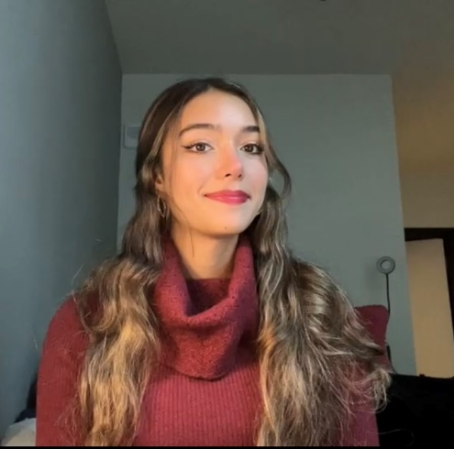
Name: Yasmine Mohseni
College: College of Medicine
Major: Nutritional Sciences
Minor: Disabilities in Society

Mentor: Dr. David Winchester

Project Title: The Relationship between Food Insecurity in the Low Socioeconomic Status Population and their Level of Self-actualization

Project Description: The study consists of a questionnaire that collects the demographics, food accessibility information (proximity to grocery store, if SNAP benefits are used, USDA food security level), and a Short Index of Self-Actualization Inventory (SISA). This study will allow government officials and medical professionals to gain more insight on how disadvantaged populations, who experience food insecurity, are less likely to reach a state of self-actualization. I plan on publishing these findings and sharing them with government officials in the City of Gainesville to advocate for more food nutrition focused free programs for the lower socioeconomic populations of Gainesville.

Research Interests: Endocrinology and Health Disparities in Nutrition

Academic Awards: 2020 Anne Frank Humanitarian Award, 2020 George Eastman Young Leaders Award, and President’s List
Involvement: MEDLIFE, Equal Access Clinic Research Research, Dance Marathon
Volunteering: Shands 8 East Oncology, Giving Garden, Project Downtown, Food4Kids
Hobbies and Other Interests: Food instagram (yumzbyyaz), College of Medicine Endocrinology Department Clinical Research Assistant, working out, and playing tennis

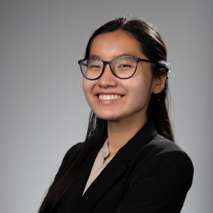
Name: Quyen Nguyen
College: College of Liberal Arts and Sciences
Major: Biochemistry
Minor:

Mentor: Stephanie Karst

Project Title: Elucidating determinants of MNV transcytosis and its strain-dependent response

Project Description: Noroviruses are the leading global cause of virally induced gastroenteritis across all groups, with an estimated 685 million cases of norovirus-induced diarrheal disease every year1. In spite of this high disease burden, there is currently no licensed vaccine and little is known about norovirus disease mechanisms2. Pertinent to understanding the infection and disease is identifying the cellular targets of the virus. Murine norovirus (MNV) is a widely used model system that has advanced the field’s understanding of host-virus interactions and virus strain variability3. For example, diarrheagenic MNV strains like MNV1 and WU23 infect immune cells during symptomatic infection4,5 whereas an attenuated strain called CR6 fails to infect immune cells in vivo6. Since CR6 efficiently infects immune cells in absence of a polarized epithelium7, we hypothesize that its restriction from immune cell infection in vivo derives from an inability to transcytose the epithelial barrierAdditionally, it was demonstrated that orally delivered CR6 infects these tissue sites in the absence of host interferon (IFN) signaling pathways, suggesting that the IFN response is blocking CR6 transcytosis8. Elucidating mechanisms of host restriction responsible for CR6 attenuation will provide insight into how diarrheagenic strains like MNV1 and WU23 avoid this restriction to establish infection and cause disease.

Research Interests: Biochemistry, Virology, Biomedical sciences, Pathogenesis

Academic Awards: Phi Beta Kappa Society Member; President's Honor Roll (2021-2022); University Honors Program
Involvement: Women's Student Association (2020-2023), Vietnamese Student Organization (2021-2022)
Hobbies and Other Interests: Nature walks, traveling, and eating delicious food.

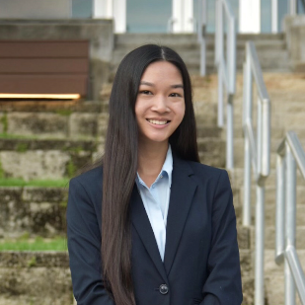
Name: Katie Pacini
College: College of Medicine
Major: Public Health
Minor: Health Disparities in Society; Anthropology

Mentor: Zhe Ma

Project Title: Anti-viral and anti-tumor responses of Kaposi's sarcoma-associated herpesvirus with STING agonist diamidobenzimidazole (diABZI)

Project Description: Kaposi's sarcoma-associated herpesvirus (KSHV) is a gammaherpesvirus responsible for multiple malignancies such as Kaposi sarcoma, multicentric Castleman disease, and primary effusion lymphoma. KSHV infection is lifelong with no available treatment or vaccines, and poses a high risk to immunocompromised individuals. The virus has a biphasic life cycle with short lytic replication and long-term latent replication, making detection difficult with the expression of few genes. Critical to the detection of KSHV infection is the cGAS-STING pathway and its subsequent activation of type 1 interferons, which has been shown to inhibit KSHV lytic replication. The aim of this project is to explore the ability of recent STING agonist diamidobenzimidazole (diABZI) to produce an anti-viral and anti-tumor response in patient-derived, KSHV+ primary effusion lymphoma cells through stimulation of the cGAS-STING pathway. To assess the effectiveness of the agonist, we will evaluate cell viability and viral replication using CTG assay, immunoblotting, RT-qPCR, and RNA-sequencing. Successful completion of this project will offer insight into potential clinical treatments for targeting KSHV infection and reactivation. I will be working on this project in the laboratory of Dr. Zhe Ma at the University of Florida under the guidance of Dr. Ma and graduate student Tiffany Nelson.

Research Interests: Cancer virology, Kaposi's sarcoma-associated herpesvirus (KSHV), health disparities, Asians and Asian Americans, epidemiology, pharmacy
Academic Awards: University Research Scholars Program; Dean's List; Pre-Pharmacy Early Assurance Program
Involvement: alpha Kappa Delta Phi International Sorority, Inc.; Chinese American Student Association; Undergraduate Public Health Association; Honors Program
Volunteering: Shands Hospital; Food4Kids Backpack Program; Adopt-a-Street

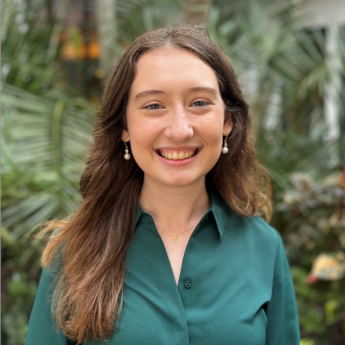
Name: Emerson Parks
College: College of Medicine
Major: Biochemistry & Molecular Biology
Minor: N/A

Mentor: Dr. Todd Brusko, Ph.D

Project Title: Assessing the impact of T1D associated coding variant rs763361 on CD4 and CD8 cell phenotype and antigen specific function.

Project Description: Type 1 Diabetes (T1D) is an autoimmune disease in which the body mounts an attack against pancreatic β-cells, mostly facilitated by the action of T cells. CD226 is a molecule expressed on T cells that promotes CD4 and CD8 activation, differentiation, and proliferation. A single nucleotide polymorphism (SNP) in the intracellular signaling domain (rs763316) on CD226 is associated with numerous autoimmune diseases. This SNP has been shown to promote inflammation by skewing CD4 T cells towards a TH17 phenotype. The expression of CD226 has also been shown to decrease the stability of Tregs, which are important in mediating autoimmune activity. In this project, I will utilize CRISPR/Cas9 to evaluate how the rs763361 SNP affects antigen specific T cell function. This project will be a novel investigation into the impact of rs763361 on CD4 and CD8 phenotype and function through using CRISPR/Cas9 to create an isogenic system, an experimental framework which is an emerging tool in T1D research. Ultimately, the project will seek to answer if the T1D associated risk variant within CD226 contributes to enhanced antigen specific function and inflammatory phenotype observed in T1D.

Research Interests: Autoimmunity, CRISPR, Genetics

Academic Awards: URSP Scholar, Dean's List Recipient
Involvement: UF Chemistry Club
Volunteering: UF Chemistry Club Outreach
Hobbies and Other Interests: Guitar, Reading, and Collecting Vinyl

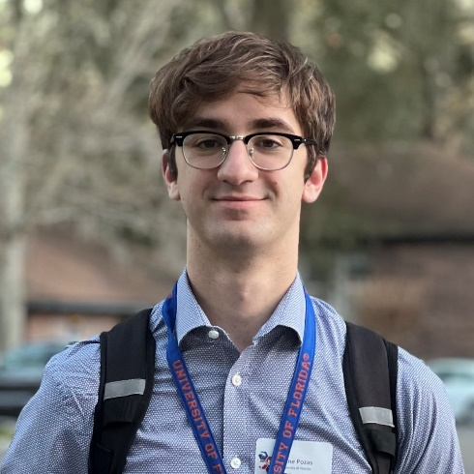
Name: Gene Pozas
College: College of Liberal Arts and Sciences
Major: Microbiology and Cell Science
Minor: N/A

Mentor: Rene Opavsky

Project Title: Identification of genes critical for the proliferation of Peripheral T cell lymphomas

Project Description: My aim is to utilize shRNA-mediated knockdown to identify and silence the genes that contribute to the oncogenicity of a certain subtype of Nodal Peripheral T-Cell Lymphoma (PTCL-NOS), which is associated with a poor prognosis in diagnosed patients.

Research Interests: Cell Biology, Cancer Treatment, Public Health, Epidemiology

Involvement: Chemistry Club, Gator Bioethics
Volunteering: Outreach Program/Alachua County Public Schools

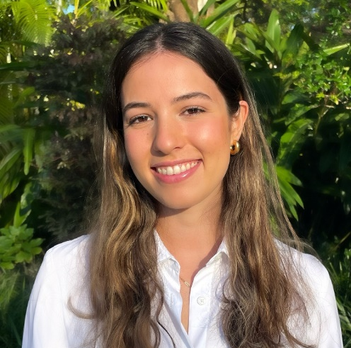
Name: Caroline Pujol
College: College of Liberal Arts and Sciences
Major: Biochemistry
Minor: N/A

Mentor: Dominick Lemas

Project Title:The impact of plasma metabolomics on maternal-infant health outcomes

Project Description: Maternal metabolite profiles have been shown to have an association with levels of infant obesity. These results suggest plasma metabolites may have a significant impact on infant outcomes and growth. Analyzing maternal plasma metabolites has potential to provide information regarding the lifestyle and diet of the patient during pregnancy. Levels of plasma lipid, glucose, protein, and fatty acid metabolites throughout the pregnancy can have a large influence on fetal growth and implicate obesity. Therefore, the goal of this proposal is to investigate the role of plasma metabolites over pregnancy and postpartum and their relationship to maternal and infant health outcomes.

Research Interests: Bioinformatics, Maternal and Infant Outcomes, Microbiology, gene sequencing

Academic Awards: University Research Scholars Program, CLAS Dean's List
Involvement: American Medical Student Association, Delta Zeta, Chemistry Club
Volunteering: Equal Access Clinic Network, Chemistry Outreach program, UF Health Shands
Hobbies and Other Interests: Running, cooking, reading, drawing and painting

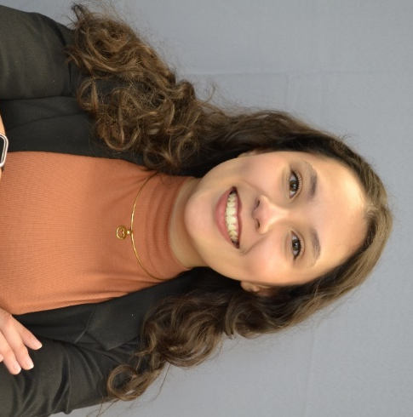
Name: Jossie Stephanie Sanchez
College: College of Medicine
Major: Microbiology and Cell Science
Minor: Anthropology

Mentor: Lei Zhou

Project Title: Analyzing Tissues Responsible for Sexual Dimorphic Inflammaging

Project Description: I am researching the clinical significance of sexual differences in immunity and inflammation. I will utilize tissue dissection, RNA extraction, and QPCR to identify which tissue(s) underlies sexual dimorphic inflammaging. Our preliminary data indicates that the sexual identity of the macrophage is important for sexual dimorphic inflammaging. I will test whether this effect is autonomous.

Research Interests: Cancer and Genetics Research

Academic Awards: Dean's list Spring and Fall 2022
Involvement: Equal Access Clinic
Volunteering: Project Continuity with UF's Health Cancer Center, Equal Access Clinic, Medi-Gators
Hobbies and Other Interests: Drawing, reading and hanging out with friends!

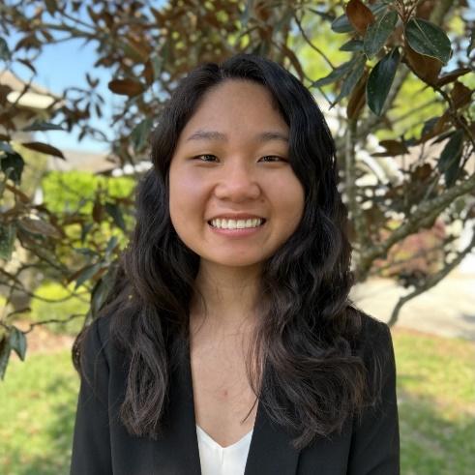
Name: Hannah Strother
College: College of Medicine
Major: Biochemistry
Minor: N/A

Mentor: Alfonso Martin Pena

Project Title: Disturbances in homeostatic sleep during prodromal Parkinson’s disease

Project Description: Studying the effects of human alpha synuclein on Drosophila to shed light onto the molecular mechanisms that support sleep disturbances in prodromal stages of PD before the classical symptoms of PD occur. The results of our experiments will reveal whether the molecular system sensing intracellular reactive oxygen species (ROS) levels mediates increased sleep in flies expressing alpha synuclein in dopaminergic neurons. The results from this project will provide key molecular components with the potential to halt disease progression into motor and cognitive symptoms.

Research Interests: Neurological diseases, genetics

Academic Awards: CLAS Dean's List, President's Honor Roll
Involvement: Phi Kappa Phi, Phi Eta Sigma
Hobbies and Other Interests: I enjoy going to concerts and solving puzzles.

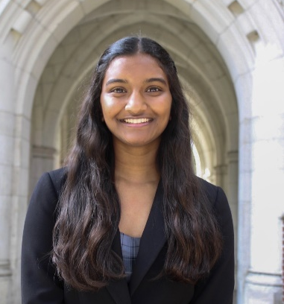
Name: Sionika Thayagabalu
College: College of Medicine
Major: Biology and Women's Studies
Minor: N/A

Mentor: Dominick Lemas

Project Title: Influence of Prenatal Vitamins/Supplements on Breast Milk Composition and Maternal-Infant Health Outcomes

Project Description: This project aims to investigate maternal consumption of prenatal vitamins/supplements and its associations with child-maternal health outcomes. I will be collecting and analyzing data from the Breastfeeding and Early Child Health (BEACH) study, led by Dr. Dominick J. Lemas. The BEACH study is a long-term study that recruits women who have completed 36-38 weeks of pregnancy and follows the mother and infant through the first 12-months postpartum. Data that will be extracted includes vitamin/supplement consumption during the third trimester, breast milk composition, breastfeeding efficacy, and infant BMI. Regression and machine learning techniques will be used to link prenatal vitamin consumption with health outcomes. Breast milk collected via the BEACH study 2-weeks postpartum will be analyzed using metabolomics software to extract lipid, carbohydrate, and mineral data. Potential correlations between supplemental vitamin consumption and both breastmilk and breastfeeding efficacy will be studied. Participant vitamin consumption and the respective infant BMI at 2 weeks, 2 months, and 12 months postpartum will be analyzed for potential correlations. This study will expand upon the current knowledge of vitamin deficiencies and maternal-infant health.

Research Interests: Women's Health

Academic Awards: Benacquisto Scholar, University Scholars Program
Involvement: Dream Team, Medi-Futures, TEDxUF
Volunteering: UF Health Shands Children’s Hospital
Hobbies and Other Interests: Traveling, kayaking, dance

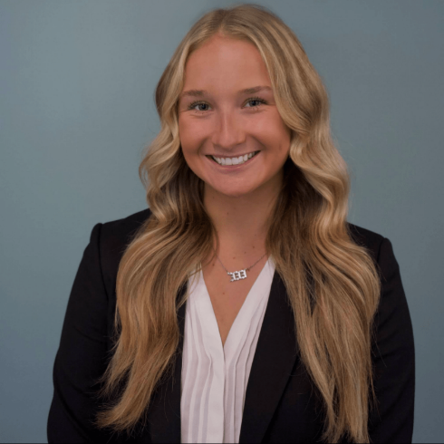
Name: Taylor Thomson
College: College of Medicine
Major: Applied Physiology and Kinesiology
Minor: N/A

Mentor: Dr. Barry Setlow

Project Title: Effects of concurrent cannabis on cocaine use and relapse in Sprague Dawley rats

Project Description: The primary aim of our project is to use a rat model to understand how PSU of cocaine and cannabis affects behavior. Despite the acknowledgement that cocaine-cannabis PSU is a common combination for cocaine users, there is little understanding of the patterns of co-use and their consequences. Considering this, our rat model is based on the results of a collaborative project with a team of UF epidemiologists, who surveyed cocaine users to determine their temporal patterns of PSU. With this background, we have gathered data from initial experiments in rats, but additional studies are needed for confirmation. Furthermore, in upcoming experiments we will be modeling exposure to clean air instead of placebo cannabis smoke (0% THC), which will more accurately reflect human nonsmoker behavior.

Research Interests: Addiction medicine, neuroscience

Academic Awards: National Merit Scholar, Honors Program, 6x Dean's List, Undergraduate Research Scholars Program
Involvement: Gator Emergency Medical Response Unit, Volunteers Around the World Medical
Volunteering: Shands Volunteer program
Hobbies and Other Interests: Health and fitness

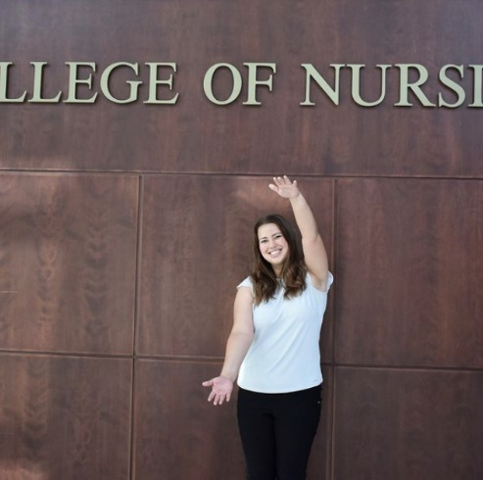
Name: Alessia Rosa
College: College of Nursing
Major: Nursing
Minor: N/A

Mentor: Dr. Lakeisha Cousin

Project Title: Sociocultural Use of Marijuana and Implications for Health

Project Description: My project aims to examine different variables within social determinants of health and how they correlate with different levels of marijuana usage. I also aim to look at a variety of physical and mental health variables in order to gain better insight to something that is very quickly becoming more and more prominently used by patients both recreationally and medicinally.

Research Interests: Ethnic health disparities and sociocultural effects on health

Academic Awards: Dean’s List
Volunteering: West End Animal Hospital, Humane Society, Plenty of Pit Bulls
Hobbies and Other Interests: soccer, reading, baking

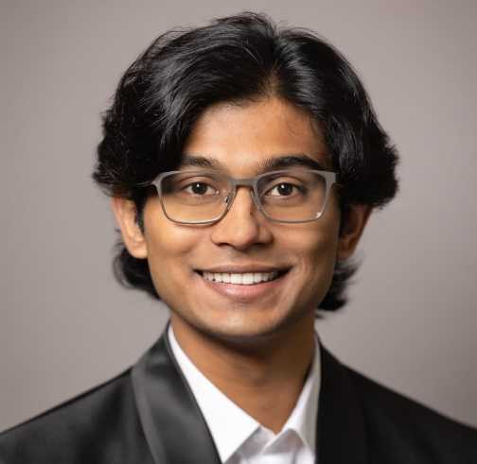
Name: Gautham Amaravadi
College: College of Pharmacy
Major: Biochemistry
Minor: Philosophy

Mentor: Dr. Yousong Ding

Project Title: Bioactivity guided isolation and characterization of natural product from bird nest fungus, Nidularia pulvinata.

Project Description: Natural products derived from living organisms often offer great advantages in pharmaceutical design and also have diverse biological activities. Hence, investigation into natural products often involves improving treatments for infectious diseases. N. pulvinata produces natural products that show promising antifungal activity. In this project, we aim to: isolate and characterize the bioactive molecules produced by N. pulvinata; identify the biosynthetic gene sequence responsible for the metabolites; and evaluate the activity of the natural products against different human fungal pathogens.

Research Interests: Medicinal Chemistry

Academic Awards:
Involvement: Baking4Wellness
Volunteering: Alachua County Crisis Center
Hobbies and Other Interests: Traveling

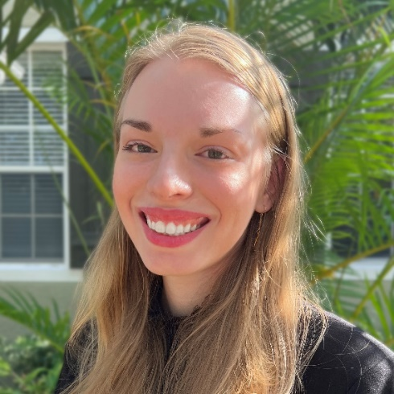
Name: Kayleigh Ballas
College: College of Pharmacy
Major: Microbiology
Minor: Chinese, Chemistry

Mentor: Chengguo (CX) Xing, Ph.D.

Project Title: Cotinine’s Potential Role in Lung Cancer Tumorigenesis

Project Description: Lung cancer has been the leading cause of cancer death worldwide for several decades. Lung cancer diagnosis and mortality are closely linked to the smoking of tobacco products. Tobacco smoke has been reported to contain an estimated 7000 compounds, 60 of which are known carcinogens. Although not a carcinogen, nicotine is the major constituent of tobacco smoke responsible for its addictive nature, leading to continued exposure of the carcinogens in tobacco smoke. On average 1-1.5 mg of nicotine will be absorbed by the body while smoking a cigarette, 70-80% of which will be metabolized into cotinine, the major metabolite of nicotine. Cotinine has a half-life (8-30 hr) much longer than that of nicotine (1-2 hr). Nicotine exposure has been shown to increase poor patient prognosis by enhancing tumorigenesis, promoting angiogenesis, and preventing cell death. As the main metabolite of nicotine, and with its extended exposure to bodily tissues, it stands to reason that cotinine plays an important role in cellular tumorigenesis. As such, this project aims to characterize the relationship between cotinine exposure and cellular tumorigenesis.

Research Interests: Disease prevention and progression, Tumorigenesis, Traditional medicine, Reverse pharmacology, Metabolomics

Academic Awards: UF Presidential Scholarship, UF College of Liberal Arts and Sciences Dean's List (all semesters)
Involvement: UF Chemistry Club
Volunteering: Cade Museum Summer Camp, UF Science Bowl, Give Kids the World
Hobbies and Other Interests: Snuggling with my cat, Baking, Reading, Playing violin, Ice skating, Cross-stitching

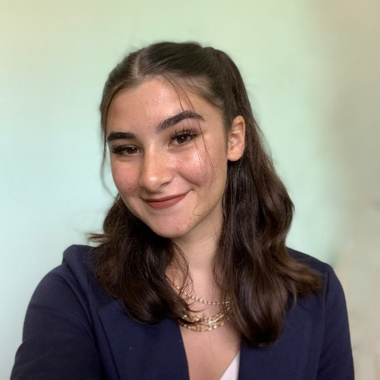
Name: Sarah Paprotna
College: College of Pharmacy
Major: Behavioral and Cognitive Neuroscience
Minor: Flute Performance

Mentor: Brandon Warren

Project Title: Nucleus Accumbens Core neurons mediate cocaine self-administration

Project Description: The nucleus accumbens core (NAcCore) has been shown to mediate cocaine learning, and is therefore linked with cocaine-use disorder (CUD). Recent evidence suggests that the NacCore has specific neuronal populations sensitive to cocaine or sucrose, but this data has not yet been tested experimentally. We seek to test our hypothesis that the NacCore contains neurons that are sensitive to cocaine and mediate cocaine learning.

Research Interests: Addiction, behavioral research methods

Academic Awards: Presidential honor role, University Research Scholars Program
Involvement: Alpha Epsilon Delta, Luminaries
Volunteering: Streetlight
Hobbies and Other Interests: Playing the piano, fashion, video games, and cooking

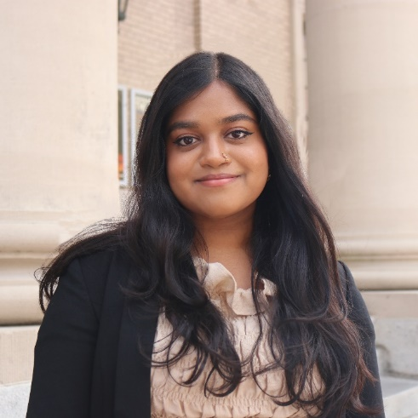
Name: Yusra Ahmed
College: College of Public Health and Health Professions
Major: Public Health
Minor: N/A

Mentor: Joseph Bisesi

Project Title: Investigating the Effects of Polybrominated Diphenyl Ethers (PBDEs) on Thyroid Hormone Synthesis Pathways

Project Description: Polybrominated diphenyl ethers (PBDEs) were used as flame retardants and continue to persist in the environment, including household dust. Although they have been phased out, exposure to BDEs remains a concern due to their potential health effects. Previous studies have linked exposure to PBDEs with thyroid system toxicity, likely due to their structural similarity to thyroid hormones and affinity for thyroid receptors. Our study investigates the interaction between OH-BDE metabolites and thyroid receptor beta 2 (TRβ2) in the hypothalamus and pituitary glands. Results of this research could provide evidence for a novel mechanism by which PBDEs can directly influence circulating thyroid hormones and epidemiological evidence associated with hypothyroidism.

Research Interests: Environmental Health, Toxicology, and Health Disparities

Academic Awards: PHHP Dean's List, CDC Undergraduate Public Health Scholar
Involvement: Health Educated Asian Leaders, Undergraduate Public Health Association, Asian American Student Union, Bangladeshi Students' Association
Volunteering: Grace Marketplace Clinic and Days for Girls
Hobbies and Other Interests: In my free time, I love to crochet, paint, play piano, and collect plants.

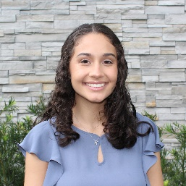
Name: Kylie Fernandez
College: College of Public Health and Health Professions
Major: Communication Sciences and Disorders
Minor: Educational Studies/Deaf and Hearing Sciences

Mentor: Susan Nittrouer

Project Title: The Effects of Parental Language Input and Parental Knowledge of Child Development on Child Language Development

Project Description: Past experiments have demonstrated that the amount and kind of parental language input affects language development, and poverty-related delays in language development have been attributed to poor parental language input. Concern has been raised, however, that parental language input may simply reflect broader parental competencies, largely related to how knowledgeable parents are about child development and how to support it optimally. This ongoing study addresses this possible confound by examining how parental language input is mediated by parental knowledge of child development. Twenty parent-child dyads across various SES will be tested over the course of this study using 5 measures. The parent and child will be recorded playing with Tinkertoys together and parental language behaviors will be scored to measure (1) parental language input. The child will complete two tasks measuring (2) vocabulary knowledge and (3) auditory comprehension of language. The parent will complete two surveys measuring (4) general knowledge of child development and (5) knowledge of best practices to use in parenting scenarios.

Research Interests: Child Language Development, Cochlear Implant Modification, Speech Perception for Children with Autism

Academic Awards: Stamps Scholar, Hispanic Scholarship Fund, URSP, USP 2022
Involvement: National Student Speech Language and Hearing Association, Honors and Aprons
Volunteering: Balance 180 Adaptive Gymnastics, Reading Pals, Alachua County Hearing Screenings
Hobbies and Other Interests: Baking, Camping, Hiking, Rollerskating, Intramural Volleyball/Soccer

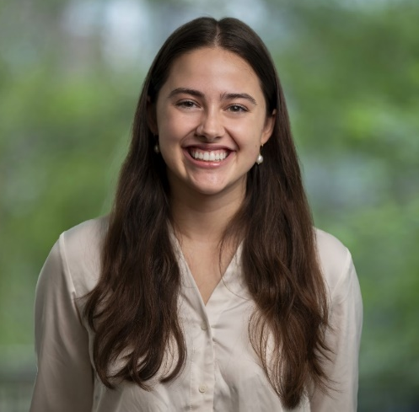
Name: Gabrielle Gonzalez
College: College of Public Health and Health Professions
Major: Statistics
Minor: Public Health

Mentor: Dr. Tracie Baker

Project Title: Characterizing the transgenerational and life stage-specific neurobehavioral effect of lead (Pb2+) exposure in zebrafish

Project Description: Lead (Pb) is one of ten World Health Organization (WHO)-identified toxicants of major public health concern, as exposure from paint, dust, soil, air, household items, and drinking water, can severely impair neurological functions at several life stages. There is a current lack of research on the mechanisms that mediate Pb-induced developmental, geriatric, and transgenerational neurobehavioral deficits. Previous work has been conducted on Pb exposures in the F0 generation of zebrafish (Danio rerio), showing significant changes in behavior for both embryonic and aged exposures as well as significant transcriptomic dysregulation in neurogenesis pathways. As significant effects have been observed, further research into neurobehavioral deficits is needed. The purpose of this study is to evaluate the transgenerational effects and life stage-specific transcriptomic changes in neurobehavioral disorders of environmentally relevant levels of Pb exposure on larval and aged zebrafish. The results from this study will provide greater insight into the direct neurobehavioral effects of both embryonic and aged exposure and can inform legal limits for Pb concentration in consumer products and the environment.

Research Interests: Toxicology, biostatistics, epidemiology, biology, public health

Academic Awards: USP, UF CLAS Dean's List, Bright Futures Academic Scholar
Involvement: University Research Scholars Program, Florida Club Swimming
Hobbies and Other Interests: Swimming, scuba diving, baking, reading

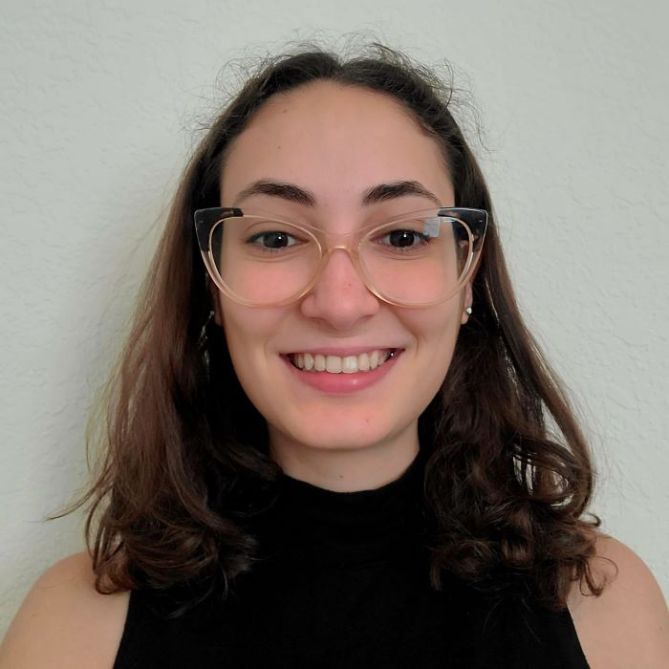
Name: Ana Rodriguez
College: College of Public Health and Health Professions
Major: Communication Sciences and Disorders
Minor: Family, Youth & Community Sciences + Disabilities in Society

Mentor: Matthew Masapollo

Project Title: The goal of this project is to test dyslexic talkers on a set of measures assessing the coordination of articulatory gestures, phonological sensitivity, and the relationship between those two skills.

Project Description: The goal of this project is to test dyslexic talkers on a set of measures assessing the coordination of articulatory gestures, phonological sensitivity, and the relationship between those two skills.

Research Interests: Dyslexia, reading disorders, bilingualism

Academic Awards: Robert W. Young Award for Undegraduate Research in Phonetics
Involvement: FSDC, Hooked to the Book Club
Volunteering: Kids Count, ENGin
Hobbies and Other Interests: Swing dancing, reading, creative writing

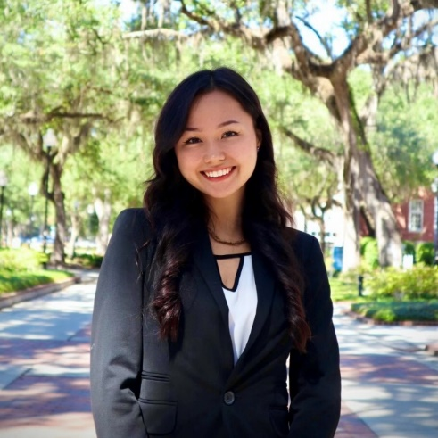
Name: Shion Simms
College: College of Public Health and Health Professions
Major: Communication Sciences and Disorders
Minor: Linguistics and Deaf & Hearing Sciences

Mentor: Shinichi Someya

Project Title: Effects of Estrogen Receptor 1 (Esr1) deficiency on Auditory Function in Mice

Project Description: It is well documented that early onset of age-related hearing loss, which is most pronounced at higher frequencies, is more common in men than women. Numerous studies have suggested that estrogen may play a key role in these sex differences. However, the cellular and molecular mechanisms underlying sex differences in hearing loss still remain unclear. In this study, we are investigating the effects of Esr1, a gene that encodes estrogen receptor proteins, on the maintenance of normal auditory function in wildtype (WT) and Esr1 knockout (Esr1 KO) mice. To investigate the effects of Esr1 on auditory function and balance performance, auditory brainstem response (ABR) (thresholds, wave I-V amplitudes and latencies), distortion product otoacoustic emission (DPOAE) (amplitude and thresholds), and rotarod balance performance (latency to fall) tests will be performed in male and female WT and Esr1-KO mice at 2-3 months of age.

Research Interests: Audiology / Age-Related Hearing Loss

Academic Awards: PHHP Honors Program, Dean's List, Florida Bright Futures
Involvement: National Student Speech-Language Hearing Association, Japanese Student Association, Best Buddies
Volunteering: Hearoes for Hearing, Children Beyond Our Borders, CLAS Language Studio
Hobbies and Other Interests: Traveling, meditating, weightlifting, baking, ceramics

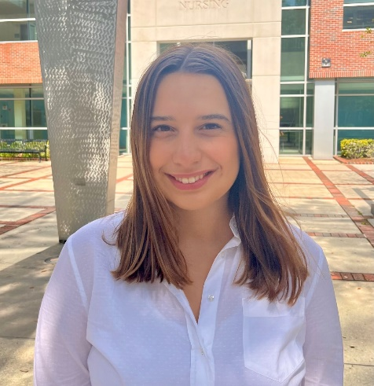
Name: Buse Utkan
College: College of Public Health and Health Professions
Major: Communication Sciences and Disorders
Minor: Event Management

Mentor: Sharon DiFino

Project Title: The Health Transformation Program’s Impact on the Decline in Infant Mortality in Turkey

Project Description: Exploring how the healthcare reforms in Turkey, made in 2003, affected the fall in infant mortality rate and the rise in patient satisfaction rate.

Research Interests: Speech and Language, Healthcare

Academic Awards: N/A
Involvement: NSSHLA, Relay For Life
Volunteering: Balance 180

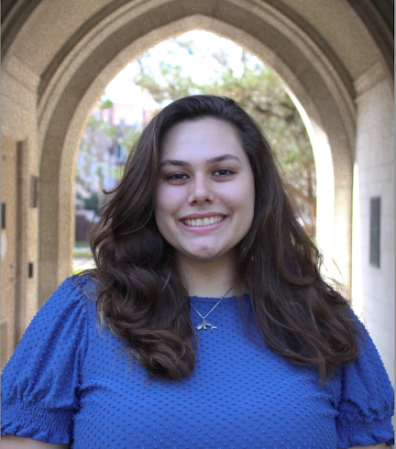
Name: Madeline McCoy
College: College of Veterinary Medicine
Major: Zoology
Minor: Anthropology

Mentor: Christopher J Martyniuk

Project Title: Epigenetic Effects on Zebrafish Following PFTeDA Exposure

Project Description: Perfluorinated compounds are an anthropogenic class of molecules that are industrially created as lubricants, protectants, pesticides, detergents, and flame retardants. PFCs have widely been recognized to have considerable physiological and behavioral effects such as developmental toxicity/neurotoxicity, immunotoxicity, and endocrine disruption. PFTeDA is a long chain perfluorinated carboxylic acid that is used in commercial and industrial products and due to its prevalence, its environmental presence is high. This study aims to assess the adult zebrafish exposed to 0.1% DMSO or 0.1 μM PFTeDA for 7 days following a 7-day exposure in the embryonic state and a depurination period. The impacts of each exposure will be assessed according to gene expression, changes in the gastrointestinal microbiome, and transcriptomics. This study can be added to the growing literature on PFCs and their harm to the environment, aquatic and terrestrial wildlife, as well as within human and domesticated animal populations to help control and prevent further detriment to these groups.

Research Interests: Toxicology, immunology, epigenetics, genomics, and host-microbiome interactions- specifically within the gastrointestinal tract

Involvement: UF Minority Pre-Vet Students
Volunteering: UF Sheep and Goat Extension, Volunteer Technician at the Humane Society of North Central Florida, Brevard Zoo, Florida Wildlife Hospital Rehabilitation Program,
Hobbies and Other Interests: Hiking and exploring with my friends and my dog Angus, triathlons, sculpting, and reading fiction and nonfiction books

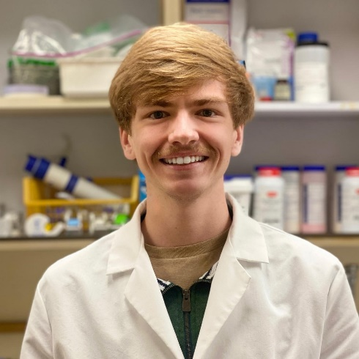
Name: Douglas Natoce Jr.
College: College of Veterinary Medicine
Major: Animal Sciences: Food Animal Production
Minor: N/A

Mentor: Dr. Roy Curtiss III

Project Title: Recombinant Salmonella Strains to induce protective immunity in poultry

Project Description: Recently developed Self-Destructing Attenuated Adjuvant Salmonella strains (SDAAS) have superior attributes to display, and very efficiently induce innate immunity effectors to augment the ability of subunit and live vaccines to induce protective immunity against challenges with pathogens. These SDAAS administered in ovo to 18-day old chick embryos permitted normal levels of hatchability and provided some level of protection against Avian Pathogenic E. coli and Salmonella Typhimurium challenge. The goal of this project will be to construct and validate new SDAAS strains designed to be safer and more immunogenic when administered to chicken embryos in ovo for use in future subunit and live vaccines in poultry.

Research Interests: Meat and muscle biology, Food safety, Microbiology, Biotechnology

Involvement: UF IFAS Animal Science Ambassadors
Volunteering: Florida 4H and FFA
Hobbies and Other Interests: Running, road biking, diving

Name: Dalia Bronisas Dooley
College: University Libraries
Major: History with a Legal History Specialization
Minor: Agricultural and Natural Resource Law

Mentor: Dr. Neil Weijer

Project Title: American Wartime Propaganda and Its Influence on Female Marginalization

Project Description: Persuading the American public to become a wartime industry was almost as important as the manufacturing of bullets and planes. The United States Government has launched countless aggressive propaganda campaigns throughout the course of American history in order to gain fiscal and emotional support. Each campaign had its own clearly articulated goals and strategies to galvanize public support. Through the recruitment of some of the nation's foremost intellectuals and artists, the government knew the importance of gathering support on the home front with marginalized groups having specific importance. The basis of my research will surround the changing strategies used by artists in their American wartime illustrations to influence female support of the respected conflict. Through the comparison of the propaganda’s messages and illustration styles, I will find the commonalities along with the differences in wartime propaganda from various periods.

Research Interests: Early and Modern American History, Legal History, Art History.

Academic Awards: Florida Bright Futures Scholarship, University of Florida Dean’s List, and University Scholars Fellowship.
Involvement: Phi Alpha Delta, The Taylor Swift Society, Phi Alpha Theta, and Florida Cryptocurrency and Alternative Assets Club.
Volunteering: University Archivist Student Assistant, Phi Alpha Theta Book Sale, and Montbrook Fossil Excavation Volunteer.
Hobbies and Other Interests: Art (graphic design, fashion, painting, or drawing), Reading, Star Wars, and Taylor Swift.

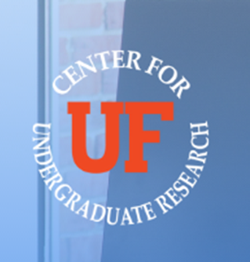
Name: Diego Carrascosa
College: Herbert Wertheim College of Engineering
Major: Computer Science
Minor: Mathematics

Mentor: Dr. Angelos Barmpoutis

Project Title: ATUNDA

Project Description AI-Driven dance movement recognition and classification project

Research Interests: Artificial Intelligence
Academic Awards: Honors Program, University Research Scholars Program, President's Honor Roll
Involvement: Poker Club
Volunteering: Boy Scouts of America
Hobbies and Other Interests: Coding, Ai, running, video games.

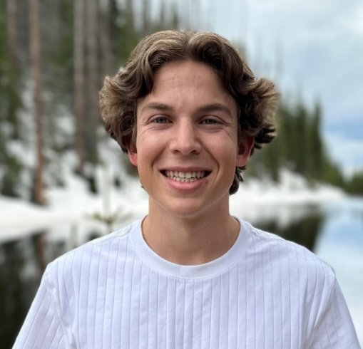
Name: Tristan Pank
College: Herbert Wertheim College of Engineering
Major: Computer Science
Minor: Mathematics

Mentor: Dr. Angelos Barmpoutis

Project Title: ATUNDA: AI-Driven dance movement recognition and classification project

Project Description: Atunda project is an interdisciplinary collaboration with researchers, scientists and various dance communities contributing significantly to various components of the project. The focus of the project is the development of software for analyzing dance moves across cultures, using AI-Driven movement recognition and classification methods. Previously the team collected the first AI-ready dataset for Afrogenic dance analysis. The dataset collected in partnership with The QDance Center Lagos consists of 394 videos that show 13 types of Afrogenic dances. The data bank will continue to grow and be available as an open access test bed that can be used in this project to develop and compare AI methods that analyze human motion from raw videos. Human movement classification and analysis are important in the many fields. Technology-supported human movement analysis employs motion sensors, infrared cameras, and other wearable devices to capture critical joints of the human skeleton and facial key points. This study will create a video data collection web-based tool that will organize videos and categorical tags into a dataset that will then be used to train and compare different machine learning algorithms. The goal of the project is to develop a system that will be able to automatically categorize dance videos based on previously acquired knowledge. To accomplish this, various software packages in Python will be used that will put together the data collection website, video database curation scripts, video processing, skeleton point extraction for each video frame, and finally AI training using existing python machine learning packages.

Research Interests: Software Engineering, Machine Learning
Academic Awards: Honors Program, University Research Scholars Program, President's Honor Roll
Involvement: Association for Computing Machinery
Volunteering: Boy Scouts of America
Hobbies and Other Interests: Triathlons
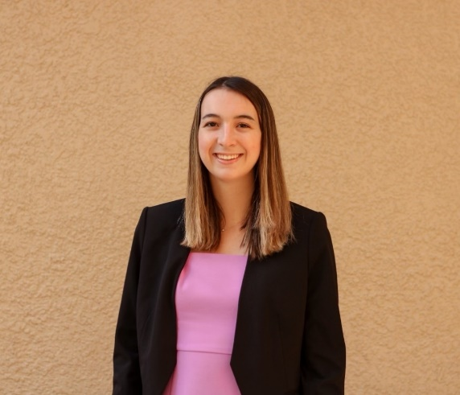
Name: Lauren Dawson-Scully
College: Florida Museum of Natural History
Major: Biology
Minor: Anthropology

Mentor: Dr. Scott Robinson

Project Title: Effects of urbanization on community composition and phenotypes of birds in wetland ecosystems

Project Description: The goal of my research is to gain an understanding of how human involvement in wetland ecosystems has changed the abundance, phenotypes, and behavior of wetland birds. I will be investigating changes in population and species composition along urban-rural gradients. I will also be investigating differences between birds collected in urban areas versus birds collected in rural areas using the Florida Museum of Natural History’s collection. I believe this project is important as it will contribute to further understanding the influence urban infrastructure and human presence has on wetland birds. Because urban areas are expanding rapidly, it is important to be able to predict the consequences for avian biodiversity. These data will also help identify wetlands of special value to the maintenance of local wetland communities.

Research Interests: biology, ecology, evolution, environmental sciences, conservation

Involvement: Alpha Zeta, Sigma Kappa
Hobbies and Other Interests: hiking, working out, spending time with family and friends

Name: Chandana Karumanchi
College: Florida Museum of Natural History
Major: Microbiology and Cell Sciences
Minor: Health Disparties in Society

Mentor: Steven R. Manchester

Project Title: Characterization of a flower of fossil genus Sahnianthus, from the Latest Cretaceous of India by micro-CT and cladistic analysis of placement in Lythraceae

Project Description: The completion of this study will contribute to the understanding of overall paleoclimatic and paleogeographic change in the area, as well as confirm the affinity of reproductive material to the family Lythraceae, expanding the known fossil record and geography of the family.

Research Interests: Paleobotany

Academic Awards: Winona Jordan Undergraduate Research Award, Conservation Paleobiology Network Fellow, CLAS Scholar,
Involvement: Immigator Association, Engineers Without Borders, Improve the Dream,
Volunteering: Shands NICU volunteering, AdventHealth Childlife Volunteering,Girls for Science College Mentor
Hobbies and Other Interests: Singing, Taekwondo, exploring cafes and museums, reading, and album collecting.

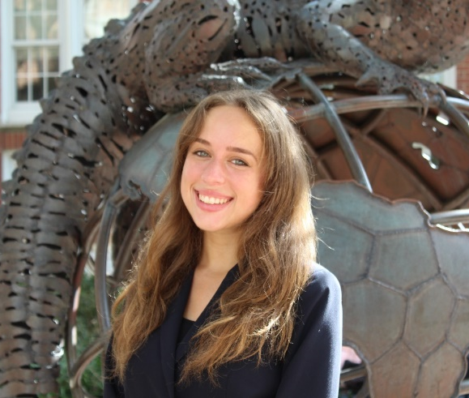
Name: Olivia Maule
College: Florida Museum of Natural History
Major: Biology and Anthropology
Minor: Sustainability and Entomology

Mentor: Dr. Keith Willmott

Project Title: Andean Uplift and Neotropical Butterfly Species Divergence

Project Description: My research relates to evolutionary dynamics of Andean butterflies, and specifically investigates three possible mechanisms for lepidoptera speciation across the Andes: vicariance (one population split as a geographic barrier emerged), dispersal across the Andes (population split after uplift), or dispersal around the Andes (also occurring after uplift). The primary hypothesis is that elevation correlates with DNA divergence, specifically that higher divergence is present at lower elevations. However, I would expect that DNA divergence among species at the same elevation could depend on differences in traits such as host-plant interactions, wing morphology, flight speed, and canopy cover. This study is the first to examine Lepidoptera DNA divergence between east and west Andean populations at different elevations, as well as incorporate the mentioned traits into a biogeographic study of species divergence.

Research Interests: evolution, climate change, entomology, biological anthropology, genetics

Academic Awards: Conservation Paleobiology Scholar, Dean's List
Involvement: Honors Program, Undergraduate Florida Anthropology Student Association, Science Communigators, The Women's Network, Spoon University
Volunteering: Smithsonian Encyclopedia of Life Project
Hobbies and Other Interests: Traveling, Landscape Photography, Holistic Cooking, Journaling, Working Out, Playing Chess

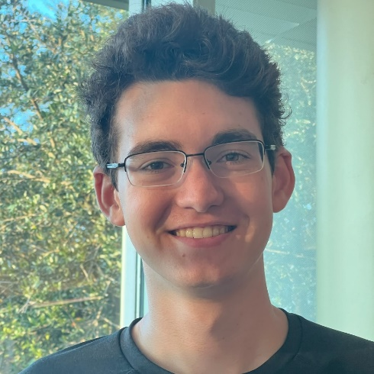
Name: Stephen Patten
College: Florida Museum of Natural History
Major: Biology, Philosophy
Minor: N/A

Mentor: Grant Godden

Project Title: Ecological and Evolutionary Processes Affecting the Co-existence of Close Relatives

Project Description: We will use our evolutionary framework, RNA-seq data for 23+ species, and ecological data to investigate: (1) patterns of ploidy variation, (2) gene duplication dynamics, and ancient polyploidy, and ultimately (3) their correspondence to shifts in diversification rates, traits, niches, and/or species ranges. This integrative approach will provide a mechanistic view of speciation, historical range expansion, and species co-existence.

Research Interests: Genetics, Ecology, Botany, Bioinformatics, Systematics, Evolution

Academic Awards: Phi Beta Kappa Society, Academic Top Scholars Award, National Merit Scholar, Dean's List Fall 2021
Involvement: Undergraduate Philosophy Society, University Research Scholars Program, Honors Program
Volunteering: Habitat for Humanity
Hobbies and Other Interests: Reading, browsing Wikipedia, strength training, strategy games, football

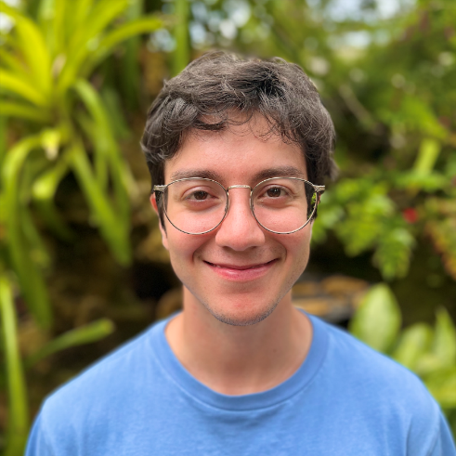
Name: Nicholas Wallis-Mauro
College: Florida Museum of Natural History
Major: Marine Science and Zoology
Minor: N/A

Mentor: Larry Page

Project Title: Investigating the Schistura sexcauda species complex

Project Description: Several species of Schistura (nemacheilines loaches) in Indochina share the combination of several characteristics including a complete or nearly complete lateral line, 8½ branched dorsal fin rays, 9+8 caudal fin rays, and no sexual dimorphism. Diagnosis of these species relies on subtle morphological differences and there is lacking information on variation in characteristics; these missing variations are often meaningful taxonomically. This report will test the validity of these similar species utilizing genetic and morphological data analysis. We predict that some of these species may not be valid and there is more variation than what has previously been reported; and also that there are undescribed species that need to yet be described.

Research Interests: ecology of marine ecosystems, fish ecology and behavior, animal behavior

Academic Awards: UF Emerging Scholars Program, UF University Scholars Program, NSF REU at Yale for summer 2023, UF Dean's List
Involvement: Society of Photography for Wildlife Conservation, UF Gator SCUBA Club
Volunteering: Remote volunteer for the Florida Program for Shark Research
Hobbies and Other Interests: Wildlife photography, snorkelling and scuba diving,

